**Web API**

## ASP.NET Web API

The ASP.NET Web API is an extensible framework for building HTTP based services that can be accessed in different applications on different platforms such as web, windows, mobile etc. It works more or less the same way as ASP.NET MVC web application except that it sends data as a response instead of html view. It is like a webservice or WCF service but the exception is that it only supports HTTP protocol.

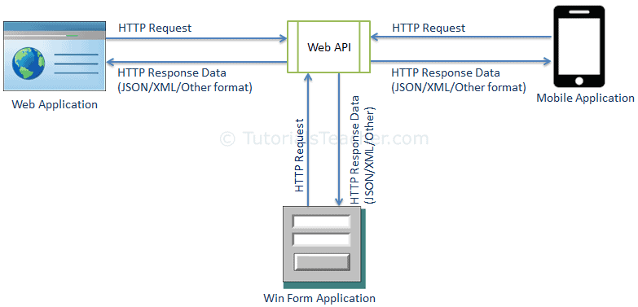

# Web API Controllers

We created Web API with MVC project in the previous section where it generated a simple controller. Here, you will learn about Web API Controller in detail.

Web API Controller is similar to ASP.NET MVC controller. It handles incoming HTTP requests and send response back to the caller.

Web API controller is a class which can be created under the **Controllers** folder or any other folder under your project's root folder.

The name of a controller class must end with "Controller" and it must be derived from System. Web. Http.**ApiController** class. All the public methods of the controller are called action methods.

# **Web API for CRUD operation**

CRUD stands **for "Create, Read, Update, and Delete**," which are the four basic database operations. Many HTTP services also model CRUD operations through REST or REST-like APIs.

**Why to Choose Web API?**

A Web API services are preferable over other services to use with a native application that does not support SOAP but require web services.

For creating resource-oriented services, the web API services are the best to choose. By using HTTP or restful service, these services are established.

If you want good performance and fast development of services, the web API services are very helpful.

For developing light weighted and maintainable web services, web API services are really helpful to develop that service. It supports any text pattern like JSON, XML etc.

The devices that have tight bandwidth or having a limitation in bandwidth, then the Web API services are the best for those devices.