# **Implementing OAuth 2.0 with Node.js**

OAuth2 is an authentication protocol that is used to authenticate and authorize users in an application by using another service provider.

## **OAuth2 flow**

Let’s take a brief look at the OAuth protocol before we jump into implementation. If you’ve ever seen a dialog similar to this, then you probably have some idea of what OAuth is:

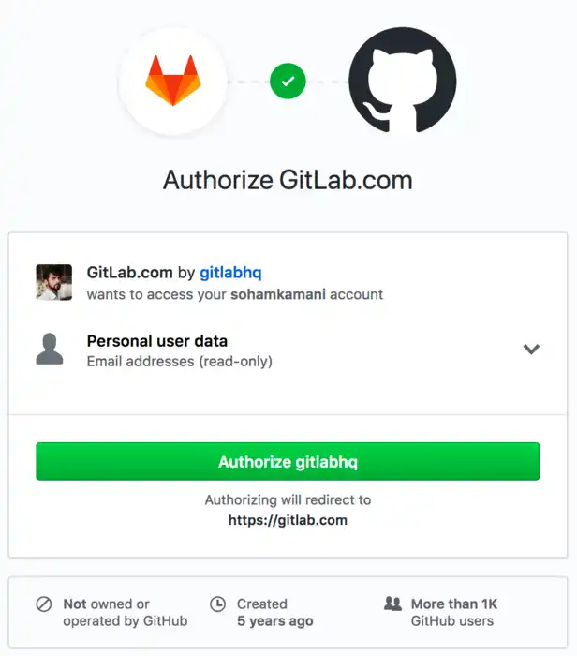

In the above image, we are trying to login to [Gitlab](https://gitlab.com) using [Github](https://github.com) to authenticate.

There are three parties in any OAuth flow:

1. **The client** - The person, or user who is logging in
2. **The consumer** - The application that the client wants to log in to (which was gitlab in the above image)
3. **The service provider** - The external application through which the user authenticates. (which was github in the above image)

In this post, we will authenticate using Google OAuth2 API, and build a sample node application, running on the local port 8080, with a web interface. So in our case, the client would be the web interface, the consumer would be the application running on localhost:8080 and the service provider would be Google. Let’s look at how this would all work:

