Steps to undertake App Registration and generate Authentication Token

1. Access the Microsoft Entra ID and access the App Registration  
   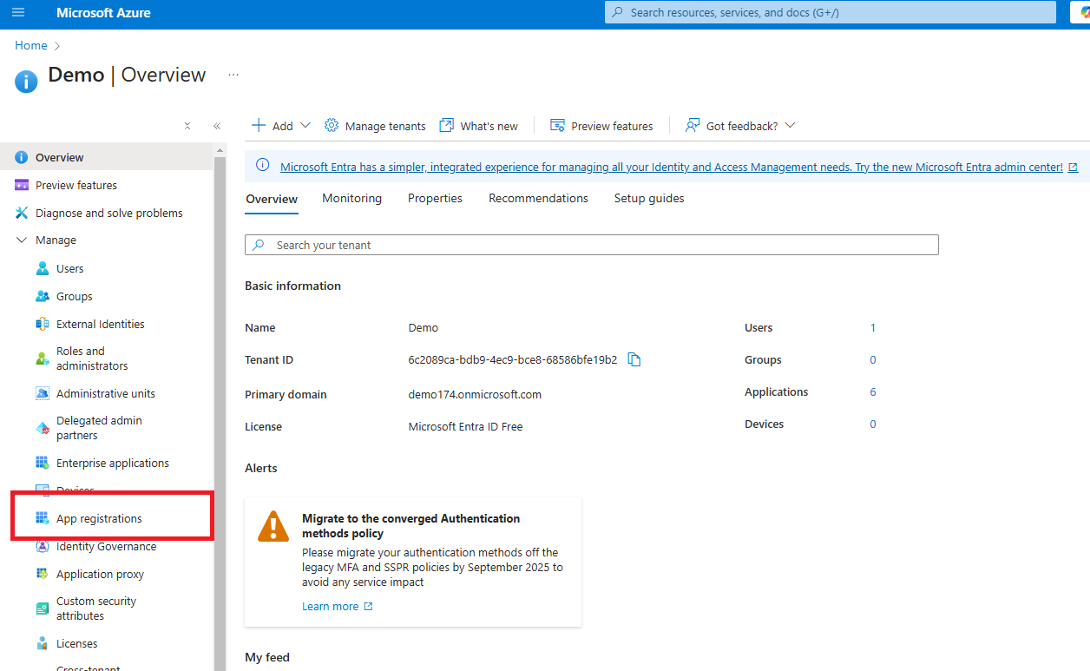
2. Click and Register a new App and copy the login and password  
   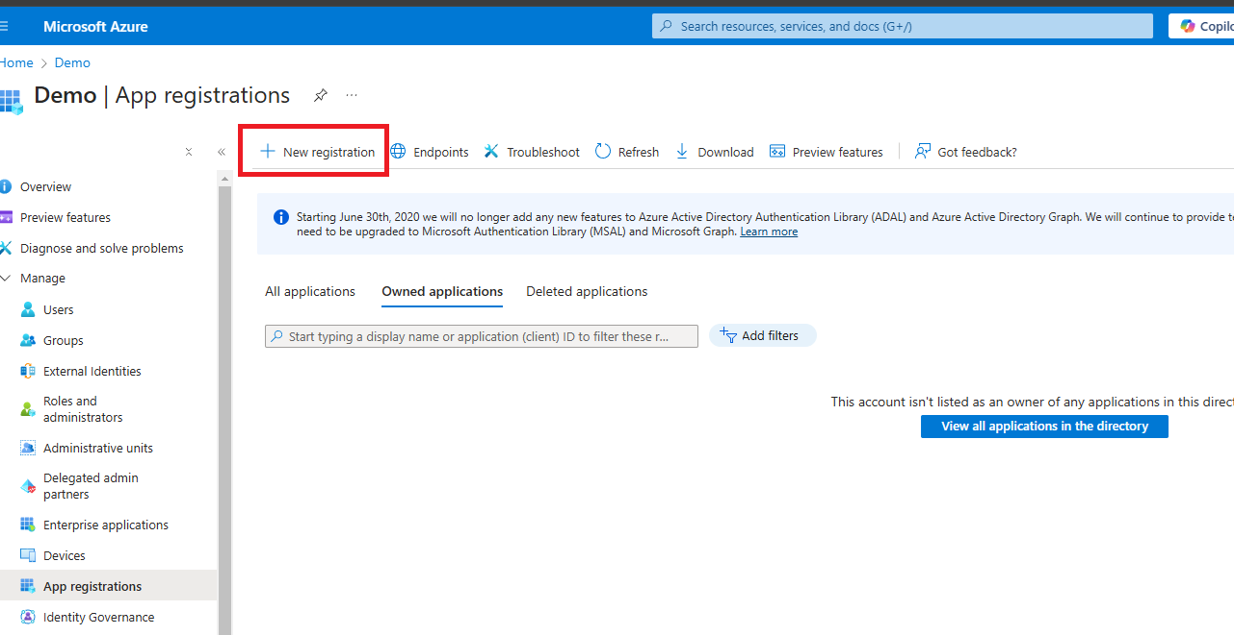
3. Add the following below permissions to the registered App  
   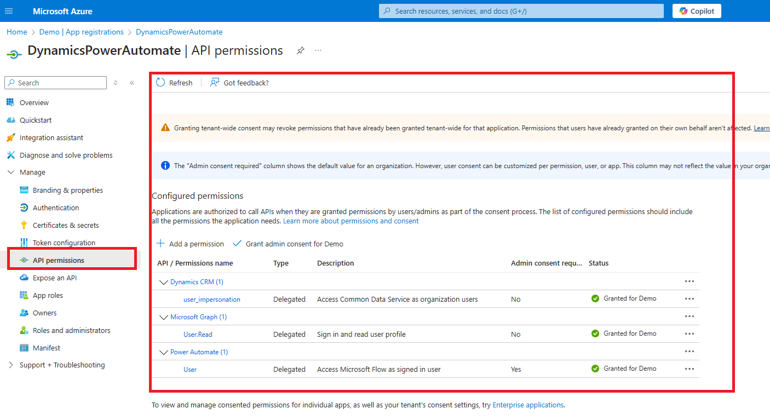
4. Associate the Registered App to the required Environment in Power Platform Admin center, and add required permissions to the user  
   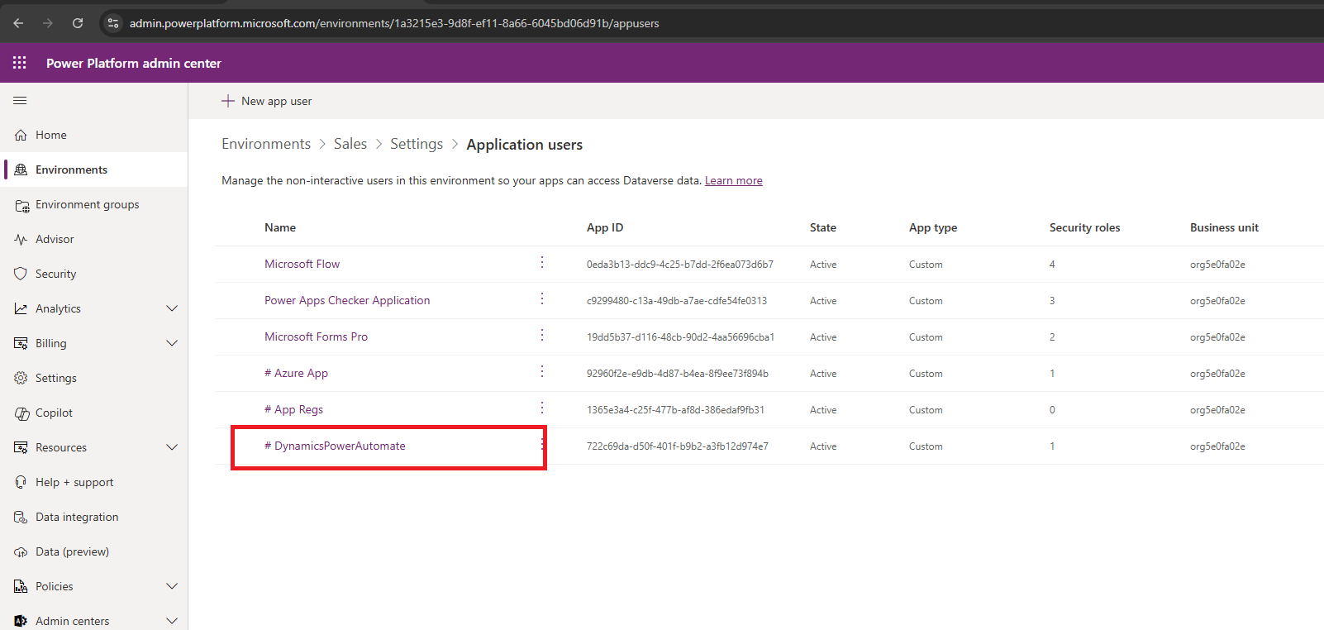

1. Details for authentication Token can be accessed through following
   1. Client ID and Client Secret from the Portal.Azure.com
   2. Go the Overview tab and click on the Endpoints to access the information

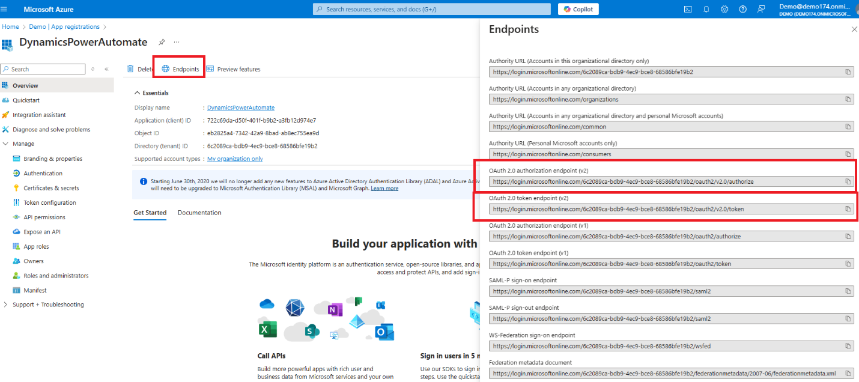  
  
  
  
Sample PostMan Envelope Screenshot to generate the Token :-

* Scope - <https://service.flow.microsoft.com//.default>
* Client ID and Client Secret as generated in Azure Portal  
    
  