# How to initialize data in Repository with BigInit or SmallInit

|  |  |  |  |
| --- | --- | --- | --- |
| **Revision History** | | | |
| **Version** | **Date** | **Auteur** | **Description** |
| 001 | 15/02/14 | A. Burgi-Panisset | First version |
| 002 | 29/07/14 | A. Burgi-Panisset | Update DB schema name “refti_n9” to “refti_n1” |
| 003 | 26/11/14 | A. Burgi-Panisset | Add step 3, upgrade links to new BigInit docs |
| 003 | 27/11/14 | A. Burgi-Panisset | Add steps 5 and 6 |
| 003 | 03/02/15 | A. Burgi-Panisset | Add links to V1.6.x |

# Description:

This document is a procedure of re-installation of data in CORAIL Repository for test.

# Procedure:

### Get script: “All_BigInitData.sql”:

#### [All_BigInitData V1.5.n](http://docinfogroupe.inetpsa.com/ead/doc/ref.20557_14_00004/v.vc/fiche)

#### [All_BigInitData V1.6.n](http://docinfogroupe.inetpsa.com/ead/doc/ref.20557_15_00010/v.vc/fiche)

### Connect to DB refti_n1

**User name**: ***ko2***

**Password**: ***korpfm00***

**Example: login to DB using sqlDeveloper :**

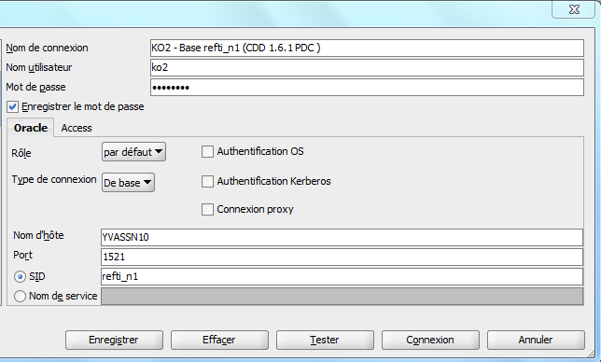

### Execute SQL command: “ALTER SESSION SET EDITION = V1_6;” on DB refti_n1

### Run “ALL_bigInitData.sql” on DB refti_n1 (or “ALL-smallInitData.sql”)

### End procedure with command “commit;”

### In case of errors running procedure, save logs and send to DSIN for analyze

# Explanation:

**BigInit** and **SmallInita** aregenerated from “**LdsRepositorySqlGenerator.java**” (under “korRepositoryLoaderManager-test”). They are produced under “**output**”.

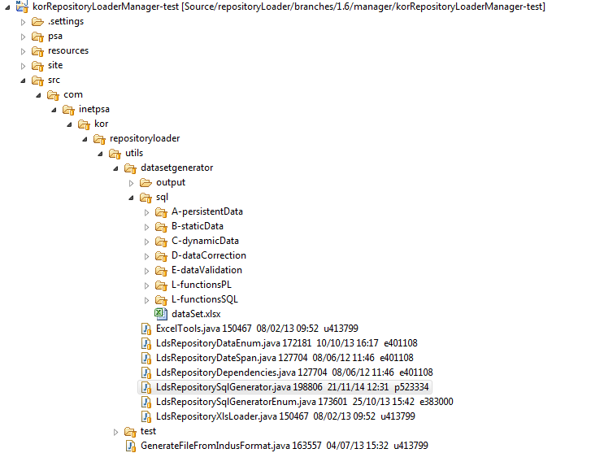

1. Results generated here
2. Run as….

**BigInit**: All data are deleted, then recreated.

* + 1-deleteDynamicData.sql
  + 2-deleteStaticData.sql
  + 3-deletePersistentData.sql
  + 4-insertPersistentData.sql
  + 5-insertStaticData.sql
  + 6-insertDynamicData.sql
  + 7x-dataCorrection.sql
  + 8-dataValidation.sql

**SmallInit**: Only dynamic data are deleted then recreated. This initialization is faster and lighter.

[SmallInit V1.5.n](http://docinfogroupe.inetpsa.com/ead/doc/ref.20557_13_22731/v.vc/fiche)

[SmallInit V1.6.n](http://docinfogroupe.inetpsa.com/ead/doc/ref.20557_14_02448/v.vc/fiche)

**For any further explanation about BigInit or SmallInit:** go to [Referentiel 1.6.x](http://docinfogroupe.inetpsa.com/ead/dom/1000395300.fd) or ([Referentiel 1.5.x](http://docinfogroupe.inetpsa.com/ead/dom/1000299558.fd)) or read document [sqlGeneratorDocumentation.doc](http://docinfogroupe.inetpsa.com/ead/doc/ref.20557_14_02451/v.vc/fiche)