# How to run a selenium test

1. check out the project from SVN.

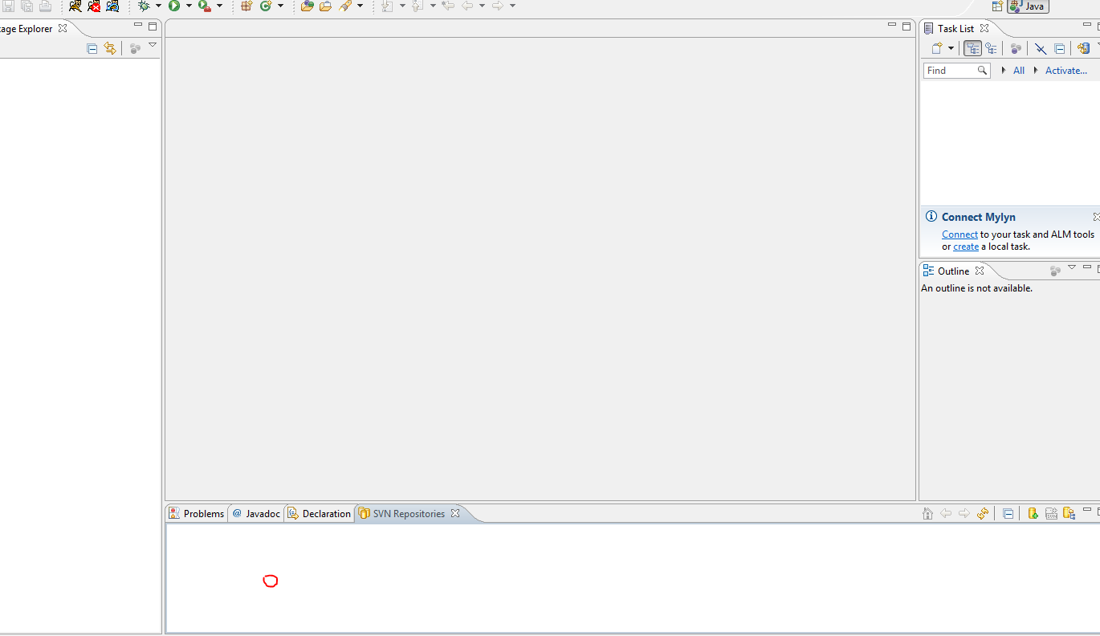

1. click right button at the blank area and select “new/Repository Location”.
2. Input URL. http://svn.informatique.inetpsa.com/svn/kor00/Tests/selenium/trunk/korRepositoryTest

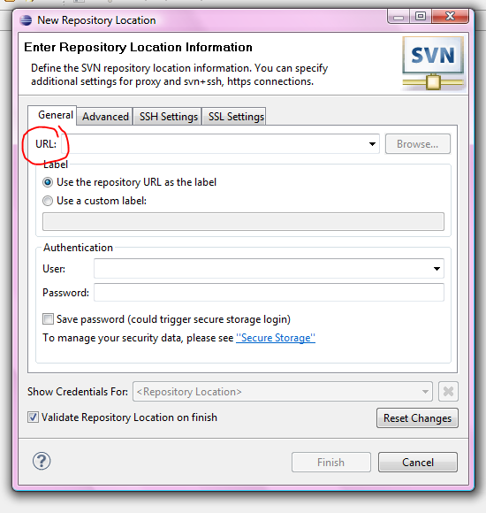

1. Input your username and password, then click finish.

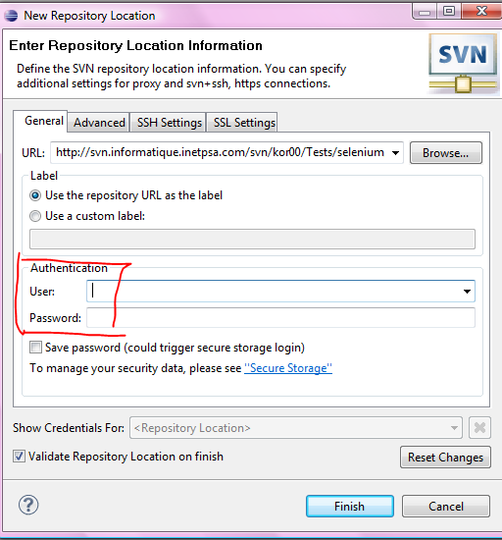

1. select this line and click right button. Then click check out.

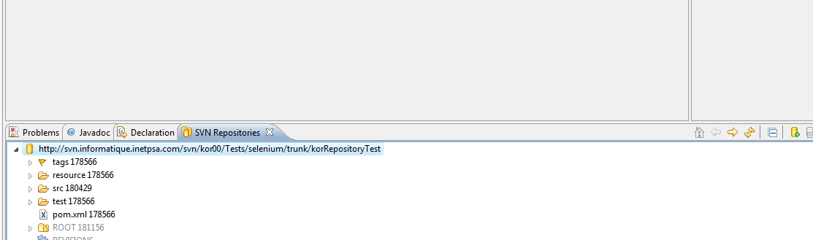

1. Set MAVEN parameters
2. select your project and click this icon then select “External Tools Configuration”

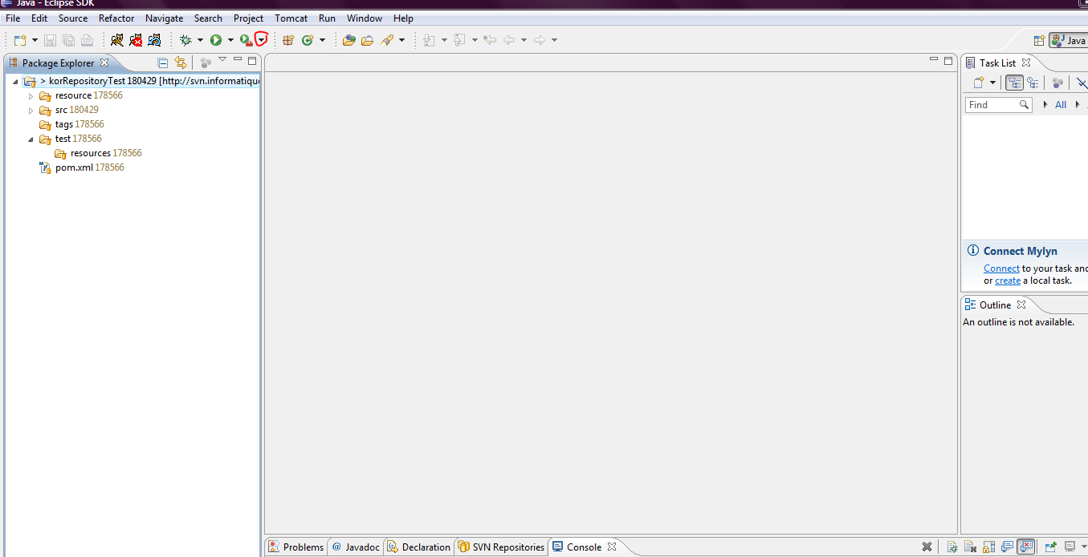

1. click the Program/ New_configuration and enter the parameters. Then click Run button.

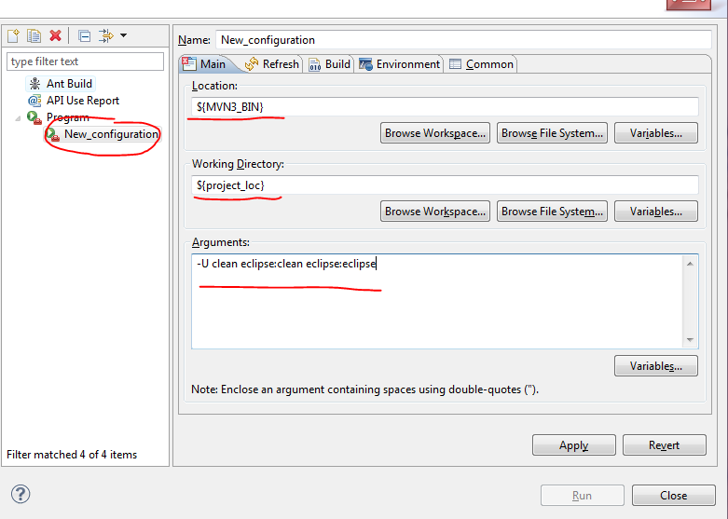

1. wait for a few minutes util MAVEN over.
2. Run test
3. parameters

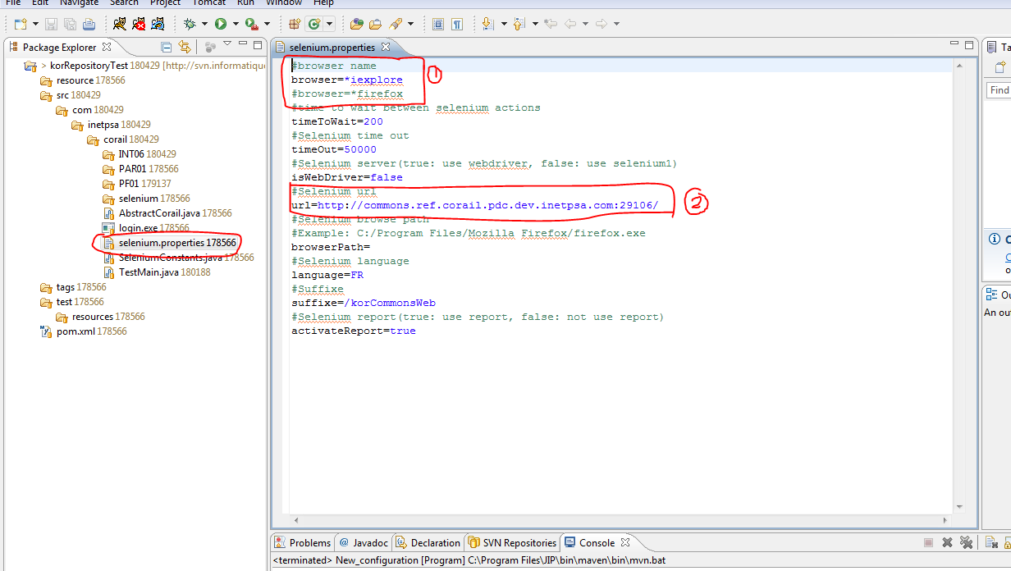

This selenium.properties file is test properties.

You can change to IE or Firefox at ①.

You can change test URL at ②.

1. run test

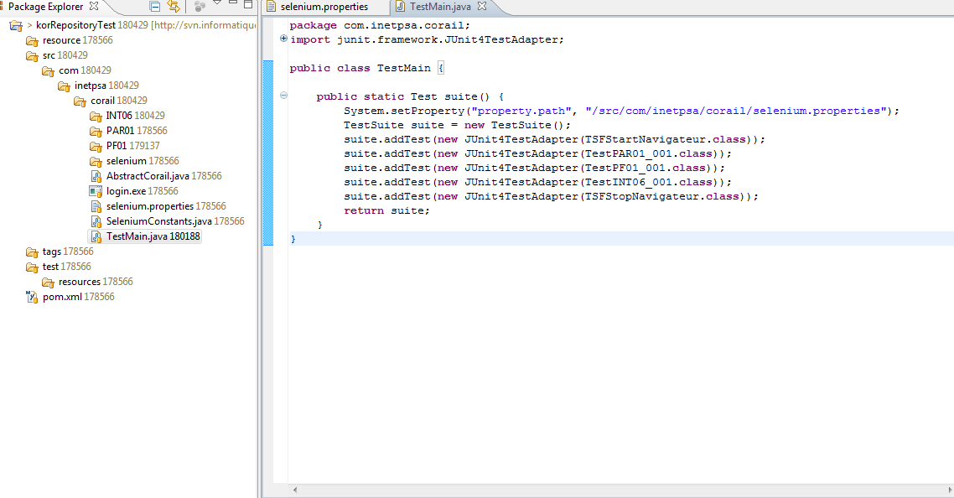

Double click TestMain.java. At the right blank area, click right button and select “Run as/TestNG Test”. Then wait for the test over.