Request for testing: Partners list (COL-REF-PAR01) et Partner Detail (COL-REF-PAR02)

|  |  |  |  |
| --- | --- | --- | --- |
| **Revision History** | | | |
| **Version** | **Date** | **Auteur** | **Description** |
| 001 | 03/12/13 | A BURGI-PANISSET | First version |
| 002 | 04/04/14 | A BURGI-PANISSET | Menu Updates |
| 003 | 19/01/15 | A BURGI-PANISSET | Technical information about tests environment specified in an external document with parameters   * Update IE / FF versions * Update DB name: **refti_n9** to **refti_n1** |
|  |  |  |  |

# Description:

This test consists in showing the list of **untyped Partners** (IHM-REF-1210A), in order to be able to choose the **COFOR** of the first Partner of the list and check that the Details of the chosen Partner are correctly returned (IHM-REF-1210B).

This test is a first step to a following test: RFT_REF_PAR0x_001.

# Tests environment:

* Test environment data: [see](http://docinfogroupe.inetpsa.com/ead/doc/ref.20557_15_00125/v.vc/pj)
* Default CU: **77**
* Default language: **English**

# User Role and Login

**User Role for tests**: Central EDI Pilote (-*)

**User Id**: ***M0000589***

**Password**: ***korpfm00***

(*)Multi-Scope

# Explanation:

After being imported with RFR integration batch, Partners are not typed in CORAIL Repository. This first step aim is select one of those in order to type it. The selection of the Partner to be typed is handled by choosing the first line in a list.

# Test plan

1. Connect to server “**Repository**”
2. Select on "**Repository / Partners and contacts/ Partners** "

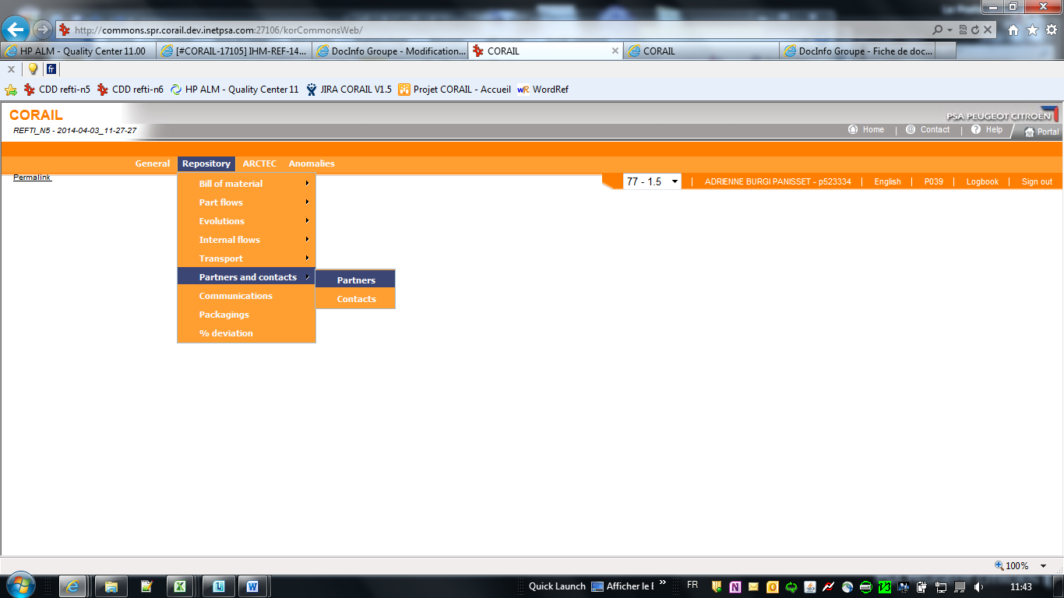

1. Select “**only untyped**” radioButton, then click on "**Refresh**" button

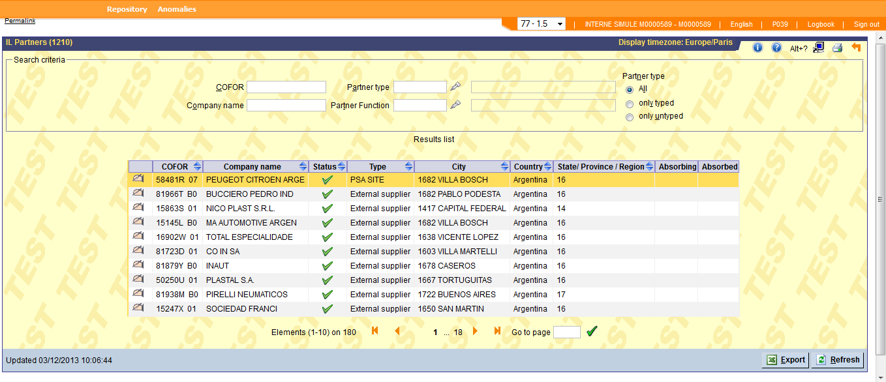

1. Check that the list is **not empty**

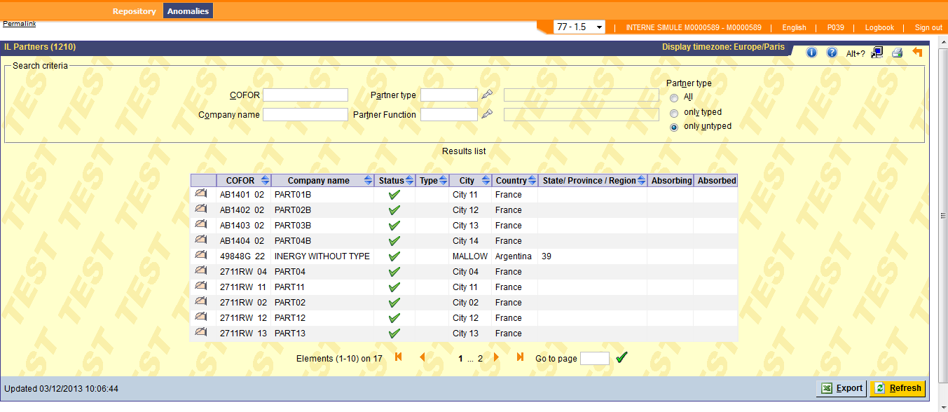

NB. In case this list is empty, import new COFORs running batch “RFR” or a “SmallInit”

1. Select the **COFOR** on the first row and click on “update” icon

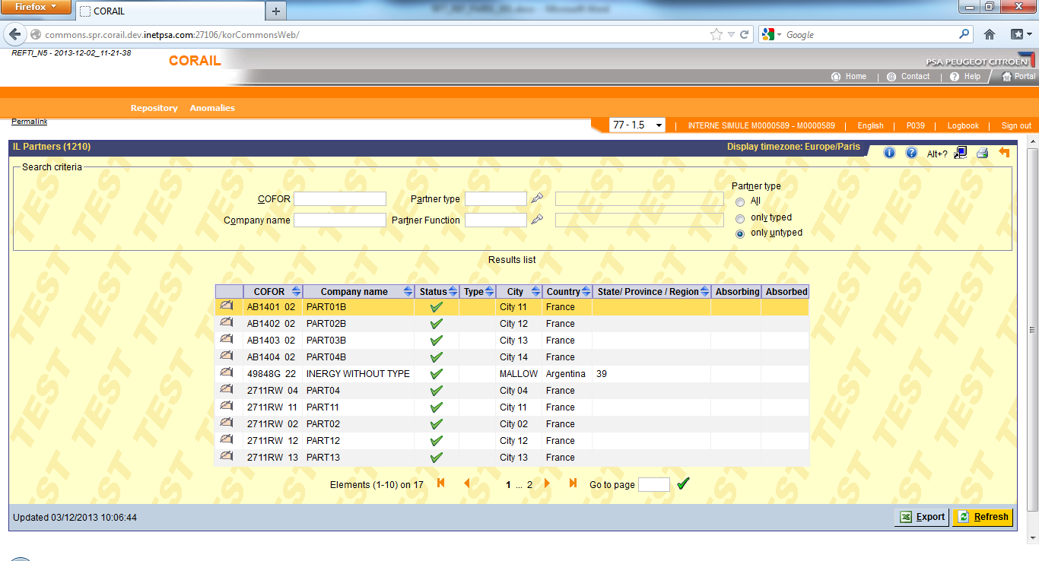

1. Check that “**Partner Detail (1210)**” screen appears with the previously selected **COFOR**

