Request for testing: Partners search (COL-REF-PAR06)

|  |  |  |  |
| --- | --- | --- | --- |
| **Revision History** | | | |
| **Version** | **Date** | **Auteur** | **Description** |
| 001 | 09/01/14 | A BURGI-PANISSET | First version |
| 002 | 04/04/14 | A BURGI-PANISSET | Menu Updates |
| 003 | 19/01/15 | A BURGI-PANISSET | Technical information about tests environment specified in an external document with parameters   * Update IE / FF versions * Update DB name: **refti_n9** to **refti_n1** |
| 004 | 04/11/2015 | F. TRAGEL | Modification V1.7 |

# Description:

This test consists in chosing by criteria a **Partner** in a popup (**popup partnerSearch**), and returning it to the current IHM (for example IHM-REF-1320B - Détail flux de pièce).

[N] : no criteria

[A1] : by COFOR name

[A2] : by Partner Type

[A3] : by Partner Function

# Tests environment:

* Test environment data: [see](http://docinfogroupe.inetpsa.com/ead/doc/ref.20557_15_00125/v.vc/pj)
* Default CU: **77**
* Default language: **English**

# User Role and Login

**User Role for tests**: PFA (-*)

**User Id**: ***M0000587***

**Password**: ***korpfm00***

(*)Multi-Scope

# Explanation:

Test of popup PartnerSearch.

# Test plan

1. Prerequisit
2. Connect to server “**Repository**”
3. Select on "**Repository / Part Flows / Part Flows** "

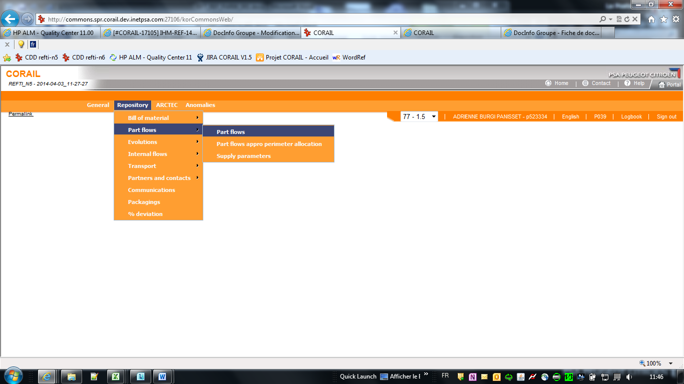



1. Open a **partnerSearch popup** clicking onicon of “Seller cofor” area

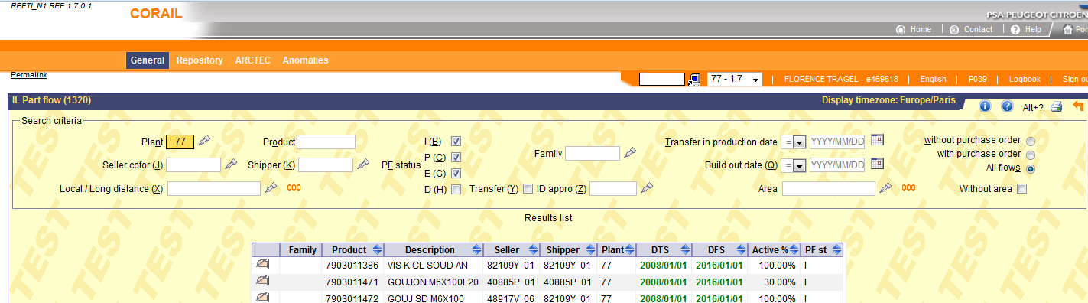

1. [N] no criteria
   1. Select a line
   2. Click on V**alidate Button**

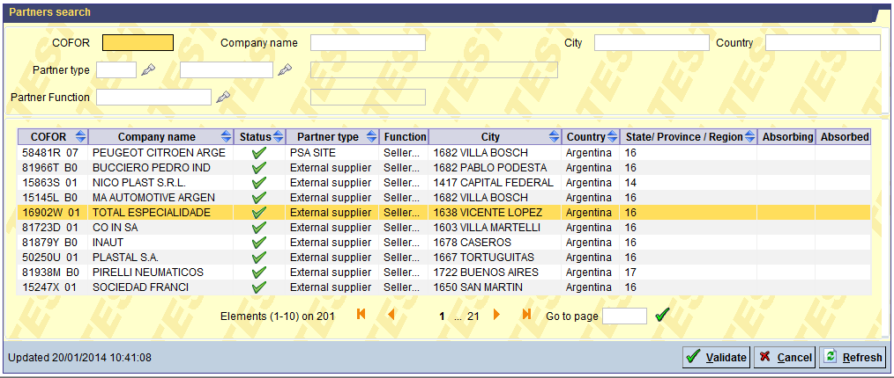

* 1. Check that “**IL Part Flow (1320)**” appears with “Seller cofor area” filled with **previously selected COFOR** .
  2. Click on “**Refresh**” button.
  3. Check that only Part Flows with **required seller** are shown in table.
  4. If no record found a **warning message** appears at the bottom of the screen.

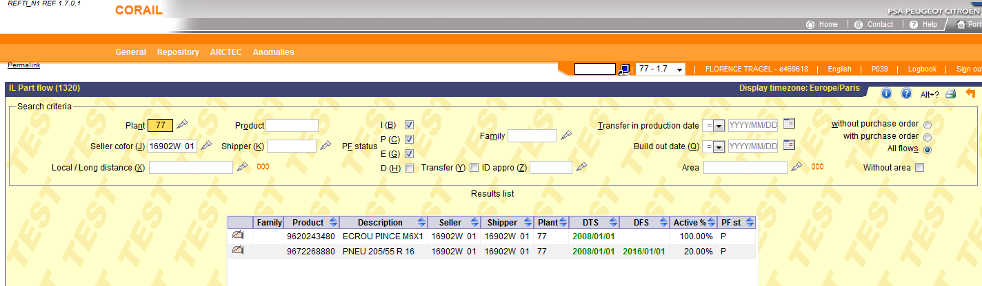

1. [A1]: by COFOR name



* 1. Open a **partnerSearch popup** clicking onicon of “Seller cofor” area.
  2. Input “ABP” (or input “82109Y 01”) in “Seller cofor area”.
  3. Click on “**Refresh**” button.
  4. Select a line and click on “**Validate**” button.

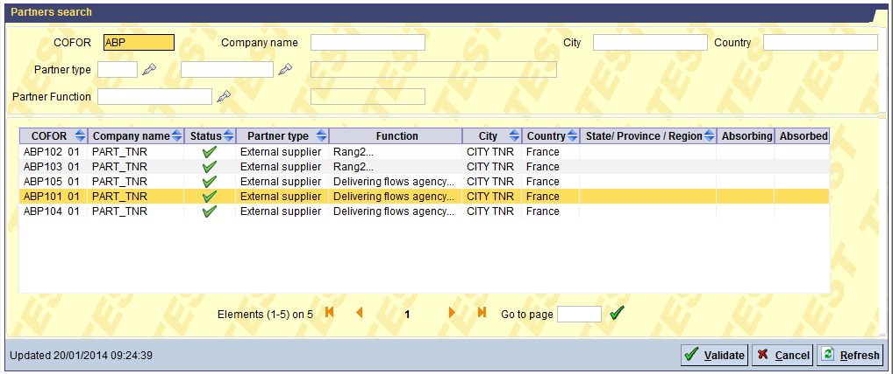

* 1. Check that “**IL Part Flow (1320)**” appears with “Seller cofor area” filled with **previously selected COFOR** .
  2. Click on “**Refresh**” button.
  3. Check that only Part Flows with **required seller** are shown in table.
  4. If no record found a **warning message** appears at the bottom of the screen.

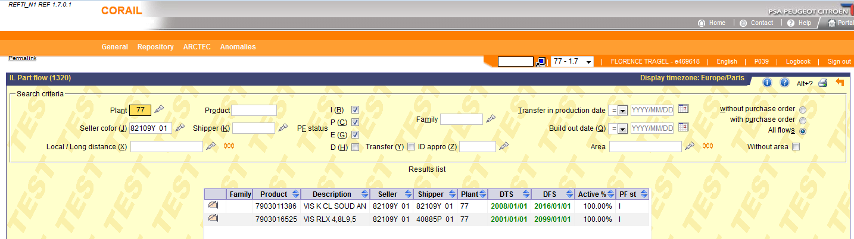

1. [A2]: by Partner Type



1. Open a **partnerSearch popup** clicking onicon of “Partner type” area
2. Select **External supplier** from **comboBox Partner Type**
3. Click on **Refresh Button**

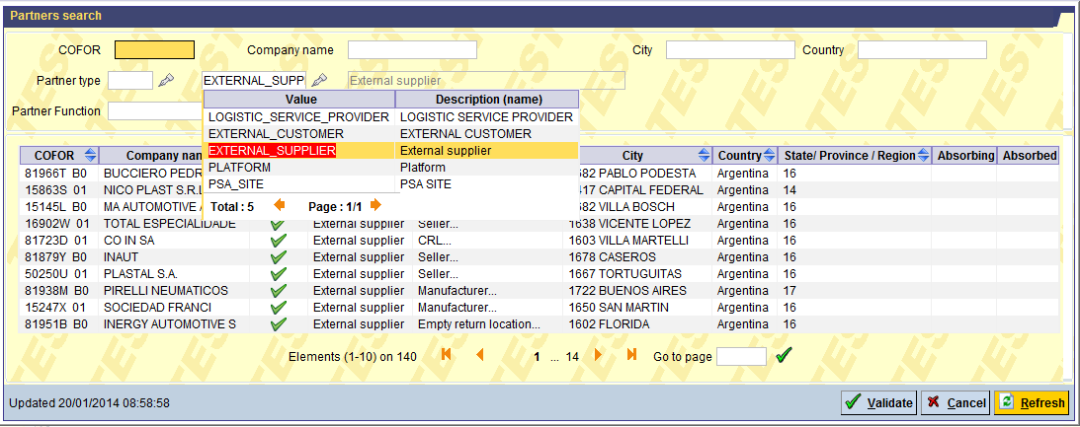

1. Check that only Partners having type “External suppliers” appear
2. Select first line, then click on “**Validate**” button

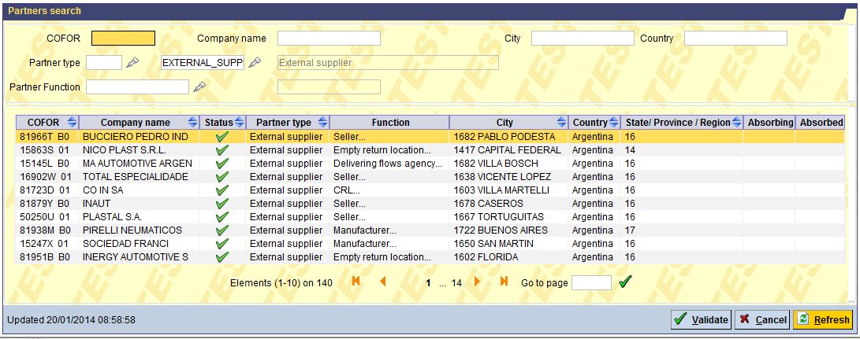

1. Check that “**IL Part Flow (1320)**” appears with “Seller cofor area” filled with **previously selected COFOR** .
2. Click on “**Refresh**” button.
3. Check that only Part Flows with **required seller** are shown in table.
4. If no record found a **warning message** appears at the bottom of the screen.

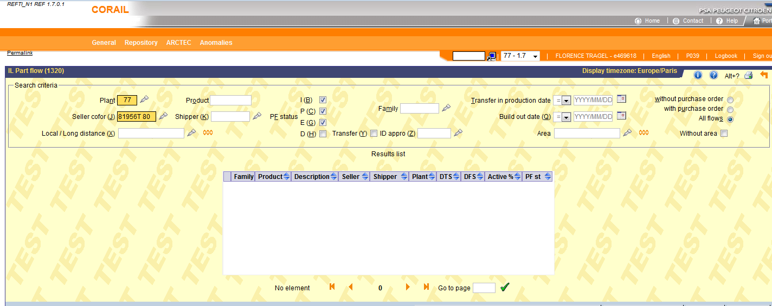



1. [A3]: by Partner Function



1. Open a **partnerSearch popup** **clicking** on icon of “Seller cofor” area
2. Select **External supplier** from **comboBox Partner Function**.
3. Click on “**Refresh**” button.

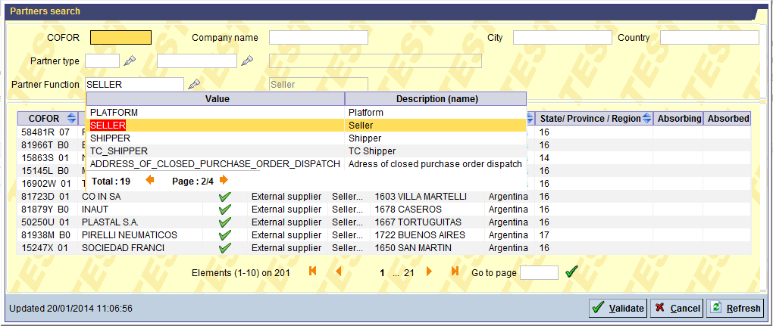

1. Select a line and click on “**Validate**” button.

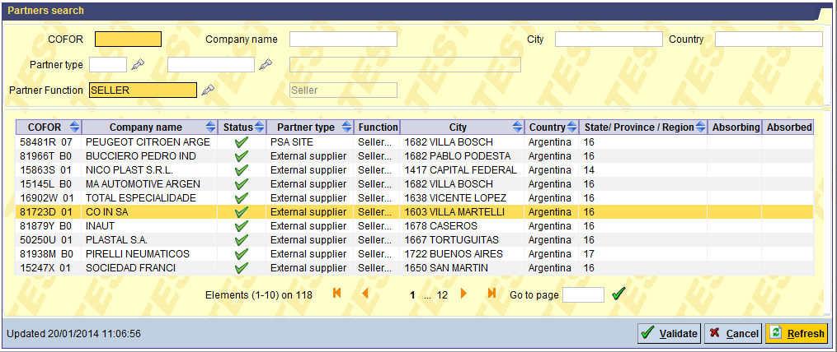

1. Check that “**IL Part Flow (1320)**” appears with “Seller cofor area” filled with **previously selected COFOR** .
2. Click on “**Refresh**” button.
3. Check that only Part Flows with **required seller** are shown in table.
4. If no record found a **warning message** appears at the bottom of the screen.

