**Model:**

We have to create model using different functionality Keras provides. There are two type of model we need to build one is Conv3D and other is Conv2D + RNN. For Conv3D we have used Maxpooling3D and TimeDistributed while creating Covn2D + RNN model. Because model need to do multiclass classification so last layer of the model is **‘Sofmax’.**

We have created sample model to do experiment with: -

1. Image resolution
2. Number of frames
3. Batch size

After performing the different experiments with above hyper parameters, we have concluded that Image resolution and number of frames in the sequence have more impact on the training time than batch size.

So, we keep experimenting with batch size between 15-40 and keep changing the image resolution and number of frames.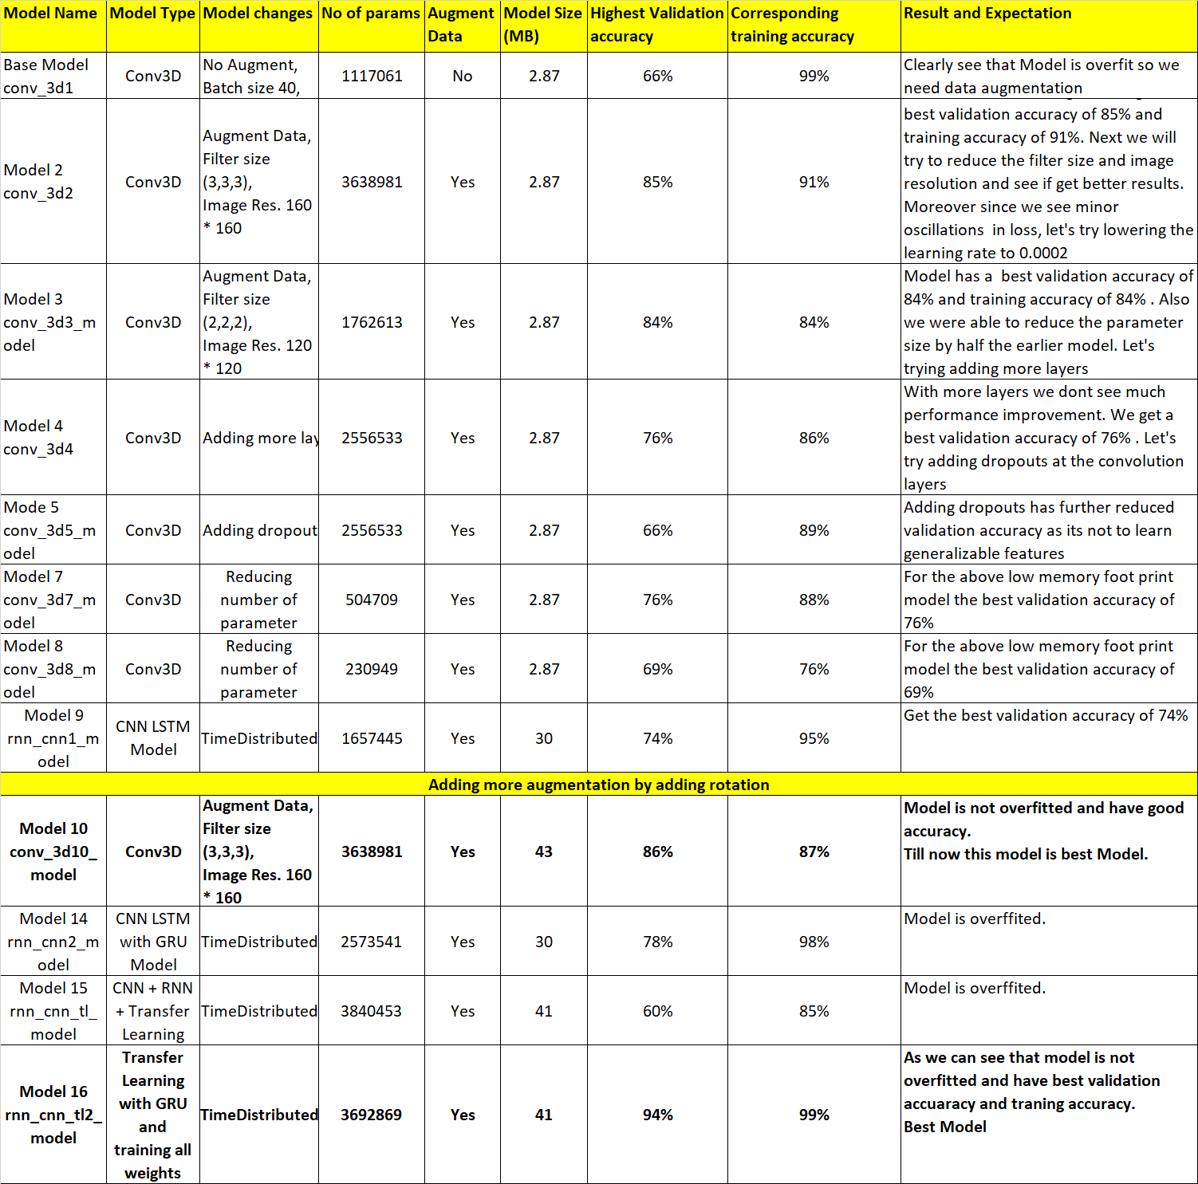

From above analysis we can see that **Model 10 and Model 16** are the best models.

**#Model Links**

- Model 10: <https://drive.google.com/file/d/162pXjb6s4bJa0ilxTcYd8KKL5Yavah4q/view?usp=sharing>

- Model 16: <https://drive.google.com/file/d/1zkveVQUvKlsGKVV4k5cgZGFJJ1_JTGSt/view?usp=sharing>