Web Api Hands-on – 5
- Theory & Concepts
CORS Enablement
- CORS (Cross-Origin Resource Sharing) is a security mechanism implemented by web browsers to restrict web pages from making requests to a different domain than the one that served the web page.
- By default, a Web API will block requests coming from local frontend applications (like an Angular or React app running on a different local port).
- To resolve this, developers enable CORS in the API’s configuration to explicitly whitelist specific domains (or allow all origins, headers, and methods) to communicate safely with the backend.
JSON Web Tokens (JWT) & API Security
JWT is an open standard used to securely transmit information between parties as a JSON object.
- Authentication: It is a methodology of passing a signed token in the Authorization header (Bearer <token>) of an HTTP request. The Web API intercepts this token, validates its signature, and if invalid or missing, throws an ‘Unauthorized’ status message with a 401 status code.
- Claims & Roles: JWTs contain an encoded payload of “Claims”, which are statements about the user (e.g., their User ID or Role). The API can use these claims for Role-Based Authorization, ensuring users not only have a valid token but also the correct privileges to access specific endpoints.
- Implementation
The following steps were taken to implement robust JWT Authentication and secure the existing CRUD endpoints natively in .NET 10.
Step 1: JWT & CORS Configuration (Program.cs)
- The Microsoft.AspNetCore.Authentication.JwtBearer NuGet package was installed.
- A CORS policy was added to the service container to allow cross-origin requests from local UI applications.
- AddAuthentication and AddJwtBearer services were implemented to define the TokenValidationParameters. The application was configured to validate the Issuer (“mySystem”), Audience (“myUsers”), Lifetime, and a Symmetric Security Key. (NOTE: To comply with modern .NET security standards, a 256-bit/32-character security key was utilized instead of the legacy 18-character key).
- App.UseAuthentication() and app.UseAuthorization() were added to the middleware pipeline.
Step 2: Token Generation (AuthContoller)
- A new AuthController was creted and decorated with the [AllowAnonymous] attribute to permit public access to the login route.
- A private GenerateJSONWebToken method was built using SymmetrucSecurityKey and SigningCredentials.
- A JwtSecurityToken was instantiated containing Claims for UserId (101) and Role (“Admin”). The token’s expiration was initially set to 10 minutes, and later manipulated to 2 minutes for expiration testing.
Step 3: Securing the API (EmployeeController)
- The legacy custom authentication filter was removed.
- The native [Authorize] attribute was applied to the controller to enforce the JWT validation.
- Role-based access was tested by modifying the attribute to [Authorize(Roles = “POC”)] (which correctly rejected the Admin token) and then to [Authorize(Roles = “Admin, POC”)].
- Implementation Screenshots
- Program.cs Configuration:
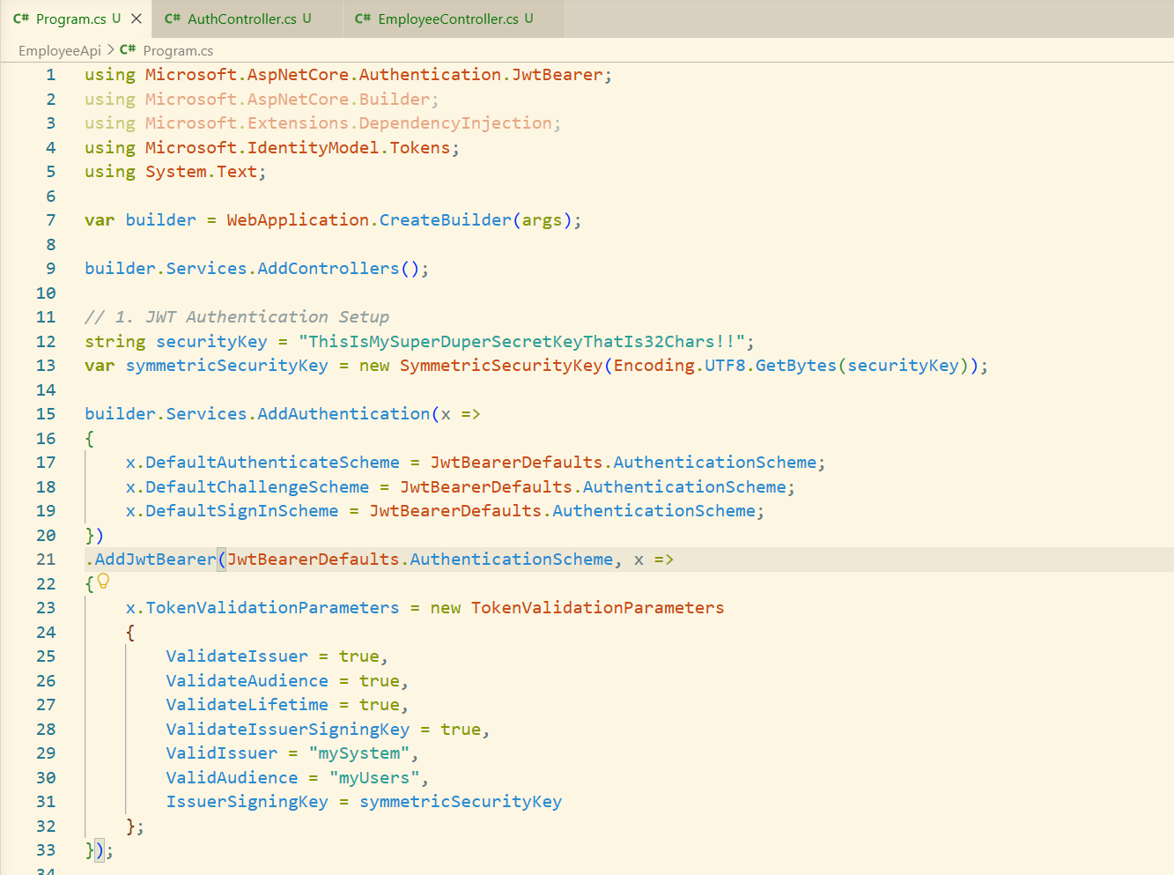
- AuthController Code:
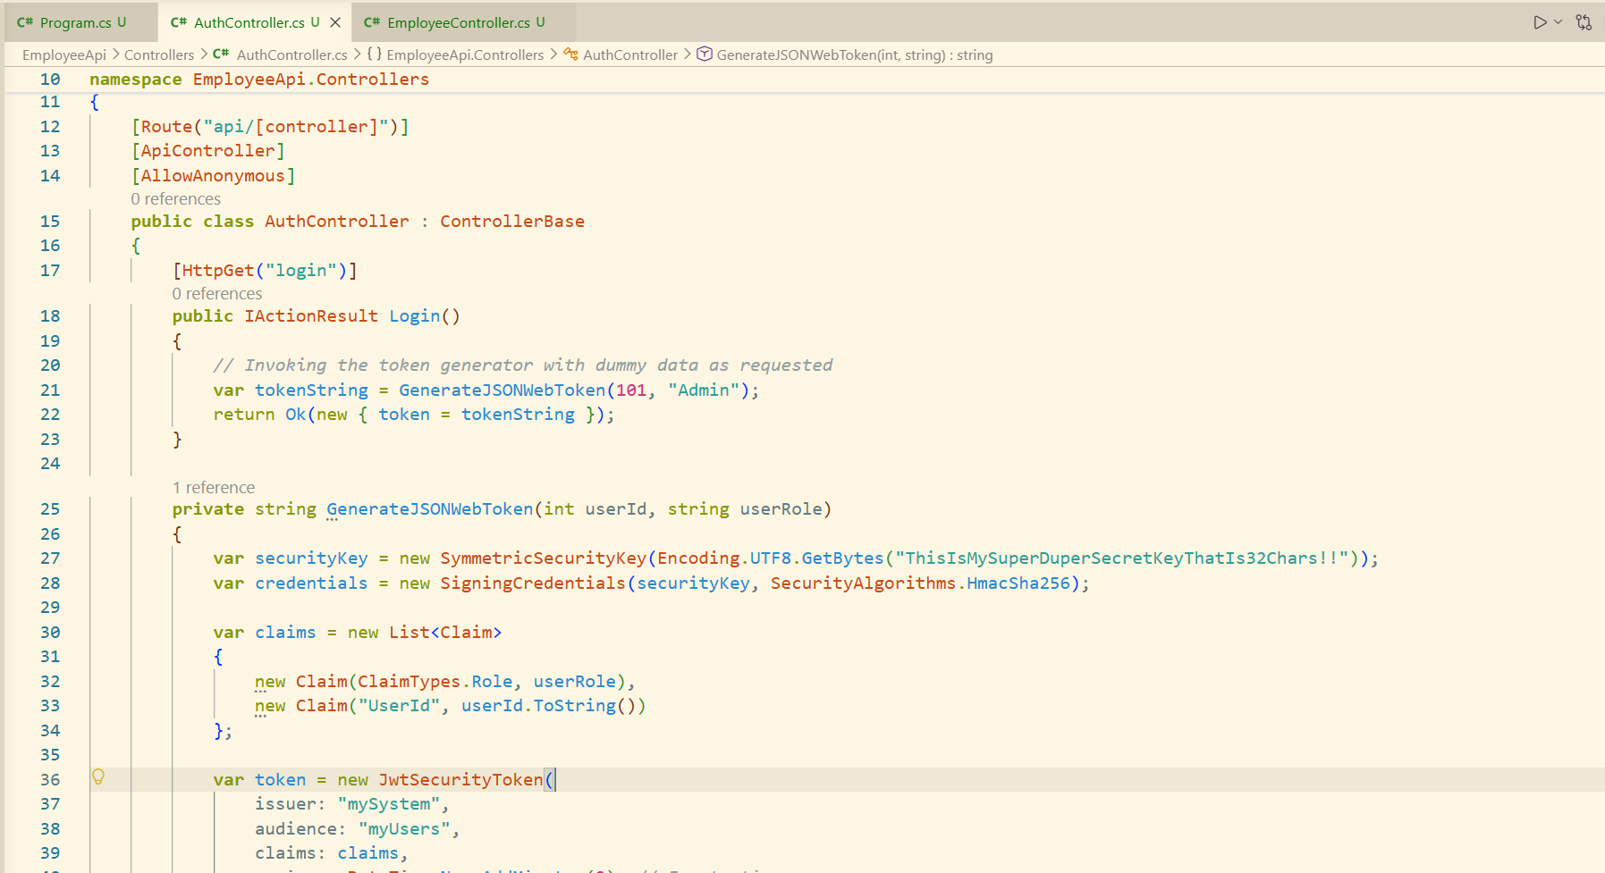
- EmployeeController Code:
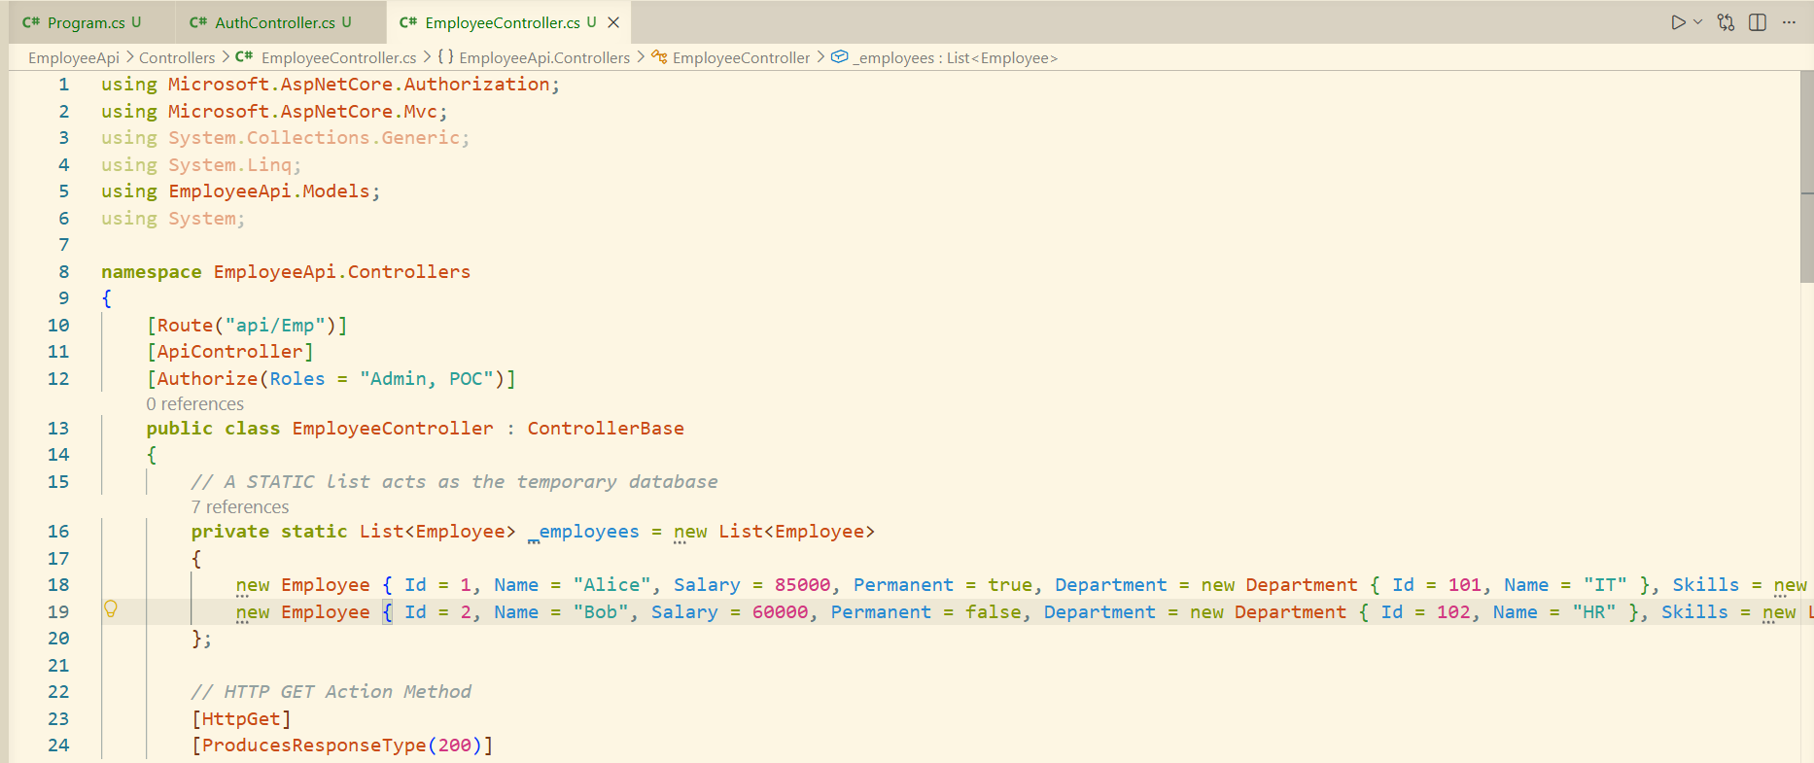
- API Output Screenshots
- Unauthenticated Access:
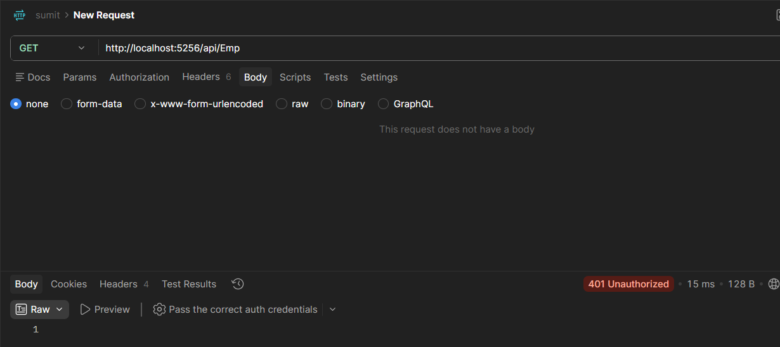
- Token Generation:
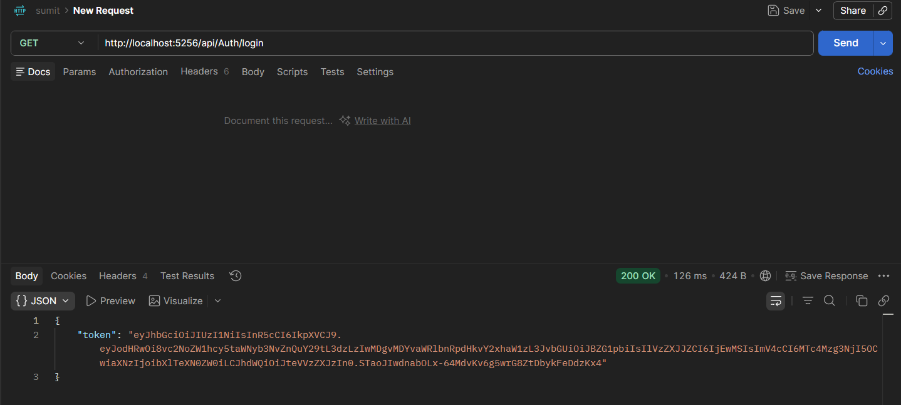
- Authenticated Access:
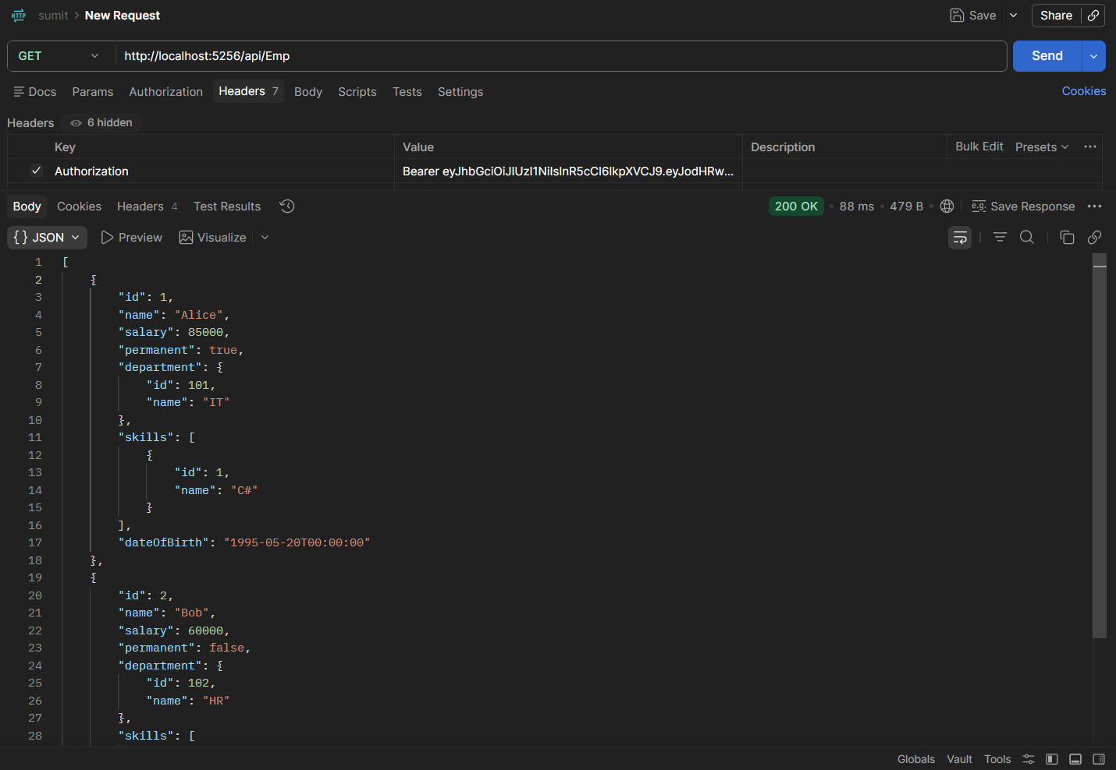
- Expiration Test:
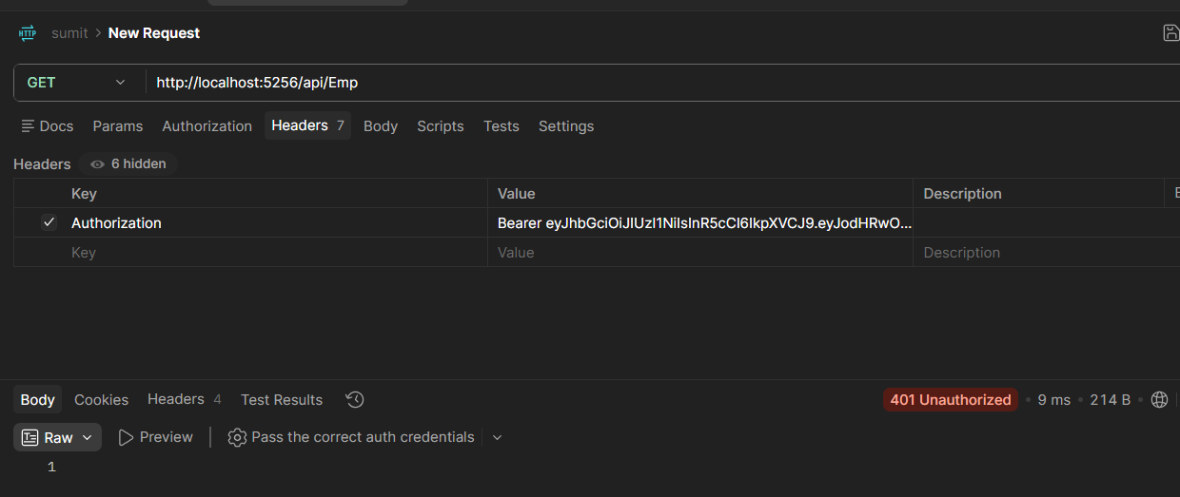
- Role-Based Rejection:
