Git HOL – 1
- Task 1 – Setup Git Configuration
  - Brief Explanation:
Git configuration is the process of setting up Git with the user’s identity and preferences before using it. The username and email configured in Git are associated with every commit, allowing changes to be identified and tracked. In this task, Git is verified for installation and configured with the user’s name and email.
  - Implementation:
Command 1:
1. git --version
Checks whether Git is installed correctly and displays the installed version.
Command 2:
1. git config --global user.name "Sumit Kumar"
Sets the global username that Git associates with commits made from this system.
Command 3:
1. git config --global user.email "sumitsonata673@gmail.com"
Sets the global email address that Git records with commits.
Command 4:
1. git config --global --list
Displays the current global Git configuration to verify that the username and email have been configured successfully.
  - Implementation Screenshot
    - 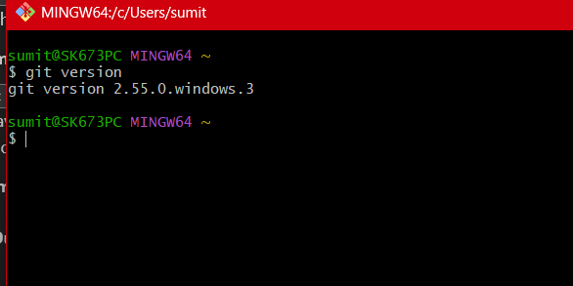

  - Output Screenshot
    - 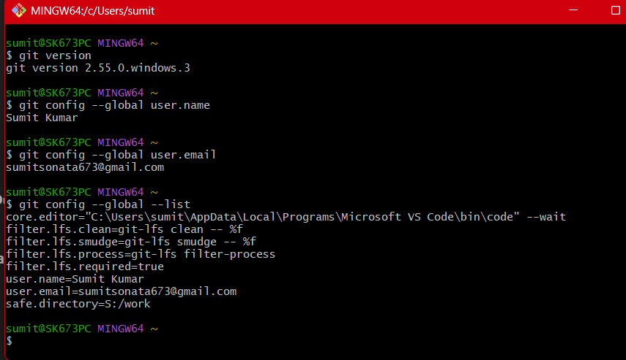

- Task 2 – Integrate Notepad++ as the Default Git Editor
  - Brief Explanation
Git uses a text editor whenever a commit message or configuration needs to be edited. By default, Git may open the system’s default editor, but it can be configured to use a preferred editor such as Notepad++. In this task, Notepad++ is added to the system path (if necessary) and configured as Git’s default editor. This allows Git to automatically launch Notepad++ whenever an editor is required.
  - Implementation
Following commands were used one by one:
1. notepad++
2. notepad++.exe ~/.bash_profile
3. alias npp='notepad++.exe -multiInst -nosession' // not a command but added to the bash_profile
4. git config --global core.editor "notepad++.exe -multiInst -nosession"
5. git config --global -e
6.

  - Implementation Screenshot
    - 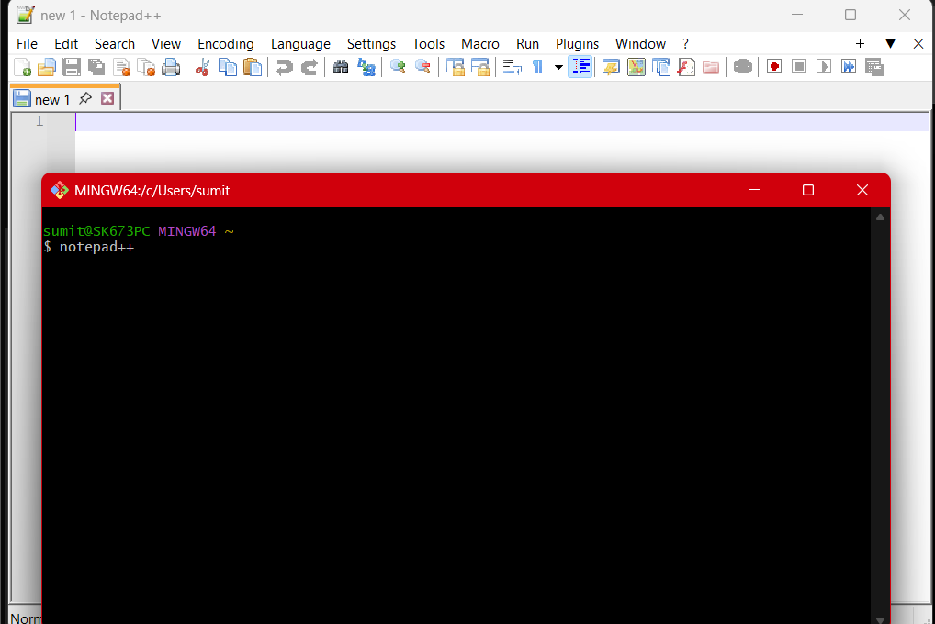
    - 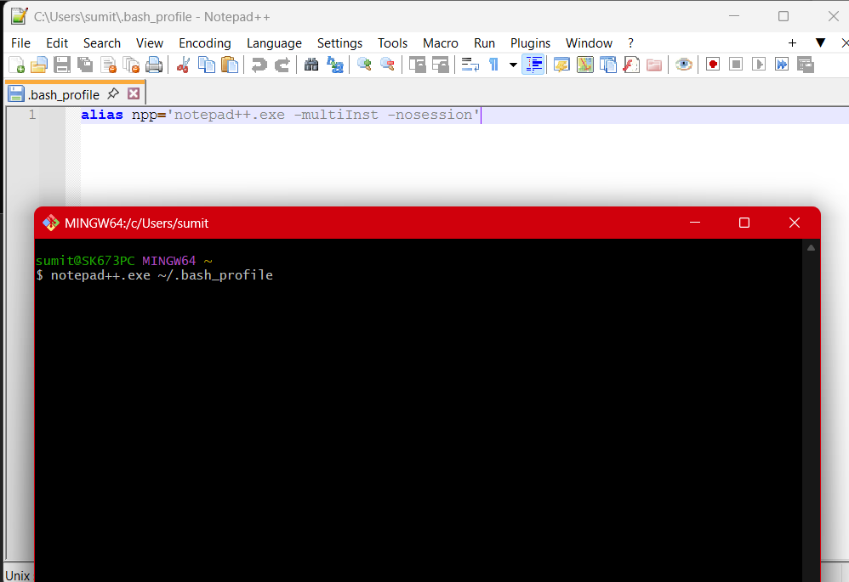
    - 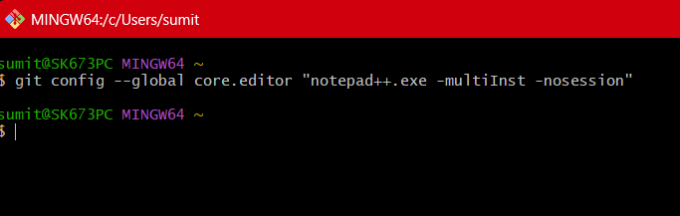

  - Output Screenshot
    - 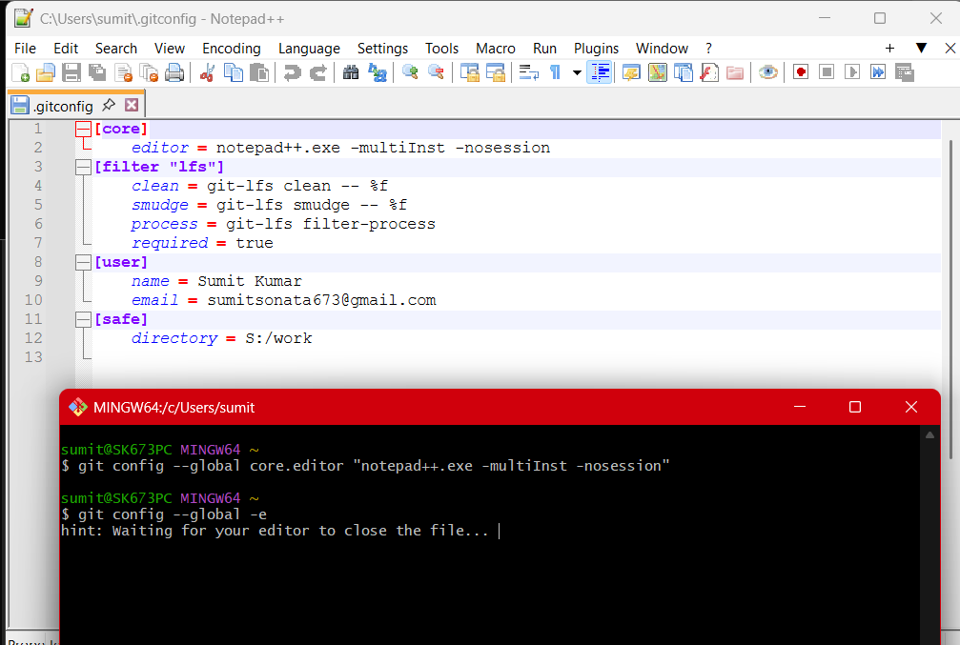

- Task 3 – Add a file to source code repository
3.1 Brief Explanation:
A Git repository is a storage location that tracks changes made to files over time. In this task, a new repository is initialized, a text file is created and added to the staging area, committed to the local repository, and finally synchronized with a remote repository hosted on GitLab/GitHub. This demonstrates the basic Git workflow for version control.
3.2 Implementation:
Step 1: Create a new project directory and initialize a Git repository
1. mkdir GitDemo
2. cd GitDemo
3. git init
Step 2: Verify Repository
ls -la
Step 3: Create
echo "Welcome to the version control" > welcome.txt
Step 4: Verify the file
ls -la
cat welcome.txt
Step 5: Check status
git status
Step 6: Stage the file
git add welcome.txt
Step 7: Commit
git commit
Step 8: Verify clean working tree
git status
Step 9: Push to remote
git push
3.3 Implementation Screenshot:
3.3.1 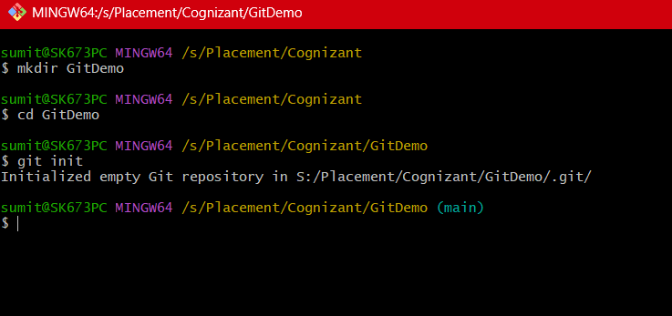
3.3.2 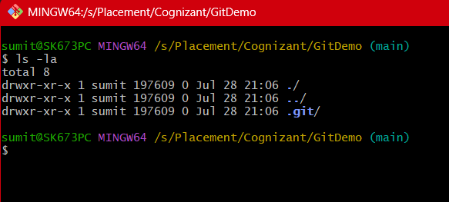
3.3.3 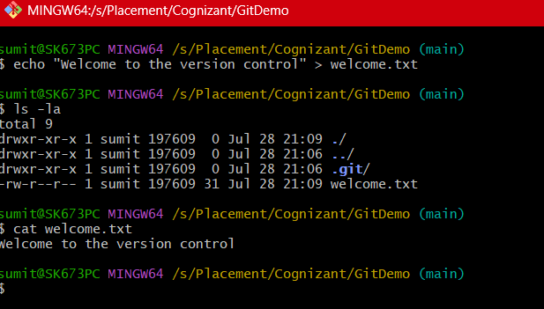
3.3.4 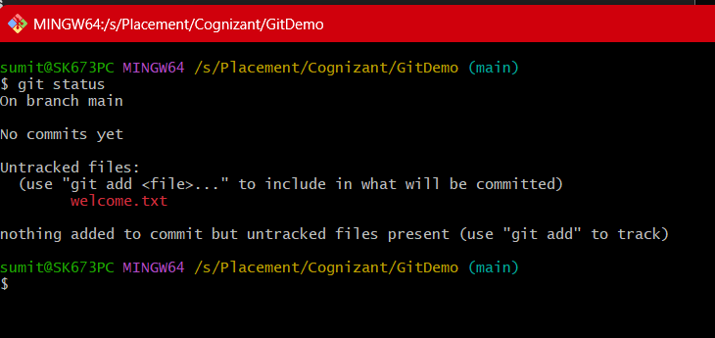
3.3.5 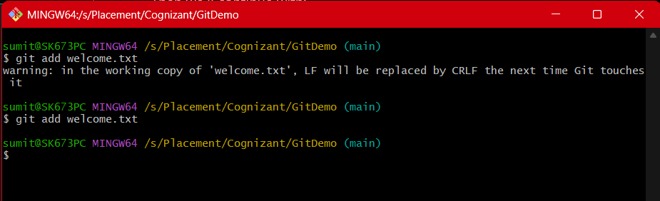
3.3.6 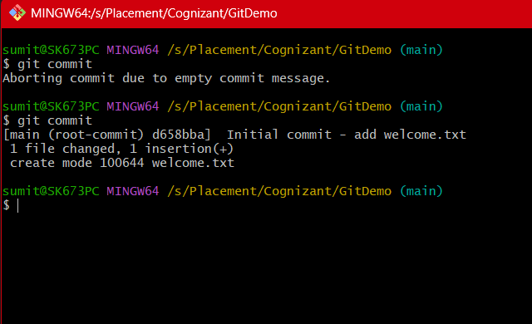
3.3.7 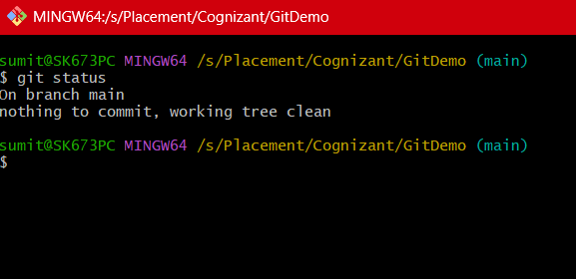
3.3.8 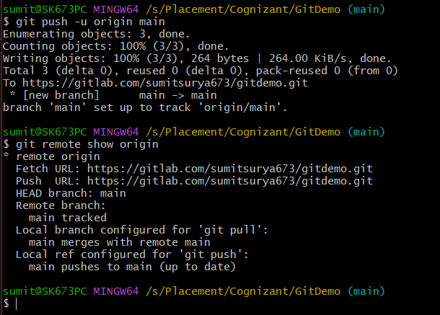
3.4 Output Screenshot:
3.4.1 