Git HOL – 2
Task 1 – Ignore Unwanted Files Using .gitignore
  - Brief Explanation
The .gitignore file is used to specify files and directories that Git should ignore. Files matching the patterns defined in .gitignore are not tracked by Git, preventing temporary files, logs, build artifacts, and other unnecessary files from being committed to the repository. In this task, .log files and the log directory are configured to be ignored by Git.
  - Implementation
Step 1: Create a .log file and a log directory
1. touch sample.log
2. mkdir log
3.
Step 2: Create a .gitignore file
1. touch .gitignore
2.
Step 3: Edit .gitignore and add the following entries
1. *.log
2. log/
3.
Step 4: Verify the repository status
1. git status
2.
Verification: The git status command confirms that files matching the patterns in .gitignore are ignored and are not shown as untracked files.
  - Implementation Screenshot
    - 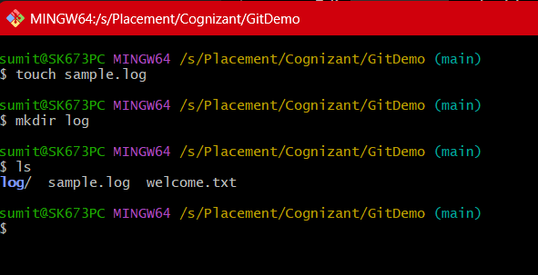
    - 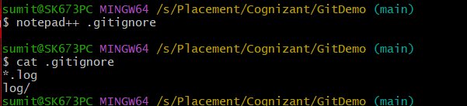
    - 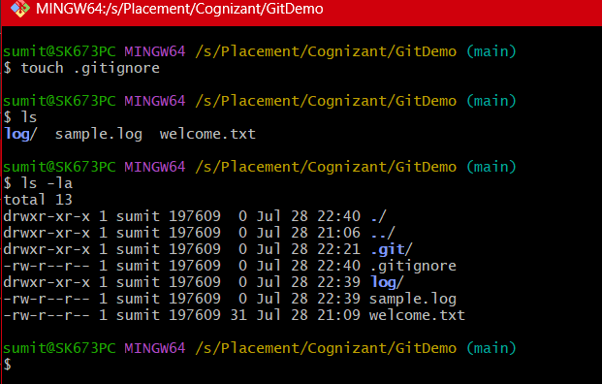
    - 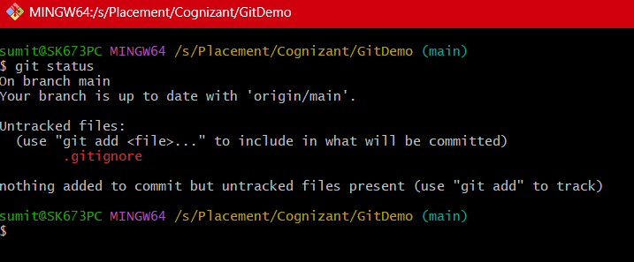

  - Output Screenshot
    - 
     