Git HOL – 3
Task 1: Branching and Merging in Git
  - Brief Explanation:
Git branching allows developers to create an independent line of development without affecting the main branch. Changes can be developed, tested, and committed separately. Once the changes are complete, Git merging combines the branch back into the main branch, preserving the commit history. This workflow enables parallel development while keeping the main branch stable.
  - Implementation:
Step 1: Create a new branch
1. git branch GitNewBranch
2.
Step 2: List all local and remote branches
1. git branch -a
2.
Step 3: Switch to the new branch
1. git checkout GitNewBranch
2.
Step 4: Create or modify files:
1. echo "Branch Demo" > branch.txt
2.
Step 5: Stage and commit the changes
1. git add .
2. git commit -m "Added branch demo file"
3.
Step 6: Verify repository status
1. git status
2.
Step 7: Switch back to the main branch
1. git checkout main
2.
Step 8: View differences between branches
1. git diff main GitNewBranch
2.
Step 9: Merge the branch
1. git merge GitNewBranch
2.
Step 10: View commit history
1. git log --oneline --graph --decorate
2.
Step 11: Delete the merged branch
1. git branch -d GitNewBranch
2.
Step 12: Verify repository status
1. git status
2.

  - Implementation Screenshot:
    - 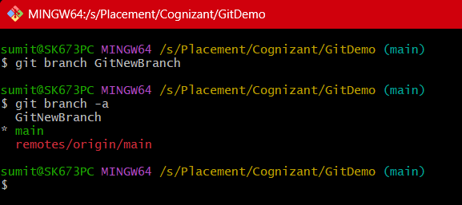
    - 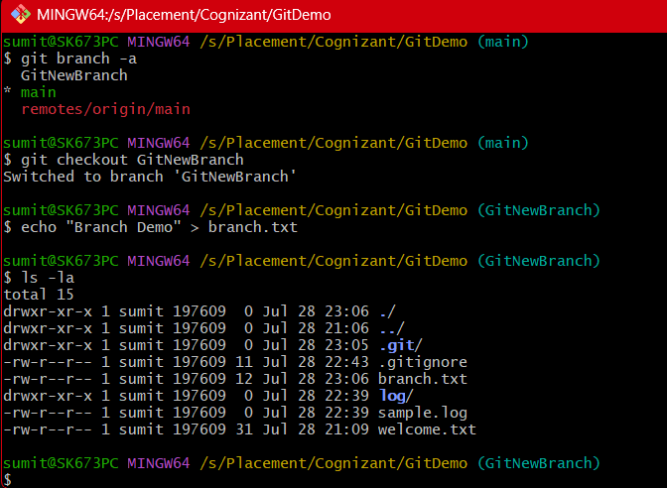
    - 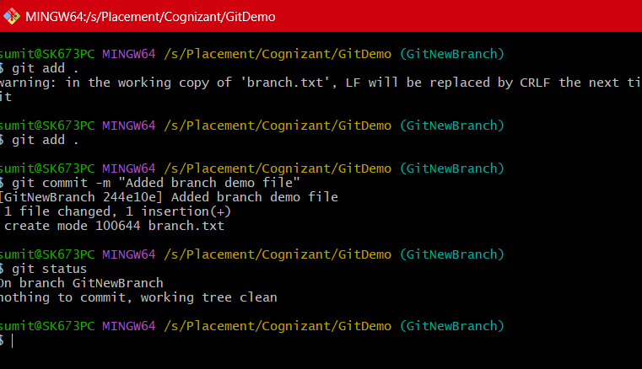
    - 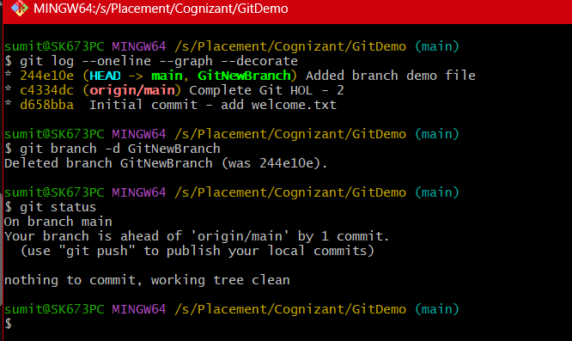

  - Output Screenshot:
    - 
     