Git HOL – 4
Task 1 : Resolve Merge Conflicts
  - Brief Explanation
A merge conflict occurs when Git cannot automatically combine changes because the same part of a file has been modified differently in two branches. Git marks the conflicting sections and requires the user to resolve them manually before completing the merge. In this task, conflicting changes are created in hello.xml on both the main branch and the GitWork branch, the conflict is resolved using Git’s merge mechanism.
  - Implementation
Step 1: Verify that the main branch is clean
1. git status
2.
Step 2: Create a new branch
1. git branch GitWork
2. git checkout GitWork
3.
Step 3: Create hello.xml with some content
1. touch hello.xml
2. <message>Hello from GitWork branch</message> // write in hello.xml
3.
Step 4: Commit the branch changes
1. git add hello.xml
2. git commit -m "Added hello.xml in GitWork"
3.
Step 5: Switch back to the main branch
1. git checkout main
2.
Step 6: Modify hello.xml differently
1. <message>Hello from Main Branch</message> // update hello.xml
2. git add hello.xml
3. git commit -m "Modified hello.xml in main"
4.
Step 7: View the commit history
1. git log --oneline --graph --decorate --all
2.
Step 8: View the differences
1. git diff main GitWork
2.
Step 9: Merge the branch
1. git merge GitWork
2.
Step 10: Resolve the conflict
Open hello.xml, remove the conflict markets, keep the required content, and save the file.
Step 11: Complete the merge
1. git add hello.xml
2. git commit
3.
Step 12: Ignore backup files
1. *.bak // update .gitignore
2. git add .gitignore
3. git commit -m "Updated .gitignore"
4.
Step 13: List branches
1. git branch
2.
Step 14: Delete the merged branch
1. git branch -d GitWork
2.
Step 15: Verify the final history
1. git log --oneline --graph --decorate
2. git status
3.

  - Implementation Screenshot
    - 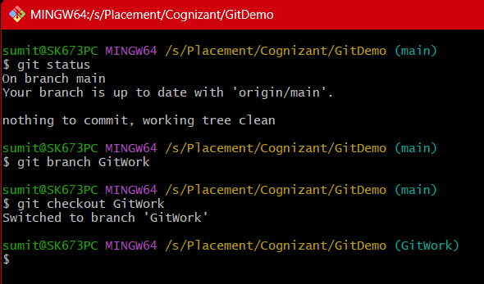
    - 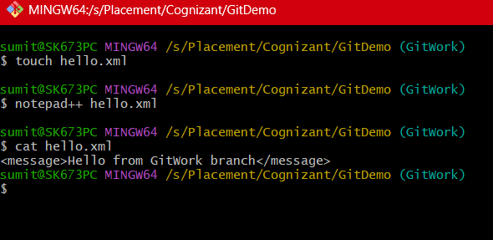
    - 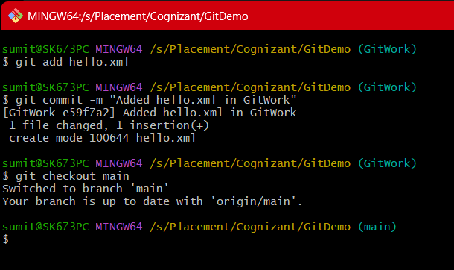
    - 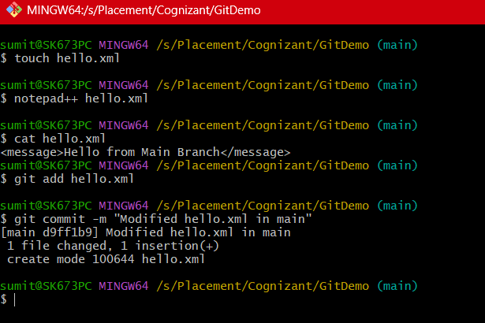
    - 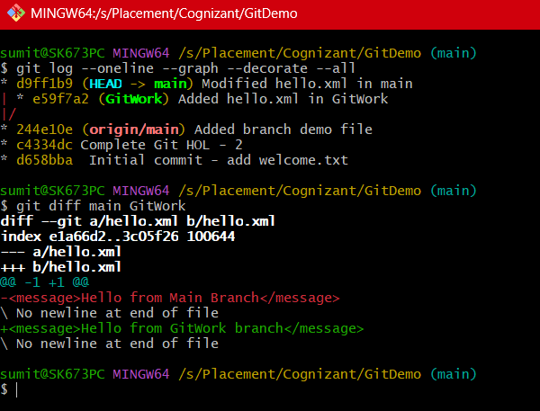
    - 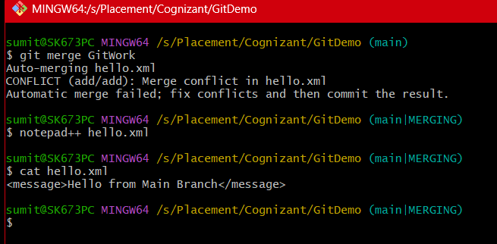
    - 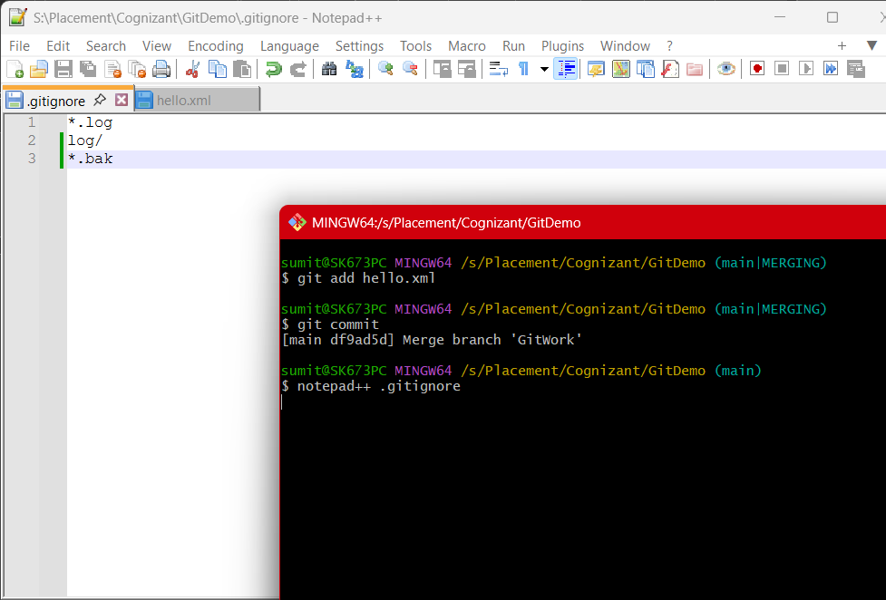
    - 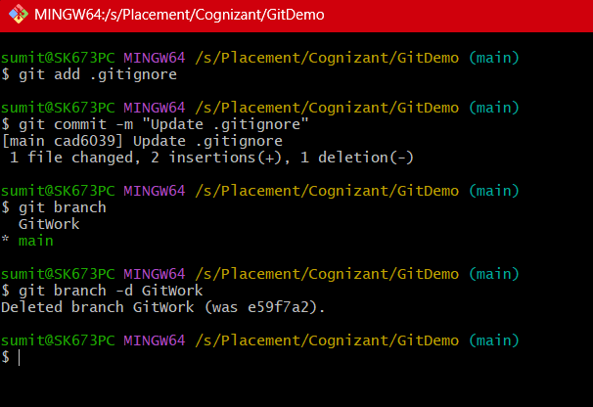

  - Output Screenshot
    - 
     