Git HOL – 5
Task 1 – Clean Up and Push to Remote Repository
  - Brief Explanation
Git synchronization ensures that the local repository and the remote repository contain he latest changes. Before pushing updates, the repository should be in a clean state and synchronized with the remote repository. In this task, the repository status is verified, available branches are listed, the latest changes are pulled from the remote repository, pending commits are pushed and the remote repository is checked to confirm that the changes have been uploaded successfully.
  - Implementation
Step 1: Verify that the repository is in a clean state
1. git status
2.
Step 2: List all available branches
1. git branch -a
2.
Step 3: Pull the latest changes from the remote repository
1. git pull origin main
2.
Step 4: Push pending changes to the remote repository
1. git push origin main
2.
Step 5: Verify the changes in the remote repository
Open the GitLab repository in a web browser and confirm that the latest commit and files are visible.
  - Implementation Screenshot
    - 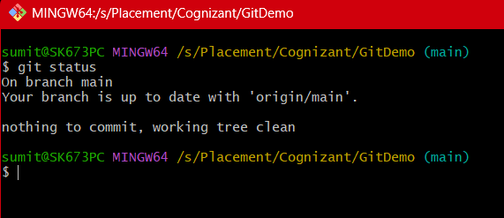
    - 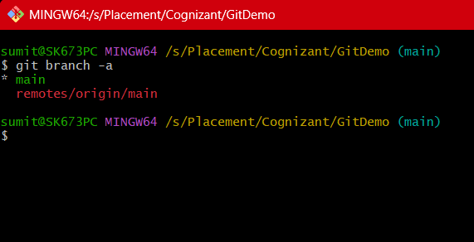
    - 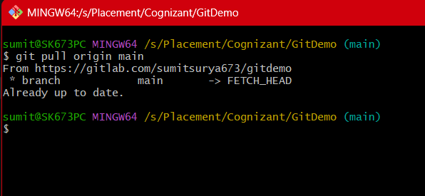
    - 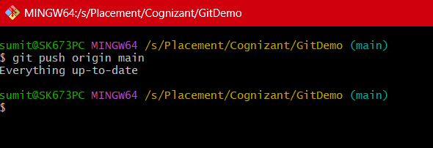

  - Output Screenshot
    - 
     