Employee Management System (Functions)

DB Setup:
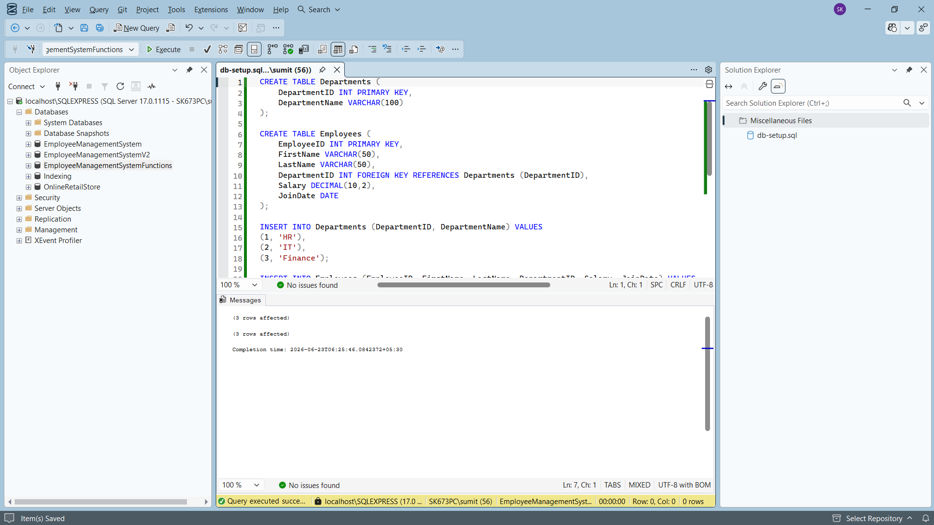
Exercise 1: Create a Scalar Function
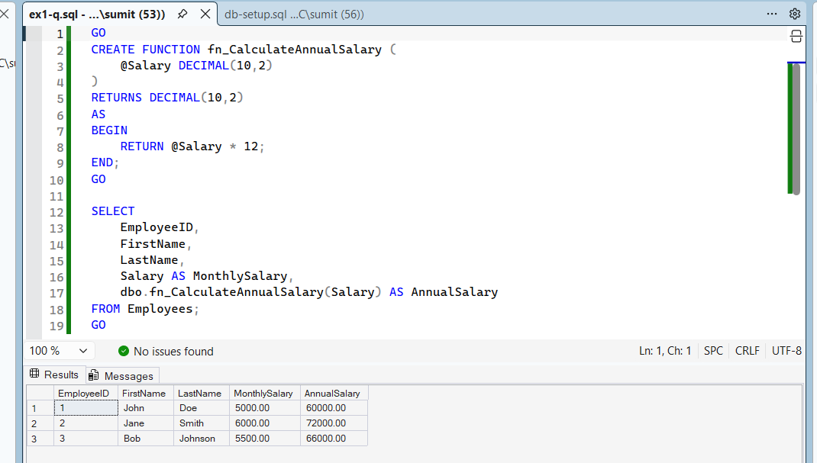
Exercise 2: Create a Table-Valued Function
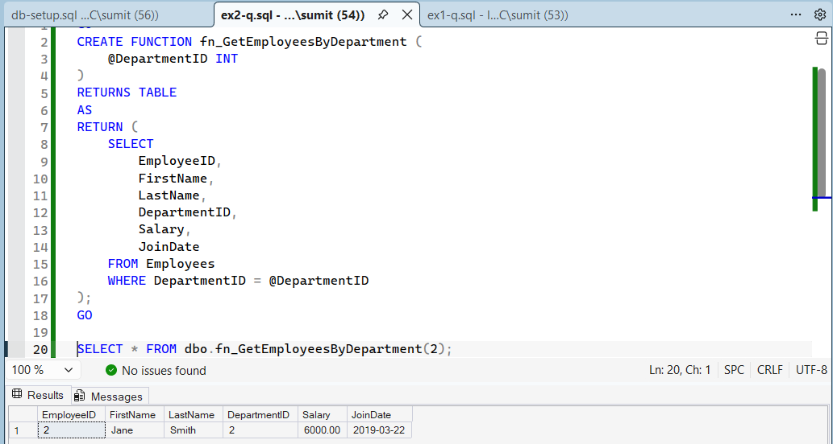
Exercise 3: Create a User-Defined Function
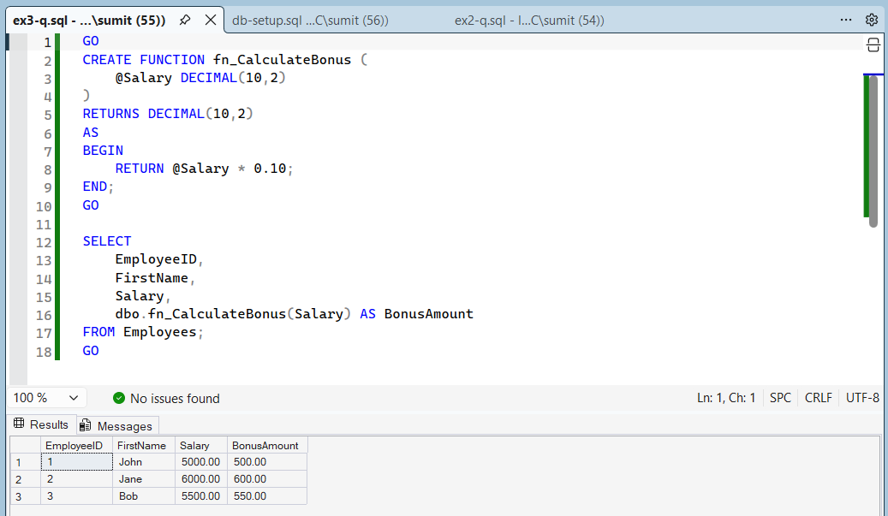
Exercise 4: Modify a User-Defined Function
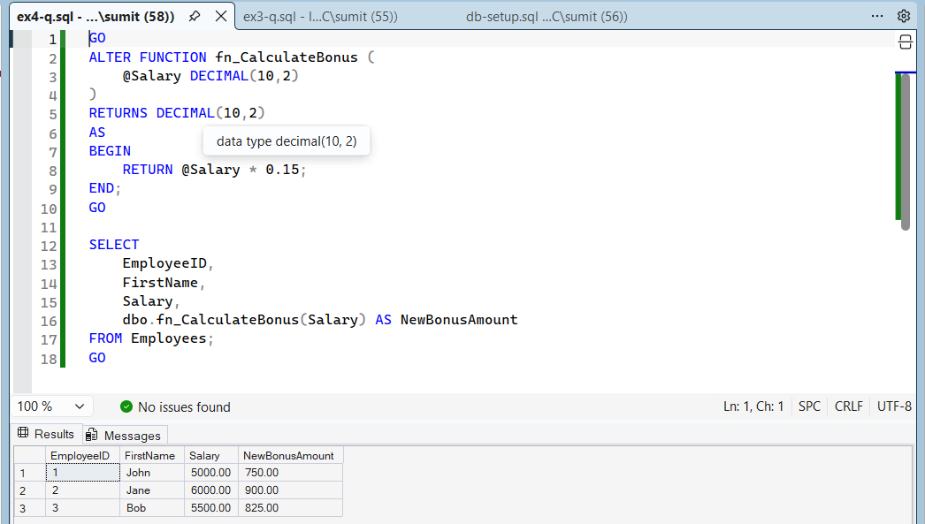
Exercise 5: Delete a User-Defined Function
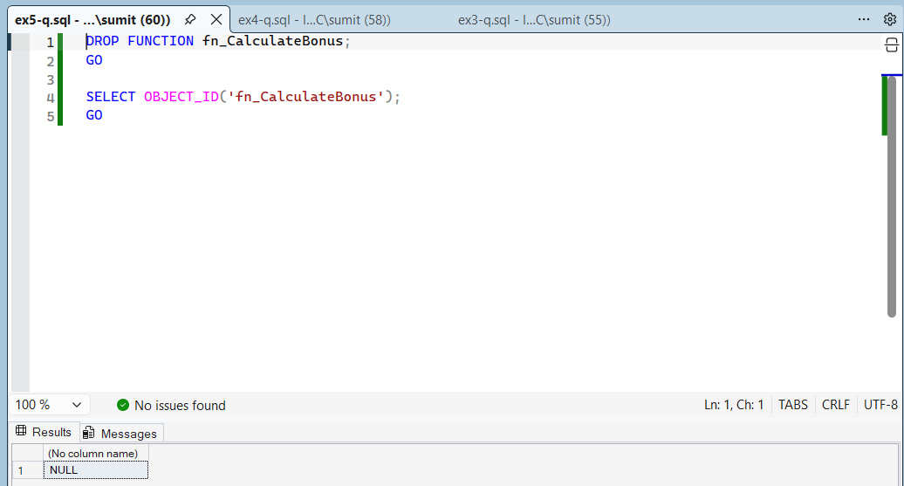
Exercise 6: Execute a User-Defined Function
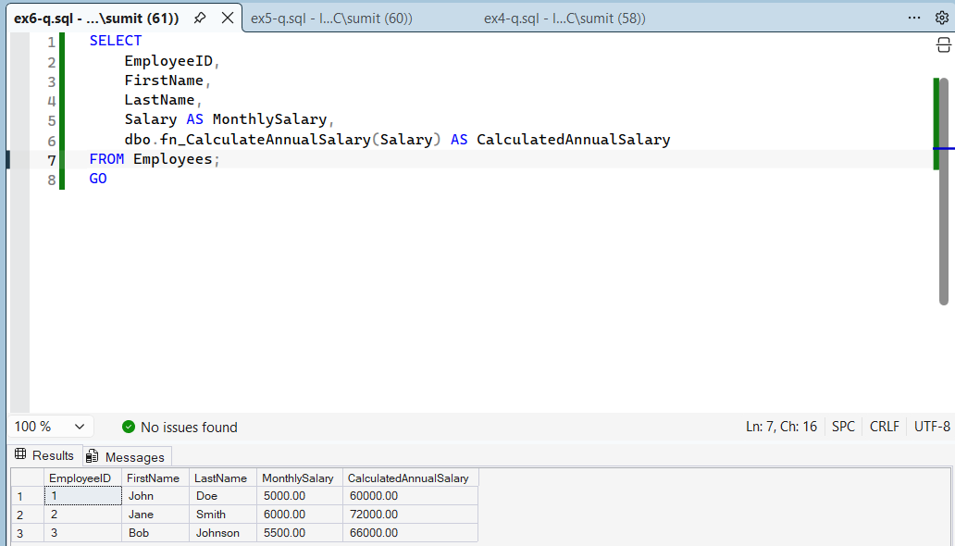
Exercise 7: Return Data from a Scalar Function
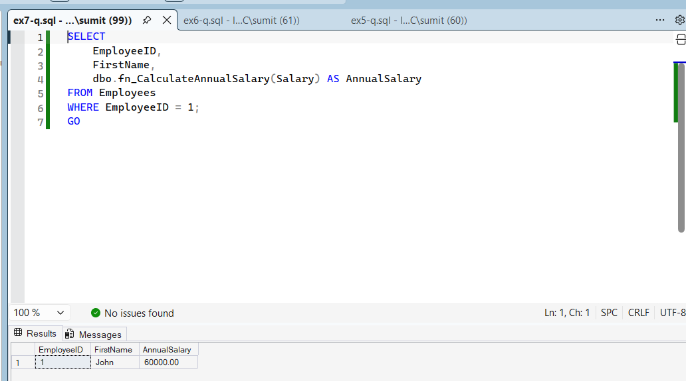
Exercise 8: Return Data from a Table-Valued Function
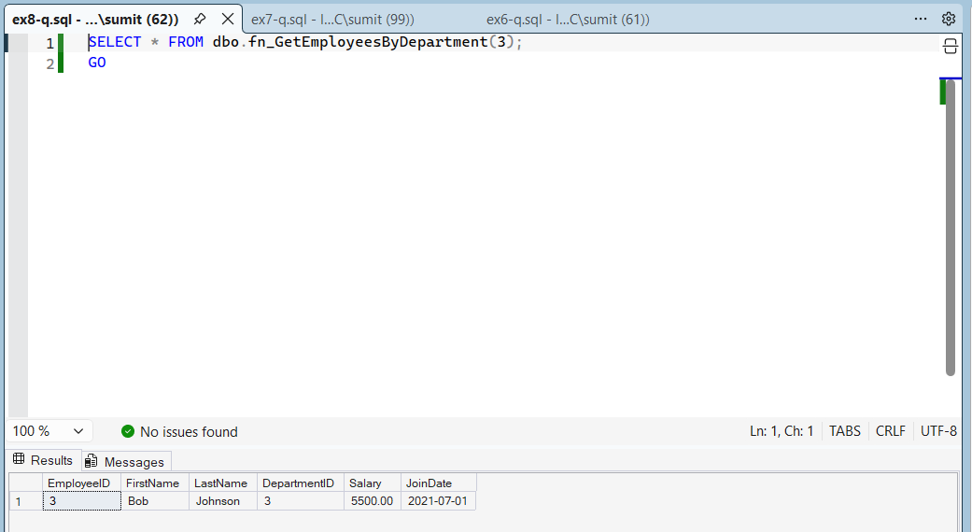
Exercise 9: Create a Nested User-Defined Function
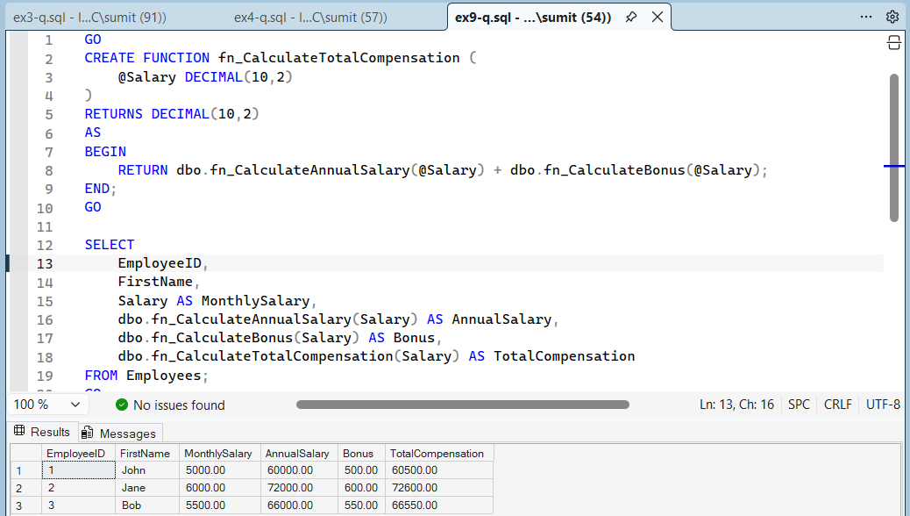
Exercise 10: Modify a Nested User-Defined Function
