Employee Management System (Stored Procedures)

DB Setup:
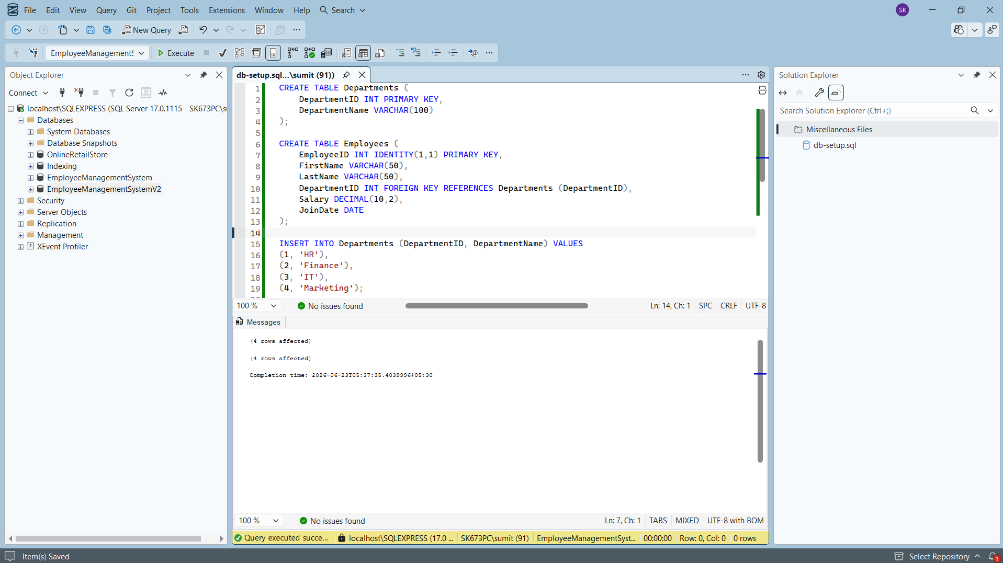
Exercise 1: Create a Stored Procedure
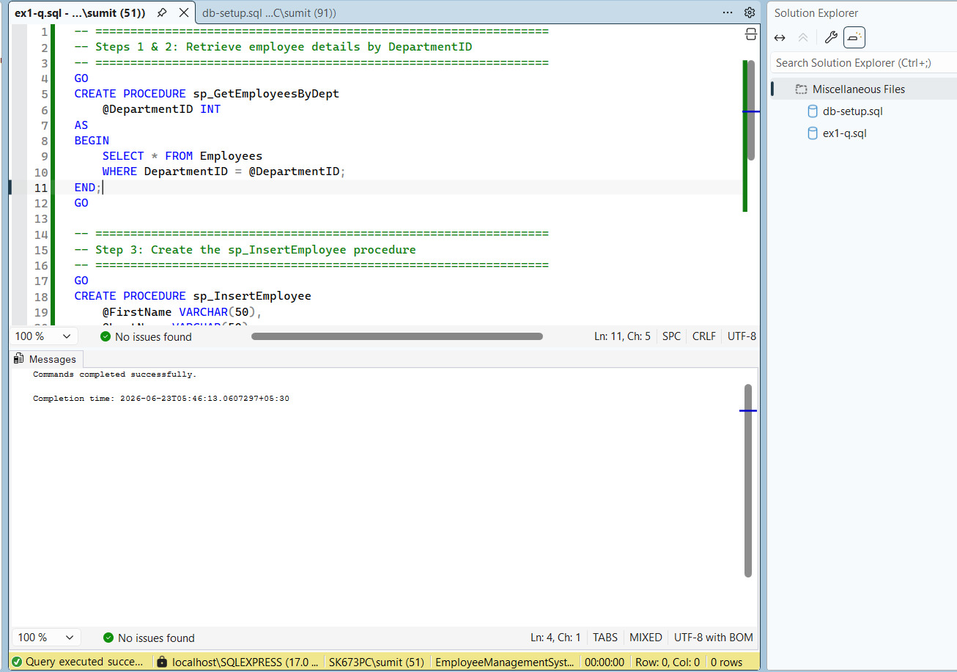
Exercise 2: Modify a Stored Procedure
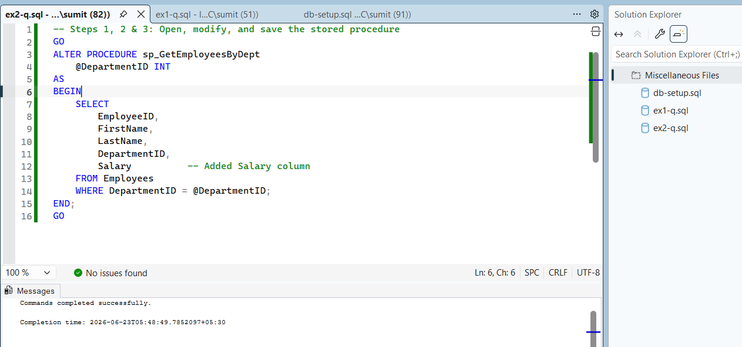
Exercise 3: Delete a Stored Procedure
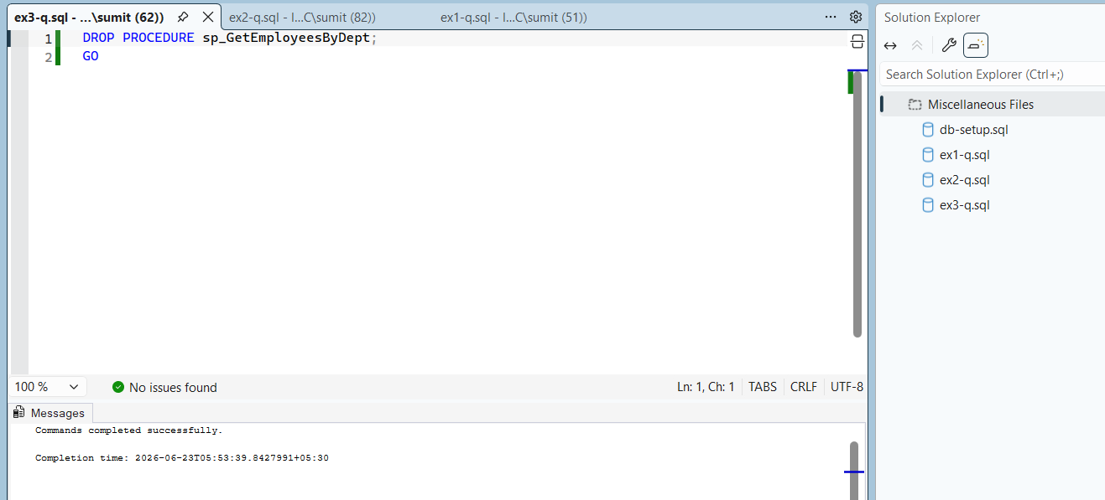
Exercise 4: Execute a Stored Procedure
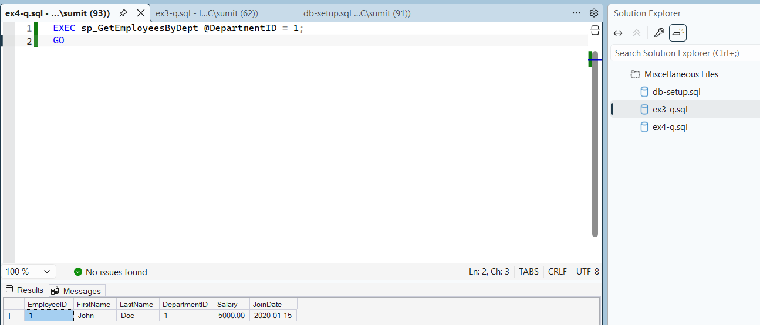
Exercise 5: Return Data from a Stored Procedure
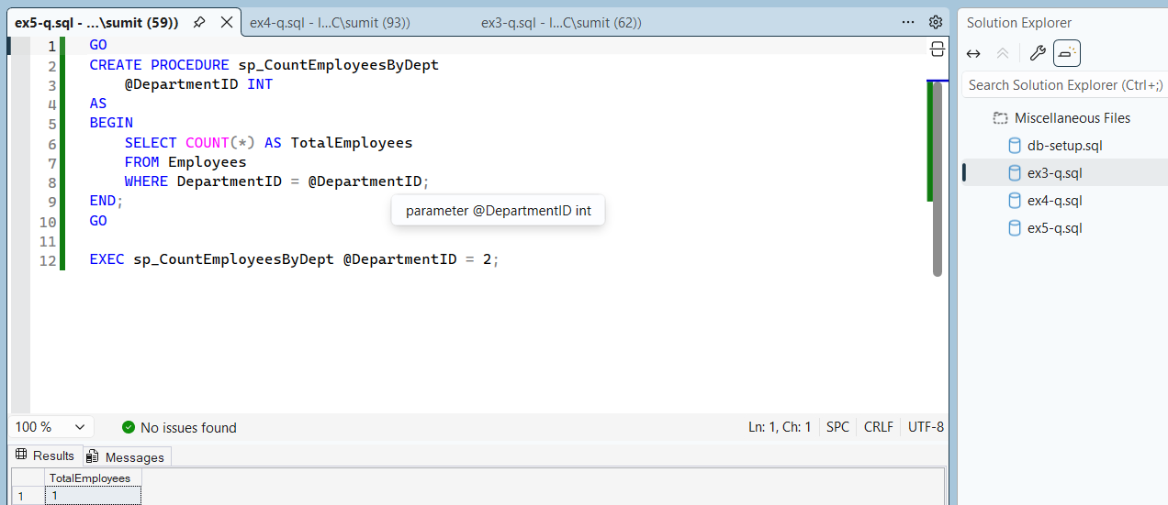
Exercise 6: Use Output Parameters in a Stored Procedure
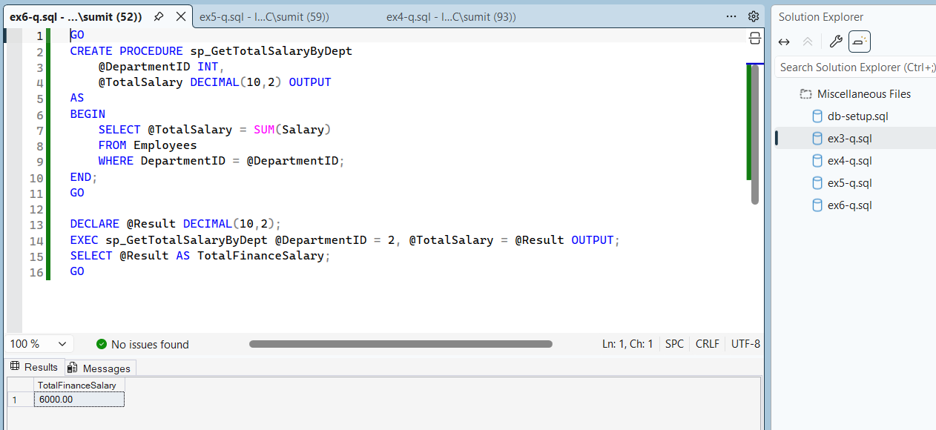
Exercise 7: Create a Stored Procedure with Multiple Parameters
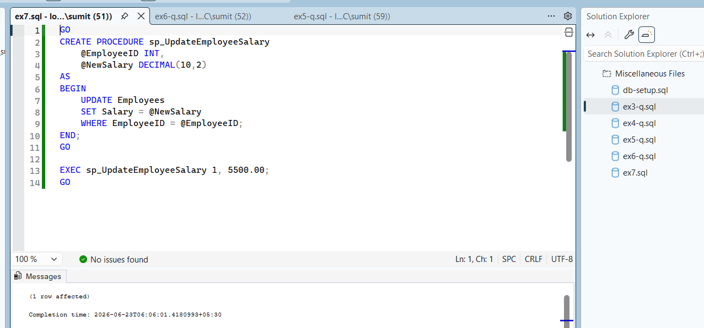
Exercise 8: Create a Stored Procedure with Conditional Logic
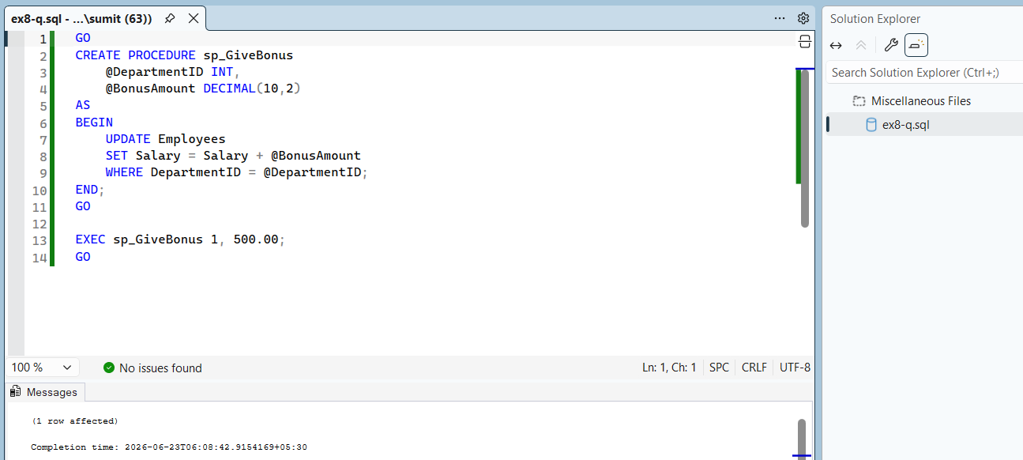
Exercise 9: Use Transactions in a Stored Procedure
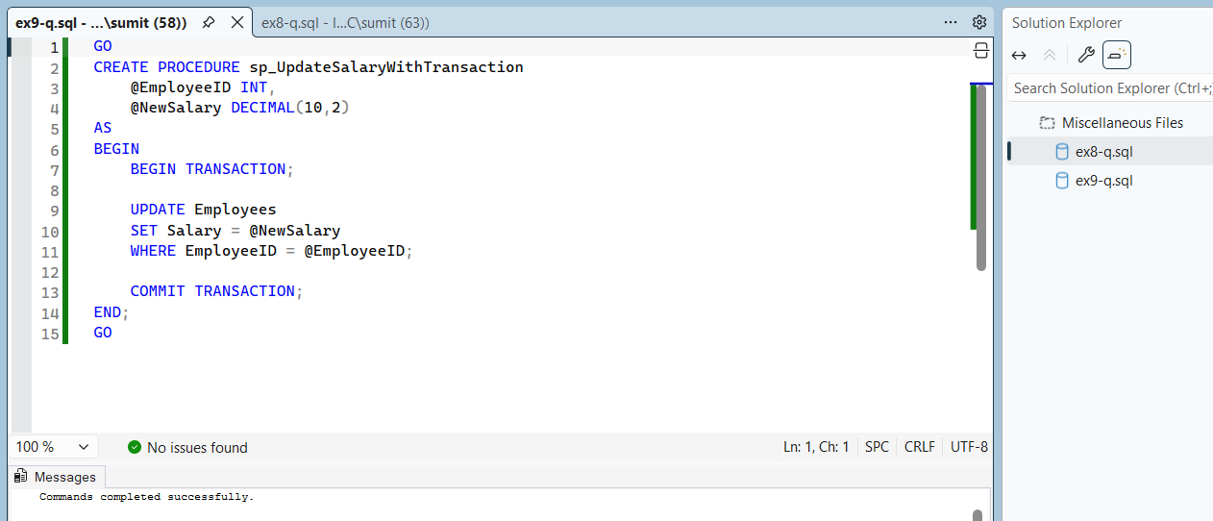
Exercise 10: Use Dynamic SQL in a Stored Procedure
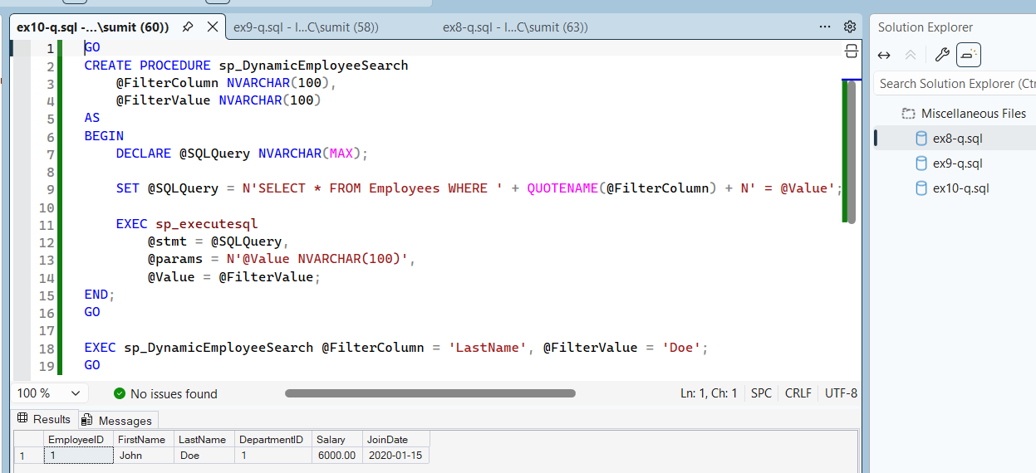
Exercise 11: Handle Errors in a Stored Procedure
