Employee Management System (Triggers)

DB Setup:
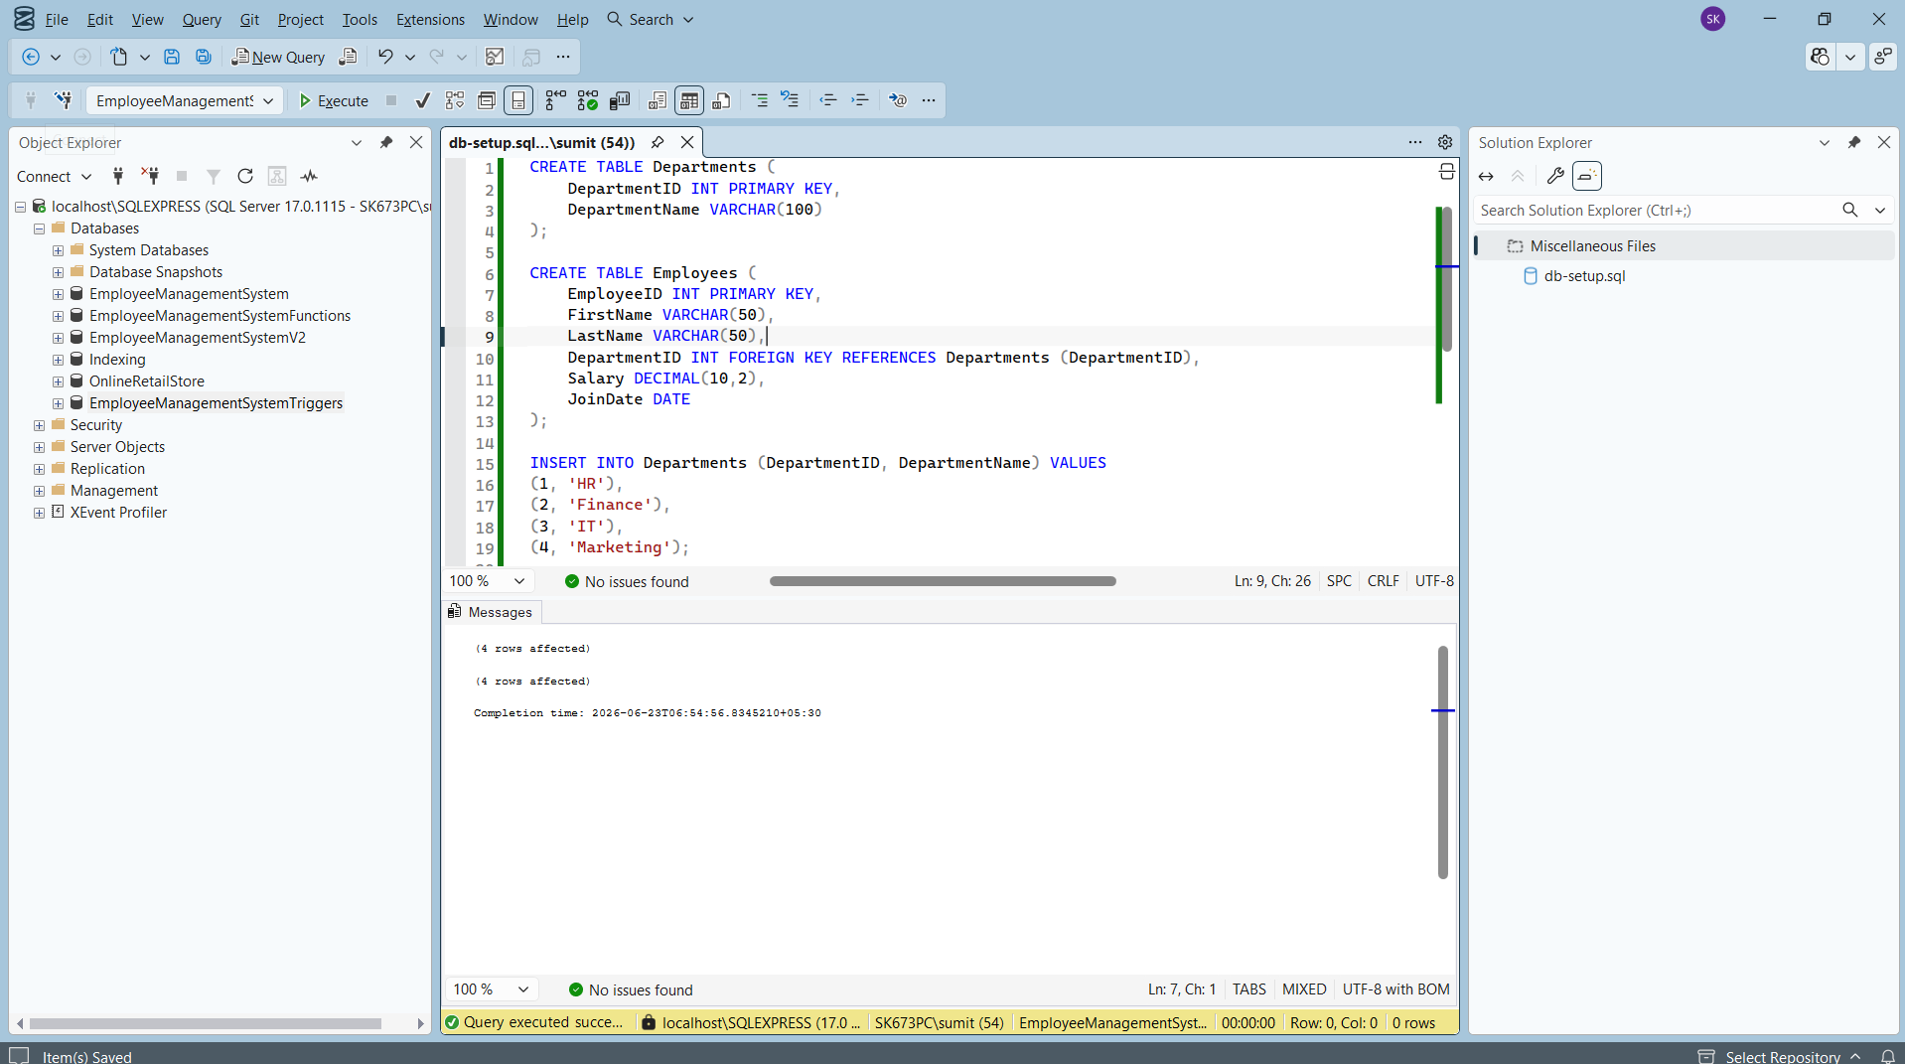
Exercise 1: Create an After Trigger
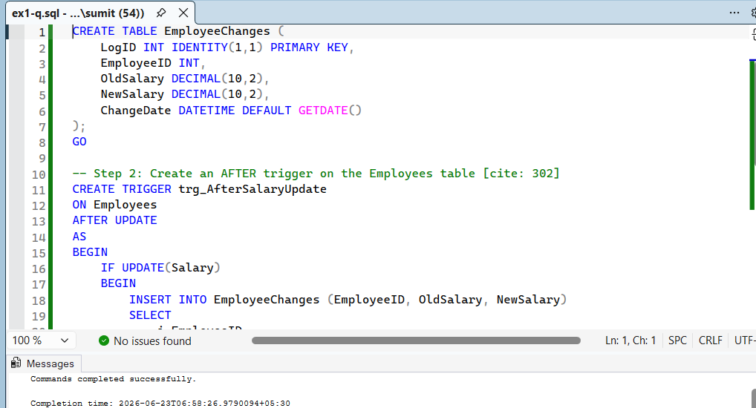
Exercise 2: Create an Instead of Trigger

Exercise 3: Create a Logon Trigger
Exercise 4: Modify a Trigger using SSMS
Exercise 5: Delete a Trigger
Exercise 6: Create a Trigger to Update a Computed Column

