Employee Management System (Views)

DB Setup:
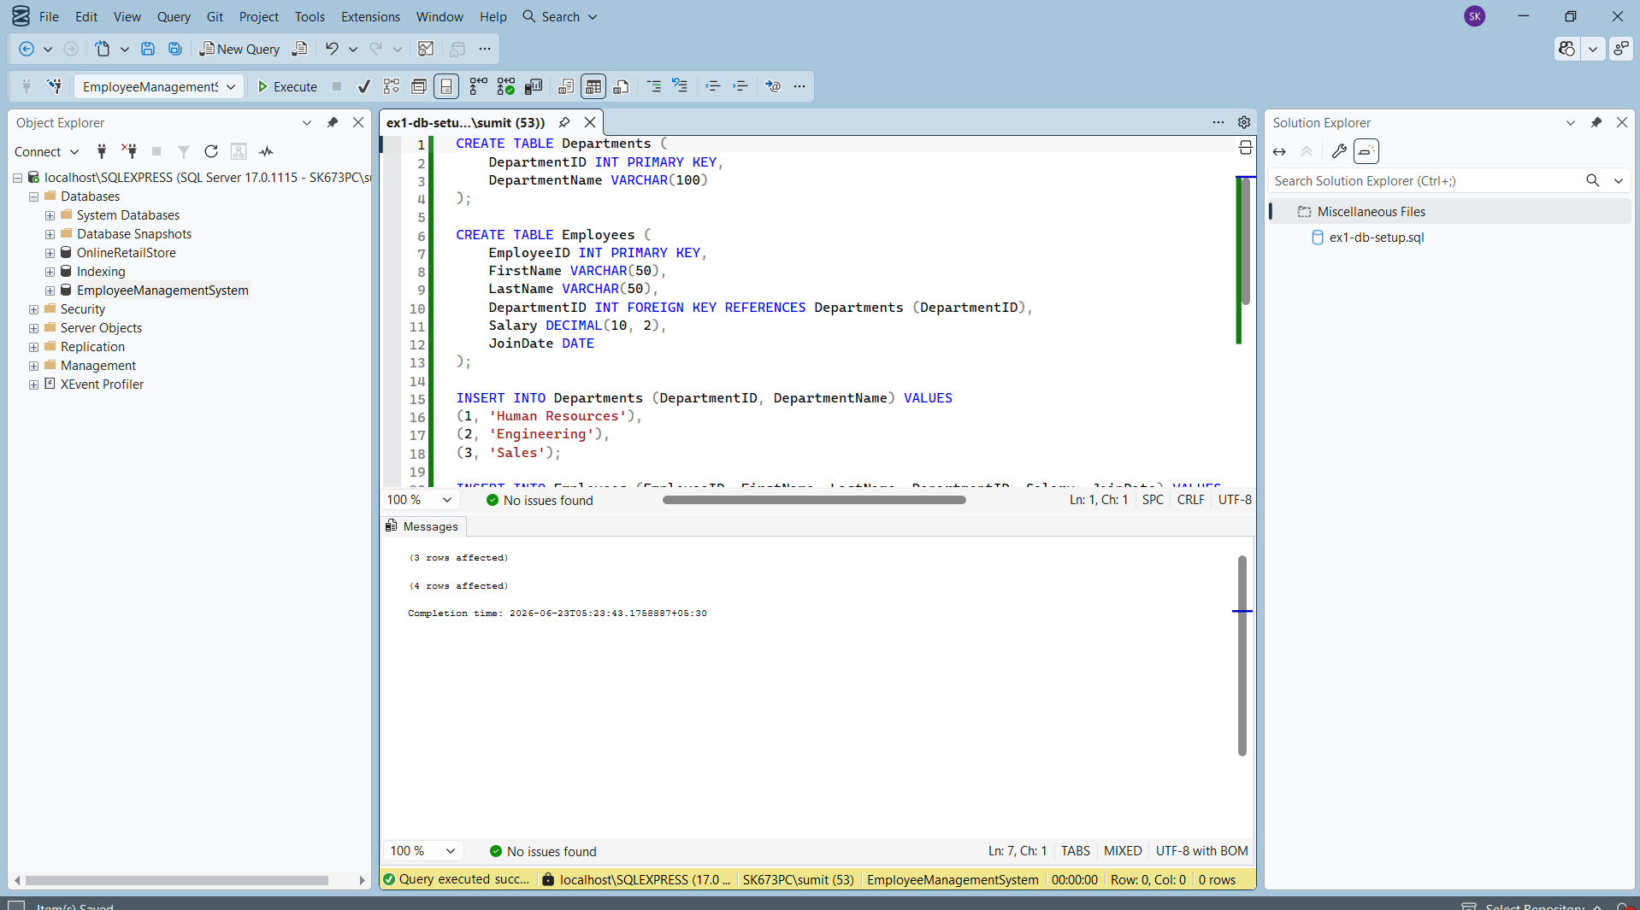
Exercise 1: Create a Simple View
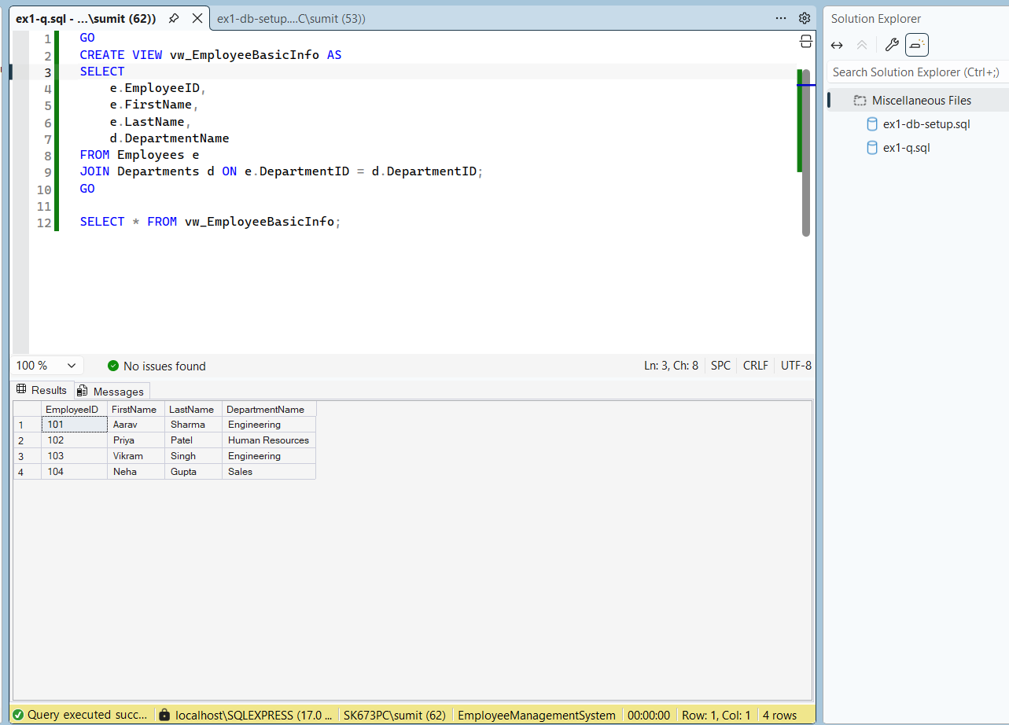
Exercise 2: Add Computed Column - Full Name
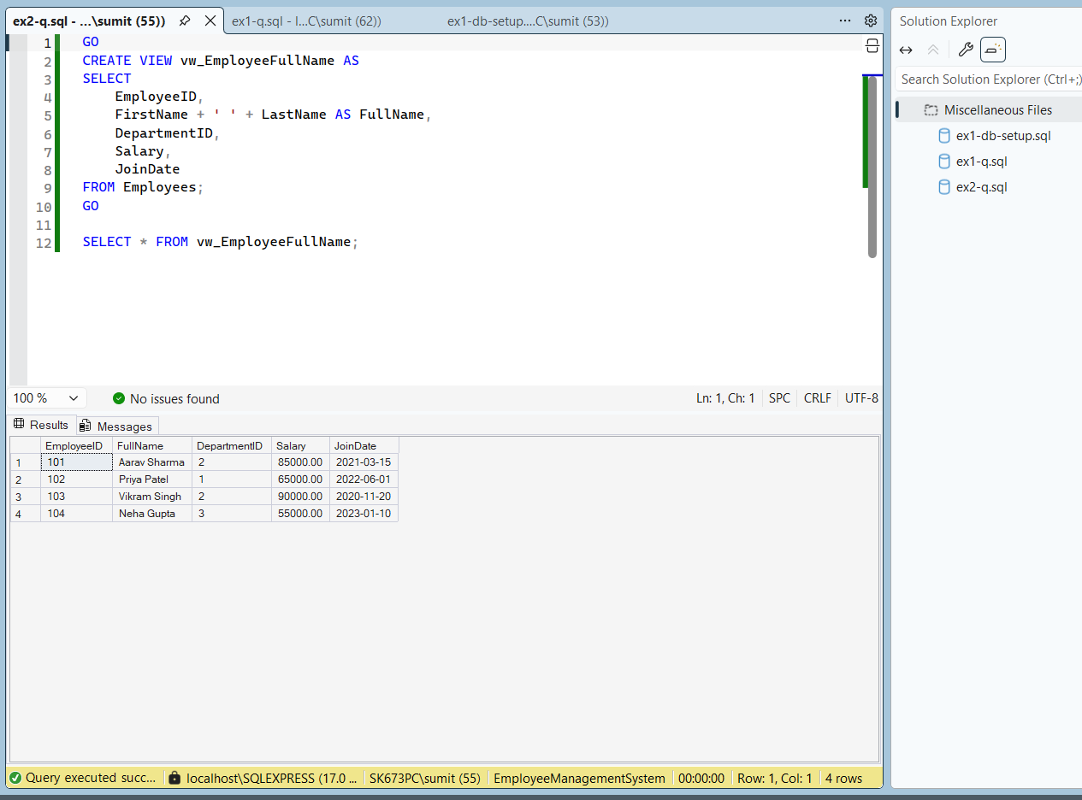
Exercise 3: Add Computed Column - Annual Salary
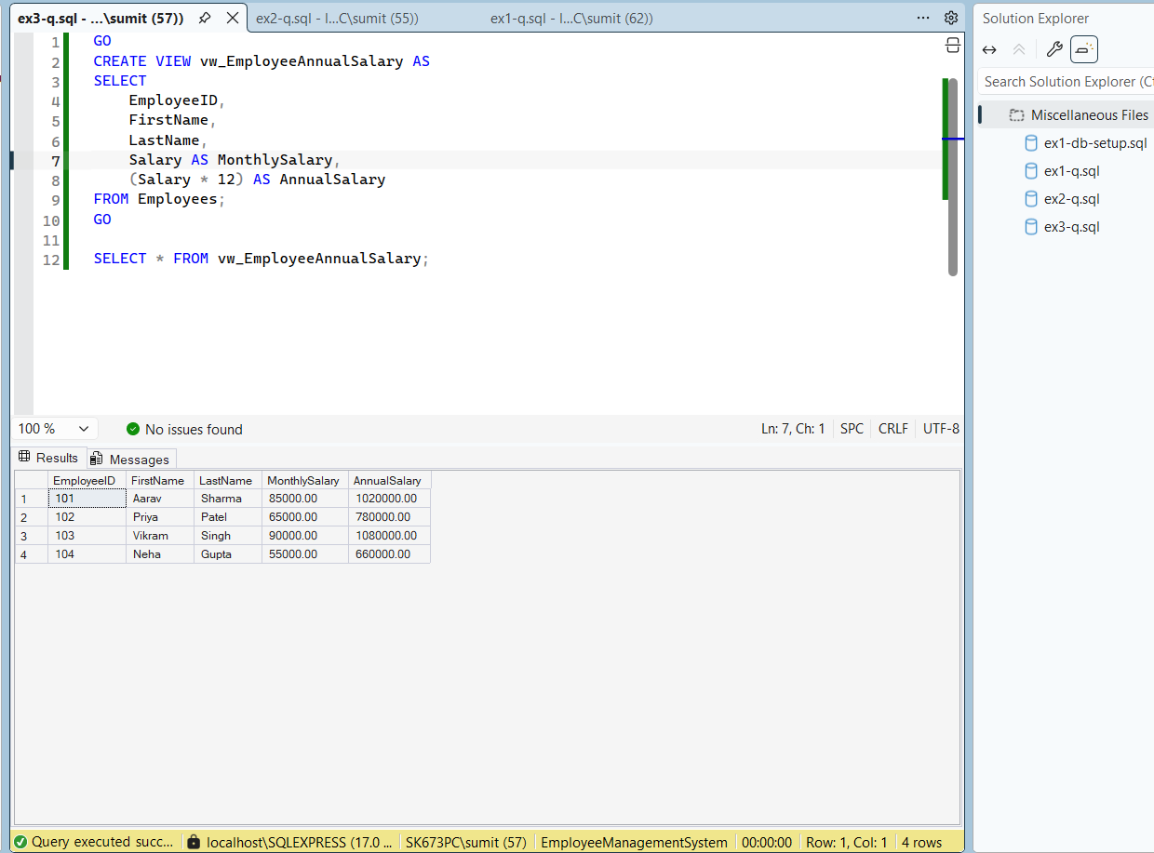
Exercise 4: Add Multiple Computed Columns
