Index
DB Setup:
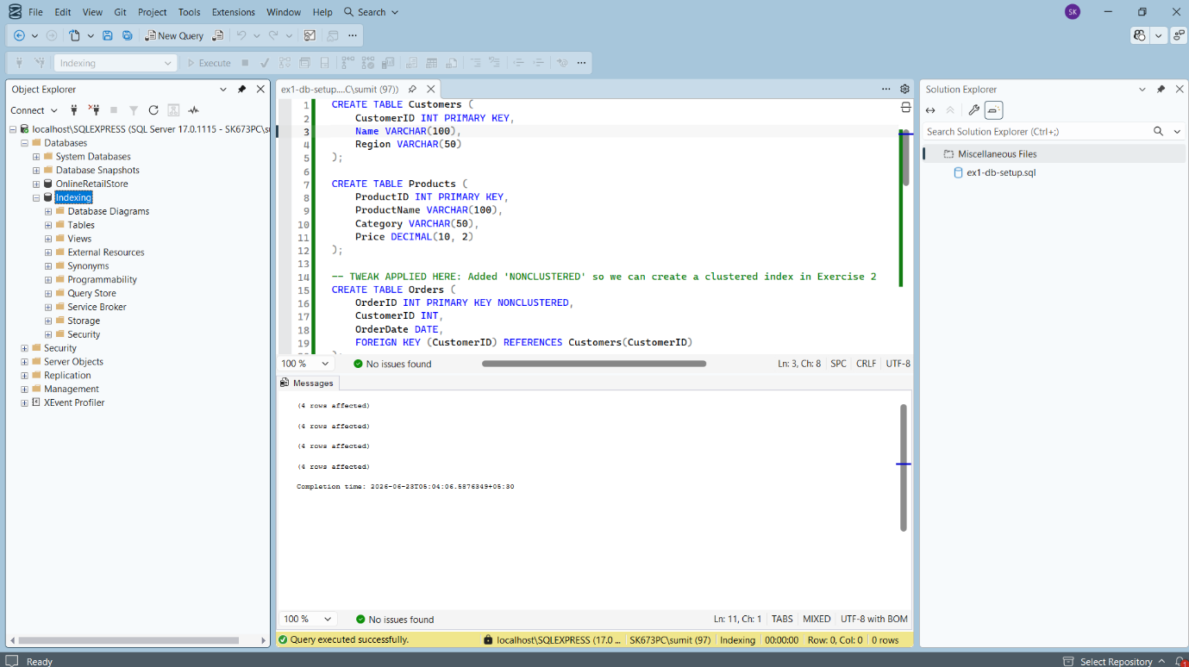
Exercise 1: Creating a Non-Clustered Index
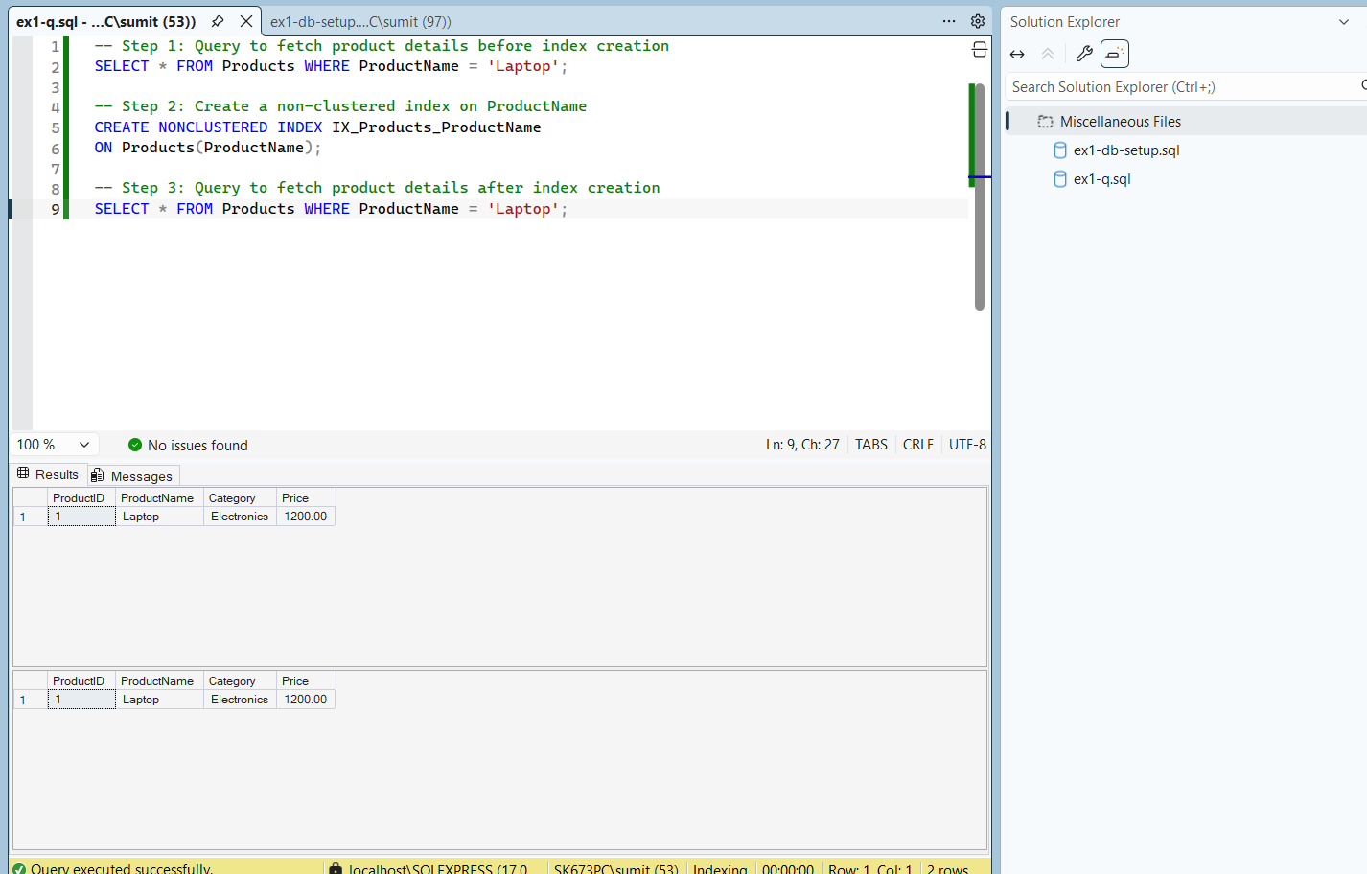
Exercise 2: Creating a Clustered Index
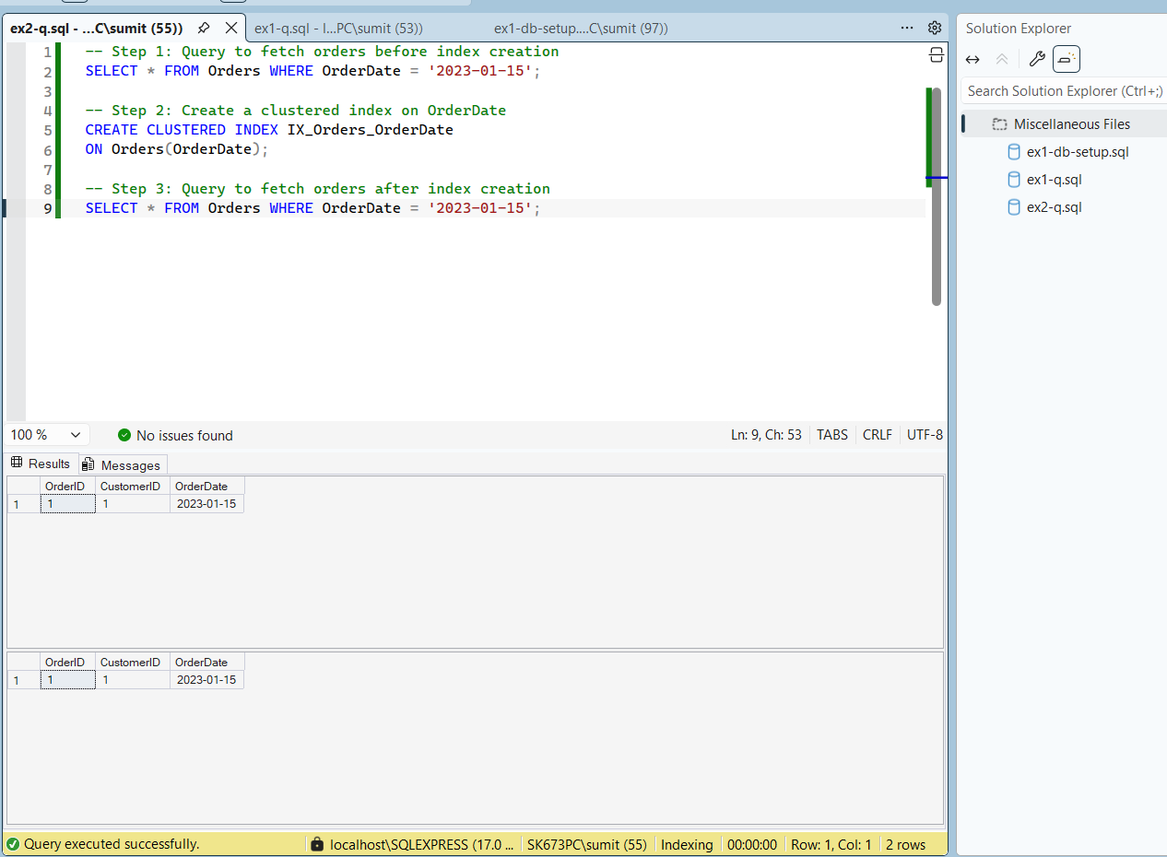
Exercise 3: Creating a Composite Index
