Advanced SQL Exercises for Online Retail Store
Implementation: Check all the SQL files in the current directory.
Exercise 1: Ranking and Window Functions
DB setup:
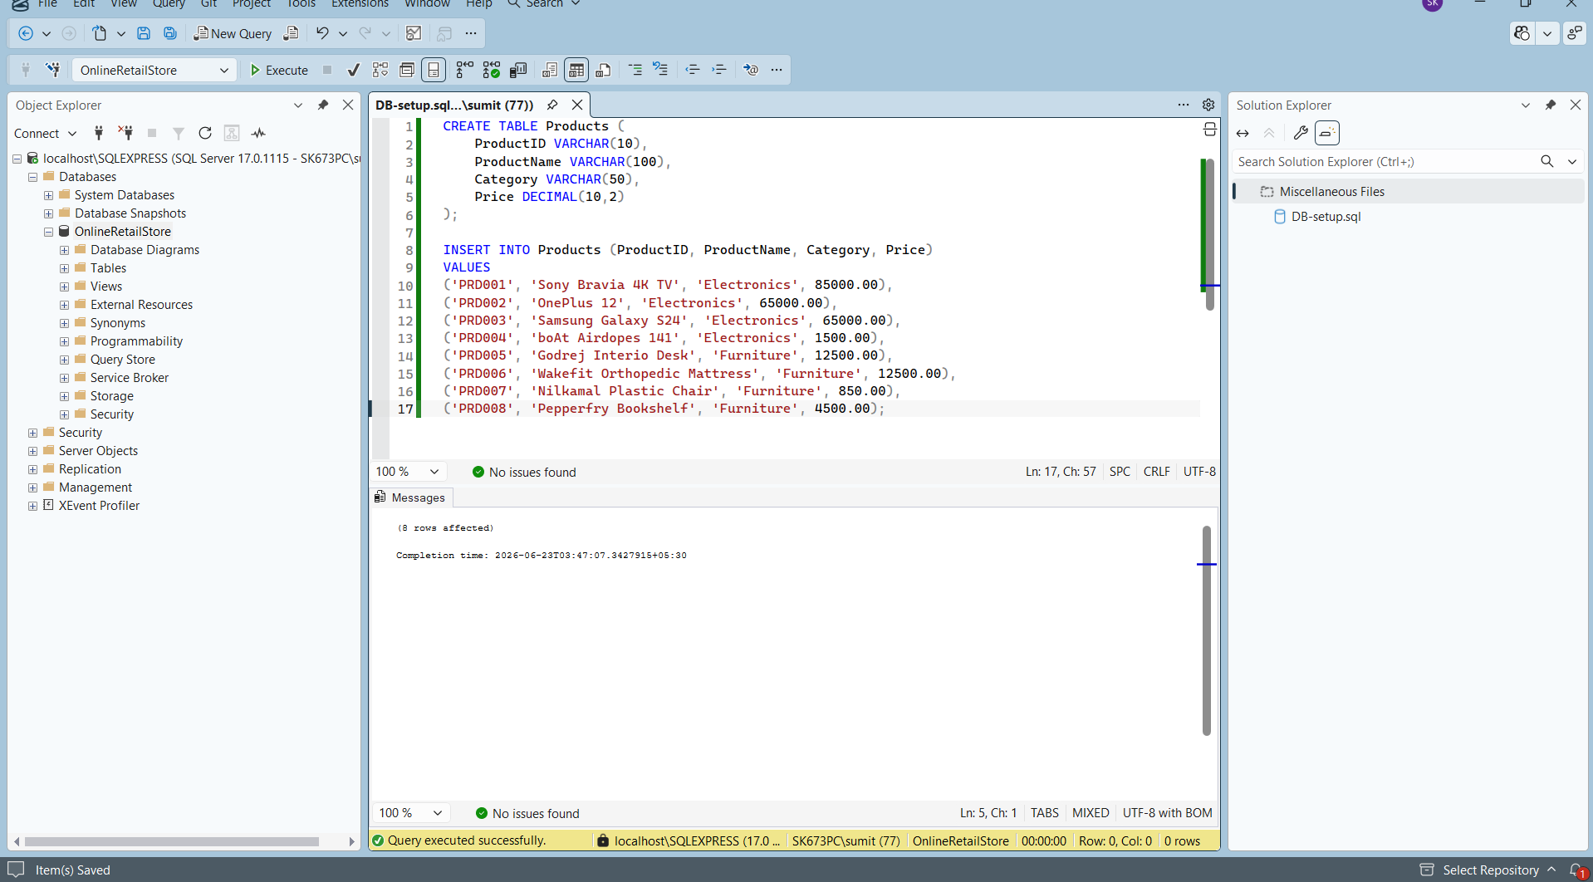
Query Results:
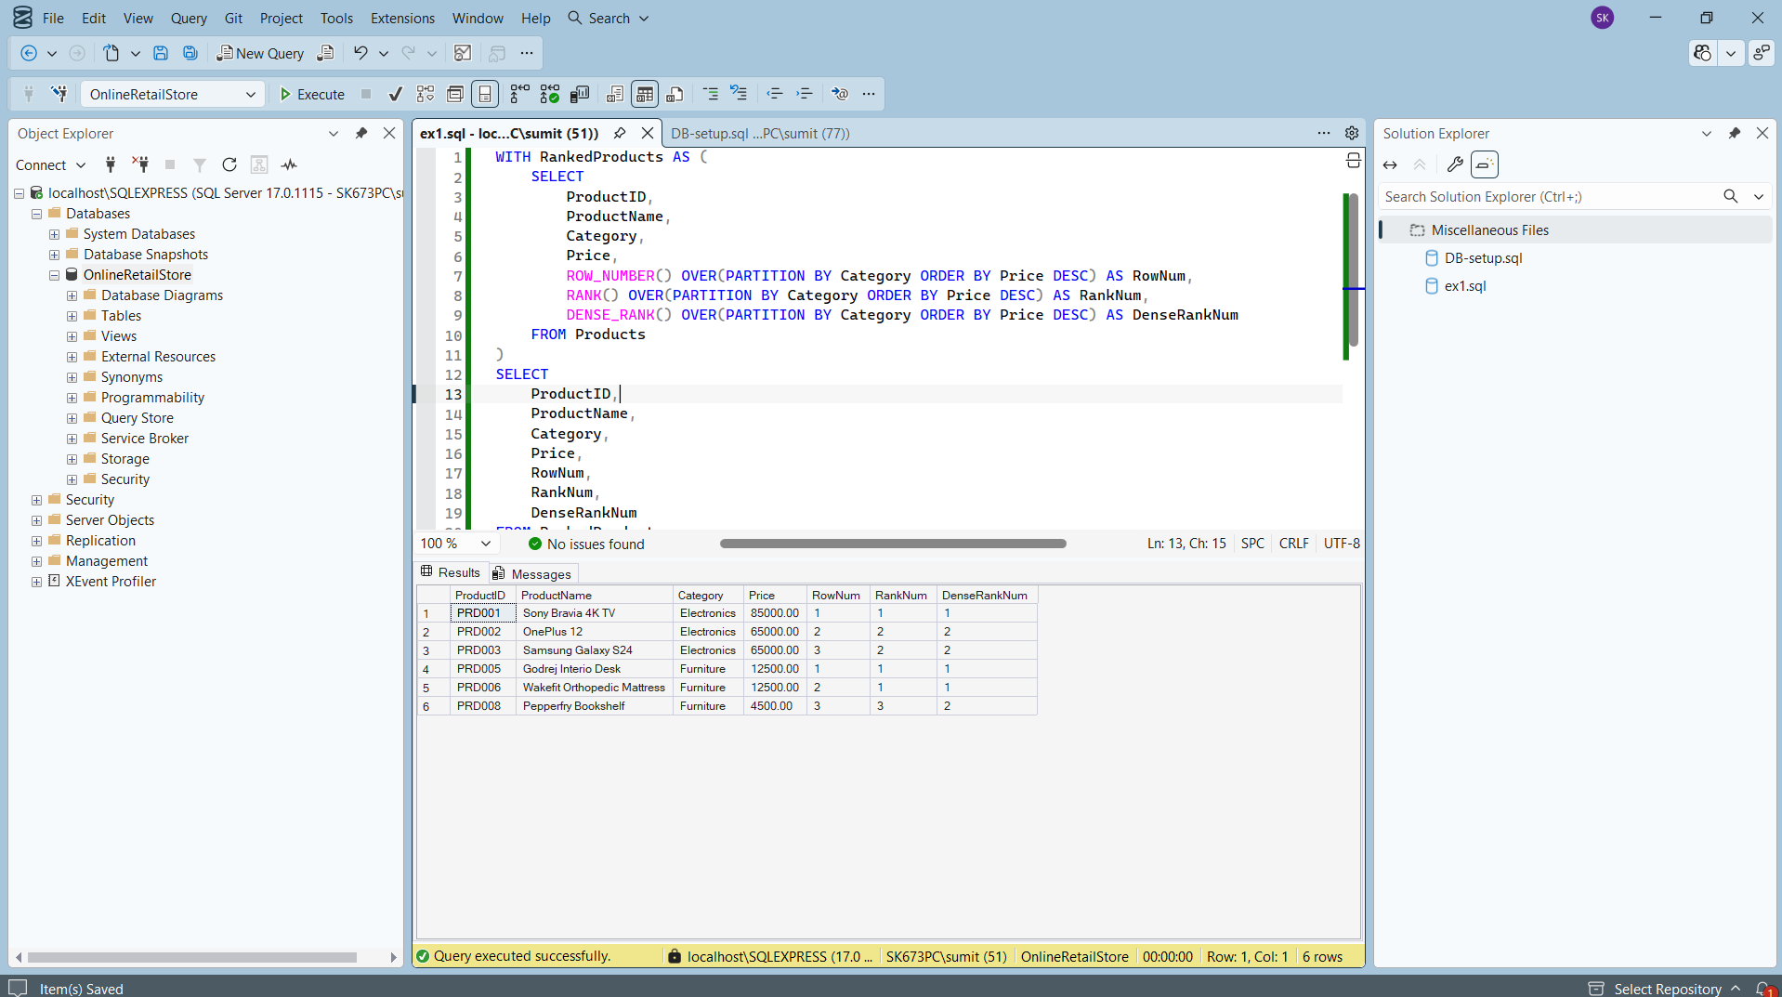

Exercise 2: Aggregation with GROUPING SETS, CUBE, and ROLLUP
Altering the DB:
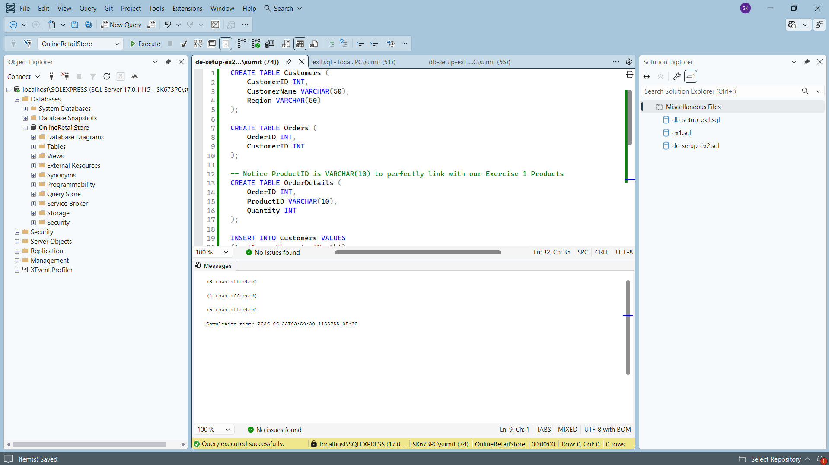
Query A: GROUPING SETS
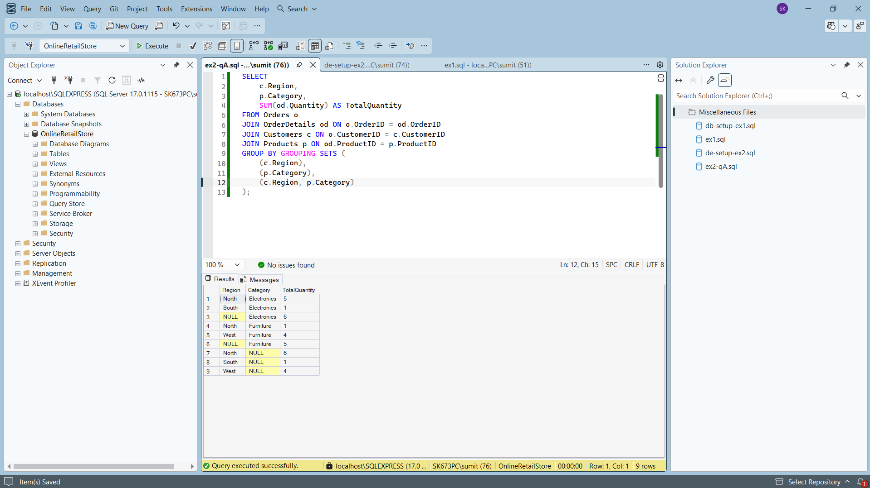
Query B: ROLLUP
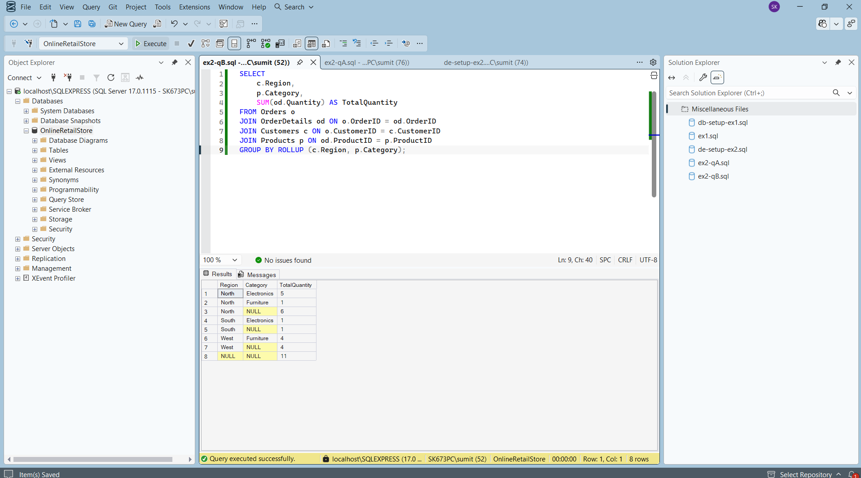
Query C: CUBE
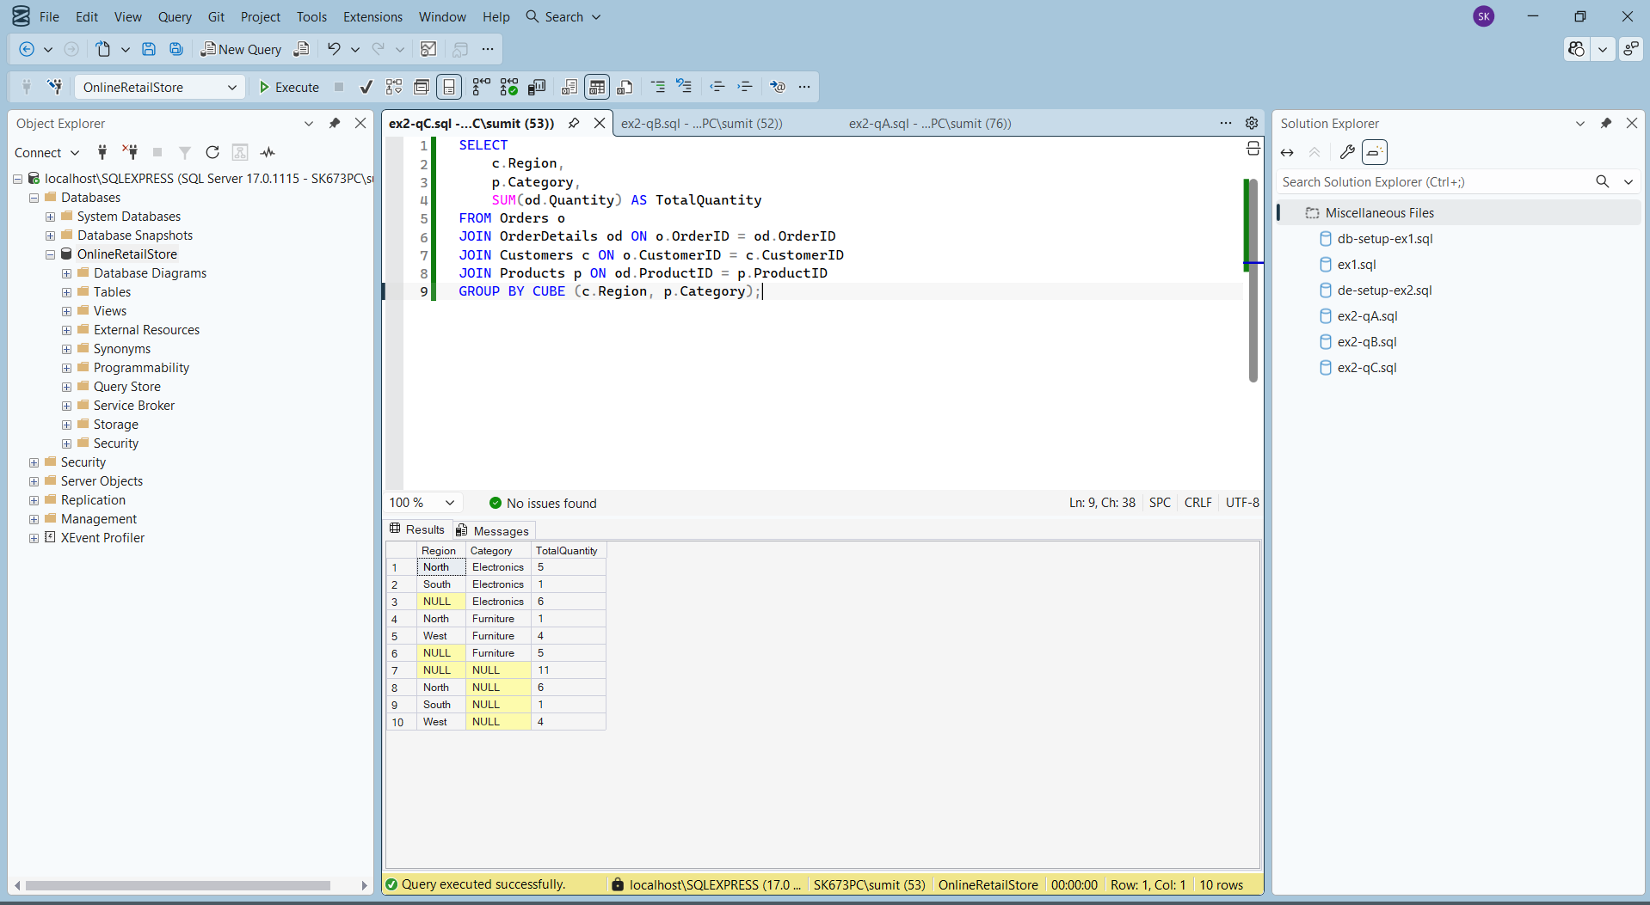

Exercise 3: CTEs and MERGE
DB Setup:
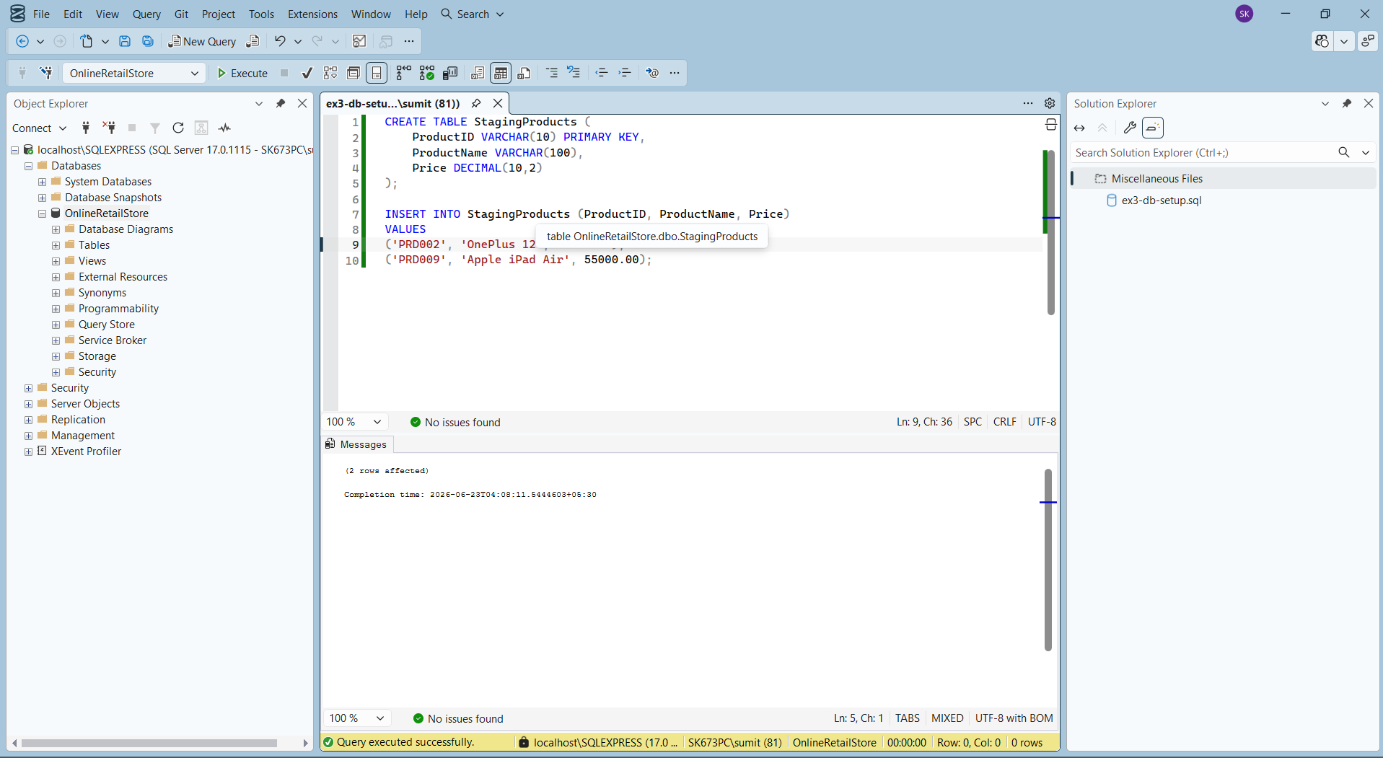
Query A: Recursive CTE for Calendar Generation
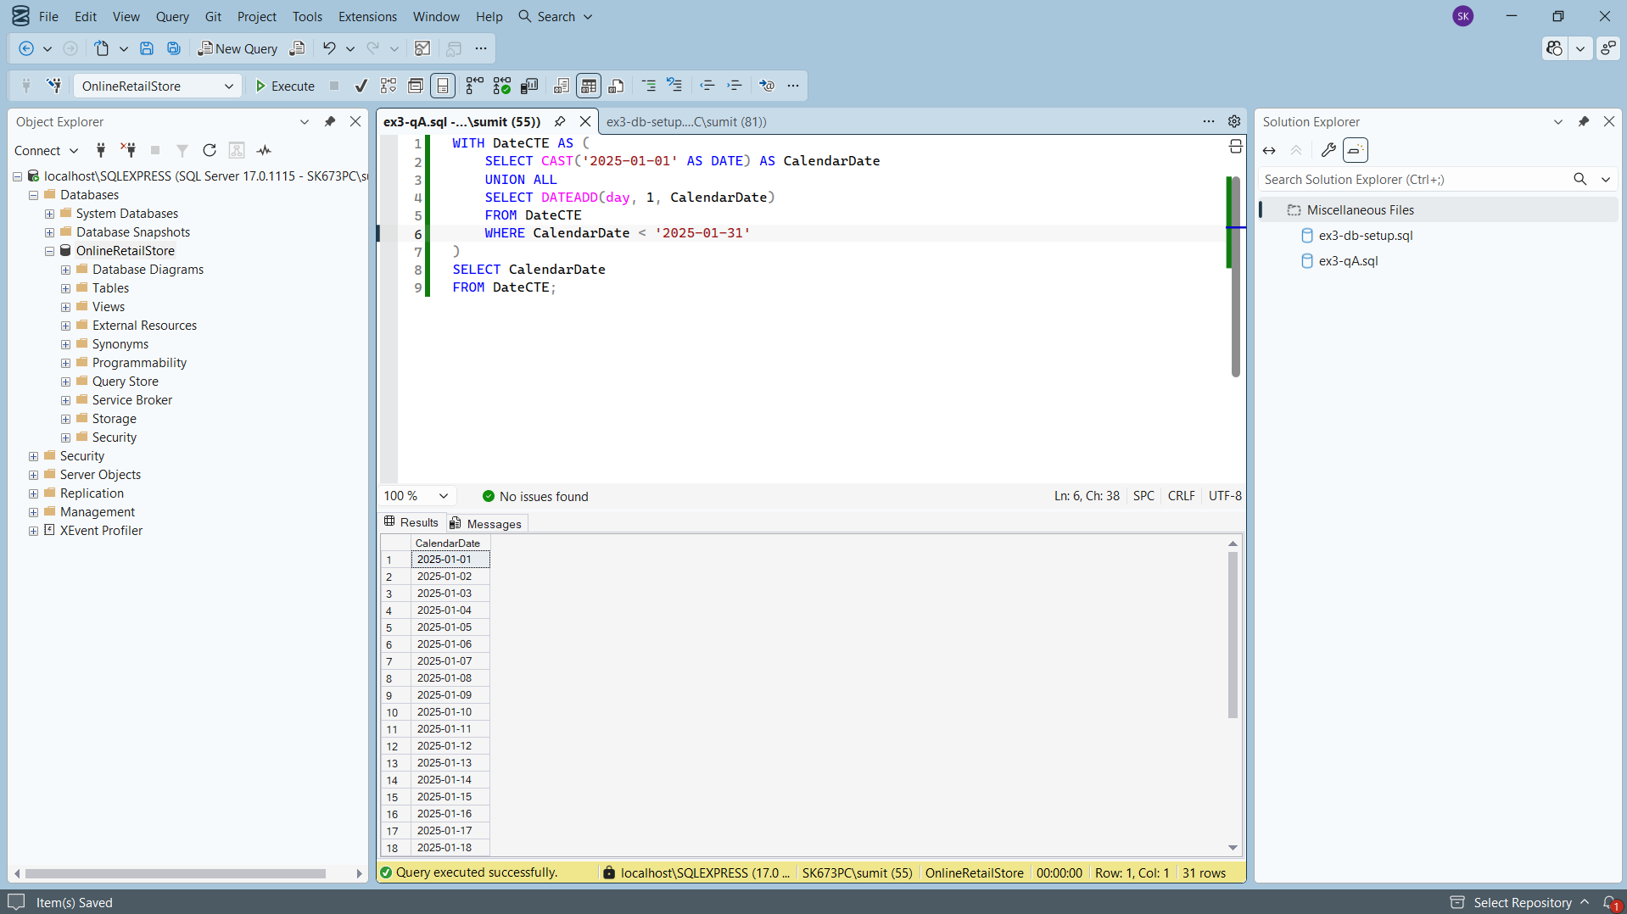
Query B: The MERGE Statement
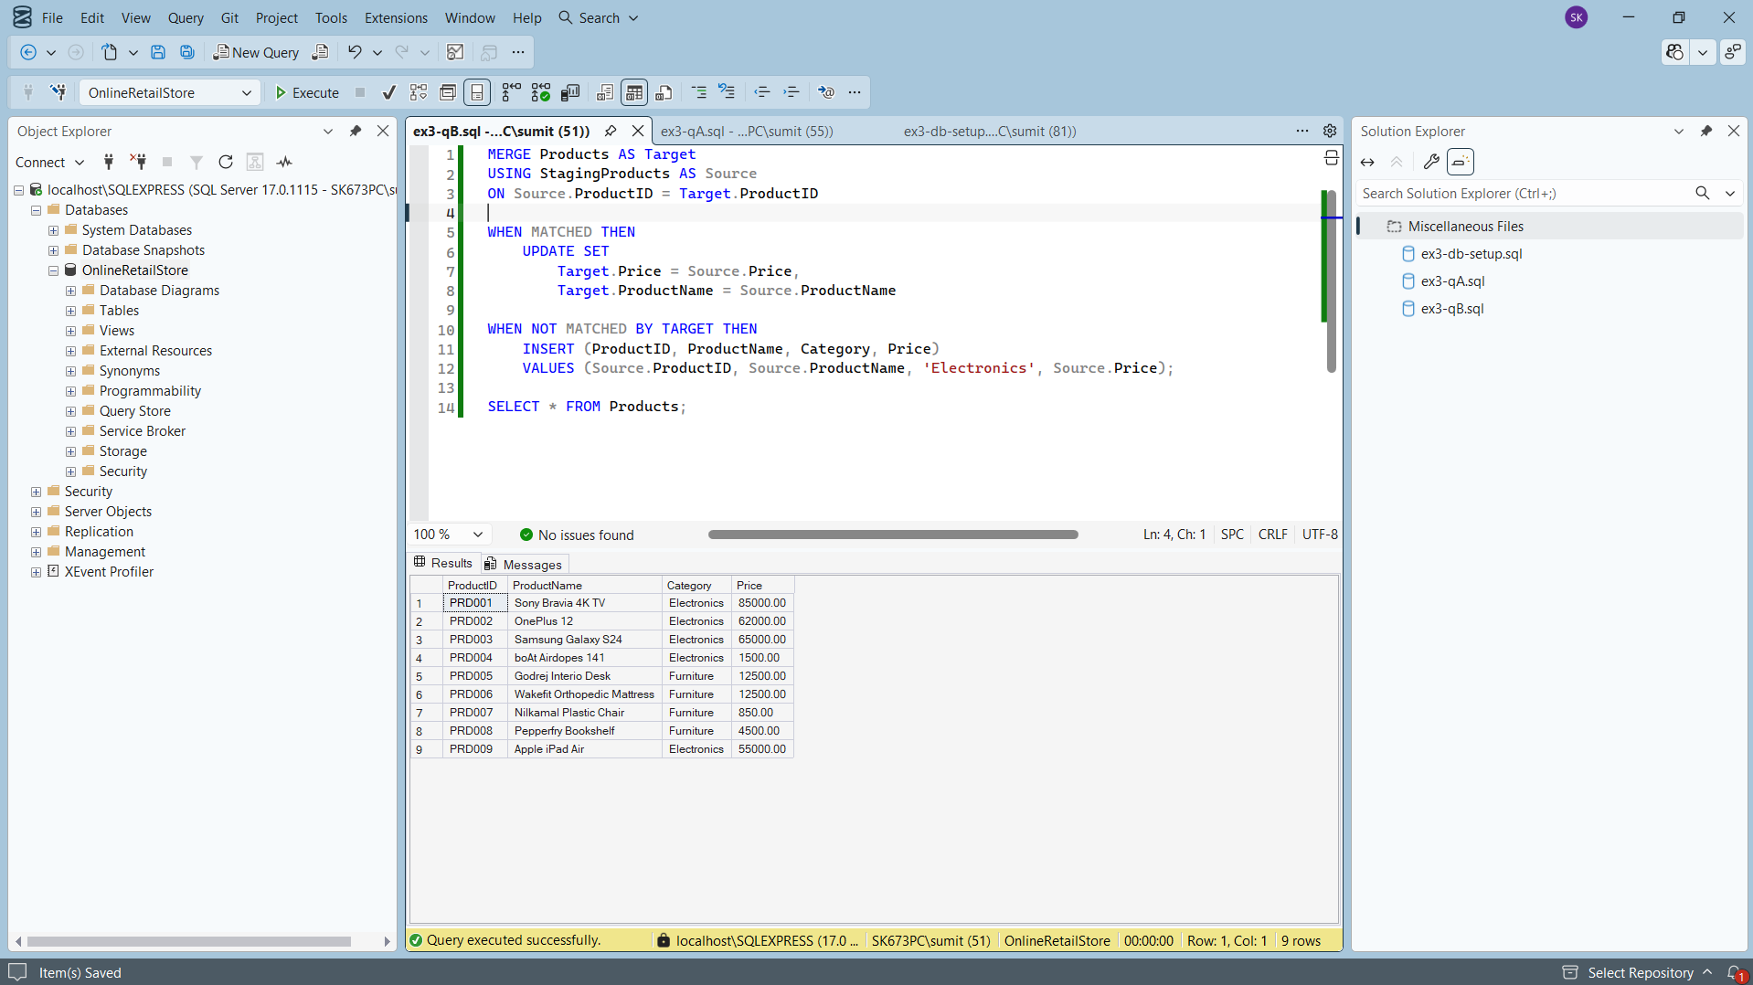

Exercise 4: PIVOT and UNPIVOT
DB Setup:
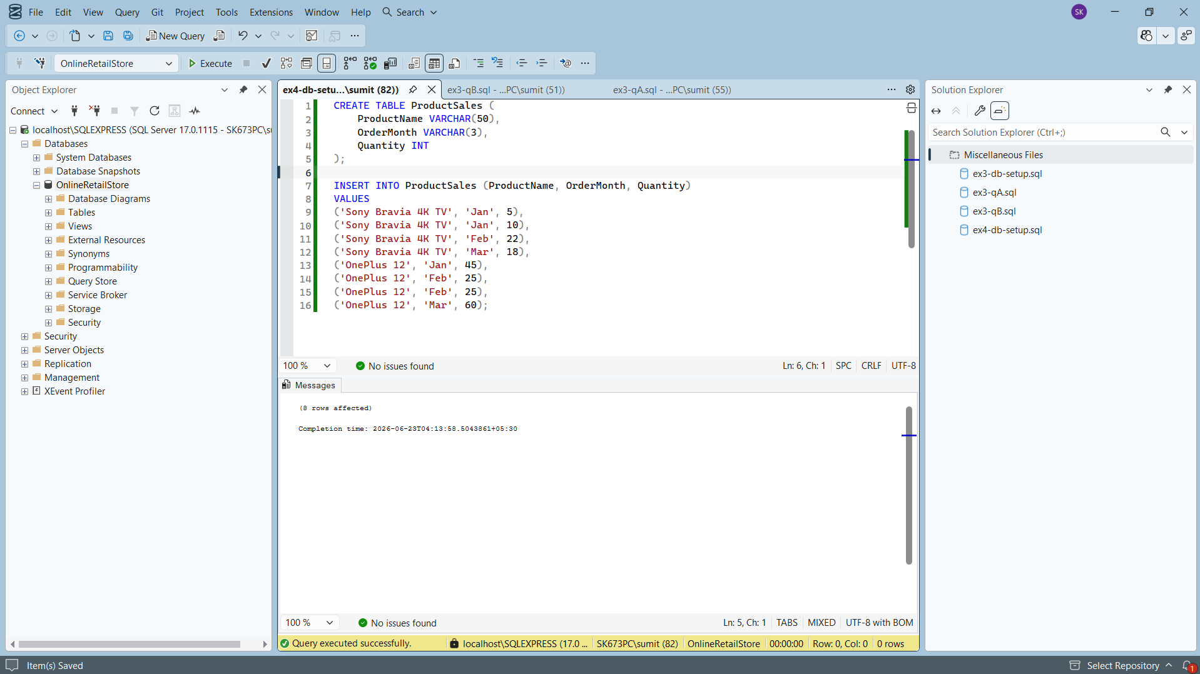
Query A: The PIVOT Operation:
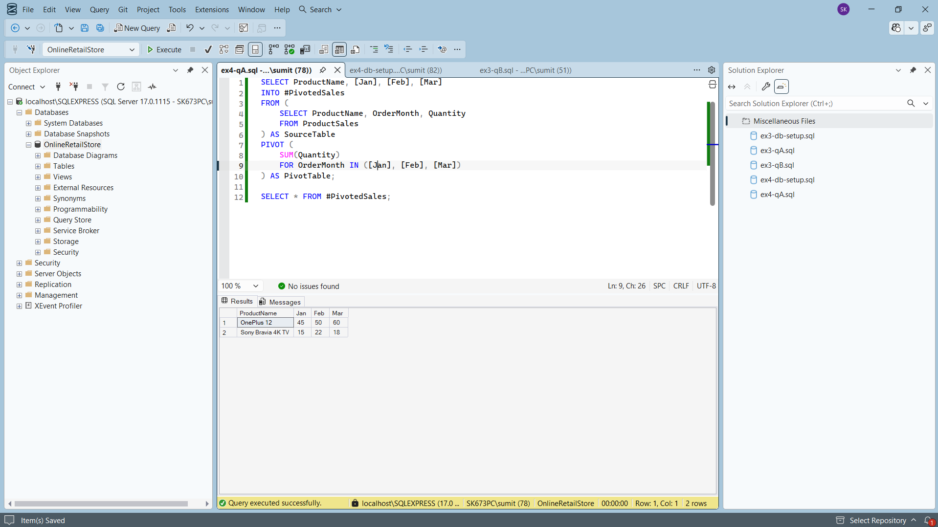
Query B: The UNPIVOT Operation:
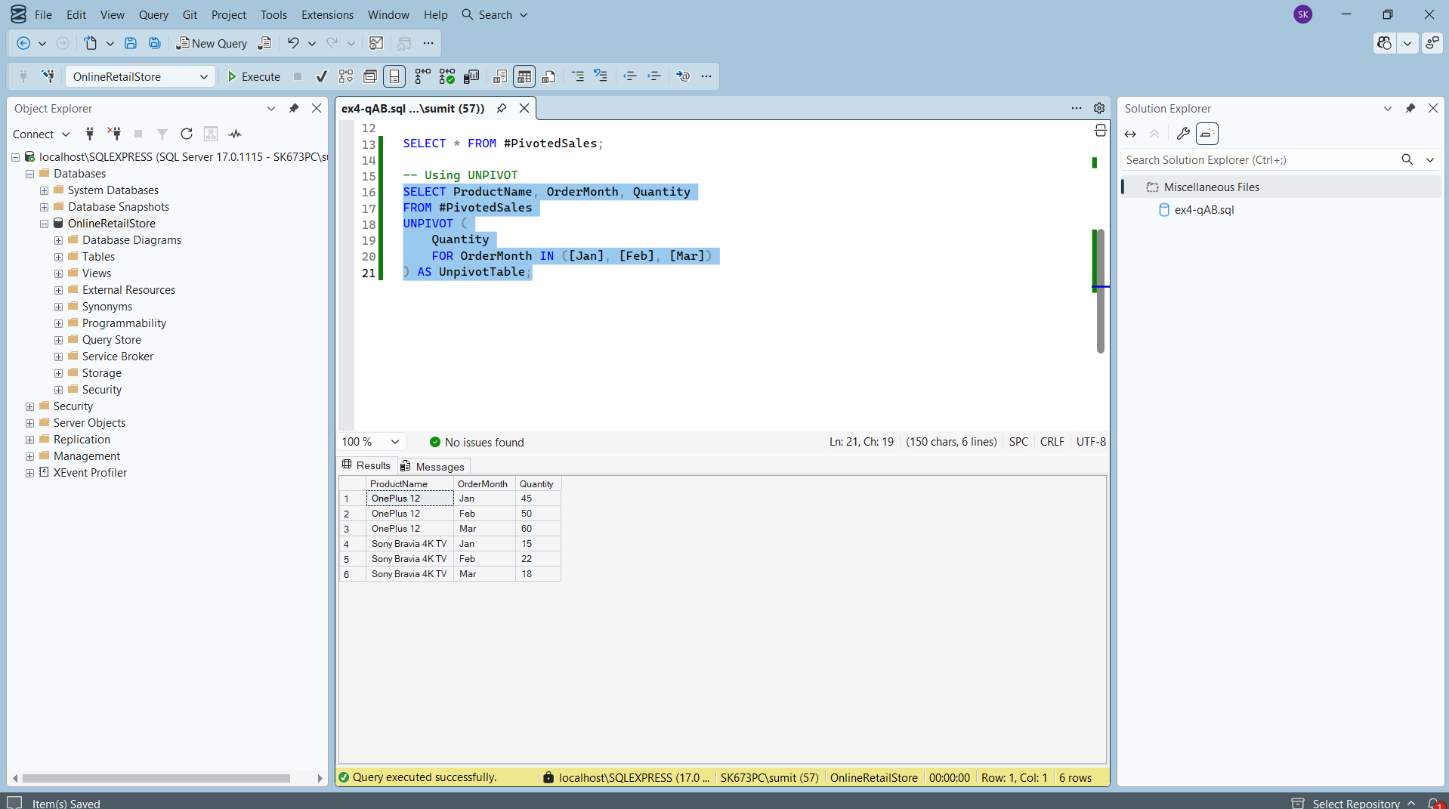

Exercise 5: Using CTE to Simplify a Query
Altering the DB:
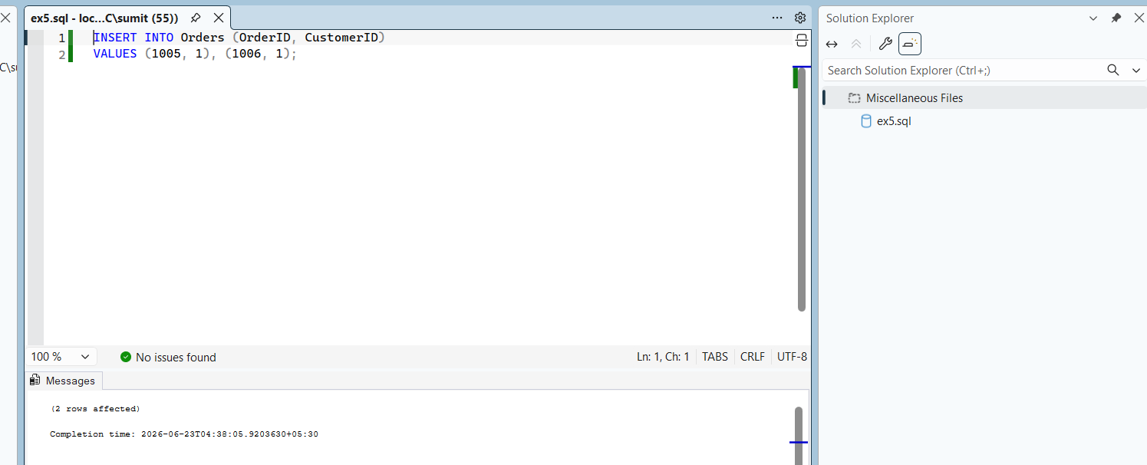
Query: CTE
