Exercise 1: Inventory Management System
- Understanding the Problem
Data structures and Algorithms are absolutely essential in handling large inventories because of the sheer number of transactions in such a warehouse system (restocks, dispatches, price changes etc.) every single day. If the system is built on inefficient data structure, after a sometime, even a small transaction like searching for an item and updating its cost or stock; may make the system hit its bottleneck, causing severe performance drops.

In an Inventory System, Items are constantly being looked up using its unique identifier (like Barcode or product ID). Since this system would constantly need data retrievals, Hash Table would be very suitable in this case as it allows for near-instantaneous data retrieval. In C#, Dictionary <TKey, TValue> class exists for this purpose.

- Output Screenshot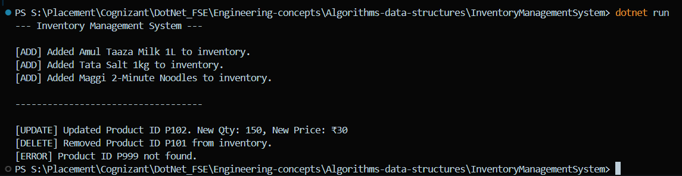

- Implementation
Check the InventoryManagementSystem Folder for the implementation code.

- Analysis
- Time Complexity: Since we used Dictionary which utilizes Hash Table; the average case of add, update, and delete is strictly O(1). The system computes a mathematical hash of the ProductId and jumps directly to that memory location. In worst case scenario (severe hash collisions), the worst case would be O(N), though it’s quite rare in case of C#.

- To further Optimize these operations – pre-allocating the initial capacity of the Dictionary would prevent the constant resizing of the data structure and re-hashing of all the existing items in the inventory, Provided we have an idea of the approximate size of the warehouse.

Exercise 2: E-commerce Platform Search Function
- Understanding the Asymptotic Notation
The Big O Notation defines the upper bound of an algorithm’s time complexity, which means, it calculates the worst-case scenario for how long the algorithm would take to run as the dataset grows.

For Search operations:
  - Linear Search:
    - Best Case: O(1) If the item is the very first element.
    - Average Case: O(N) where it has to search through half the list.
    - Worst Case: O(N) if the item is at the very end or does not exist.
  - Binary Search:
    - Average/Worst Case: O(Log N) because the search area is halved during every step.

- Setup and Implementation
Check the EcommerceSearchOptimization folder for the code implementation.

- Output Screenshot:
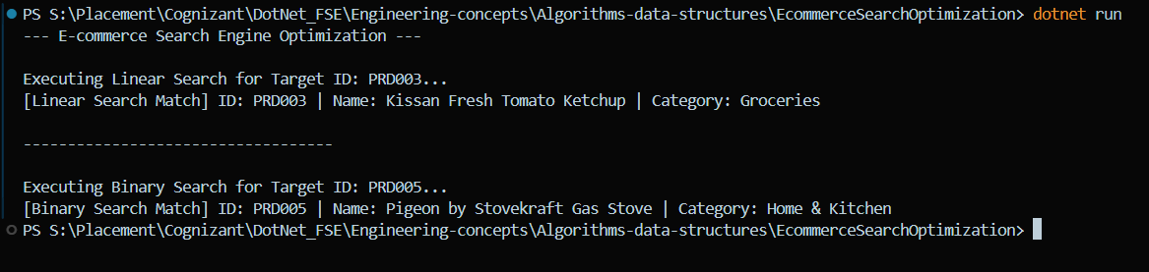

- Analysis
Linear Search checks every single item sequentially, resulting in an O(N) time complexity; on the other hand, Binary Seach is drastically more efficient at O(log N) because it repeatedly divides the dataset in half.
For an e-commerce platform processing millions of queries, Binary Search is required to maintain performance as compared to Linear Search. Though, it has one limitation, the dataset must be pre-sorted before the algorithm can be executed.

Exercise 3: Sorting Customer Orders
- Understanding the Sorting Algorithms
Sorting algorithms organize data into a specific sequence, which is essential for reporting and data retrieval.

- Bubble Sort: A simple, comparison-based algorithm that repeatedly steps through the list, compares adjacent elements, and swaps them id they are in the wrong order.
- Insertion Sort: Builds a sorted array one element at a time by picking the next item and inserting it into its correct relative position.
- Merge Sort: A “Divide and Conquer” algorithm, that splits the array in half, sorts the halves recursively, and merges them back together.
- Quick Sort: A highly efficient “Divide and Conquer” algorithm that selects a “pivot” element, partitions the array into smaller and larger subsets relative to the pivot, and sorts them recursively.
- Setup and Implementation
Check the OrderSortingSystem for the code Implementation.

- Output Screenshot
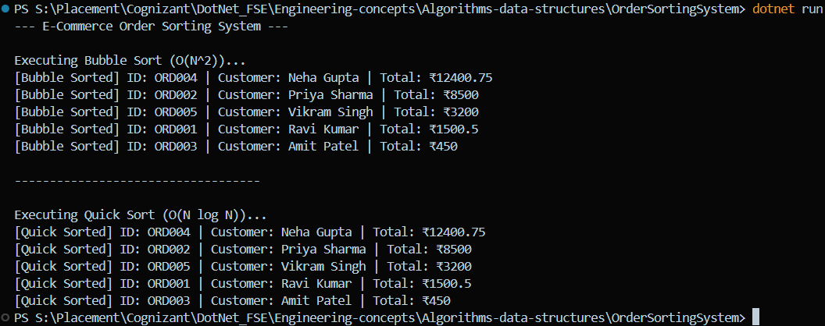

- Analysis
- Bubble Sort Complexity: O(N²) in the average and worst cases because of the nested loops required to verify every adjacent pair.
- Quick Sort Complexity: O(N log N) in the best and average cases. The worst-case is O(N²), but this is exceptionally rare with randomized or mid-point pivot selection.

Exercise 4: Employee Management System
- Understanding Array Representation
An array is a linear data structure that stores elements in contiguous memory locations.

- Memory Representation: Because elements are stored back-to-back, the computer can instantly calculate the exact memory address of any item if it knows the starting address and the index.
- Advantages: This contiguous nature provides instantaneous O(1) access time to any element if you know its exact index position. Arrays are incredibly fast for reading data and are highly memory-efficient since they do not require extra pointers.

- Setup and Implementation
Check EmployeeManagementSystem folder for the code Implementation.

- Output Screenshot
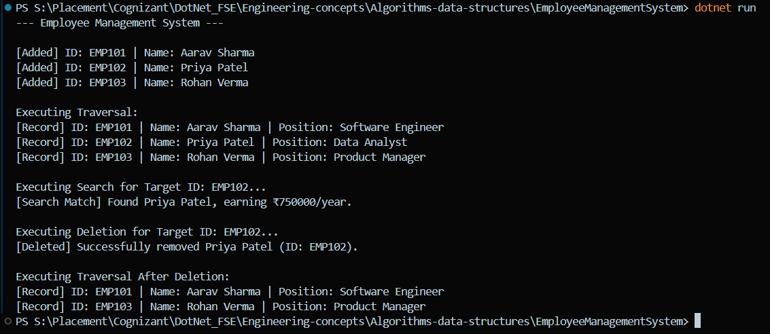

- Analysis
- Add Operation: O(1); we simply place the new employee at the end of the array using our _count index variable.
- Search Operation: O(N); Since the array is unsorted, we must check every single employee ID sequentially until we find a match.
- Traverse Operation: O(N); We must visit exactly N elements to print all N records.
- Delete Operation: O(N); Finding the record takes up to O(N) time. Once found, we must shift all subsequent elements to the left by one position to fill the gap, which also takes O(N) time.
- Limitations:
  - Arrays possess a fixed, rigid size that must be declared at initialization. If the data size exceeds the array’s capacity, the system crashes unless the developer writes another expensive code to create a brand new, larger array and manually copies all the existing records over.
  - Additionally, inserting or deleting records in the middle of an array is computationally heavy due to the constant need to shift all adjacent elements.
- Best use-case:
  - Arrays are best used for static datasets where the number of elements is known in advance and rarely changes.

Exercise 5: Task Management System
- Understanding Linked Lists
A linked list is a linear data structure where elements are not stored in contiguous memory locations. Instead, each element (called a node) points to the next one.

Singly Linked List: Each node contains two parts: the actual data, and a single reference to the very next node in the sequence. It can only be traversed in one direction (forward).
Doubly Linked List: Each node contains three parts: the data, a pointer to the next node, and a pointer to the previous node. This allows traversal in both directions (forward and backward) but requires more memory per node to store the extra pointer.

- Setup and Implementation
Check the TaskManagementSystem Folder for code implementation.

- Output Screenshot
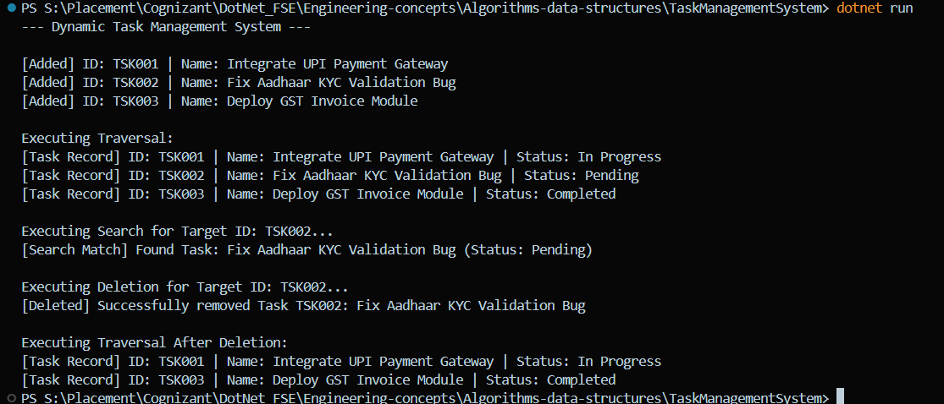

- Analysis
- Add Operation: O(N) time complexity in this implementation because we iterate to the very end of the list to attach the new task. This can be optimized to O(1) by keeping a secondary reference variable pointing exclusively to the ‘tail’ node.
- Search Operation: O(N) time complexity. In the worst-case scenario, the target is the last node, requiring us to traverse every single link.
- Traverse Operation: O(N) time complexity. Every node must be visited once.
- Delete Operation: O(N) time complexity. We must traverse the list to find the node right before the target in order to safely bypass and remove the target node.
- Advantages:
  - For a highly dynamic system like task management, linked lists drastically outperform arrays in flexibility. Arrays have a fixed capacity, whereas a linked list can grow and shrink dynamically at runtime without ever hitting a “full capacity” error.
  - Furthermore, deleting a task from the middle of a linked list Is highly efficient—it simply requires updating a single pointer to bypass the deleted node. If we deleted a task from the middle of an array , we would have to computationally shift every single subsequent task backward by one index.

Exercise 6: Library Management System
- Understanding Search Algorithms
When a user searches for a specific book title in a large catalog, the underlying algorithm determines how fast they get their result.
- Linear Search: This is the simplest approach. It starts at the first book in the catalog and checks every single book one by one until it finds the exact title. It requires no preliminary sorting.
- Binary Search: This is a much more advanced algorithm that requires the catalog to be strictly sorted alphabetically. It checks the middle book in the catalog; if the target title comes alphabetically before the middle book, it discards the entire second half of the catalog and repeats the process on the first half.

- Setup and Implementation
Check the LibraryManagementSystem folder for the code implementation.
- Output Screenshot
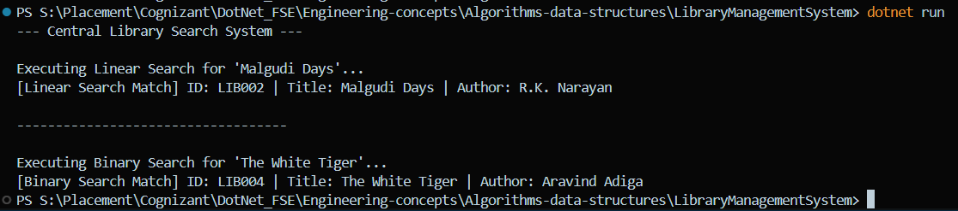

- Analysis
- Linear Search Time Complexity: O(N). In the worst-case scenario, the algorithm must scan every single book in the library.
- Binary Search Time Complexity: O(log N). By consistently halving the search area, the algorithm finds the target in a fraction of the time as compared to Linear Search.
- Linear Search should be used when the dataset is very small or when the dataset is completely unsorted, as the overhead of running a sorting algorithm just to perform a single search is mathematically heavier (O (N log N)) than simply running a linear search (O (N)).
- Binary search is strictly required for large datasets due to its lightning-fast O(log N) performance, but it must be used on data that is already sorted. If a new book is added, the library system must either re-sort the catalog or insert the book in its exact alphabetical place for Binary Search to continue functioning properly.
Exercise 7: Financial Forecasting
- Understanding Recursive Algorithms
Recursion is a programming technique where a method calls itself to solve a smaller instance of the same problem.
- The Base Case: Every recursive function must have a termination condition that stops the recursion from continuing infinitely, that is the Base Case.
- The Recursive Case: The part of the function that performs a piece of the work and then calls itself with modified parameters to handle the remaining work.
- Why use it: Recursion simplifies complex problems—like mathematical sequences, tree traversals, or compounding financial calculations—by breaking them down into self-similar sub-problems, resulting in highly elegant and readable code.

- Setup and Implementation
Check the FinancialForecastTool folder for the code implementation.
- Output Screenshot
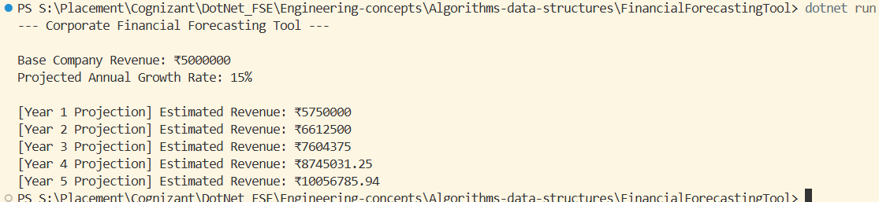

- Analysis
- Time Complexity: The time complexity of this specific recursive algorithm is O(N), where N is the number of years. For a 5-e number of years. For a 5-year projection, the function calls itself exactly 5 times.
- Optimization to Avoid Excessive Computation: While it is very helpful, pure recursion can be quite dangerous for deep calculations. If we tried to forecast 50,000 years into the future, the O(N) space complexity would cause a StackOverflowException, crashing the program because the computer runs out of call stack memory.
So, to optimize this, we can do the following things:
  - Memoization (Caching): If the financial formula involved overlapping calculations (like predicting stock volatility paths), we would store previously calculated years in a dictionary or array so we never compute the exact same state twice.

  - Mathematical Closed-Form: For simple compounding interest, we can completely eliminate the recursion and use a direct mathematical formula: Value = Principal * Math.Pow(1 + Rate, Years). This immediately reduces both Time and Space complexity to an incredibly optimized O (1).

