Exercise 1: Implementing the Singleton Pattern
Output screenshot:
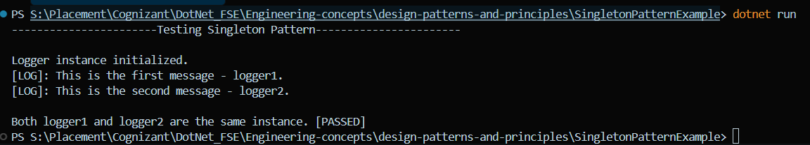
Exercise 2: Implementing the Factory Method Pattern
Output Screenshot:
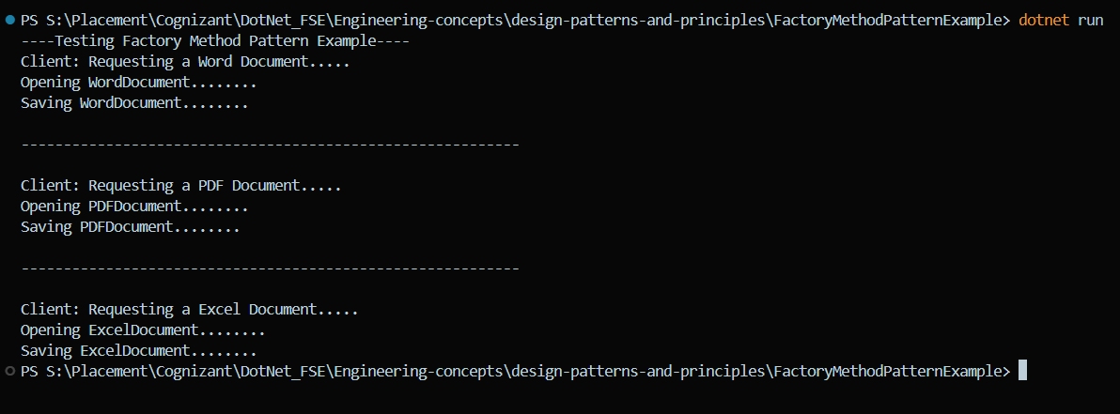
Exercise 3: Implementing the Builder Pattern
Output Screenshot:
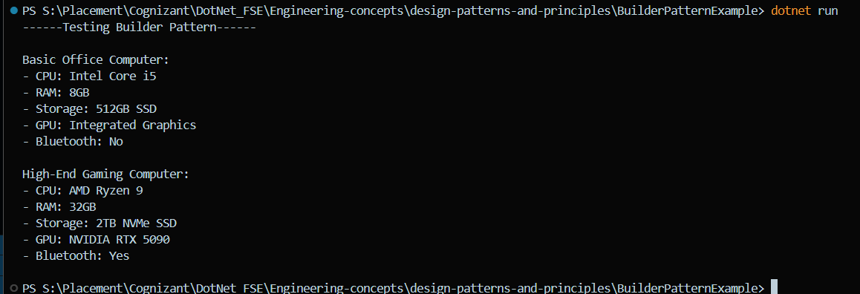
Exercise 4: Implementing the Adapter Pattern
Output Screenshot:
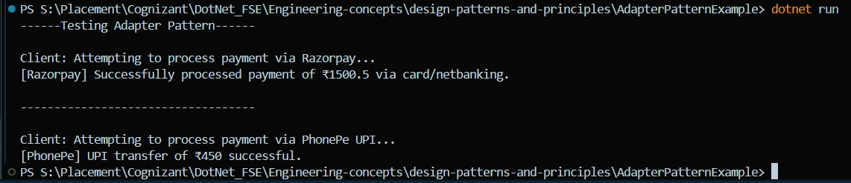
Exercise 5: Implementing the Decorator Pattern
Output Screenshot:
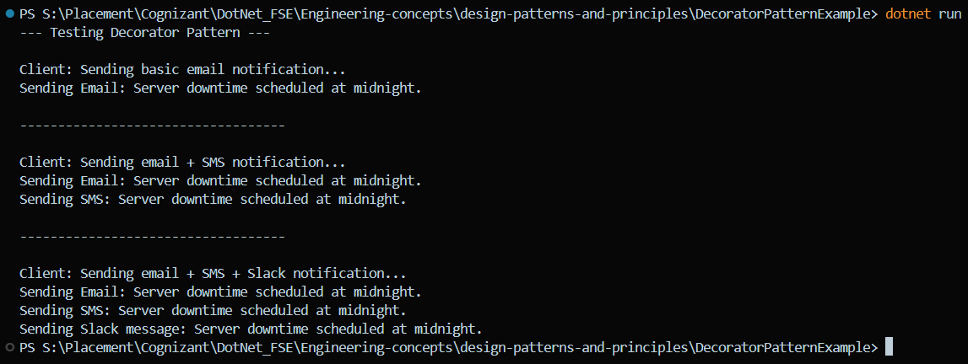
Exercise 6: Implementing the Proxy Pattern
Output Screenshot:
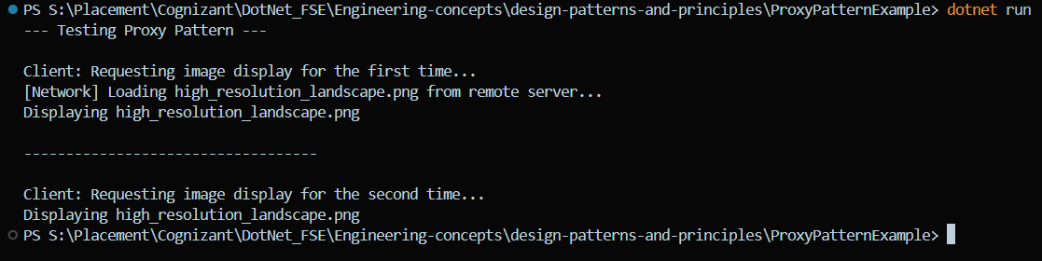
Exercise 7: Implementing the Observer Pattern
Output Screenshot:
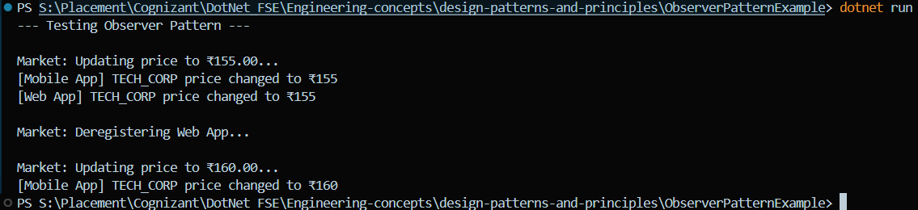
Exercise 8: Implementing the Strategy Pattern
Output Screenshot:
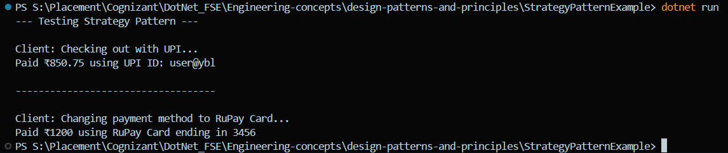
Exercise 9: Implementing the Command Pattern
Output Screenshot:
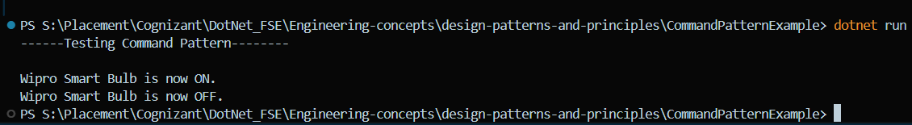
Exercise 10: Implementing the MVC Pattern
Output Screenshot:
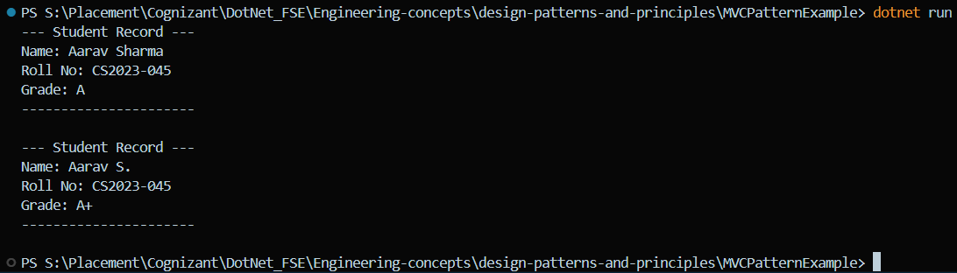
Exercise 11: Implementing Dependency Injection
Output Screenshot:
