Employee Management System (Cursors)
DB Setup:
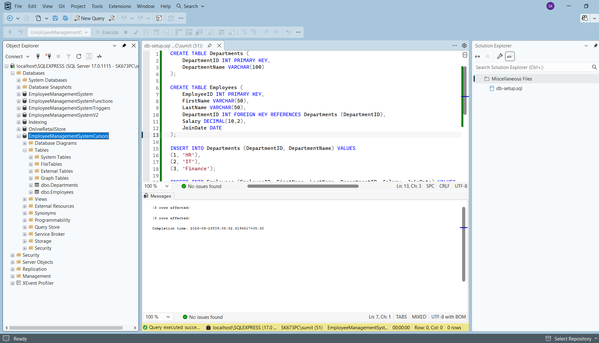
Exercise 1: Create a Cursor
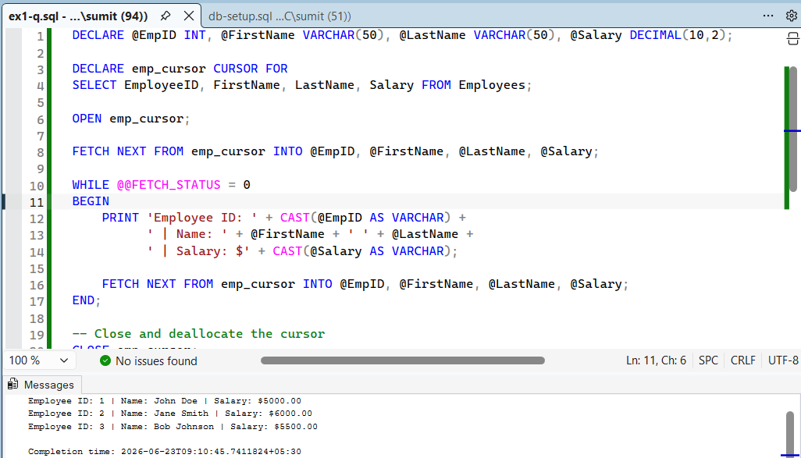

Exercise 2: Types of Cursors
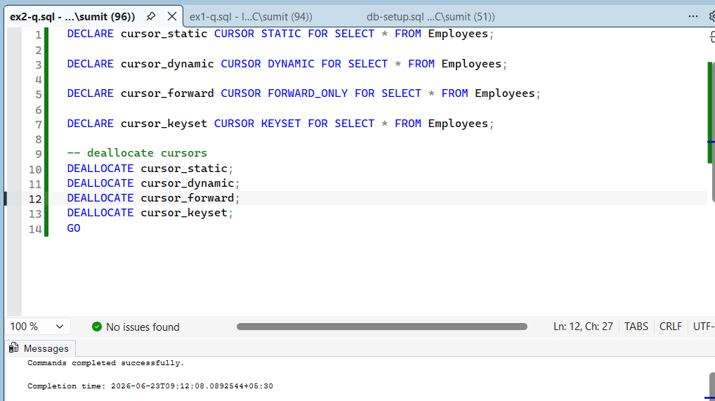
Static Cursors: Creates a temporary, hidden copy of the data in the tempdb. IT is completely blind to any changes made by other users after the cursor is opened. It allows scrolling in any direction (First, Last, Prior, Next).
Dynamic Cursors: The exact opposite of Static cursors. As it scrolls, it dynamically reflrexts all INSERT, UPDATE, and DELETE changes made by other users in real-time. It allows scrolling in any direction.
Forward-Only Cursors: The fastest and most efficient type. It does not create a temporary table, but it can only scroll forward one row at a time using FETCH NEXT. You cannot go backward.
Keyset-Driven Cursors: A hybrid approach. It copies only the keys (like EmployeeID) into a temporary table when opened. If another user updates an employee’s salary, the cursor sees it. If another user deletes an employee, the cursor throws an error because the key is orphaned. If another user insets a new employee, the cursor does not see it because the key wasn’t grabbed when the cursor first opened.

