WebApi Hands-On – 4
- Theory & Concepts
CRUD Operations in Web API
CRUD stands for Create, Read, Update, and Delete. These operations map directly map directly to HTTP action verbs in a RESTful API:
- POST (Create): Accepts data from the client and adds a new record to the data source.
- GET (Read): Retrieves data form the server without modifying it.
- PUT (Update): Accepts an identifier and a data payload to modify an existing record.
- DELETE (Delete): Accepts an identifier to completely remove ta record from the data source.
Data Binding: [FromBody]
The [FromBody] attribute forces the ASP.NET Core framework to read the incoming data payload from the HTTP request body instead of the URL parameters. This is strictly required for POST and PUT methods when receiving complex structured data, like our Employee JSON object, ensuring it deserializes correctly into our C# class.
- Implementation
The following steps were taken to implement full CRYD operations and input validation using a static mock database.
Step 1: Project Setup & Static Data
A new Web API project was initialized. To ensure data persistence across multiple HTTP requests during testing, the _employees data source within the EmployeeController was instantiated as a static List<Employee>.
Step 2: Implementing PUT with Validation
The [HttpPut(“{id}”)] action method was created to handle update operations.
- Validation 1 (Invalid ID Format): The method first checks I the provided id is less than or equal to 0, it returns a 400 BadRequest with the message “Invalid employee id”.
- Validation 2 (Record Not, Found): LINQ’s FirstOrDefault is used to search the static list for the provided ID. If the employee does not exist, it returns a 400 BadRequest with the same “Invalid employee id“ message.
- Data Update: If validation passes, the existing employee record is updated using the properties extracted from the [FromBody] Employee updatedEmployee parameter.
- The updated object is then returned to the client inside an Ok() ActionResult.
Step 3: Completing CRUD
To fully satisfy the CRUD requirements, an [HttpPost] method was added to accept new employee objects and dynamically assign them, an ID, and an [HttpDelete(“{id}”)] method was implemented to remove records from the static list based on their ID.
- Implementation Screenshots
- Controller Code:
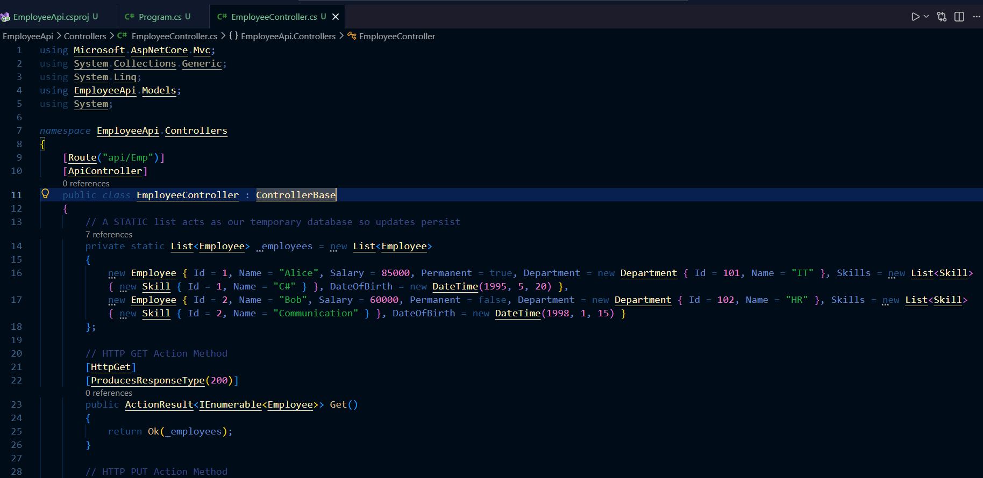
- Swagger Documentastion
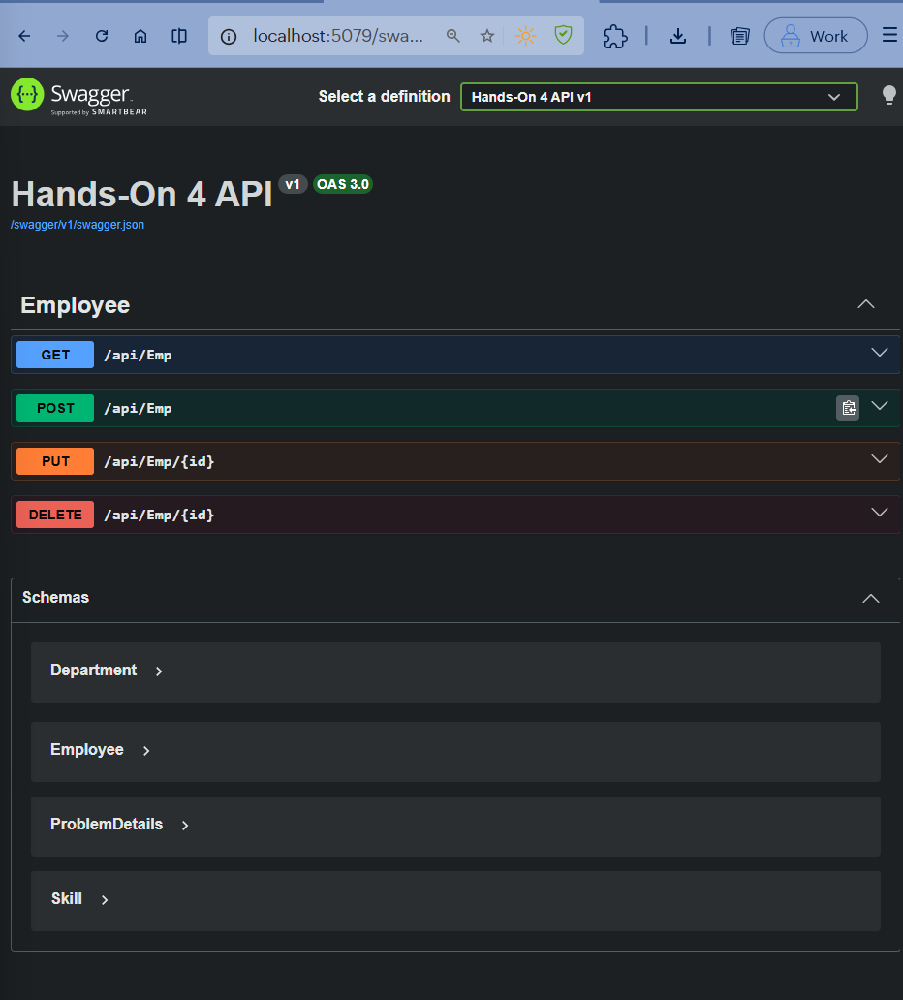
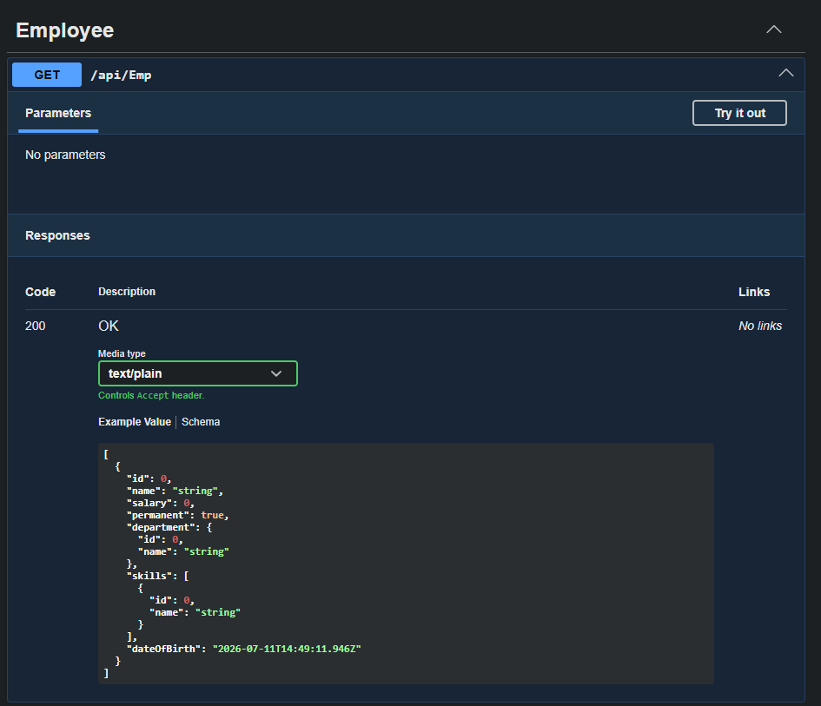
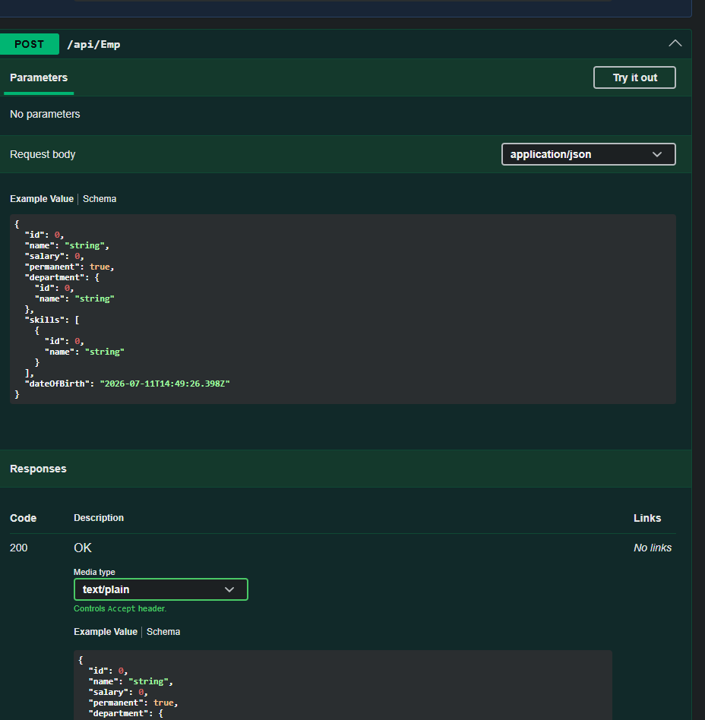
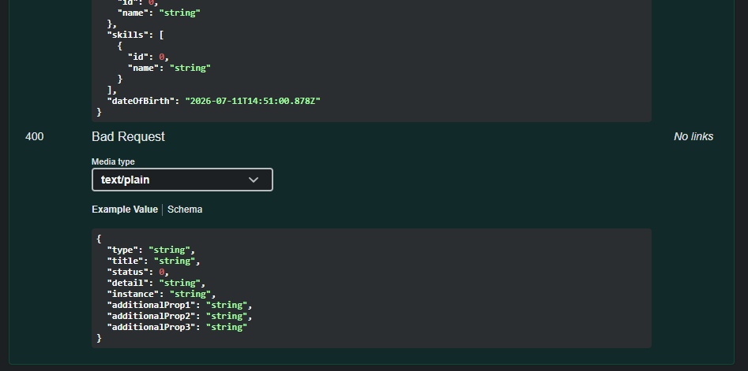
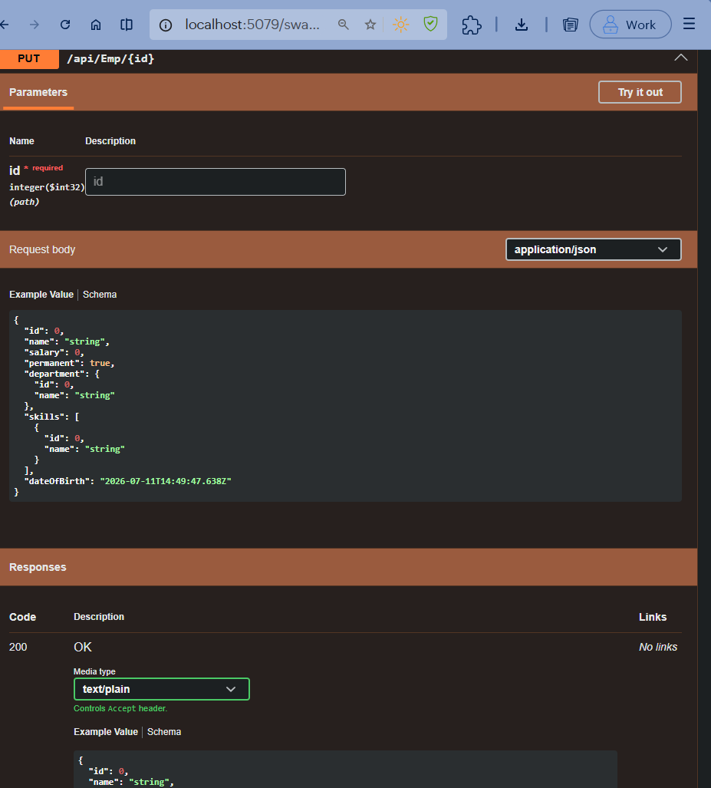
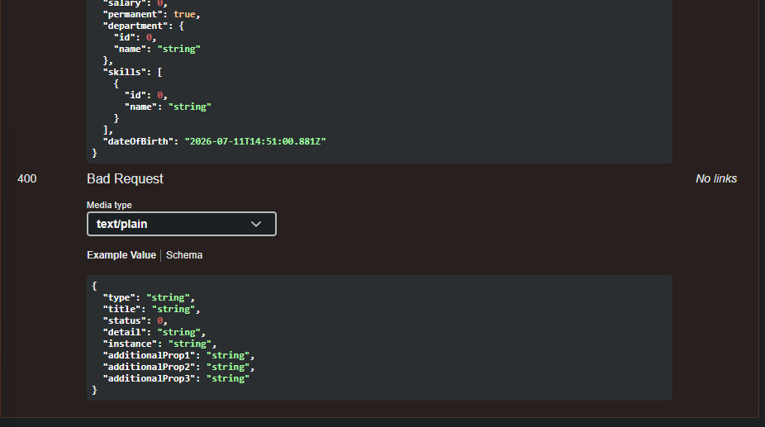
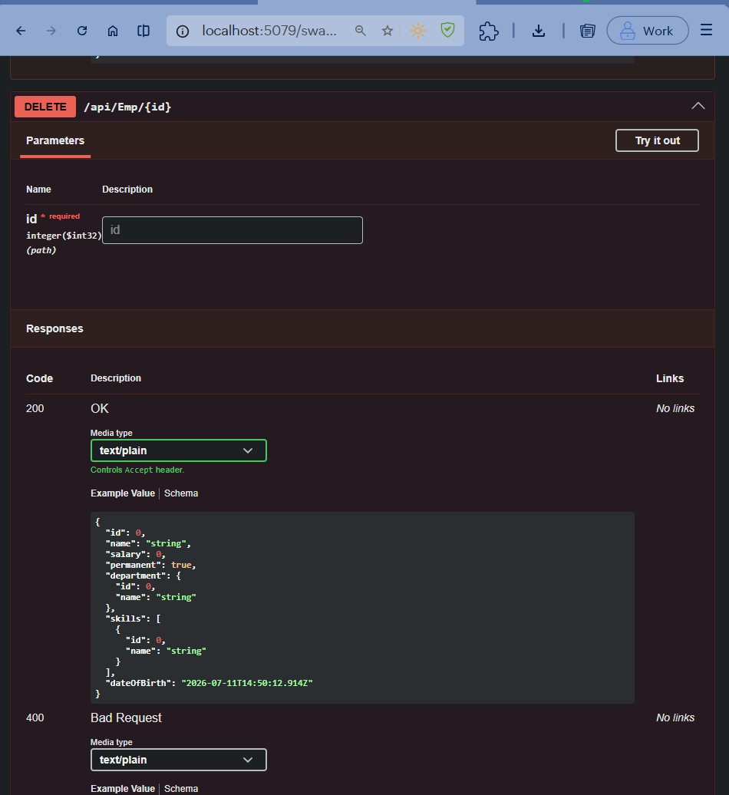
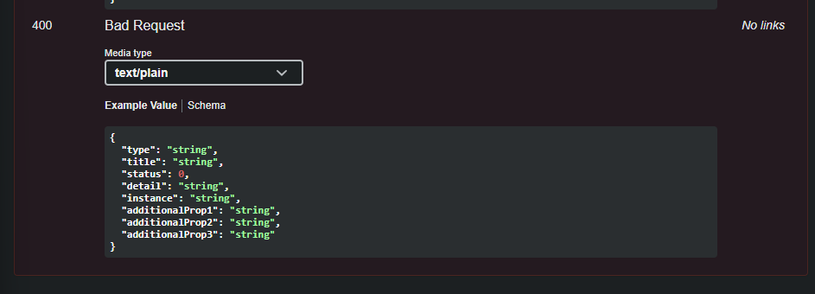
- API Output Screenshots
- PUT Validation Failure (-1):
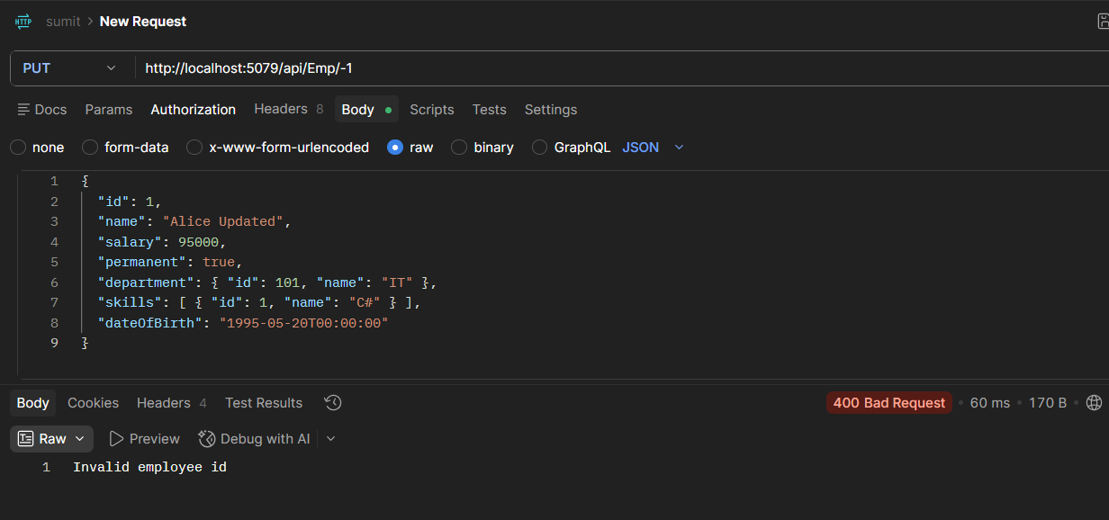
- PUT Validation Failure (99):
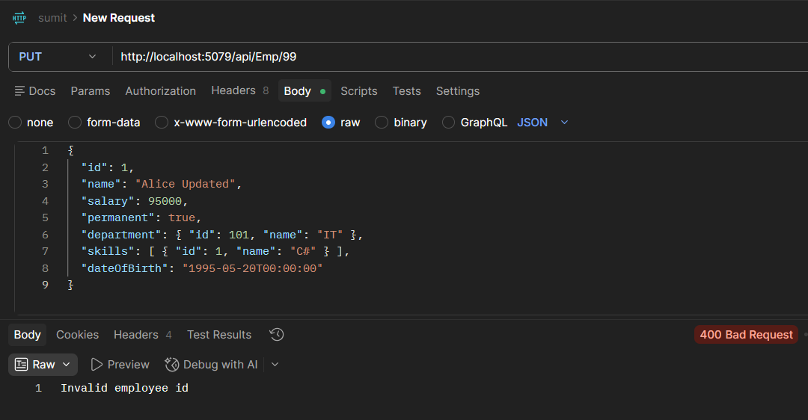
- PUT Success Update:
