Moq Hands-on
Part – A: Core Concepts & Terminology
Before diving into the implementation, it is important to understand the architectural patterns used in these exercises to chieve testable code.
- Test-Driven Development (TDD) & Advantages: TDD is a software development process where tests are written before the actual code. The key advantages include speedier test execution, looser coupling of code, and ensuring the code is designed to be testable from the ground up.
- Dependency Injection (DI): DI is a design pattern used to implement Inversion of Control, allowing the creation of dependent objects outside of a class and passing them in. This is crucial for unit testing.
  - Constructor Injection: Passing dependencies through a class constructor (used in Exercise 1).
  - Method Injection: Passing dependencies as parameters to a specific method.
- Isolation in Unit Testing: True unit tests must isolate the specific block of code being tested from external dependencies (like databases file systems, or mal servers) to ensure tests are fast, reliable, and do not cause unintended side effects.
- Test Doubles (Mocks vs. Stubs vs. Fakes): To achieve isolation, we replace real dependencies with test doubles:
  - Fake: A working implementation that takes shortcuts, making it unsuitable for production (example: an in-memory database).
  - Stub: An object that holds predefined data and uses it to answer calls during tests, but doesn’t verify how it was called.
  - Mock: An object that registers calls they receive. In our tests, we use Moq to both return specific data and verify that specific methods (like SendMail) were actually executed.
Part – B: Exercises
- Write Testable Code with Moq
- Objective: Refactor a mail sender module to use mocked dependencies so the logic can be tested without sending actual emails.
- Files Created/Modified:
  - CustomerCommLib/IMailSender.cs (Created interface and implementation)
  - CustomerCommLib/CustomerComm.cs (Implemented Constructor Injection)
  - CustomerComm.Tests/CustomerCommTests.cs (The NUnit/Moq test class)
- Implementation: I extracted the SendMail logic into the IMailSender interface so It could be injected into CustomerComm. In the test project, I used Moq to simulate the email server, configuring it to accepts any string arguments and return true.
- Test Execution:
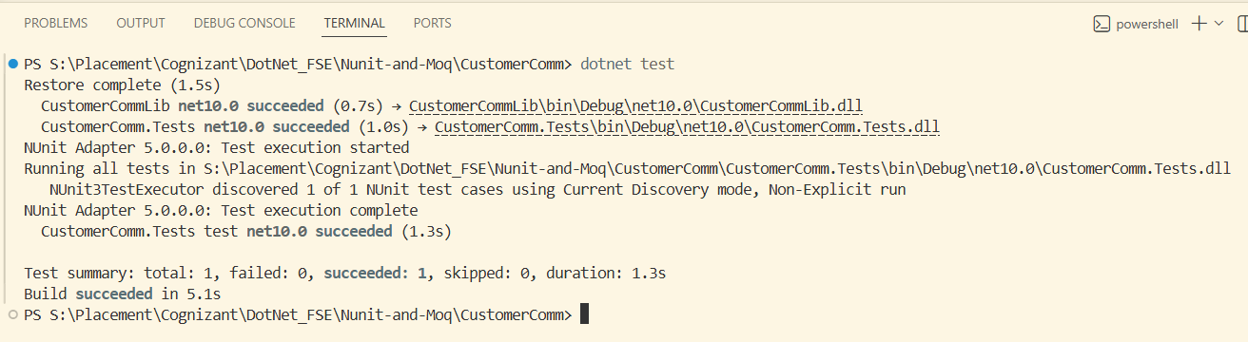

- Mock file object for Unit Tests
- Objective: Refactor static file system calls into mockable interface so the file retrieval logic can be tested without accessing the actual, physical file system.
- Files Created/Modified:
  - MagicFilesLib/DirectoryExplorer.cs (Created the IDirectoryExplorer nterface and implementation class)
  - DirectoryExplorer.tests/DirectoryExplorerTests.cs (The NUnit/Moq test class)
- Implementation: I removed the direct reliance on the static System.IO.Directory.GetFiles method by wrapping it in a custom IDirectoryExplorer interface. I the test project, I mocked this interface to return a hardcoded list containing two fake files (“file.txt” and “file2.txt”). The test assert that the returned collection is not null, has exactly a count of 2, and contains ”file.txt”.
- Test Execution:
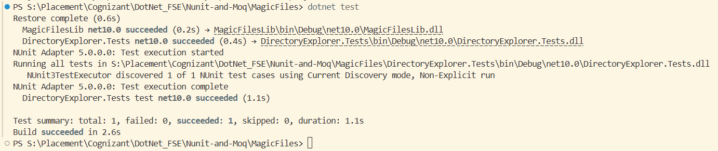
- Mock database for Unit Tests
- Objective: Create a mock object that accesses the database to allow for speedier test execution and loose coupling of code.
- Files Created/Modified:
  - PlayersManagerLib/PlayerMapper.cs (Database connection logic and interface)
  - PlayersManagerLib/Player.cs (Domain logic with Method Injection)
  - PlayerManager.Tests/PlayerTests.cs (NUnit tests using Moq)
- Implementation: I created an IPlayerMapper interface to decouple the SqlConnection logic from the Player class. In the tests, I injected a mocked IPlayerMapper.
  - Note on Exceptions: The assignment requested the use of the [ExpectedException] attribute. Because this attribute was deprecated and removed in modern NUnit versions, I implemented the current industry-standard equivalent: Assert.Throws<ArgumentException>().
  - I successfully tested both the failure state (mocking the DB to return true for an existing player) and the success state (mocking the DB to return false and asserting the returned player’s attributes).
- Test Execution:
