EF Core 8.0 Hands-On
Lab 1: Understanding ORM with a Retail Inventory System
- What is ORM?
Object-Oriented Mapping (ORM) is a technique that maps C# classes to database tables. It acts as a bridge, allowing developers to interact with a relational database using standard C# objects instead of writing manual SQL queries.
Benefits: The primary advantages of using an ORM include significantly increased developer productivity, improved code maintainability, and a clean abstraction from underlying SQL syntax.
- EF Core vs. EF Framework:
- EF Core: This is a modern, cross-platform, and lightweight framework. It supports advanced, modern features such as LINQ, async queries, and compiled queries.
- EF Framework (EF6): The legacy version is strictly Windows-only. While it is considered more mature due to its age, it is significantly less flexible than EF Core.
- EF Core 8.0 Features:
The EF Core 8.0 release includes several major enhancements:
- JSON Column Mapping: Allows developers to map C# objects directly to JSON columns in the database.
- Compiled Models: Delivers improved application startup performance and query execution.
- Advanced Operations: Introduces powerful database interceptors and better support for bulk operations.
Output:
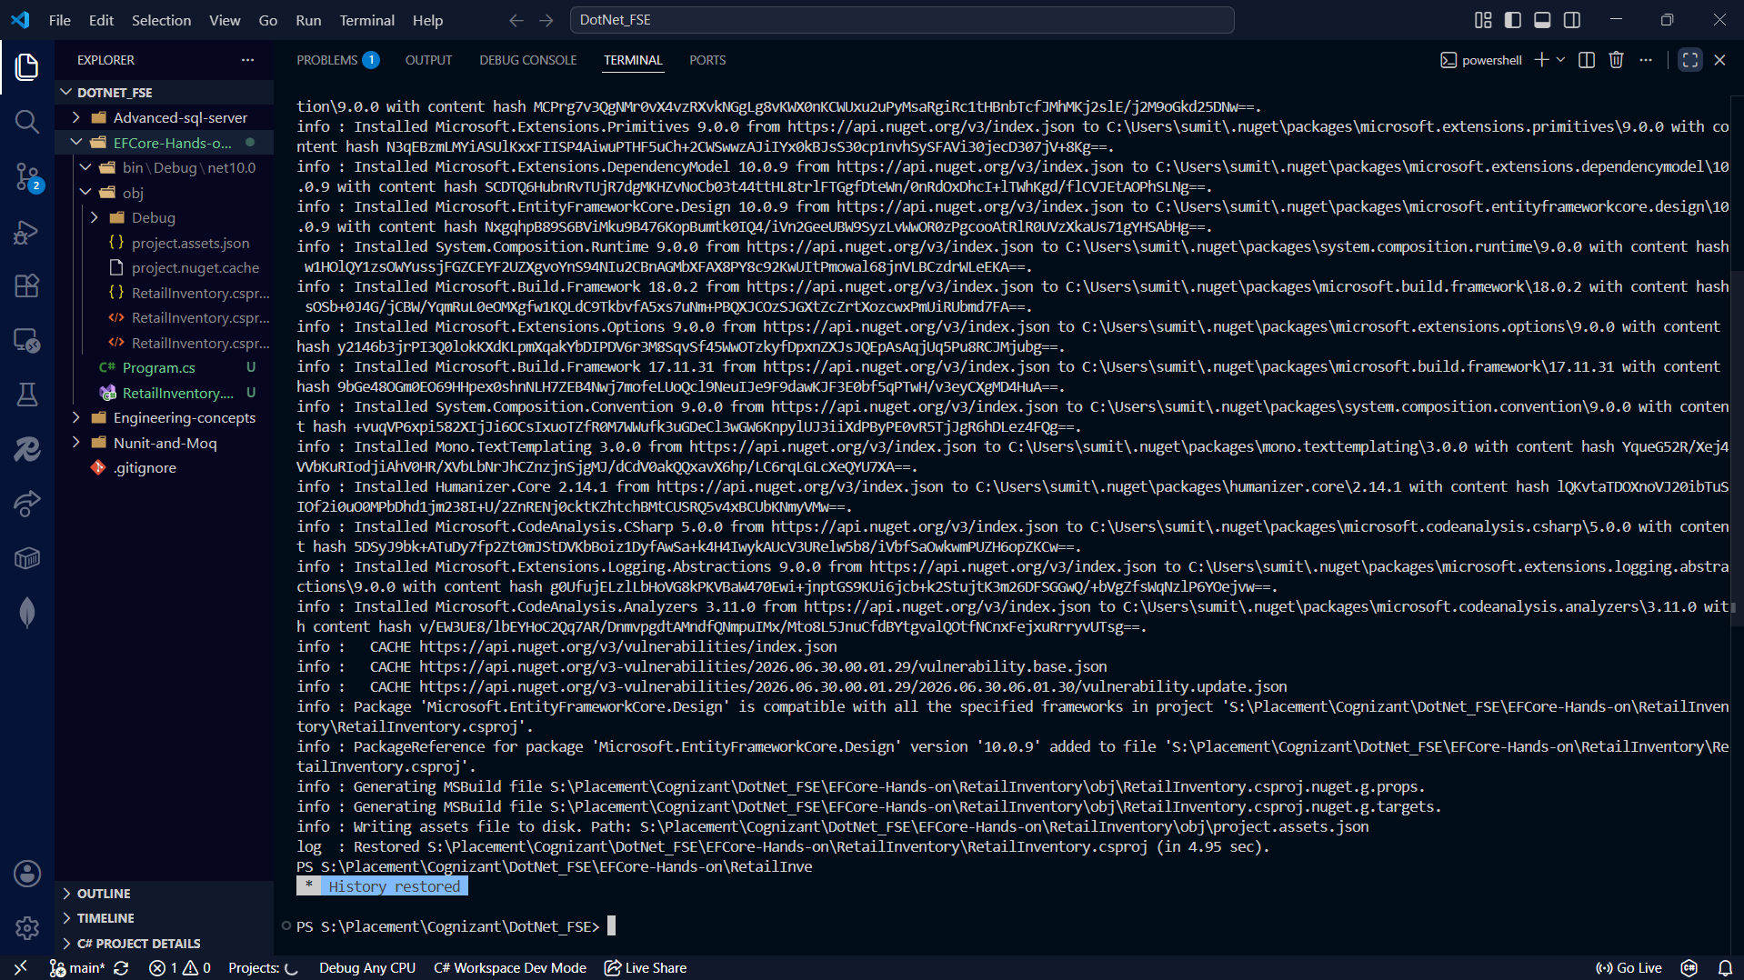
Lab 2: Setting Up the Database Context for a Retail Store
Output:
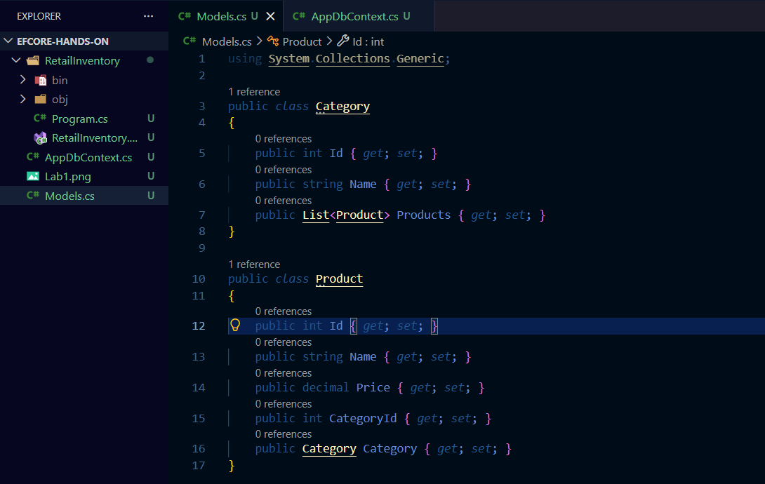
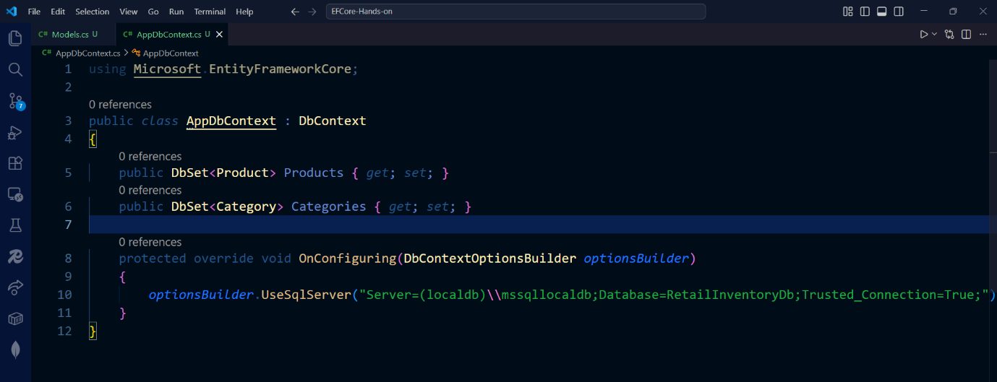
Lab 3: Using EF Core CLI to Create and Apply Migrations
Output:
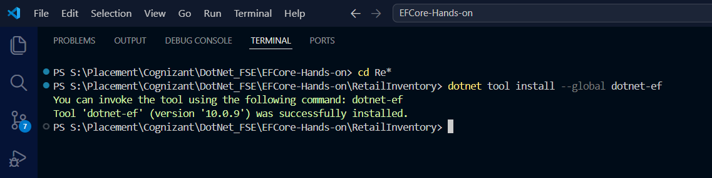
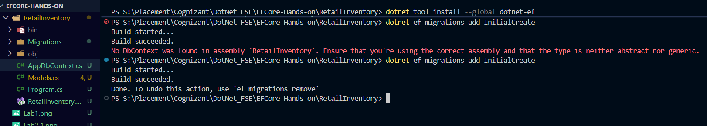
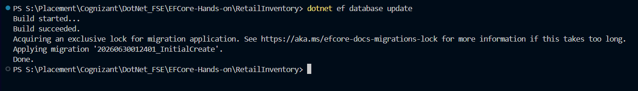
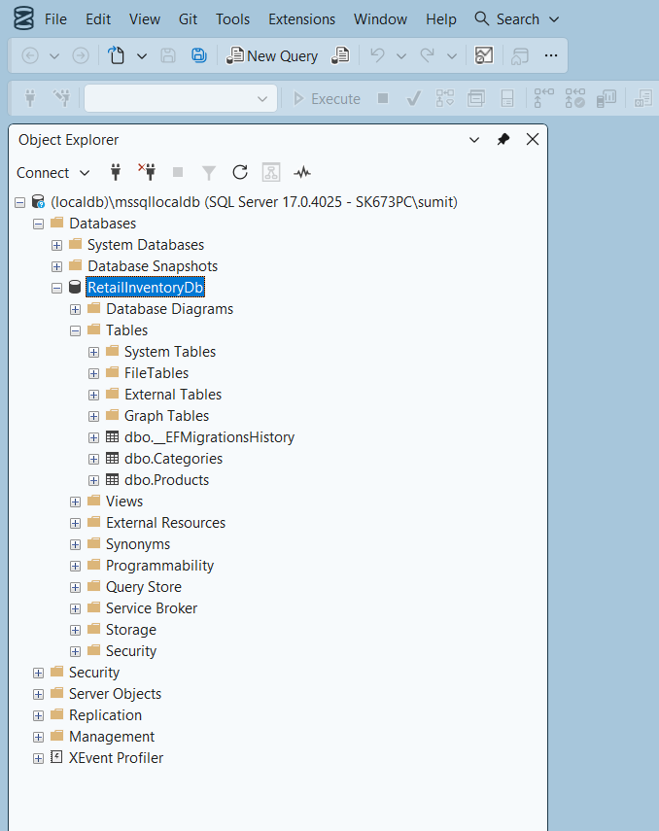
Lab 4: Inserting Initial Data into the Database
Output:
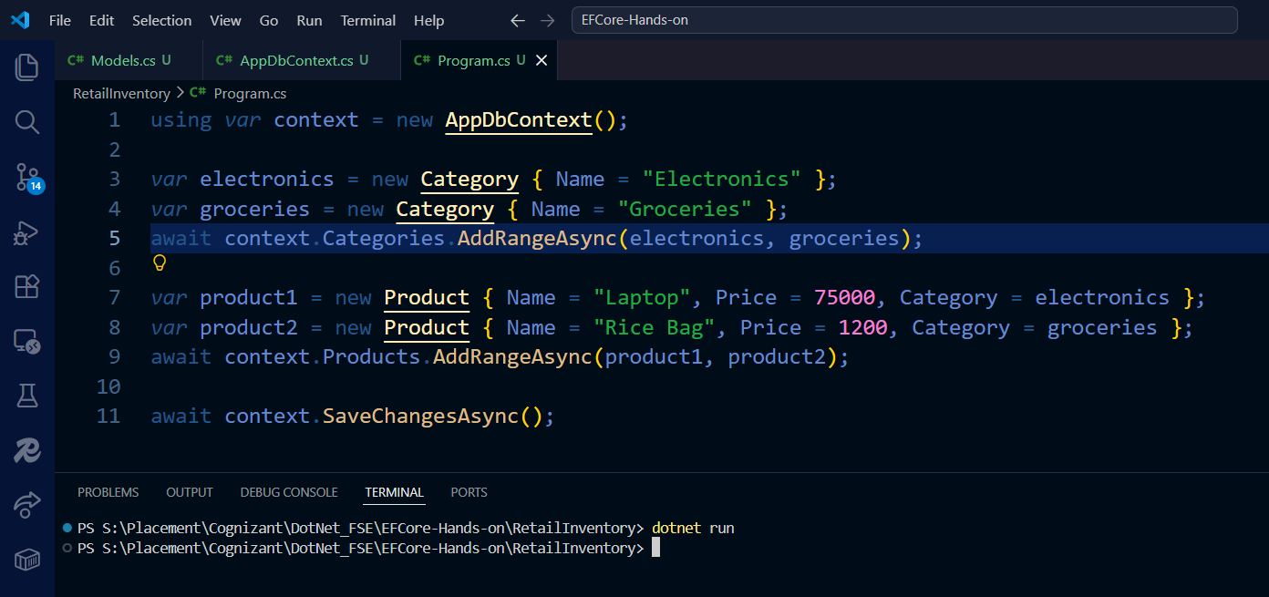
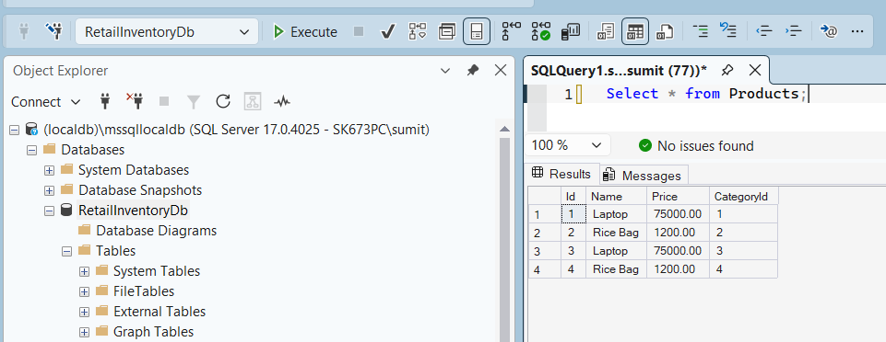
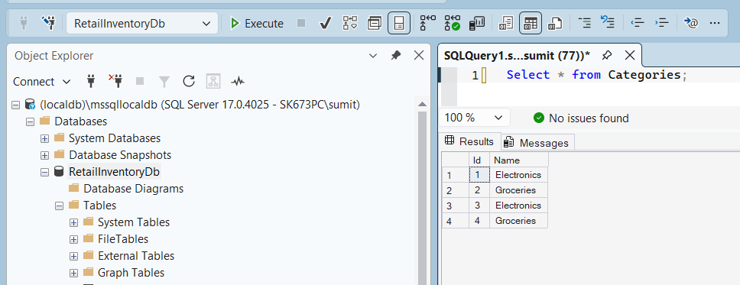
Lab 5: Retrieving Data from the Database
Output:
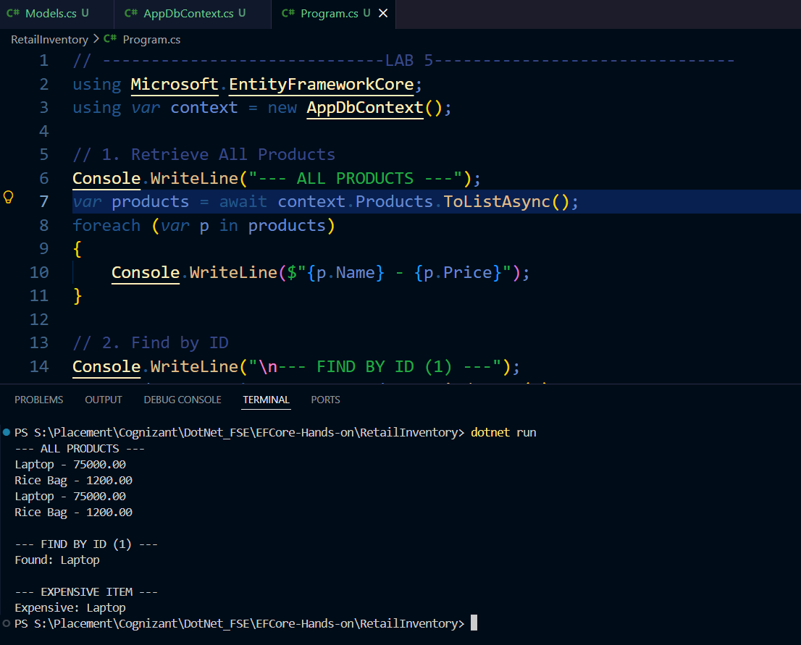
Lab 6: Updating and Deleting Records
Output:
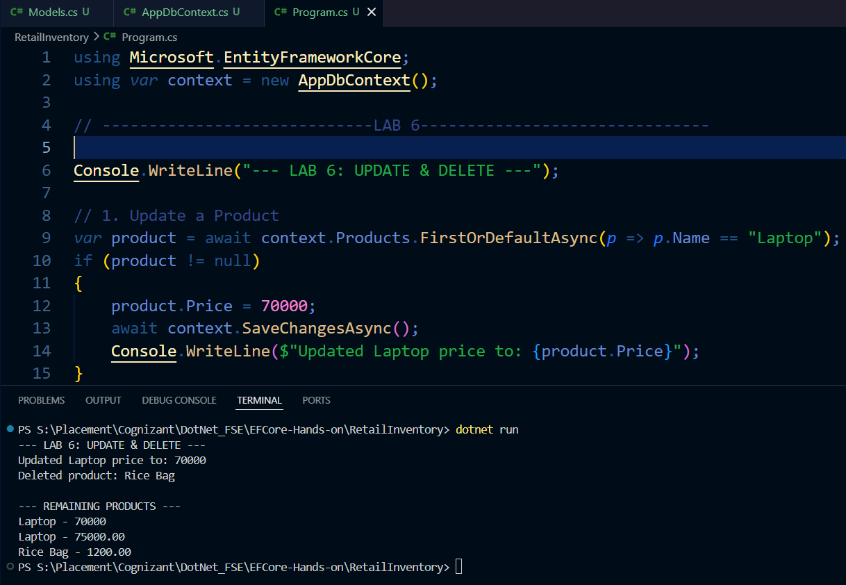
Lab 7: Writing Queries with LINQ
Output:
