WebApi Hands-On - 2
- Theory
Routing and Name Attribute
Routing defines how an incoming HTTP request is mapped to a specific action method in the controller. Web APIs heavily use Attribute Routing (e.g., [Route(“api/[controller]”)]), which allows developers to define exact, predictable URLs.
- Importance of User-Friendly Names: Creating a user-friendly route (like /api/Emp instead of /api/EmployeeDatabaseManager) makes the API intuitive, easier to document, and simper for client applications to consume without exposing internal backend structures.
- ActionName and RouteNames: If a controller has multiple methods using the same HTTP verb (e.g., two [HttpGet] methods), the framework will throw and ambiguous routing error. To solve this, developer use the [ActionName(“CustomerName”)] attribute or add a specific route template/Name attribute (e.g., [HttpGet(“details”, Name = “GetDetails”)]). This allows multiple identical verbs to exist peacefully by giving them unique route paths.
1. using Microsoft.AspNetCore.Mvc;
2. using System.Collections.Generic;
3. using EmployeeApi.Models;
4.
5. namespace EmployeeApi.Controllers
6. {
7. [Route("api/Emp")]
8. [ApiController]
9. public class EmployeeController : ControllerBase
10. {
11. // READ ACTION
12. [HttpGet]
13. public IEnumerable<Employee> Get()
14. {
15. return new List<Employee> { new Employee { Id = 1, Name = "Alice", Department = "IT" } };
16. }
17.
18. // READ ACTION (Second GET method using a distinct route/name)
19. [HttpGet("{id}", Name = "GetEmployeeById")]
20. public Employee Get(int id)
21. {
22. return new Employee { Id = id, Name = "Target Employee", Department = "IT" };
23. }
24.
25. // WRITE ACTION
26. [HttpPost]
27. public void Post([FromBody] Employee newEmployee)
28. {
29. // Logic to insert newEmployee into the database
30. }
31. }
32. }
33.

- Implementation:
The following steps were taken to build, document, and test the Employee Web API. Because the application utilizes .NET 10, the configuration traditionally found in Startup.cs was modernized and implemented entirely withing Program.cs.
- Step 1: Project & Model Setup
  - A new Web API project was created using the .NET CLI. An EmployeeController was established to handle incoming requests and serve the required employee data.
- Step 2: Swagger Configuration
  - The Swashbuckle.AspNetCore NuGet package was installed via the terminal.
  - Builder.Services.AddEndpointsApiExplorer() was added to allow Swagger to discover the controller routes.
  - Builder.Services.AddSwaggerGen() was implemented to define the OpenApiInfo mapping the Title to “Swagger Demo”, Version to “v1”, and supplying custom Contact and License details.
  - App.UseSwagger() and app.UseSwaggerUI() were added to map the JSON endpoint and serve the user interface.
- Step 3: Controller Logic & Custom Routing
To fulfil the routing requirements, the EmployeeController was modified.
  - The route attribute was changed from t he default [Route(“api/[controller]”)] to a custom name: [Route(“api/Emp”)].
  - An [HttpGet] action method was implemented to return a hardcoded-array of employee names as strings (“Alice”, “Bob”, “Charlie”).
- Implementation Screenshots:
- Project Structure:
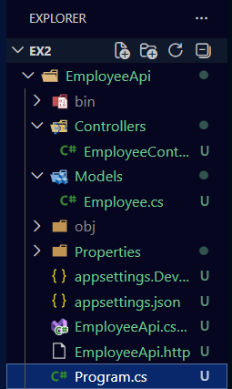

- Swagger Configuration:
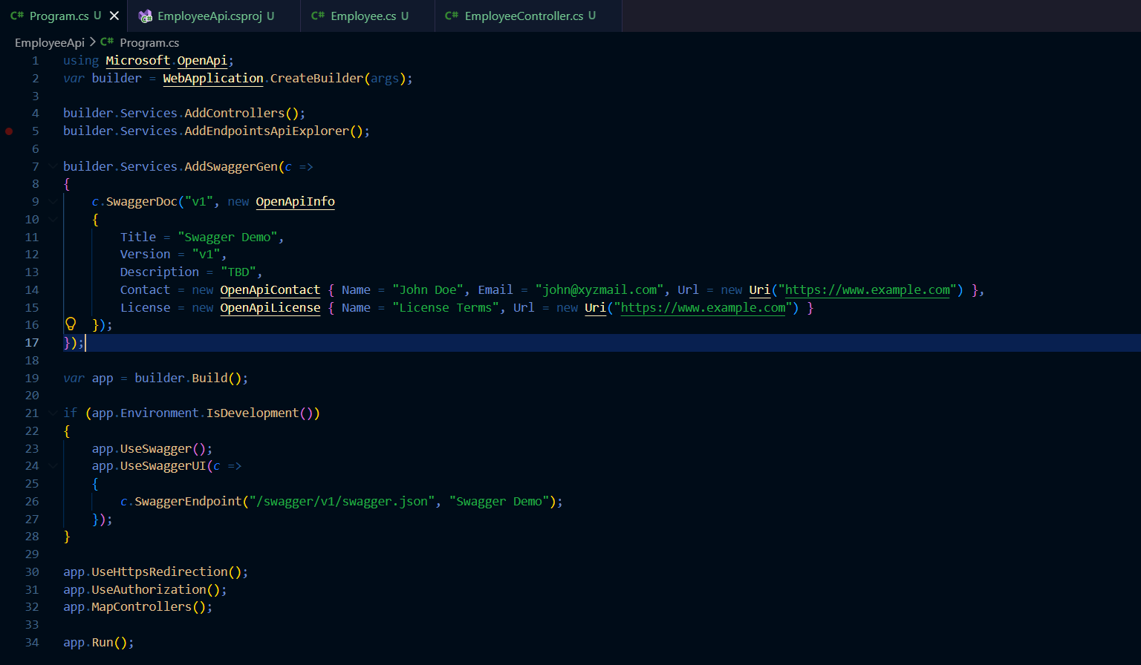
- Controller Code:
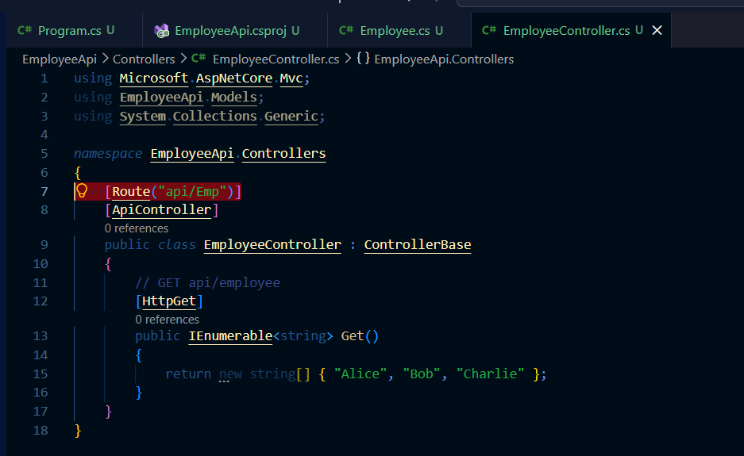

- Built and run Successfully:
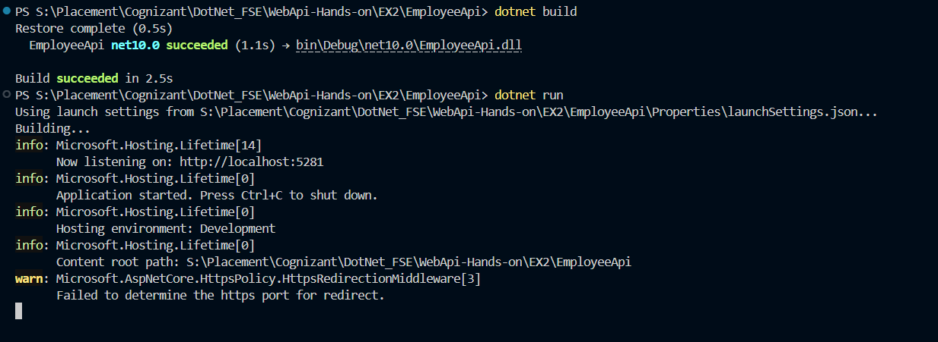

- Final Output Screenshots:
- Swagger UI (Browser):
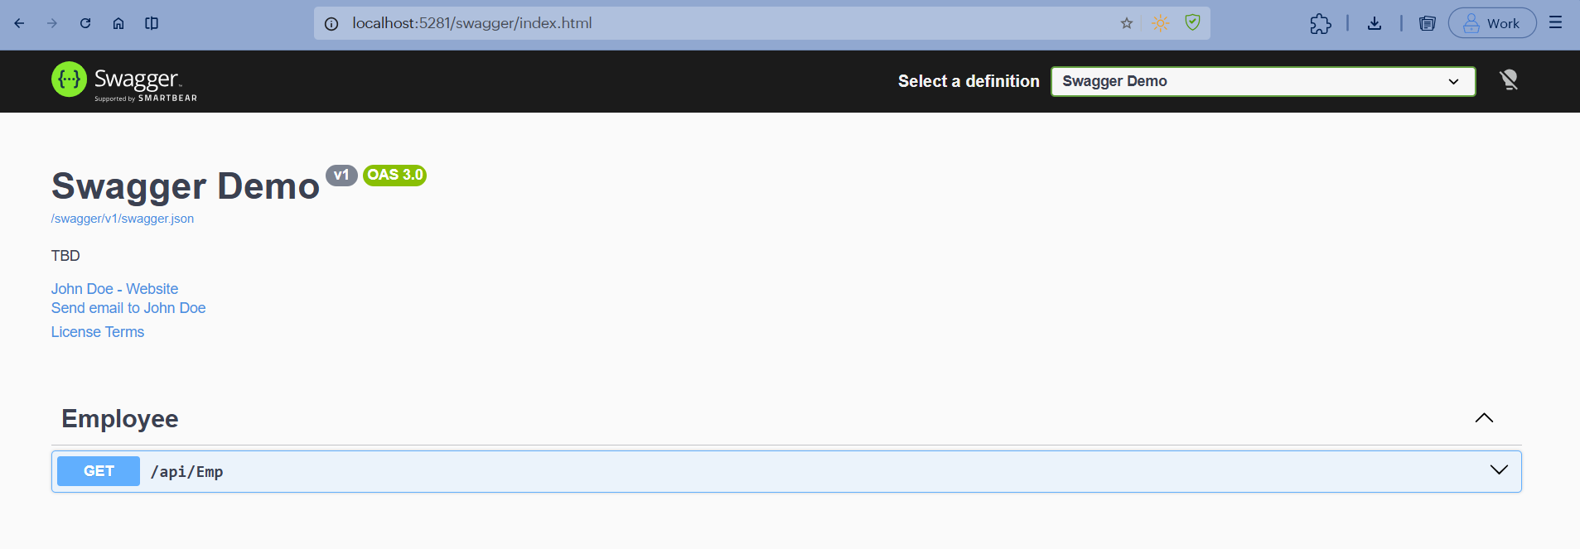

- Swagger Execution: 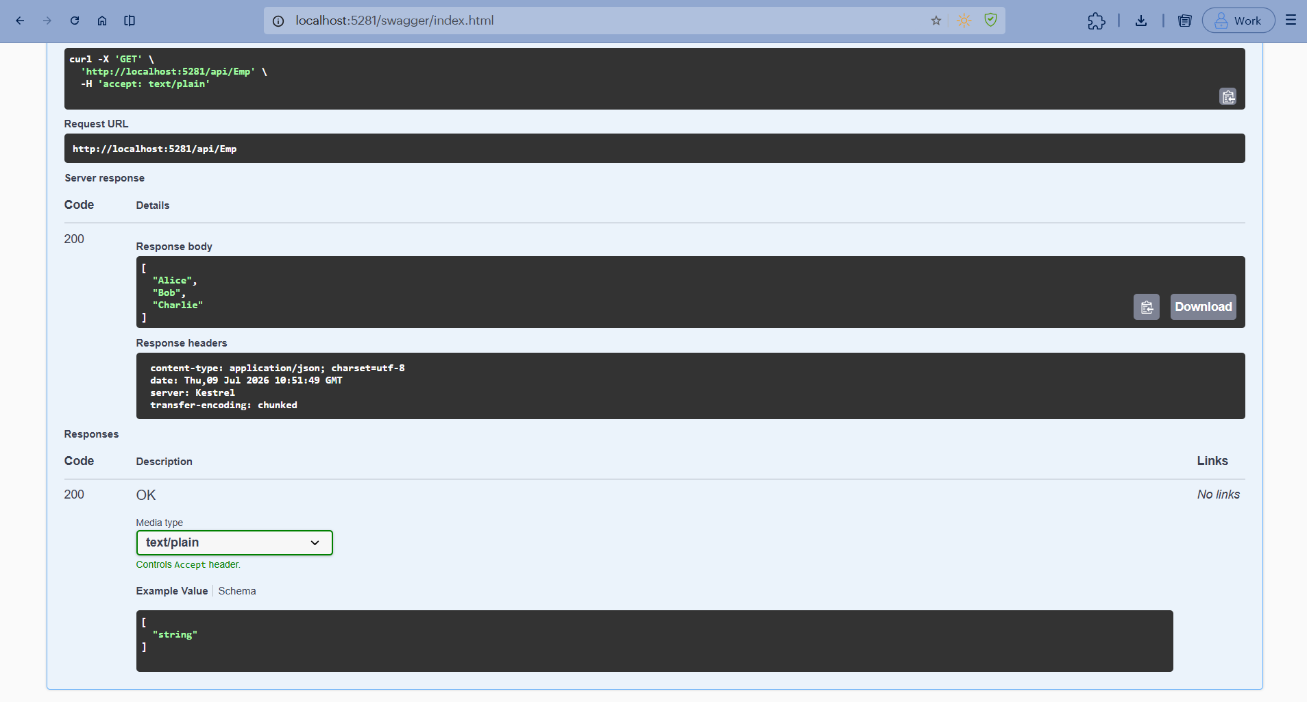
- Postman Testing:
