Web Api Hands-on – 3
- Theory & Concepts
- Data Binding: [FromBody]
  - In ASP.NET Core, data binding is the process of mapping incoming HTTP request data to action method parameters.
  - The [FromeBody] attribute explicitly tells the framework to read the data from the body of the HTTP request, rather than attempting to bind it from the URL query string or route parameters. This is essential for securely passing complex objects like an Employee during POST or PUT requests.
- Custom Filters
Filters in ASP.NET Core allow developers to run code before or after specific stages in the request processing pipeline.
  - Action Filters: By creating a class that inherits from ActionFilterAttribute and overriding the OnActionExecuting method, we can intercept an HTTP request right before it hits the controller. This is highly useful for custom validation or authorization checks.
  - Exception Filters: By implementing an exception filter (via IExceptionFilter or overriding onException), developers can catch unhandled exceptions globally across an API, format a standardized error response, and log the crash details. (NOTE: While legacy .NET Framework required the WebApiCompatShim package for certain filter behaviors, modern .NET 10 handles this natively without external dependencies).
  - AllowAnonymous: When an API is secured globally or at the controller level, the [AllowAnonymous] attribute can be applied to specific action methods to bypass the authorization filters, allowing public access to that specific endpoint.
- Implementation
The following steps were taken to build the custom models, create the standard list endpoint, and implement a custom authorization filter natively in .NET 10.
Step 1: Custom Model Creation:
A structured Employee model was created to simulate real-world entity relationships. To satisfy the requirements, supporting models for Department and Skill were also generated. The Employee class includes properties such as Id, Name, Salary, Permanent, Department, Skills (as a List), and DateOfBirth.
Step 2: Controller & Data Generation:
A new EmployeeController was established to handle write/read actions.
- A private method named GetStandardEmployeeList was created to generate and return a hardcoded list of the custom Employee objects.
- The [HttpGet] action method was modified to return an ActionResult<IEnumerable<Employee>> and was wired up to invoke the private list generator.
- The [ProducesResponseType(200)] attribute was added to the GET method to explicitly document the success status code for Swagger.

Step 3: Custom Authorization Filter
A Filters folder was created containing a new CustomAuthFilter class inheriting from ActionFilterAttribute. The OnActionExecuting method was overridden to intercept incoming requests and enforce the following security rules:
- If the Authorization header is completely missing, the API rejects the request the request with a 400 BadRequest and the message: “Invalid request – No Auth token”.
- If the header is present but lacks the ‘Bearer’ keyword, it rejects the request with: “Invalid request – Token present but Bearer unavailable”.
- The [CustomAuthFilter] attribute was then applied at the class level to the EmployeeController to secure all endpoints within it.
Step 4: Custom Exception Filter
A CustomExceptionFilter class was created in the Filters folder, implementing IExceptionFilter via the ExceptionFilterAttribute.
- The OnException method was overridden to capture unhandled application excpeetions.
- The exception message is extracted and written to a physical file (ErrorLog.txt) in the application directory using System.IO.
- The context Result is modified to return an ObjectResult containing a 500 Internal Server Error status code and the formatted exception message.
- The [CustomeExceptionFilter] attribute was applied to the EmpliyeeController. To test the filter, a manual eception was thrown inside the GET method, and [ProduceResponseType(500)] was added to document the error path in Swagger.

- Implementation Screenshots

- Project Structure:
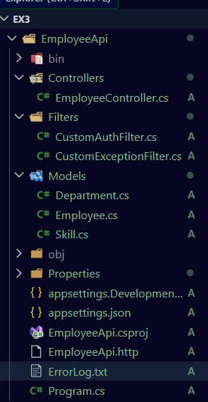
- Model Code:
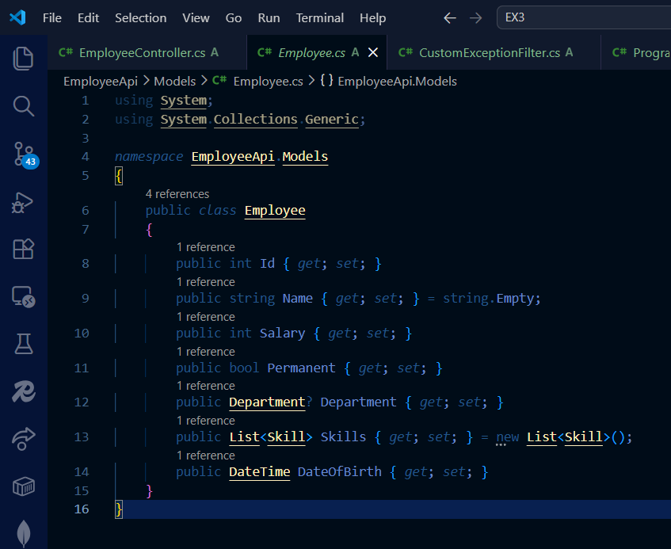

- Controller Code:

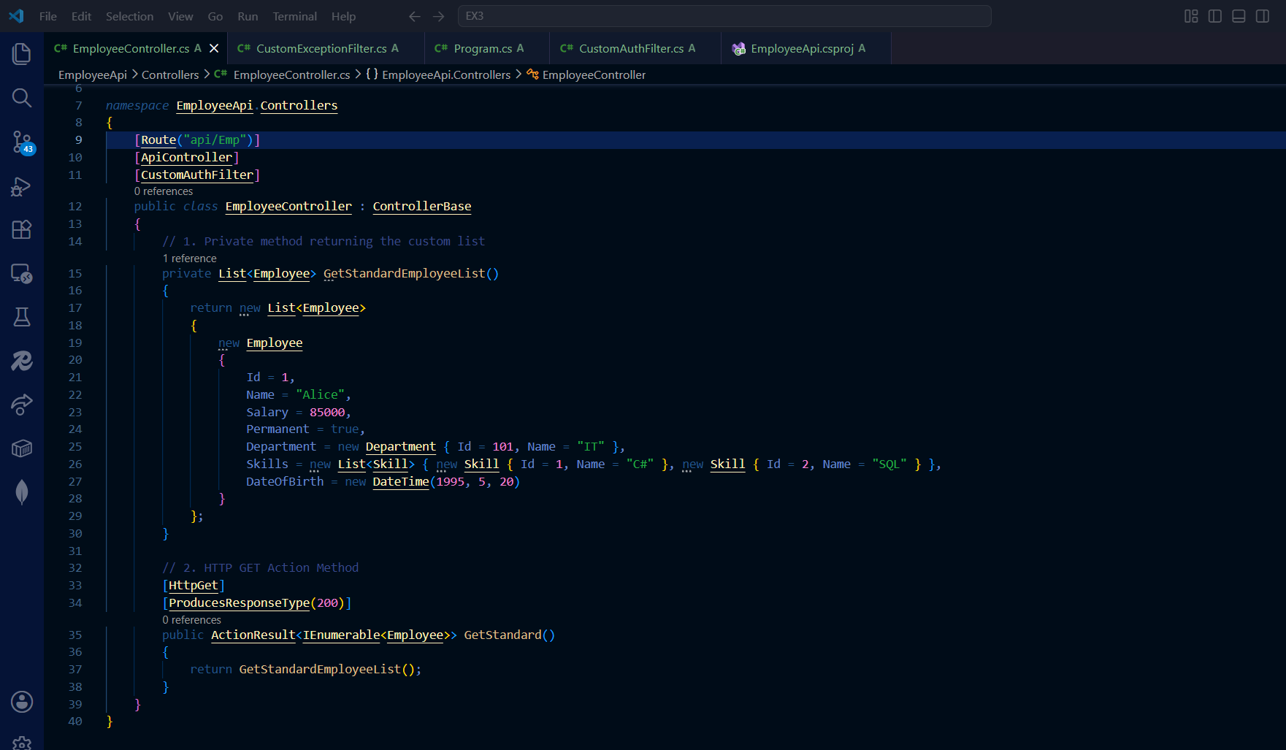

- Filter Code:
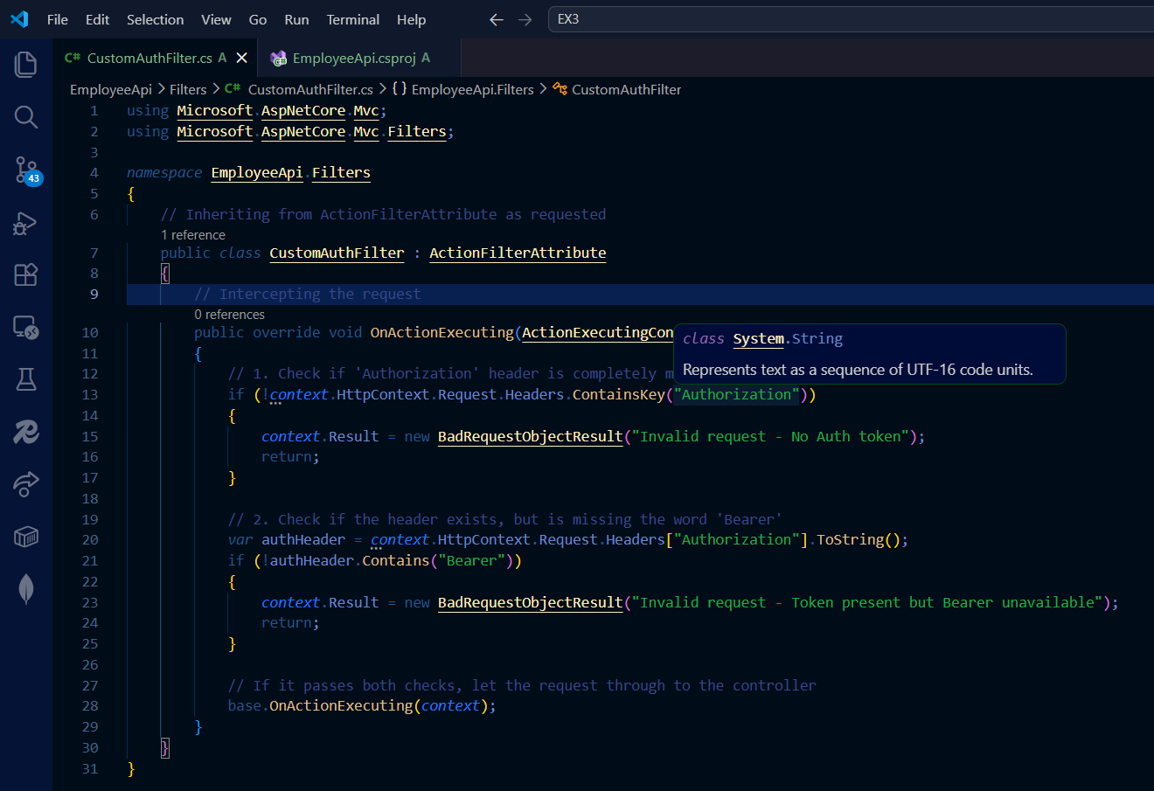

- API Output Screenshots
- Swagger Documentation:

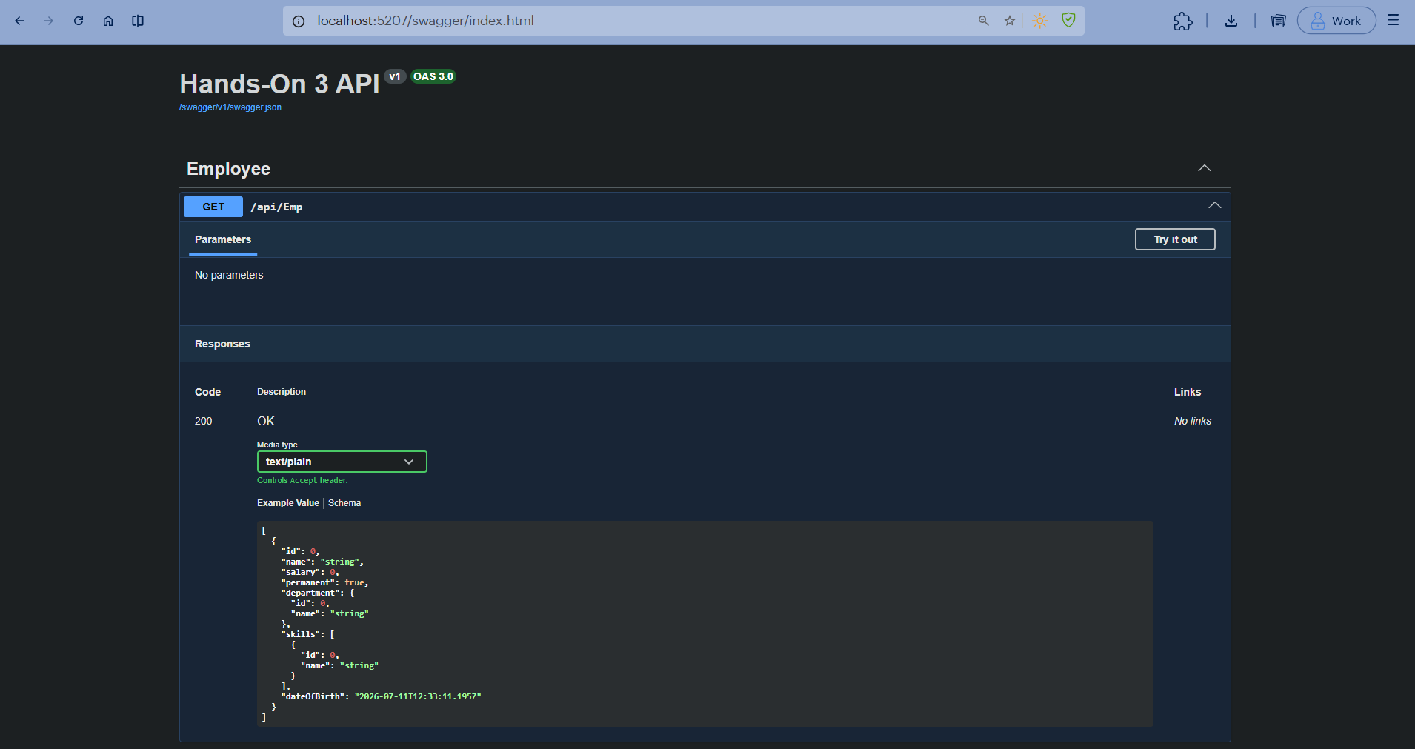

- Postman:
  - Auth Missing Failure:
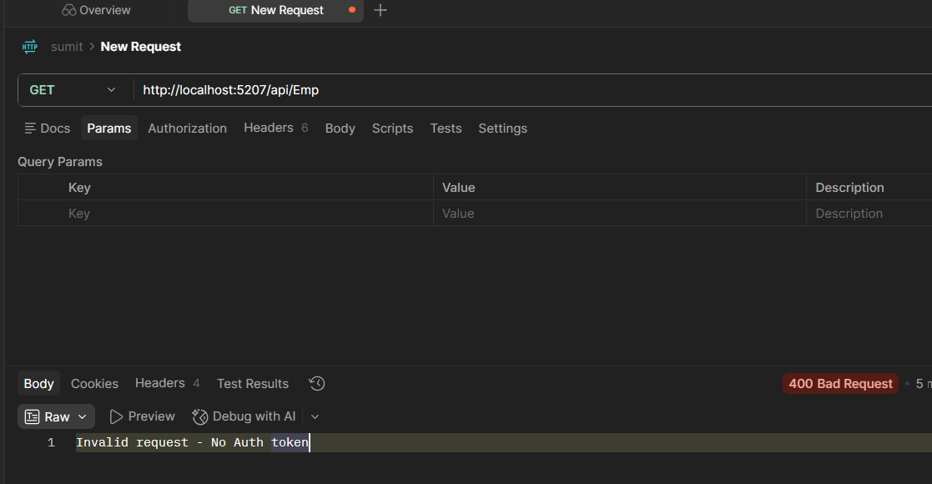

  - Token Invalid Failure:

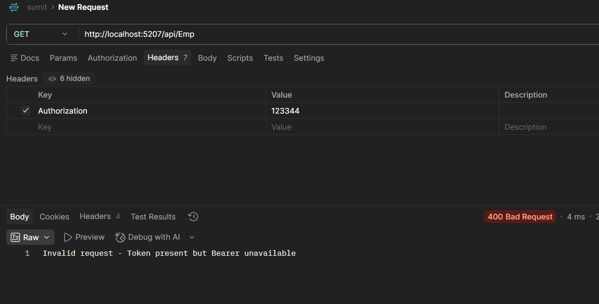
  - Success:
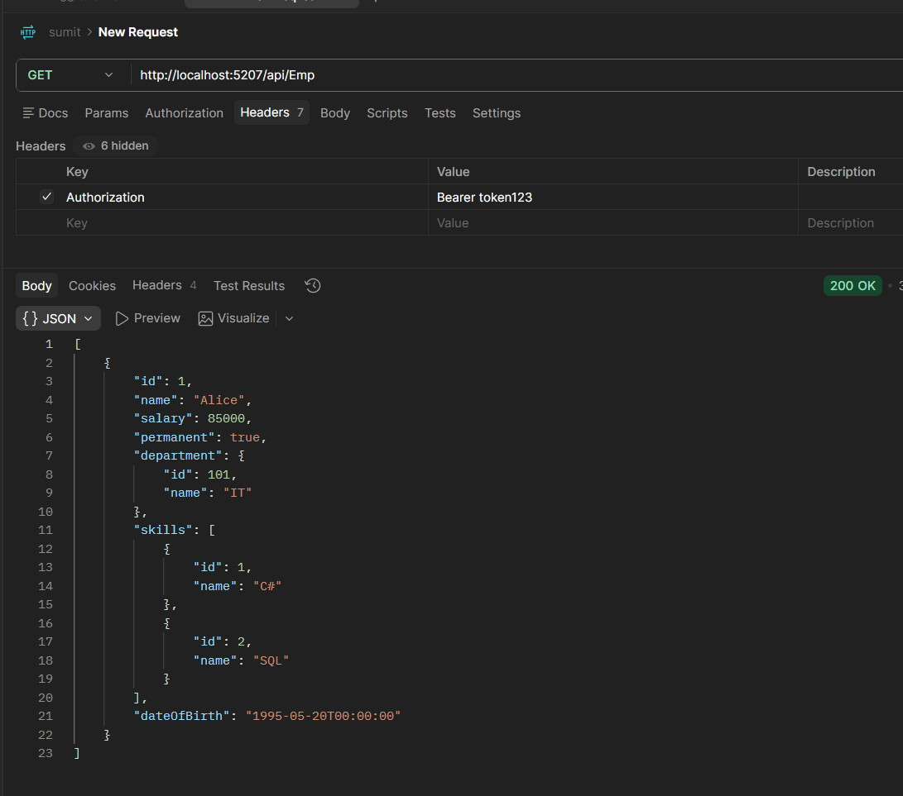
- Exception Filter Screenshots:

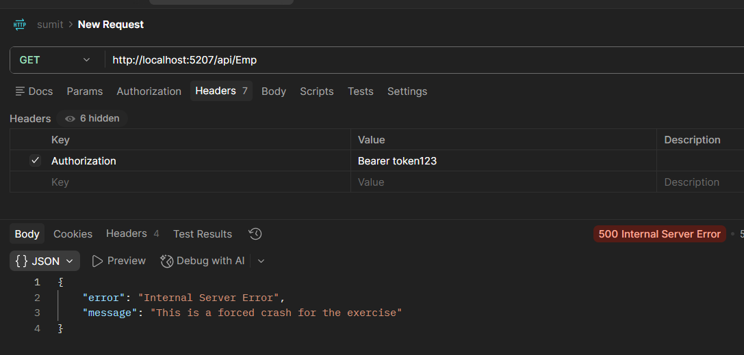
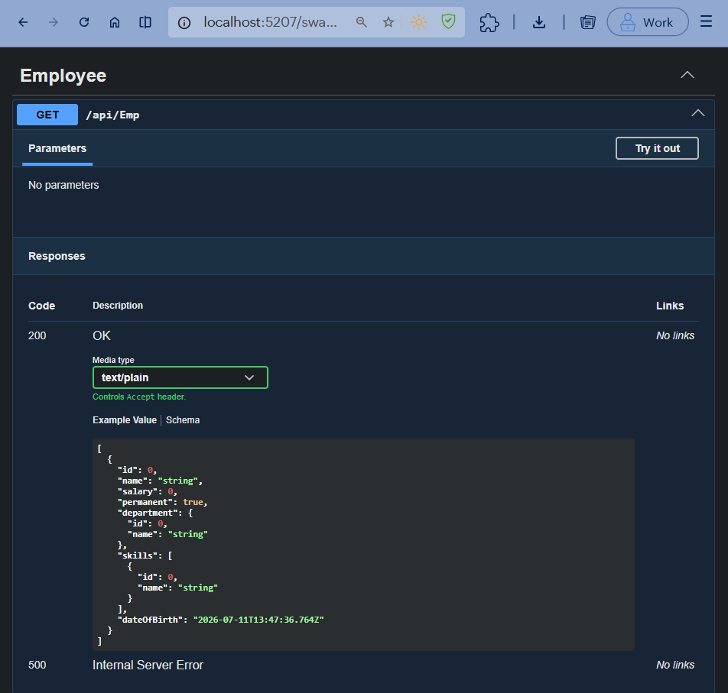

ErrorLog.txt:
