Web API Hands-on – 6
- Theory & Concepts
Introduction to Apache Kafka (v2.7.0)
Apache Kafka is a distributed event streaming platform used to collect, process, store, and integrate data feeds at scale. Unlike traditional request-response architectures (like standard REST HTTP APIs), Kafka works on a highly decoupled publish-subscribe (Pub/Sub) architecture.
Key Architectural Elements:
- Topics: A category or feed name to which records are published. Topics in Kafka are multi-subscriber logs.
- Partitions: Topics are divided into ordered sequences called partitions to allow parallel processing and scalability across nodes.
- Brokers: The core servers or instances comprising the storage cluster that receive, store, and serve event messages.
- Zookeeper: A centralized service that acts as an orchestration coordinator to manage cluster metadata, leader elections, and configuration details for the brokers.
- Implementation
The following process documents the configuration of an end-to-end local Kafka data stream integrated into a C# .NET desktop engine client.
Step 1: Environment & Dependency Intialization
- An active Apache Kafka instance (v2.7.0) was deployed locally.
- The system was brought online by instantiating Zookeeper (port 2181) followed by the core Kafka Broker engine (port 9092).
- A specialized stream pipeline topic was initialized using the terminal:
1. kafka-topics.bat --create --zookeeper localhost:2181 --replication-factor 1 --partitions 1 --topic chat-message
2.
Step 2: Windows Client Interface Development
- A native C# Windows Forms application workspace was built within the structured assignment folder (EX6).
- The Confluent.Kafka wwrapper package was installed via the NuGet Solution Package Manager to translate native C# memory variables into Kafka network data packets.
- A functional graphical interface was laid out containing a multi-line monitoring data text view control (txtMessages), a close action execution button (btnCancel), and a transmission dispatch action button (btnSend).
Step 3: Event Stream Logic Coding
- The Producer: An asynchronous block using ProducerBuilder was mapped to the Send action button. When evaluated, it securely formats raw input variables and targets the chat-message topic stream across the local loopback server.
- The Consumer: A decoupled processing pipeline using ConsumerBuilder was implemented as a managed task thread running automatically upon initialization. It streams active values off the consumer group via an explicit background sub-routine, safely handling thread invocation to dynamically append incoming broker traffic to the Ui chat history log.
- Implementation Screenshots
- Form Designer Layout:
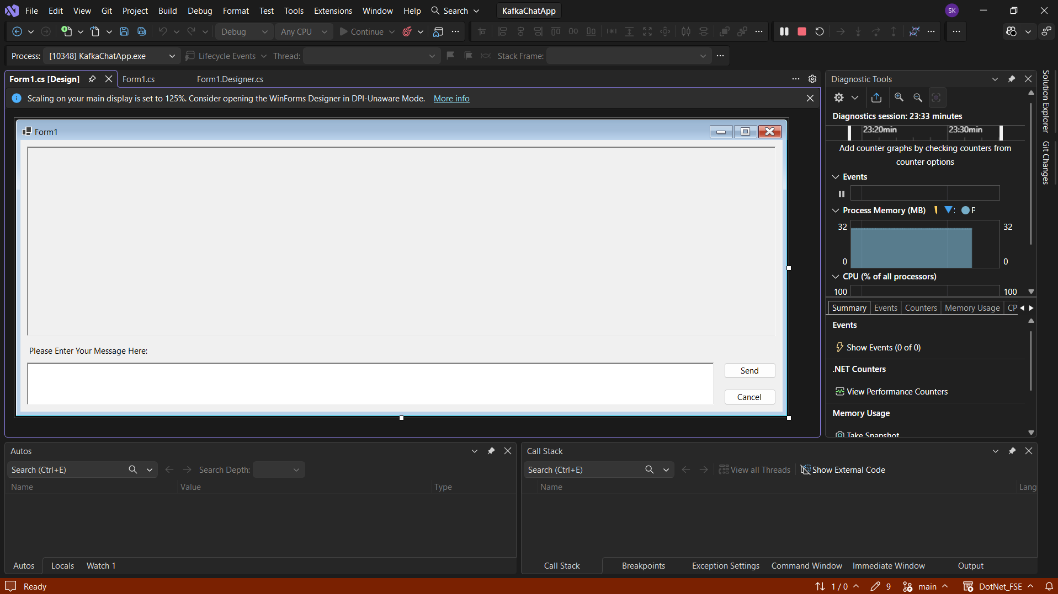

- C# Source Implementation:
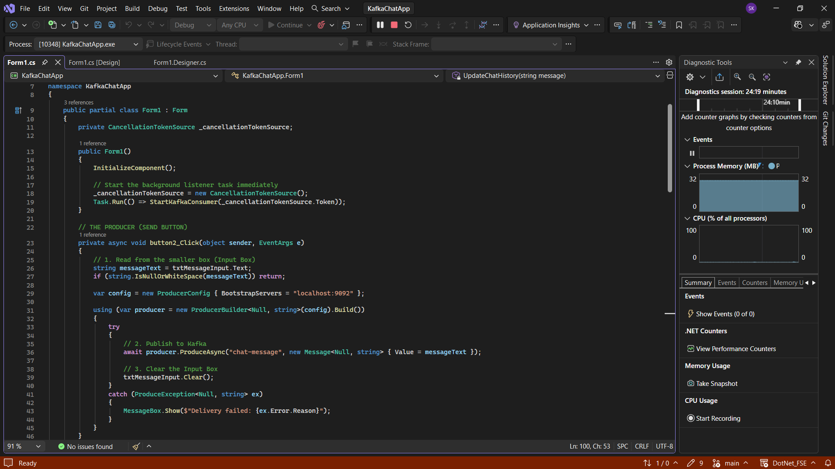
- Stream Verification Output Screenshots
- Desktop Client Runtime Success:
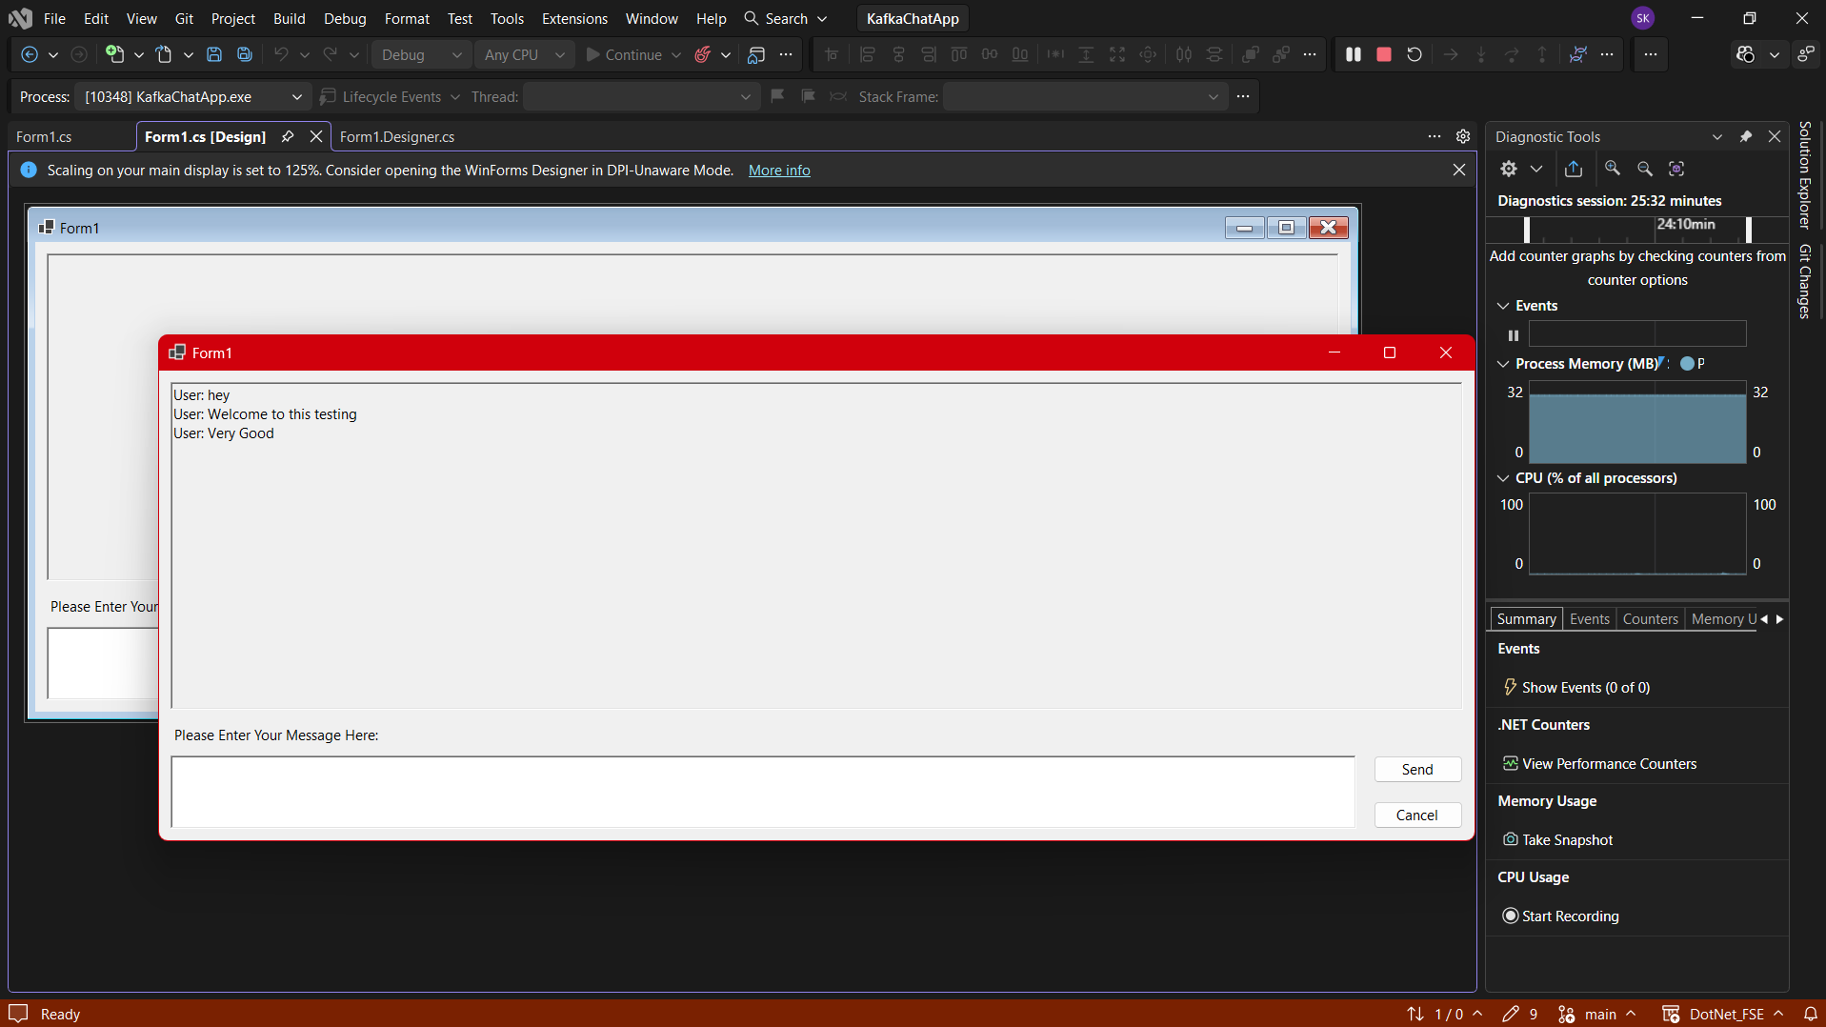

- Terminal Console Consumer Success:
