Angular_HandsOn
- HandsOn – 1 Screenshots:
  - Task 1:
    - 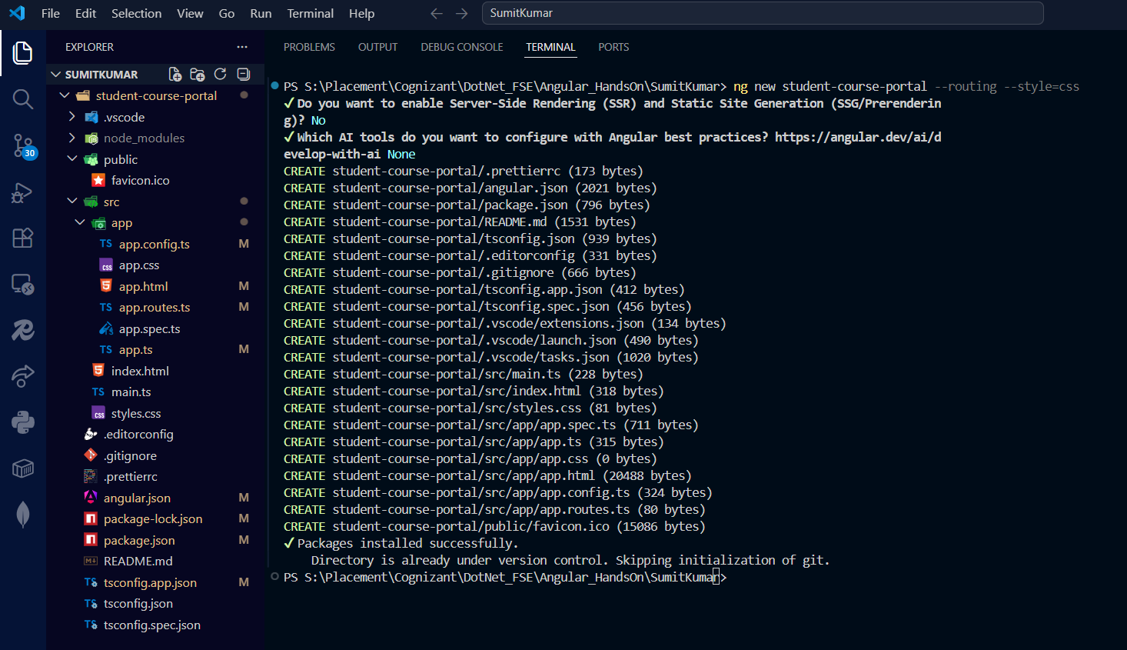
    - 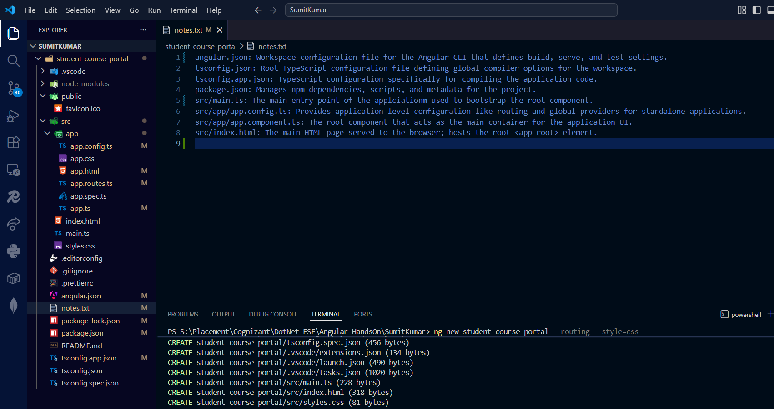
    - 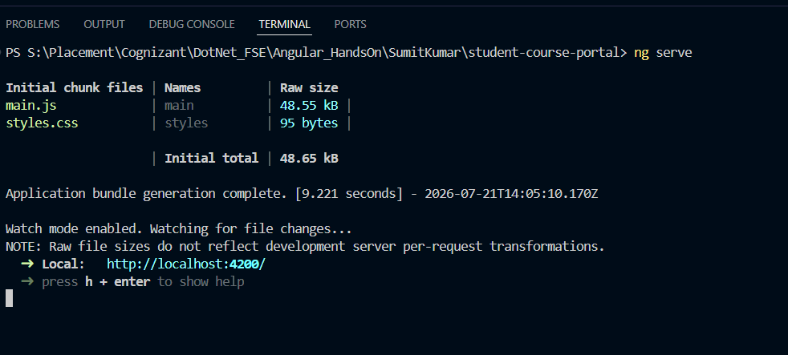
    - 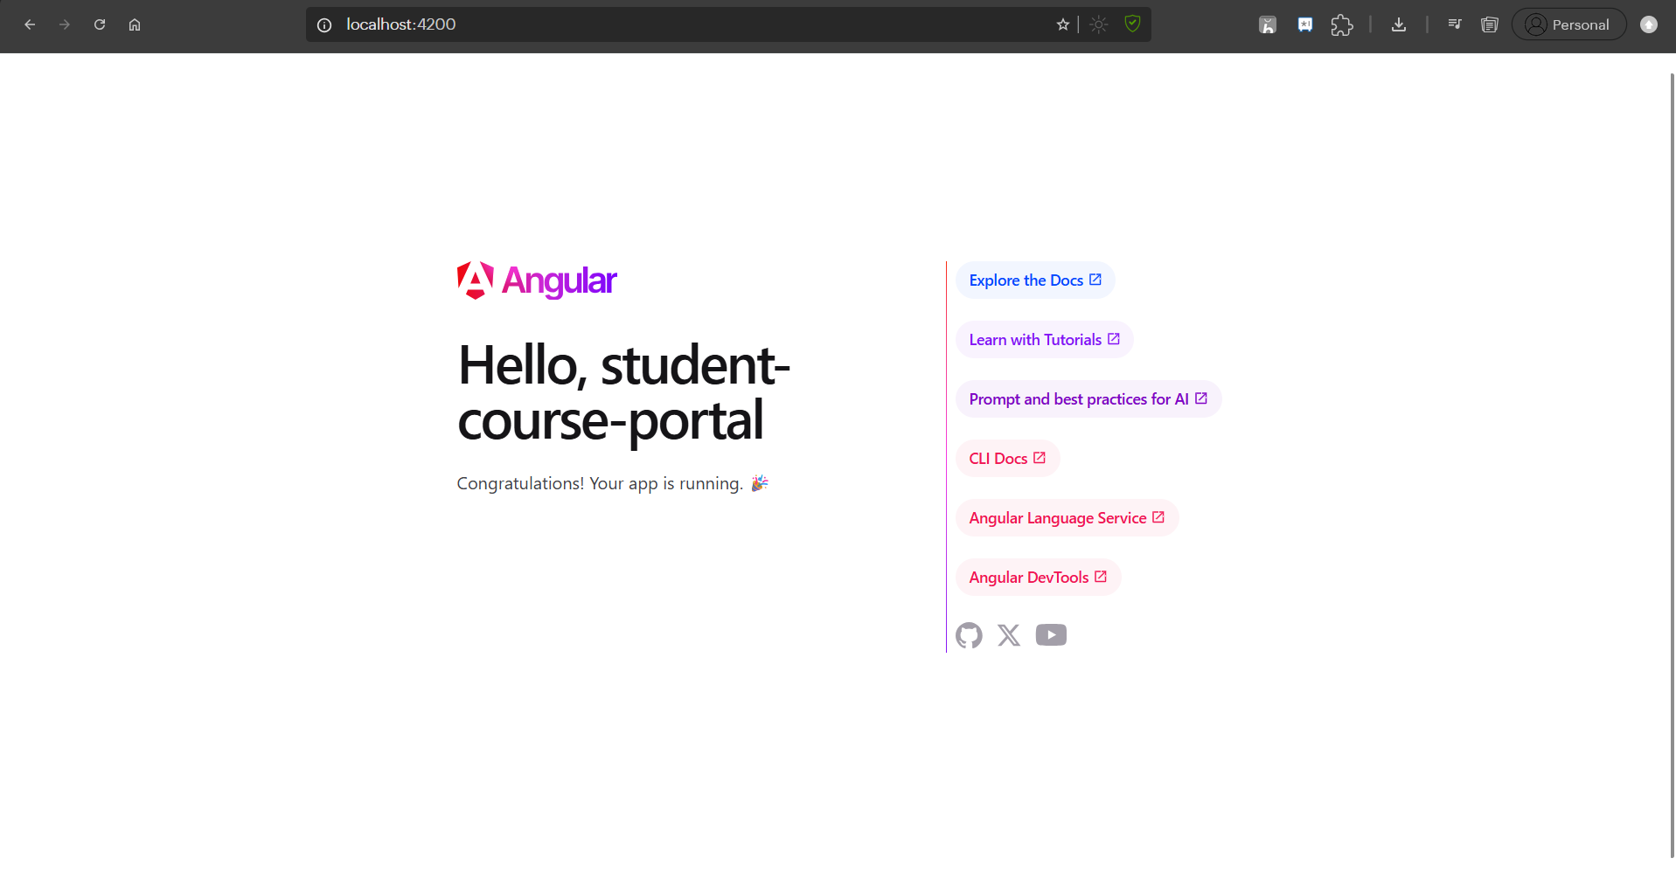

    - The main-2HZPHX33.js contains the compiled application code: 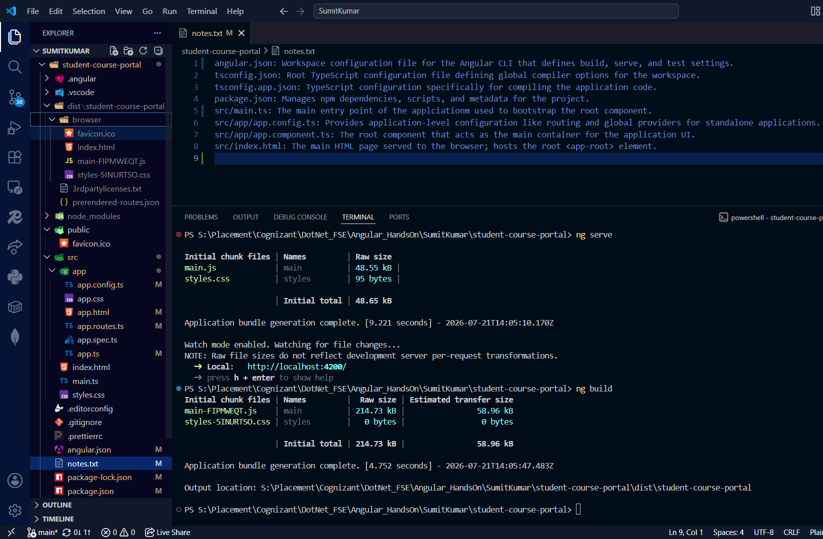
    - 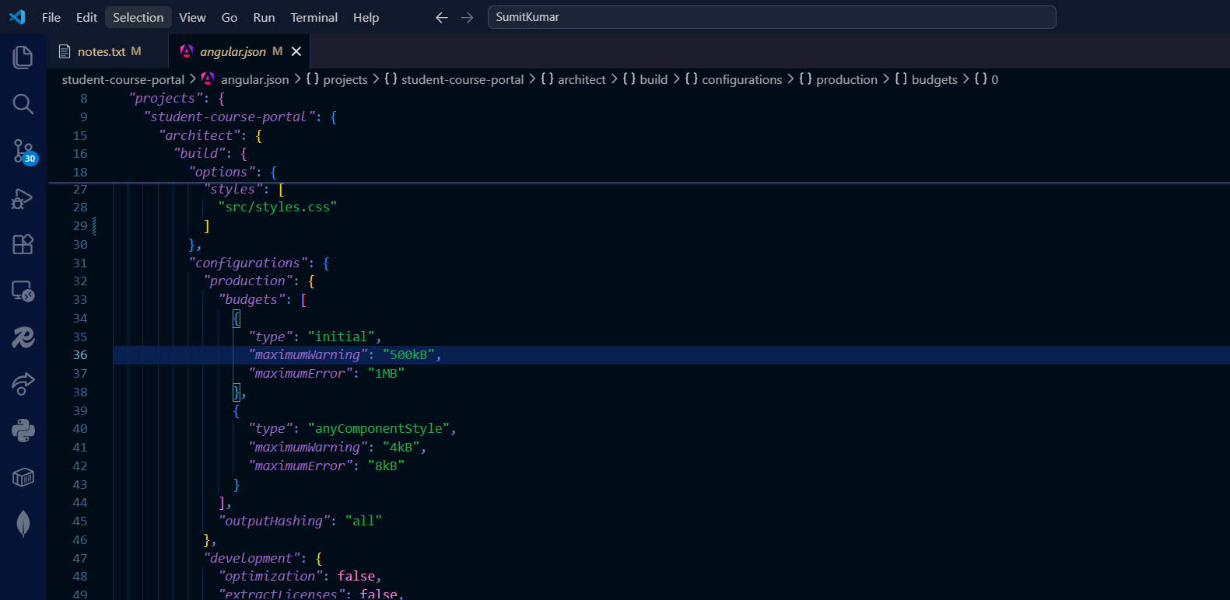maximumWarning: Triggers a console warning during the build if the bundle size exceeds this threshold.
maximumError: Causes the build to fail entirely if the bundle size exceeds this threshold, preventing you from deploying overly bloated applications.

  - Task 2:
    - 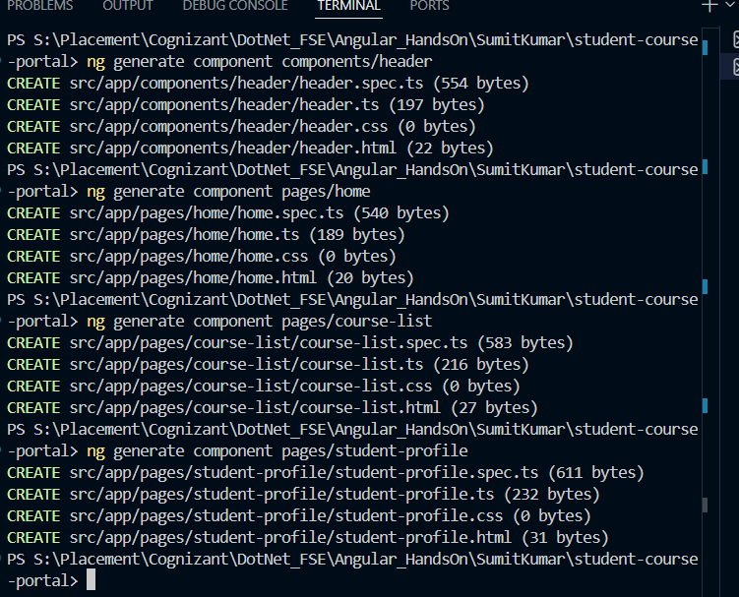
    - 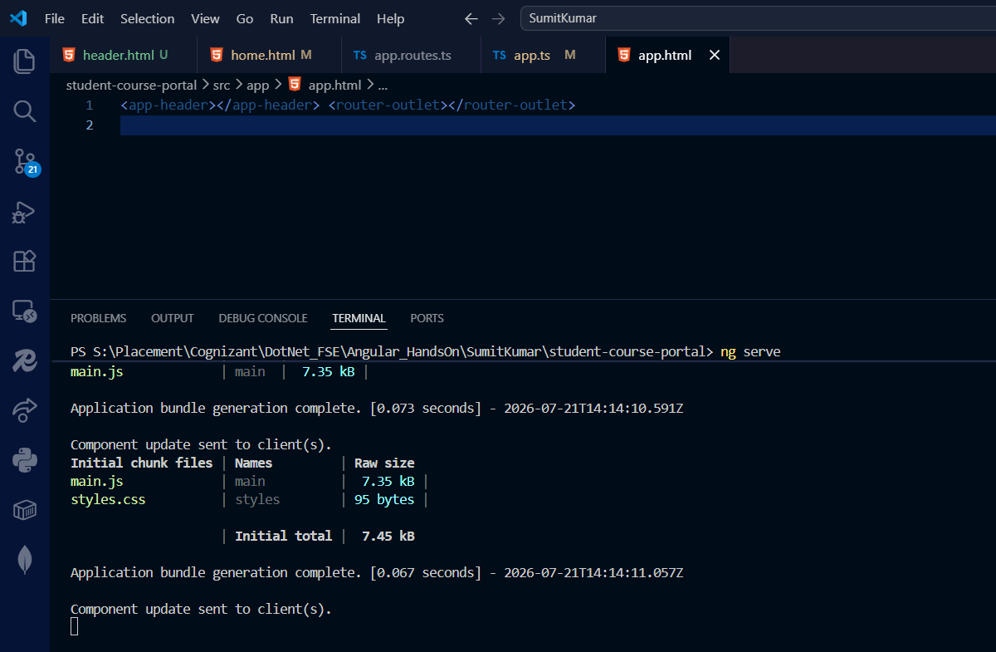
    - 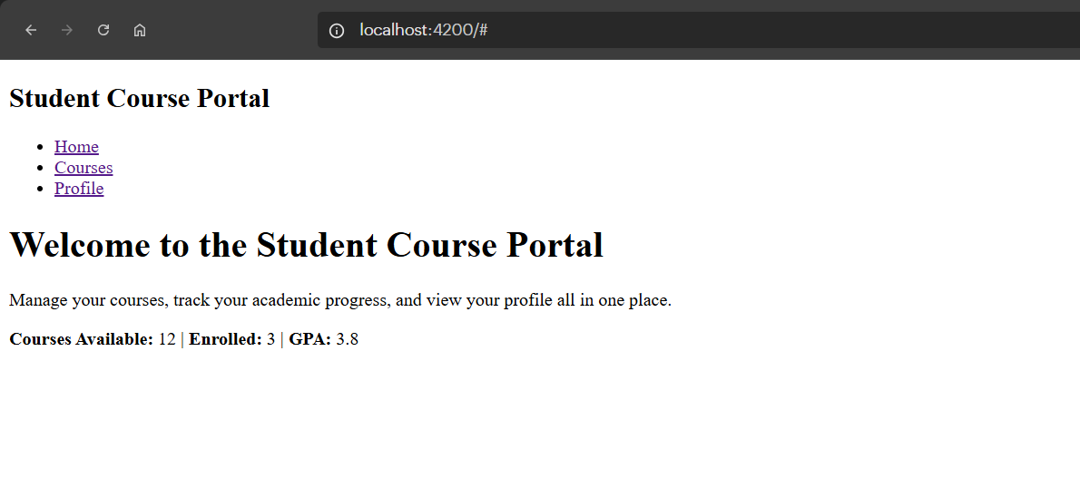

- HandsOn – 2 Screenshots
  - Task 1:
    - 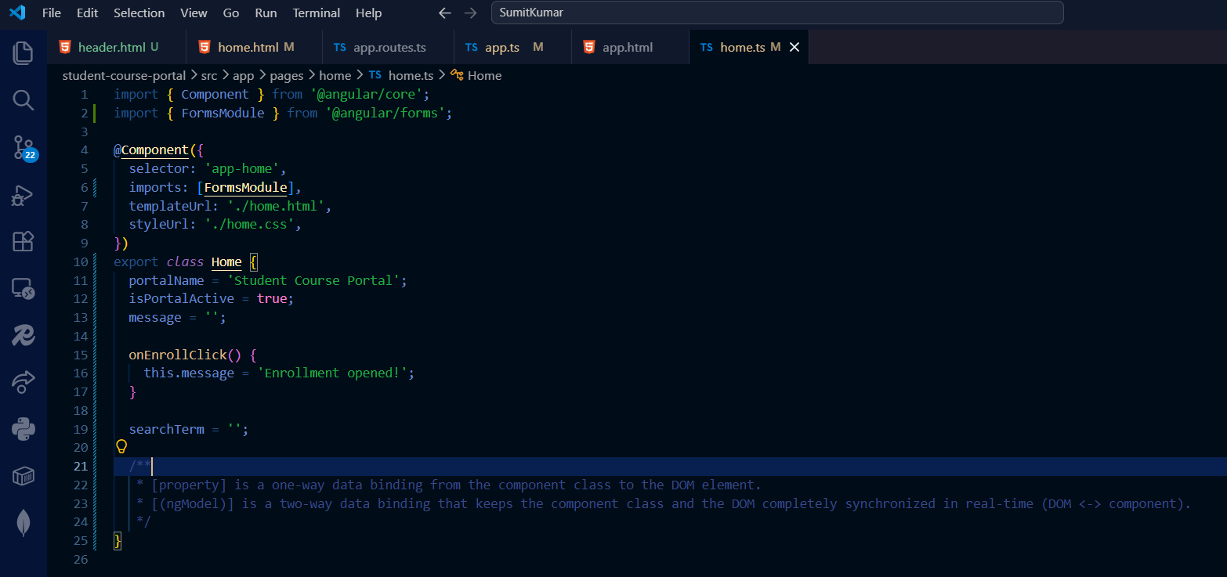
    - 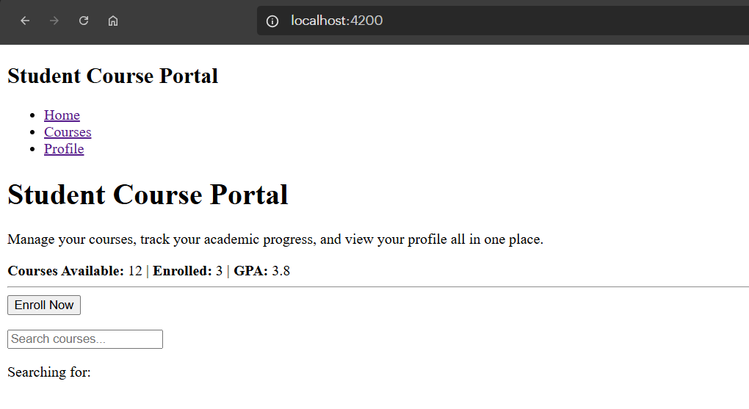
    - 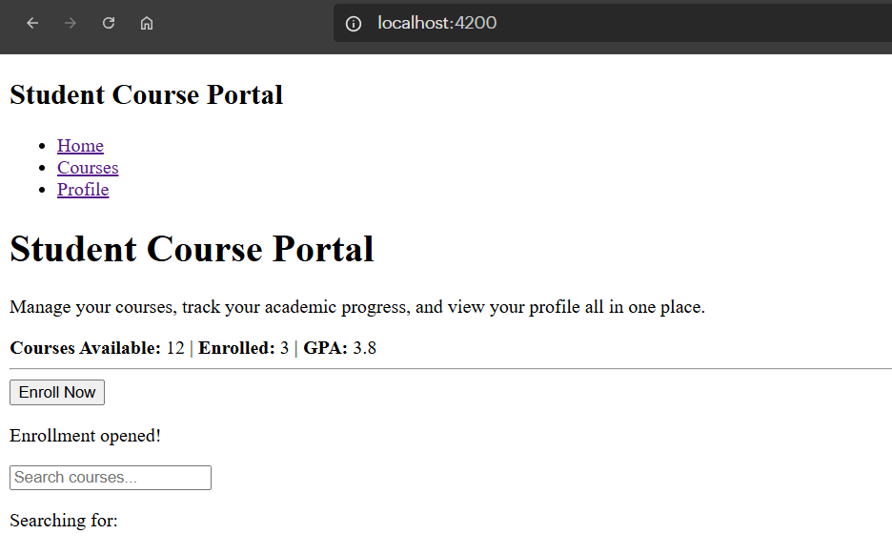
    - 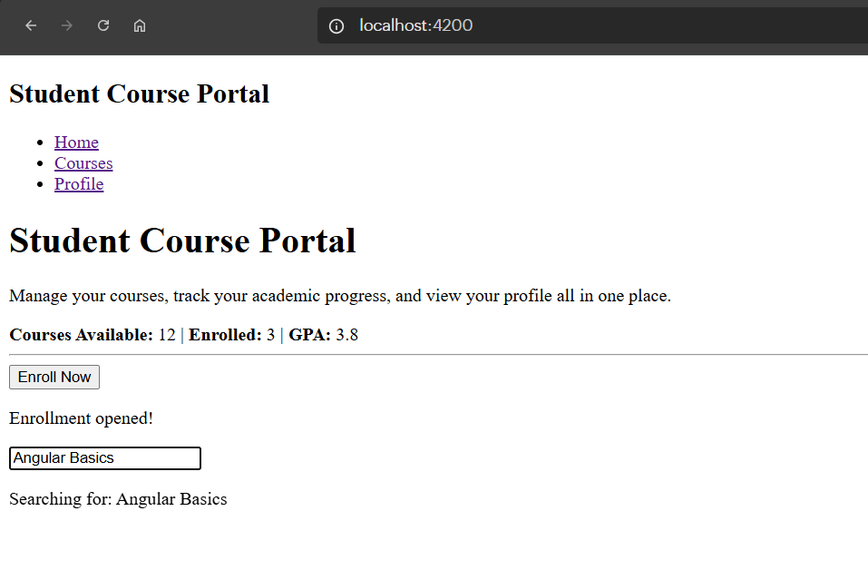

  - Task 2:
    - 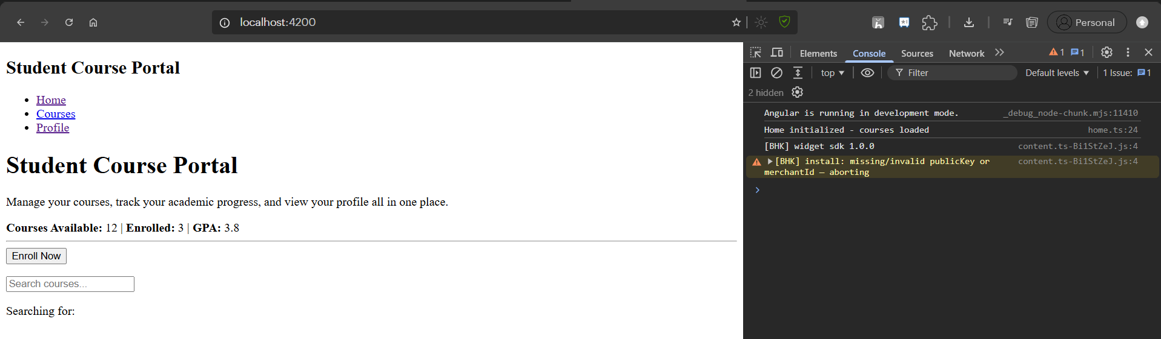
    - 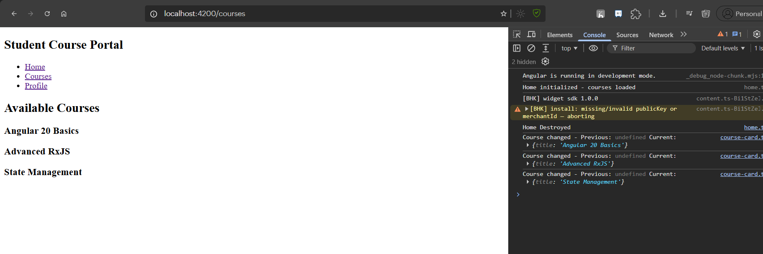

  - Task 3
    - 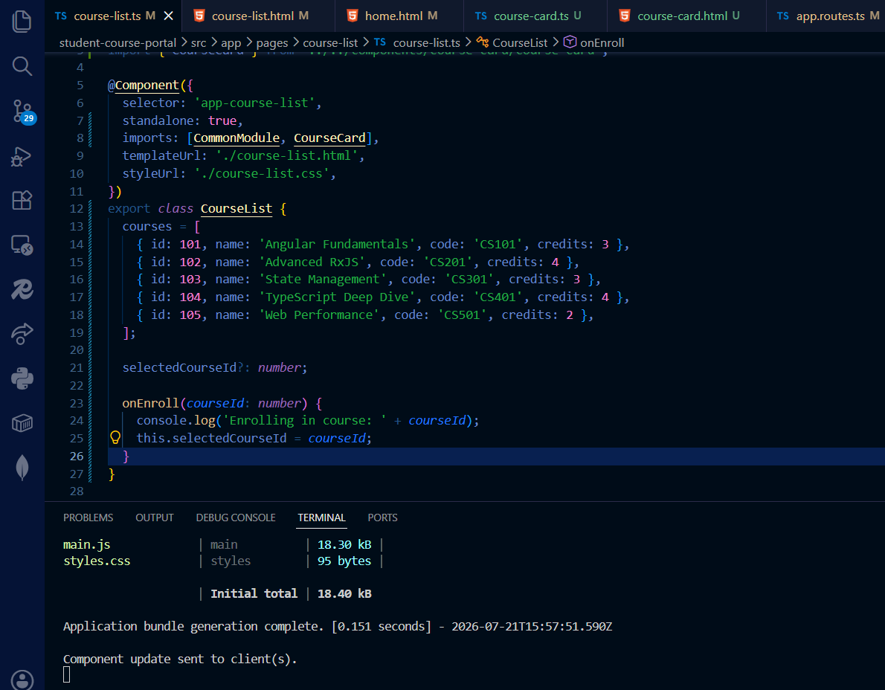
    - 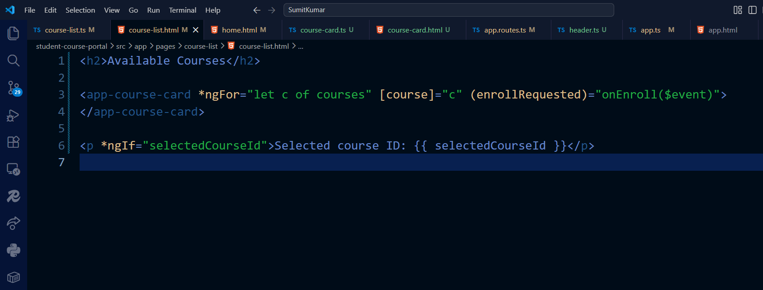
    - 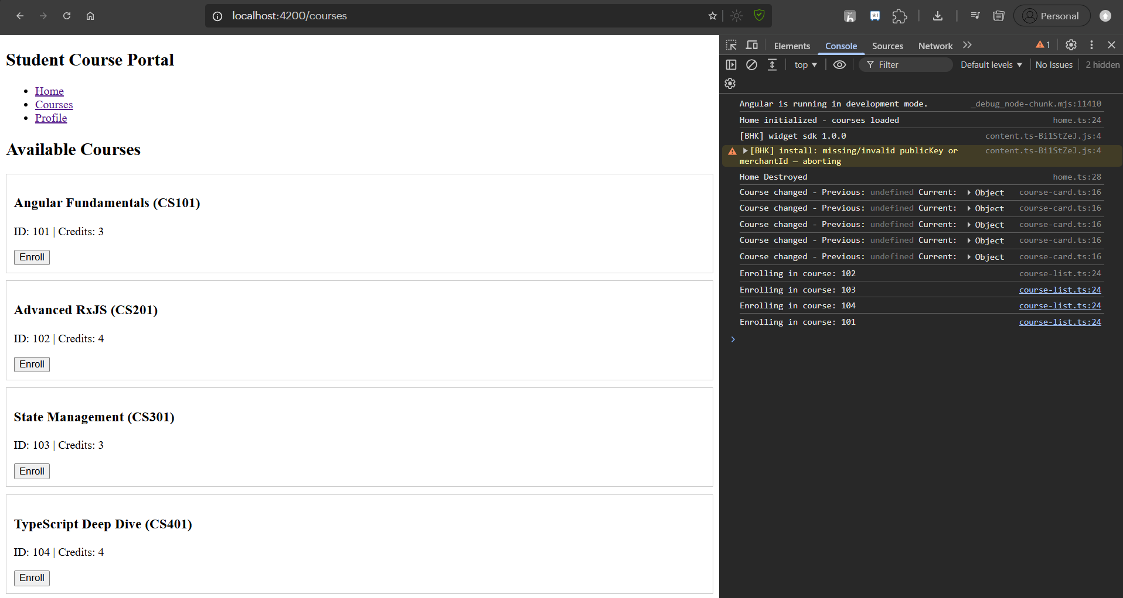
- HandsOn – 3 Screenshots
  - Task 1:

