TECH LAYOFFS ANALYSIS
Findings Report — SQL Data Cleaning, EDA & Power BI Dashboard
Data span: March 2020 – September 2026 | 3,850 cleaned records
Prepared by Sumit Kohli — DataWithSumit

1. Executive Summary
This report summarizes the findings from an end-to-end analysis of global tech industry layoffs (2020–2026). The raw dataset was cleaned and standardized in SQL Server (T-SQL), explored using window functions and aggregate queries, and visualized in an interactive Power BI dashboard. Key headline numbers:
- 932,766 total layoffs recorded across 2,602 distinct companies
- Average of 29.6% of workforce laid off per event, across all recorded rounds
- 370 companies recorded a 100% layoff (i.e. shut down or ceased operations)
- 2023 was the single worst year on record, with 265,660 layoffs
- Amazon had the highest cumulative layoffs of any company (59,560) across 17 separate rounds

2. Methodology

2.1 Data Cleaning (SQL)
Performed in T-SQL / SQL Server. Key steps applied to the raw layoffs_messy table:
- Copied raw data into a staging table (layoffs_staging) to preserve the original source
- Removed exact duplicate rows using ROW_NUMBER() over all key columns within a CTE
- Trimmed leading/trailing whitespace across all text columns (company, location, industry, stage, country)
- Standardized inconsistent industry naming (e.g. 'Crypto', 'crypto', 'CryptoCurrency' → unified to 'Crypto') — 179 records corrected
- Converted inconsistent date formats to a single standardized DATE column
- Converted blank strings in industry/country to proper NULLs, distinct from missing data
- Removed rows where both total_laid_off and percentage_laid_off were NULL (no usable signal)
- Corrected column data types (funds_raised and percentage_laid_off changed from float to DECIMAL(10,2))
- Validated no impossible values remained (negative layoffs, percentages outside 0–1 range)
Result: raw dataset reduced from source row count down to 3,850 clean, analysis-ready records.

2.2 Exploratory Data Analysis (SQL)
EDA was conducted using SQL window functions and aggregate queries, covering:
- Company-, industry-, country-, and stage-level aggregation of total layoffs
- Identification of companies with 100% workforce layoffs (effective shutdowns)
- Year-over-year and month-over-month layoff trend analysis, including a rolling cumulative total (SUM() OVER)
- Top 3 companies per year by total layoffs (DENSE_RANK() OVER PARTITION BY year)
- Companies with repeated layoff rounds, as a signal of ongoing organizational instability
- A funds-raised vs. total-layoffs comparison to test whether well-funded companies were shielded from cuts

3. Key Findings

3.1 Layoffs Over Time
Layoffs were relatively contained in the initial 2020–2021 period, spiked sharply from 2022 onward, and peaked in 2023 before a partial pullback and a renewed climb through 2025–2026.
Year | Total Laid Off
2020 | 80,998
2021 | 15,823
2022 | 165,269
2023 | 265,660
2024 | 152,922
2025 | 122,606
2026 (partial) | 129,488
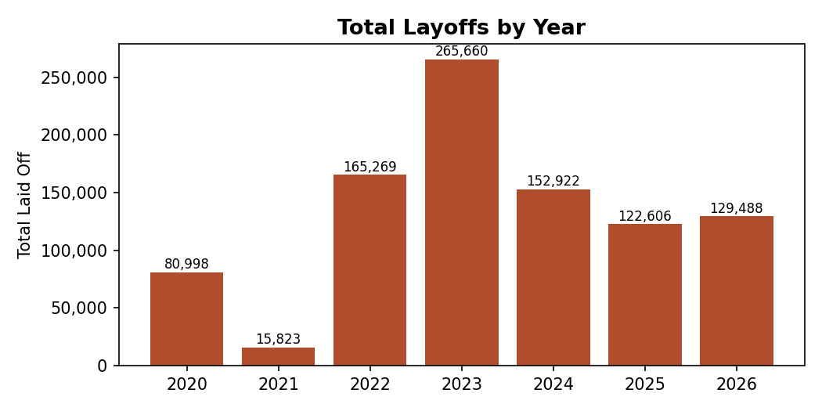

3.2 Most-Affected Companies
Aggregating across all recorded rounds, a small number of large tech companies account for a disproportionate share of total layoffs:
Company | Total Laid Off (cumulative)
Amazon | 59,560
Intel | 43,115
Meta | 35,700
Microsoft | 34,855
Dell | 23,650
Oracle | 22,294
Cisco | 18,521
Salesforce | 16,744
Tesla | 14,500
Google | 13,749
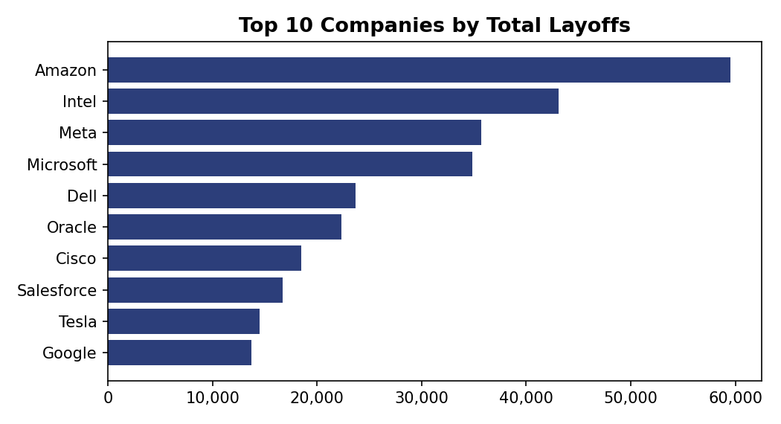
Amazon, Salesforce, Microsoft, Google, and Intel also top the list for the highest number of separate layoff rounds (17, 14, 11, 11, and 9 respectively) — indicating repeated, ongoing restructuring rather than a single large event.

3.3 Biggest Single Layoff Events
The single largest layoff events recorded in the dataset:
Company | Employees Laid Off | Date
Intel | 22,000 | 23 Apr 2025
Oracle | 21,000 | 23 Jun 2026
Amazon | 16,000 | 28 Jan 2026
Intel | 15,000 | 1 Aug 2024
Tesla | 14,000 | 15 Apr 2024

3.4 Industry & Geographic Breakdown
'Other', Retail, Hardware, and Consumer were the hardest-hit industry categories by total volume:
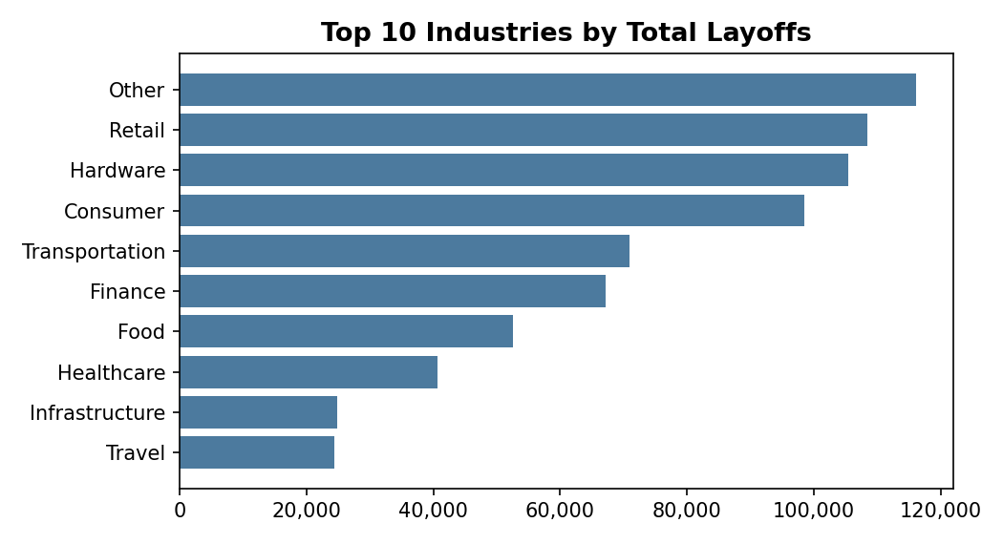
Geographically, the United States accounted for the overwhelming majority of recorded layoffs (660,310), followed at a distance by India (69,184) and Germany (32,153) — reflecting both the concentration of major tech employers in the US and the dataset's US-centric sourcing.

3.5 Company Stage & Funding
By funding stage, Post-IPO (publicly listed) companies accounted for the largest share of total layoffs (586,683) — consistent with these being the largest employers by headcount. However, a correlation check between funds raised and total layoffs returned a weak positive coefficient of 0.124, indicating funding level has little predictive relationship with layoff volume.
Several well-funded companies (having raised over $1 billion) still recorded 100% workforce layoffs, effectively shutting down operations entirely:
Company | Funds Raised ($M) | Outcome
Britishvolt | 2,400 | 100% laid off
Quibi | 1,800 | 100% laid off
Deliveroo Australia | 1,700 | 100% laid off
Fisker | 1,700 | 100% laid off
Katerra | 1,600 | 100% laid off (2,434 employees)
Lilium | 1,400 | 100% laid off (1,000 employees)
This is one of the more notable findings: substantial prior funding did not protect these companies from full shutdown, reinforcing that funding history alone is a weak indicator of company stability.

3.6 Severity Trend (Average % of Workforce Laid Off)
Looking at severity rather than volume tells a slightly different story — 2021 had the highest average percentage of workforce cut per event (61.0%), despite having the lowest total headcount impact of any year, suggesting 2021's layoffs were concentrated in a smaller number of companies making very deep cuts (often smaller startups folding entirely) rather than broad workforce reductions at scale.
Year | Avg % of Workforce Laid Off
2020 | 30.9%
2021 | 61.0%
2022 | 24.6%
2023 | 28.4%
2024 | 35.3%
2025 | 36.8%
2026 | 31.7%

4. Conclusion
The analysis shows tech layoffs were not a single isolated event but a sustained, multi-year pattern, concentrated heavily among large, publicly listed US companies, with 2023 marking the clear peak in volume. A meaningful share of affected companies (370, or roughly 1 in 7) shut down entirely, and prior fundraising success showed little correlation with avoiding this outcome. Several major employers — Amazon, Intel, Meta, and Microsoft in particular — appear repeatedly across nearly every year and every ranking, reflecting ongoing rounds of restructuring rather than one-off corrections.

5. Tools & Methods Used
- SQL Server (T-SQL) — data cleaning, deduplication, type correction, CTEs, window functions (ROW_NUMBER, DENSE_RANK, LAG, SUM OVER)
- Power BI — data modeling, DAX measures, interactive multi-page dashboard with slicers
- Python (pandas) — used for this report's summary validation and chart generation
Prepared for portfolio/interview reference — DataWithSumit

