**Experiment No.6**

**Name: Sumit Prabhakar Kamble.**

**Roll_no: 47**

**Div: B Batch: B2 Class: TY CSE**

**PRN: 21ST114282045**

**Title: Create XML schema, DTD for any database application.**

* **student.xml: -**

<?xml version="1.0" standalone="no"?>

<!DOCTYPE students SYSTEM "student.dtd">

<students>

<student>

<roll_no>1</roll_no>

<name>

<fname>Sumit</fname>

<mname>P</mname>

<lname>Kamble</lname>

</name>

<address>

<city>Kolhapur</city>

<pincode>410612</pincode>

</address>

</student>

<student>

<roll_no>2</roll_no>

<name>

<fname>Cristiano</fname>

<lname>Ronaldo</lname>

</name>

<address>

<city>Mumbai</city>

<pincode>410615</pincode>

</address>

</student>

</students>

* **student.dtd: -**

<!ELEMENT students (student+)>

<!ELEMENT student (roll_no,name,address)>

<!ELEMENT roll_no (#PCDATA)>

<!ELEMENT name (fname,mname?,lname)>

<!ELEMENT fname (#PCDATA)>

<!ELEMENT mname (#PCDATA)>

<!ELEMENT lname (#PCDATA)>

<!ELEMENT address (city,pincode)>

<!ELEMENT city (#PCDATA)>

<!ELEMENT pincode (#PCDATA)>

**Output: - (Without error)**

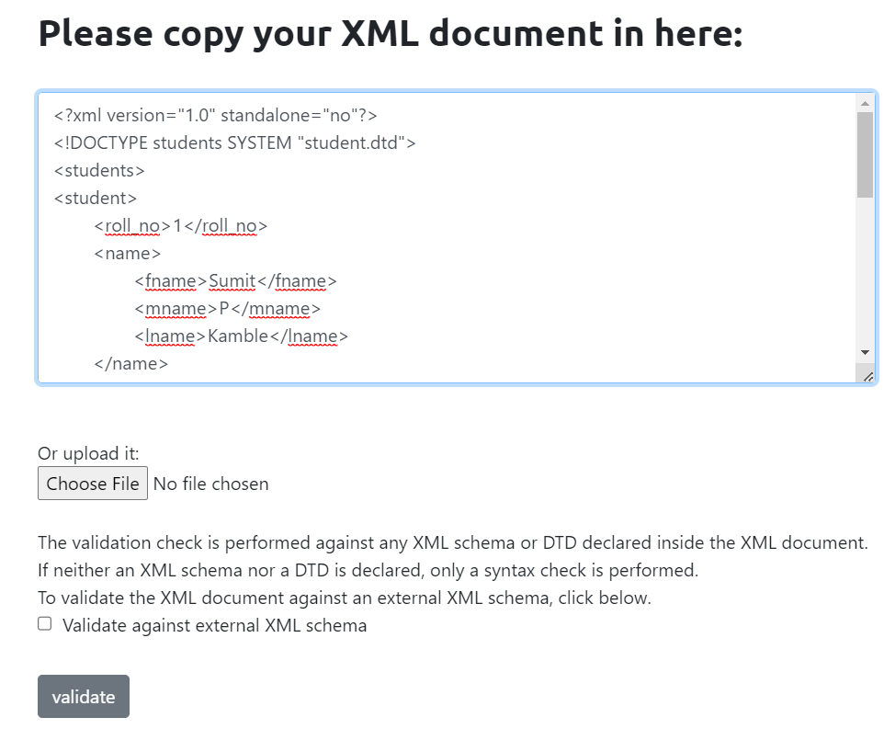

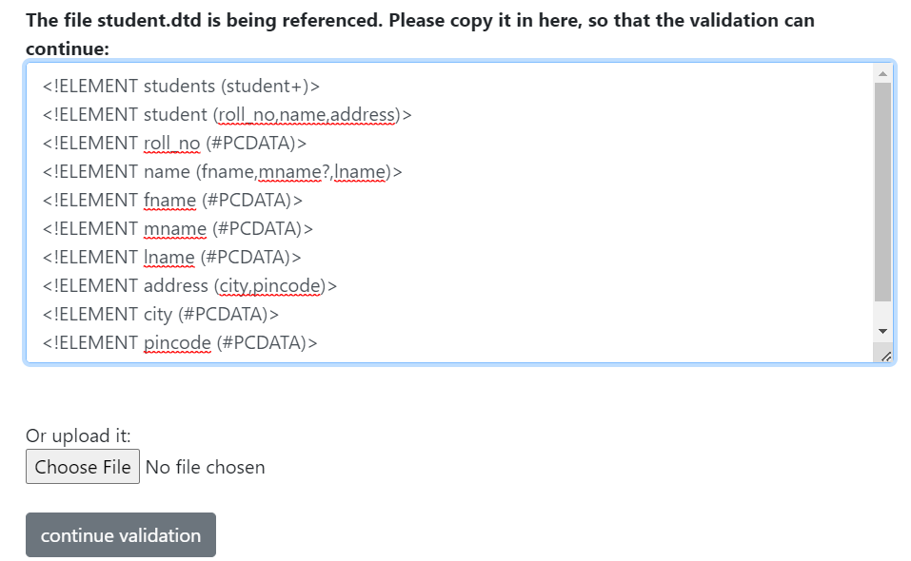

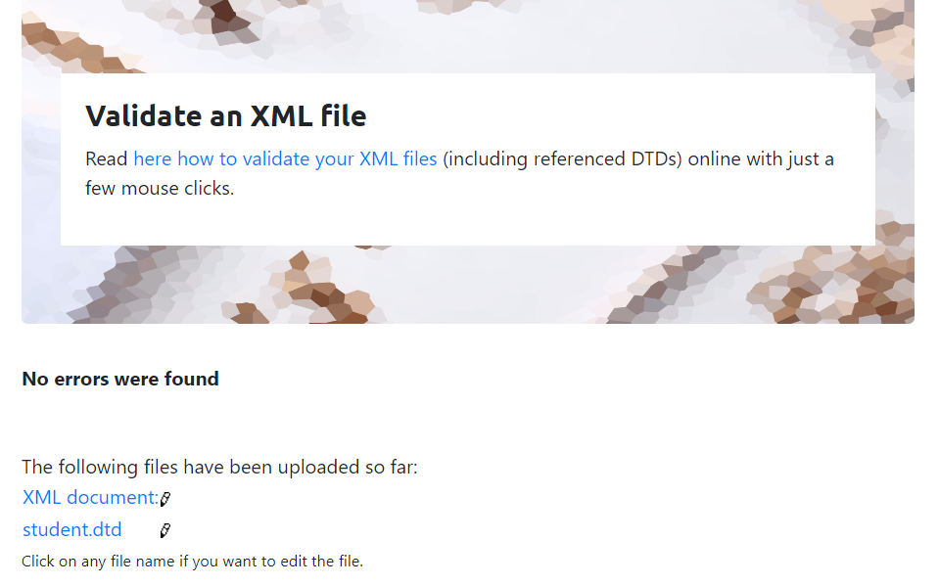

**Output: - (With error)**

