ASSIGNMENT 1

- Frontend development is the part which user can see and use, like buttons, forms and
webpages. Backend development works behind the scene. It handle database, login and server. Full-stack developer do both frontend and backend work. For example, in Amazon, frontend shows products, backend process orders, and full-stack can build the complete website.
Client (User)
│
Request (HTTP/HTTPS)
│
▼
Web Server
│ Process Request
│
▼ Database
│
Send Data Back
│
▼
Web Server
│
Response (HTML/CSS/JS)
│
▼
Client (Browser)

In this model, client send a request to the server. Server process the request, get data from database if needed, and then send the response back to client. This is how most websites like Amazon, Facebook and Instagram work.

- When a user enter a website URL in browser, the browser send a request to the web server. The server receive the request and find the required web page. Then it send HTML, CSS and JavaScript files back to the browser. After getting these files, the browser read them and display the web page on the screen.
- When a user enter a website URL in browser, the browser send a request to the web server. The server receive the request and find the required web page. Then it send HTML, CSS and JavaScript files back to the browser. After getting these files, the browser read them and display the web page on the screen.

- A web server is a software which store website files and send them to the user's browser when someone visit a website. It helps users to access web pages through the internet. Some commonly used web servers are Apache, Nginx, Microsoft IIS and

LiteSpeed. These servers are used by many websites because they are fast and reliable.

- A frontend developer make the part of website which users can see and interact with. A backend developer write the server side code, handle login, APIs and data processing. A database administrator manage the database, store data safely and make sure data is not lost. All three work together to build a complete web application.
- I installed Visual Studio Code and configured it for HTML, CSS and JavaScript development. I also installed useful extensions like Live Server, HTML CSS Support and JavaScript (ES6) Code Snippets. After completing the setup, I opened a sample HTML file to check if everything was working properly. Paste your screenshot of the VS Code setup below this answer.
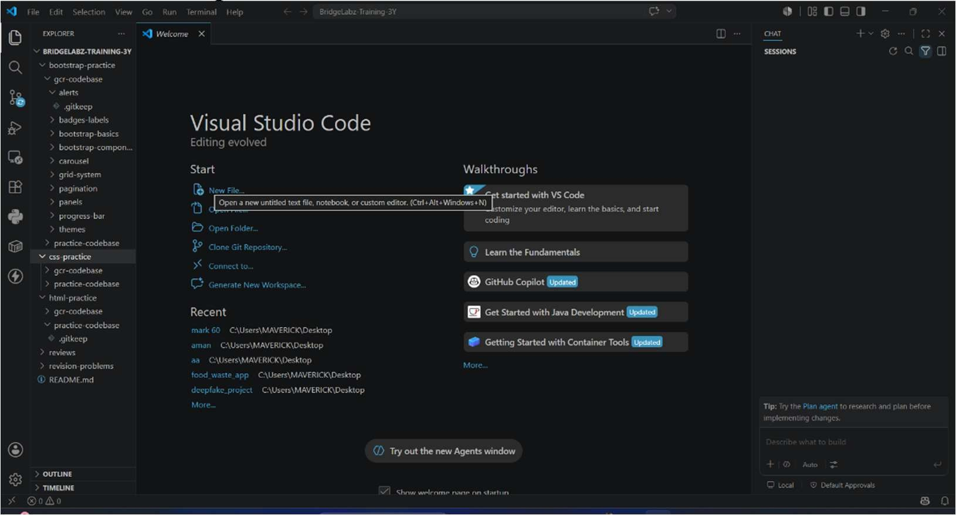
- A static website always show the same content to every user. It is made using HTML and CSS, and the content does not change unless the developer update it. Example of static website is a personal portfolio. A dynamic website show different content based on user or database. Example is Facebook, where every user see different posts and profile.
- Five popular web browsers are Google Chrome, Mozilla Firefox, Microsoft Edge, Apple Safari and Opera. These browsers use different rendering engines to display web pages. Chrome, Edge and Opera use Blink engine. Firefox use Gecko engine. Safari use WebKit engine. Because of different rendering engines, some websites may look or work little different in each browser.

+ +

| Client |

| (Web Browser) |

+ +

|

HTTP Request | v
+ +

| Web Server |

+ | +
| | |
API Call| |  | | Database Query
v | v
+ | + + | +
| APIs | | | Database |  | |
+ | + + |  | +
\ | /
\ | /
\ | /
v | v

+ +

| Web Server |

+ +

|

HTTP Response | v
+ +

| Client |

| Display Page |

+ +

This diagram shows the basic web architecture. Client send a request to the web server. Server may use APIs and database to get the required data. After processing, server send the response back to the client, and the browser display the web page.



