PROJECT REPORT
Submitted in partial fulfillment of the requirements for the award of the degree
CAFE: ONLINE FOOD ORDERING AND RESTAURANT MANAGEMENT SYSTEM

Submitted by
Sumit Kumar
Roll Number: [Enter Roll Number]
Under the Guidance of
[Enter Project Supervisor Name]
[Enter Department Name]
[Enter College / University Name]
Academic Session 2025-2026

Certificate
This is to certify that the project report entitled “Cafe: Online Food Ordering and Restaurant Management System” is a bona fide record of work carried out by Sumit Kumar, Roll Number [Enter Roll Number], under my supervision during the academic session 2025-2026.
To the best of my knowledge, the work presented in this report has not been submitted, either in full or in part, for the award of any other degree or diploma. The system was reviewed with respect to its stated objectives, implementation, database design, testing evidence, and documentation.
Project Guide | Head of Department | External Examiner
[Enter Project Supervisor Name]  Signature: __________ | Name: __________  Signature: __________ | Name: __________  Signature: __________

Place: ____________________
Date: _____________________

Student Declaration
I, Sumit Kumar, declare that the report titled “Cafe: Online Food Ordering and Restaurant Management System” is my original project work. All external ideas, software libraries, images, documentation sources, and standards referenced in this report have been acknowledged in the bibliography.
I understand the principles of academic integrity and accept responsibility for ensuring that institution-specific details, screenshots, signatures, and deployment credentials are reviewed before final submission.
Student Signature: __________________________
Name: Sumit Kumar
Roll Number: [Enter Roll Number]

Acknowledgement
I express sincere gratitude to [Enter Project Supervisor Name] for guidance, constructive feedback, and encouragement throughout the planning, development, testing, and documentation of this project.
I also thank the faculty members of [Enter Department Name], [Enter College / University Name], for providing the academic environment and technical foundation required to complete this work. Appreciation is extended to friends and family members who supported usability review and demonstration activities.
Finally, I acknowledge the maintainers of PHP, MariaDB, Apache, Bootstrap, Bootstrap Icons, Python, and other open technologies used for development and documentation.

Abstract
Cafe is a browser-based food ordering and restaurant management system implemented using Core PHP, MariaDB/MySQL, HTML, CSS, JavaScript, Bootstrap, PDO, and XAMPP. The system combines a public delivery landing page, customer menu and checkout experience, visual order tracking, and role-specific operational dashboards.
Customers can register, authenticate, browse and filter menu items, manage quantities, apply coupons, select delivery or pickup, place orders, save favorites, monitor status, and review delivered food. Administrators manage orders, menu items, food images, customers, staff roles, coupons, reviews, settings, reports, and CSV exports. Kitchen staff and delivery staff receive focused workflow screens.
The project uses server-side validation, password hashing, session regeneration, CSRF tokens, output escaping, prepared SQL statements, guarded role transitions, transaction-based order placement, stock verification, and secure image validation. The result is an educational full-stack system that demonstrates practical database-backed web application engineering.
Attribute | Value
Application type | Responsive full-stack web application
Backend | Core PHP with PDO
Database | MariaDB / MySQL
Frontend | HTML5, CSS3, JavaScript, Bootstrap 5
Primary environment | Apache and MariaDB supplied through XAMPP
Supported roles | Customer, Administrator, Kitchen, Delivery, Staff

Table of Contents
Certificate 2
Student Declaration 3
Acknowledgement 4
Abstract 5
Table of Contents 6
List of Figures 9
List of Tables 10
Abbreviations and Terminology 11
Executive Summary 12
1.1 Background of Online Food Ordering 13
1.2 Problem Statement 14
1.3 Aim of the Project 15
1.4 Project Objectives 16
1.5 Scope and Boundaries 17
1.6 Significance of the Project 18
2.1 Existing Manual System 19
2.2 Limitations of Existing Approaches 20
2.3 Proposed System 21
2.4 Technical Feasibility 22
2.5 Economic Feasibility 23
2.6 Operational and Schedule Feasibility 24
3.1 Stakeholder Identification 25
3.2 Customer Functional Requirements 26
3.3 Administrative Requirements 27
3.4 Kitchen and Delivery Requirements 28
3.5 Non-Functional Requirements 29
3.6 Hardware and Software Requirements 30
4.1 System Context 31
4.2 Layered Architecture 32
4.3 Customer Use Cases 33
4.4 Staff Use Cases 34
4.5 Context-Level Data Flow 35
4.6 Detailed Order Data Flow 36
4.7 Navigation Design 37
4.8 Order State Machine 38
5.1 Database Design Objectives 39
5.2 Entity Relationship Model 40
5.3 User and Address Tables 41
5.4 Menu and Category Tables 42
5.5 Order and Order-Item Tables 43
5.6 Supporting Tables 44
6.1 Project Structure 45
6.2 Authentication Implementation 47
6.3 Customer Interface Implementation 48
6.4 Cart, Coupon and Checkout Logic 49
6.5 Administrative Dashboard 50
6.6 Kitchen Dashboard 51
6.7 Delivery Dashboard 52
6.8 Reporting and Settings 53
7.1 Authentication and Authorization 54
7.2 CSRF and Session Security 55
7.3 SQL Injection and XSS Prevention 56
7.4 Transaction and Stock Integrity 57
7.5 Upload and Validation Controls 58
8.1 Testing Strategy 59
8.2 Authentication Tests 60
8.3 Cart and Checkout Tests 61
8.4 Multi-Role Lifecycle Test 62
8.5 CRUD and Upload Tests 63
8.6 Review, Settings and Export Tests 64
8.7 Responsive and Usability Review 65
8.8 Test Result Summary 66
9.1 Deployment Architecture 67
9.2 Installation Procedure 68
9.3 Customer User Manual 69
9.4 Administrator User Manual 70
9.5 Kitchen and Delivery Manuals 71
9.6 Backup and Maintenance 72
10.1 Results and Achievements 73
10.2 Current Limitations 74
10.3 Future Enhancements 75
10.4 Conclusion 76
Detailed Functional Test Cases 77
Boundary and Negative Test Cases 78
Project Risk Register 79
Bibliography 80
Appendix A: Database Table Dictionary 81
Appendix B: Representative Action Catalogue 82
Appendix C: Installation Checklist 83
Appendix D: Diagram Arrow Validation 84
Appendix E: Submission Customization Checklist 85
End of Report 86

The table of contents is generated from Word heading styles. Open the document in Microsoft Word, select the table, and choose Update Field if page numbers are not refreshed automatically.

List of Figures
Number | Figure Title | Validated Asset
Figure 1 | System Context Diagram | diagrams\01_system_context.png
Figure 2 | Layered Application Architecture | diagrams\02_layered_architecture.png
Figure 3 | Customer Use-Case Diagram | diagrams\03_customer_use_cases.png
Figure 4 | Role-Based Staff Use Cases | diagrams\04_staff_use_cases.png
Figure 5 | Data Flow Diagram - Level 0 | diagrams\05_dfd_level_0.png
Figure 6 | Order Processing DFD - Level 1 | diagrams\06_order_dfd_level_1.png
Figure 7 | Entity Relationship Diagram | diagrams\07_er_diagram.png
Figure 8 | Login Sequence | diagrams\08_login_sequence.png
Figure 9 | Checkout and Order Creation Sequence | diagrams\09_checkout_sequence.png
Figure 10 | Order Status State Machine | diagrams\10_order_state.png
Figure 11 | Local Deployment Diagram | diagrams\11_deployment.png
Figure 12 | Module Dependency Diagram | diagrams\12_module_dependency.png
Figure 13 | Request Security Validation Flow | diagrams\13_security_flow.png
Figure 14 | Application Navigation Structure | diagrams\14_navigation.png
Figure 15 | Verification and Test Pipeline | diagrams\15_test_pipeline.png

List of Tables
Table | Description
1 | Technology stack
2 | Stakeholder requirements
3 | Functional requirements
4 | Non-functional requirements
5 | Role-permission matrix
6 | Database table dictionary
7 | Representative action handlers
8 | Security controls
9 | Functional test cases
10 | Boundary and negative tests
11 | Deployment checklist
12 | Risk register

Abbreviations and Terminology
Term | Meaning
CRUD | Create, Read, Update and Delete
CSRF | Cross-Site Request Forgery
DBMS | Database Management System
DFD | Data Flow Diagram
ERD | Entity Relationship Diagram
HTTP | Hypertext Transfer Protocol
MVC-like | Lightweight separation of configuration, helpers, actions and views
PDO | PHP Data Objects
RBAC | Role-Based Access Control
SQL | Structured Query Language
UI / UX | User Interface / User Experience
XAMPP | Apache, MariaDB, PHP and related local development tools

PROJECT SYNOPSIS

Executive Summary
The Cafe project is an important part of the Cafe platform because it connects visible user interaction with reliable server-side processing. The implementation was designed for a local XAMPP environment while retaining patterns that can be migrated to a hosted Apache and MariaDB deployment.
In practical operation, the public website attracts visitors, the customer workspace supports purchase decisions, and operational dashboards move each accepted order through preparation and delivery In this project, all roles read and update one controlled application state. Requests are checked at the server boundary, data is exchanged through prepared PDO statements, and the resulting state is rendered back into a responsive interface.
The resulting outcome is a single demonstrable application that links customer experience to restaurant operations and persistent records. The design also provides traceability for testing because each interface action maps to a named action handler, one or more database operations, and an observable response.
- Problem addressed: fragmented and manual food-order handling.
- Primary users: customers, administrators, kitchen staff, delivery staff and cashiers.
- Core value: one shared database and controlled order-status lifecycle.
- Academic value: demonstrates frontend, backend, database, security, testing and deployment.

CHAPTER 1: INTRODUCTION

1.1 Background of Online Food Ordering
1.1 Background of Online Food Ordering is an important part of the Cafe platform because it connects visible user interaction with reliable server-side processing. The implementation was designed for a local XAMPP environment while retaining patterns that can be migrated to a hosted Apache and MariaDB deployment.
In practical operation, Digital ordering reduces telephone errors, presents an always-current menu, and provides status visibility to customers and staff. In this project, customers interact with structured menu, cart and checkout records. Requests are checked at the server boundary, data is exchanged through prepared PDO statements, and the resulting state is rendered back into a responsive interface.
The resulting outcome is orders can be processed consistently from placement through delivery. The design also provides traceability for testing because each interface action maps to a named action handler, one or more database operations, and an observable response.

CHAPTER 1: INTRODUCTION

1.2 Problem Statement
1.2 Problem Statement is an important part of the Cafe platform because it connects visible user interaction with reliable server-side processing. The implementation was designed for a local XAMPP environment while retaining patterns that can be migrated to a hosted Apache and MariaDB deployment.
In practical operation, manual ordering can produce pricing errors, missing instructions, duplicate communication and limited reporting. In this project, the application centralizes menu, customer and order information. Requests are checked at the server boundary, data is exchanged through prepared PDO statements, and the resulting state is rendered back into a responsive interface.
The resulting outcome is staff members operate from a shared source of truth. The design also provides traceability for testing because each interface action maps to a named action handler, one or more database operations, and an observable response.

CHAPTER 1: INTRODUCTION

1.3 Aim of the Project
1.3 Aim of the Project is an important part of the Cafe platform because it connects visible user interaction with reliable server-side processing. The implementation was designed for a local XAMPP environment while retaining patterns that can be migrated to a hosted Apache and MariaDB deployment.
In practical operation, the aim is to design and implement a secure responsive food ordering and restaurant management application. In this project, the implementation combines customer ordering with role-based restaurant operations. Requests are checked at the server boundary, data is exchanged through prepared PDO statements, and the resulting state is rendered back into a responsive interface.
The resulting outcome is the complete food-delivery lifecycle is represented in one system. The design also provides traceability for testing because each interface action maps to a named action handler, one or more database operations, and an observable response.

CHAPTER 1: INTRODUCTION

1.4 Project Objectives
1.4 Project Objectives is an important part of the Cafe platform because it connects visible user interaction with reliable server-side processing. The implementation was designed for a local XAMPP environment while retaining patterns that can be migrated to a hosted Apache and MariaDB deployment.
In practical operation, objectives translate the broad aim into measurable functional and quality targets. In this project, each target is mapped to an implemented module and verification case. Requests are checked at the server boundary, data is exchanged through prepared PDO statements, and the resulting state is rendered back into a responsive interface.
The resulting outcome is project completion can be evaluated objectively. The design also provides traceability for testing because each interface action maps to a named action handler, one or more database operations, and an observable response.
- Implement secure registration, login, logout and role guards.
- Provide searchable and categorized food discovery.
- Calculate cart, discounts, delivery fee, tax and final total.
- Persist transactional orders and enforce stock availability.
- Provide separate admin, kitchen, delivery and staff experiences.
- Support reporting, exports, reviews, settings and responsive design.

CHAPTER 1: INTRODUCTION

1.5 Scope and Boundaries
1.5 Scope and Boundaries is an important part of the Cafe platform because it connects visible user interaction with reliable server-side processing. The implementation was designed for a local XAMPP environment while retaining patterns that can be migrated to a hosted Apache and MariaDB deployment.
In practical operation, scope defines what the current academic implementation includes and what remains outside a local demonstration. In this project, real payment settlement, GPS telemetry and production email delivery are represented as integration points rather than live services. Requests are checked at the server boundary, data is exchanged through prepared PDO statements, and the resulting state is rendered back into a responsive interface.
The resulting outcome is the report remains accurate about implemented capability. The design also provides traceability for testing because each interface action maps to a named action handler, one or more database operations, and an observable response.

CHAPTER 1: INTRODUCTION

1.6 Significance of the Project
1.6 Significance of the Project is an important part of the Cafe platform because it connects visible user interaction with reliable server-side processing. The implementation was designed for a local XAMPP environment while retaining patterns that can be migrated to a hosted Apache and MariaDB deployment.
In practical operation, the project demonstrates how practical restaurant processes can be expressed through data models and guarded web workflows. In this project, students can inspect the complete source, SQL, setup guide and role flows. Requests are checked at the server boundary, data is exchanged through prepared PDO statements, and the resulting state is rendered back into a responsive interface.
The resulting outcome is the system is useful for learning and portfolio demonstration. The design also provides traceability for testing because each interface action maps to a named action handler, one or more database operations, and an observable response.

CHAPTER 2: EXISTING SYSTEM AND FEASIBILITY

2.1 Existing Manual System
2.1 Existing Manual System is an important part of the Cafe platform because it connects visible user interaction with reliable server-side processing. The implementation was designed for a local XAMPP environment while retaining patterns that can be migrated to a hosted Apache and MariaDB deployment.
In practical operation, traditional ordering depends on calls, handwritten tickets and disconnected spreadsheets. In this project, staff repeat customer and item information across stages. Requests are checked at the server boundary, data is exchanged through prepared PDO statements, and the resulting state is rendered back into a responsive interface.
The resulting outcome is delays and transcription errors become difficult to trace. The design also provides traceability for testing because each interface action maps to a named action handler, one or more database operations, and an observable response.

CHAPTER 2: EXISTING SYSTEM AND FEASIBILITY

2.2 Limitations of Existing Approaches
2.2 Limitations of Existing Approaches is an important part of the Cafe platform because it connects visible user interaction with reliable server-side processing. The implementation was designed for a local XAMPP environment while retaining patterns that can be migrated to a hosted Apache and MariaDB deployment.
In practical operation, static restaurant websites may display food but do not coordinate stock, coupons, order status or role permissions. In this project, Cafe adds database-backed operations and status transitions. Requests are checked at the server boundary, data is exchanged through prepared PDO statements, and the resulting state is rendered back into a responsive interface.
The resulting outcome is the website behaves as an operational application rather than a brochure. The design also provides traceability for testing because each interface action maps to a named action handler, one or more database operations, and an observable response.

CHAPTER 2: EXISTING SYSTEM AND FEASIBILITY

2.3 Proposed System
2.3 Proposed System is an important part of the Cafe platform because it connects visible user interaction with reliable server-side processing. The implementation was designed for a local XAMPP environment while retaining patterns that can be migrated to a hosted Apache and MariaDB deployment.
In practical operation, the proposed solution combines public discovery, secure customer actions and staff dashboards. In this project, a shared MariaDB schema records menu, users, orders, items, reviews and settings. Requests are checked at the server boundary, data is exchanged through prepared PDO statements, and the resulting state is rendered back into a responsive interface.
The resulting outcome is each role sees actions relevant to its responsibilities. The design also provides traceability for testing because each interface action maps to a named action handler, one or more database operations, and an observable response.

CHAPTER 2: EXISTING SYSTEM AND FEASIBILITY

2.4 Technical Feasibility
2.4 Technical Feasibility is an important part of the Cafe platform because it connects visible user interaction with reliable server-side processing. The implementation was designed for a local XAMPP environment while retaining patterns that can be migrated to a hosted Apache and MariaDB deployment.
In practical operation, Core PHP, PDO, MariaDB, Bootstrap and XAMPP are mature and widely available. In this project, the project requires no Node.js build process or paid local service. Requests are checked at the server boundary, data is exchanged through prepared PDO statements, and the resulting state is rendered back into a responsive interface.
The resulting outcome is a beginner can install and run the application using the supplied guide. The design also provides traceability for testing because each interface action maps to a named action handler, one or more database operations, and an observable response.

CHAPTER 2: EXISTING SYSTEM AND FEASIBILITY

2.5 Economic Feasibility
2.5 Economic Feasibility is an important part of the Cafe platform because it connects visible user interaction with reliable server-side processing. The implementation was designed for a local XAMPP environment while retaining patterns that can be migrated to a hosted Apache and MariaDB deployment.
In practical operation, the software stack is open source and can be demonstrated on ordinary personal computers. In this project, development and local deployment avoid license fees. Requests are checked at the server boundary, data is exchanged through prepared PDO statements, and the resulting state is rendered back into a responsive interface.
The resulting outcome is the project is economical for education and small proof-of-concept use. The design also provides traceability for testing because each interface action maps to a named action handler, one or more database operations, and an observable response.

CHAPTER 2: EXISTING SYSTEM AND FEASIBILITY

2.6 Operational and Schedule Feasibility
2.6 Operational and Schedule Feasibility is an important part of the Cafe platform because it connects visible user interaction with reliable server-side processing. The implementation was designed for a local XAMPP environment while retaining patterns that can be migrated to a hosted Apache and MariaDB deployment.
In practical operation, role-oriented interfaces match the sequence already familiar to restaurant staff. In this project, incremental modules can be demonstrated independently. Requests are checked at the server boundary, data is exchanged through prepared PDO statements, and the resulting state is rendered back into a responsive interface.
The resulting outcome is the project can be completed, tested and maintained within an academic schedule. The design also provides traceability for testing because each interface action maps to a named action handler, one or more database operations, and an observable response.

CHAPTER 3: REQUIREMENTS ENGINEERING

3.1 Stakeholder Identification
3.1 Stakeholder Identification is an important part of the Cafe platform because it connects visible user interaction with reliable server-side processing. The implementation was designed for a local XAMPP environment while retaining patterns that can be migrated to a hosted Apache and MariaDB deployment.
In practical operation, stakeholders include customers, administrators, kitchen workers, delivery partners, cashiers and project maintainers. In this project, each stakeholder has a defined goal and data boundary. Requests are checked at the server boundary, data is exchanged through prepared PDO statements, and the resulting state is rendered back into a responsive interface.
The resulting outcome is requirements can be prioritized without mixing responsibilities. The design also provides traceability for testing because each interface action maps to a named action handler, one or more database operations, and an observable response.

CHAPTER 3: REQUIREMENTS ENGINEERING

3.2 Customer Functional Requirements
3.2 Customer Functional Requirements is an important part of the Cafe platform because it connects visible user interaction with reliable server-side processing. The implementation was designed for a local XAMPP environment while retaining patterns that can be migrated to a hosted Apache and MariaDB deployment.
In practical operation, customers require account access, menu discovery, cart control, coupon calculation, checkout, tracking, favorites and reviews. In this project, the storefront and customer workspace expose these functions through responsive pages. Requests are checked at the server boundary, data is exchanged through prepared PDO statements, and the resulting state is rendered back into a responsive interface.
The resulting outcome is the complete purchase journey can be demonstrated. The design also provides traceability for testing because each interface action maps to a named action handler, one or more database operations, and an observable response.

CHAPTER 3: REQUIREMENTS ENGINEERING

3.3 Administrative Requirements
3.3 Administrative Requirements is an important part of the Cafe platform because it connects visible user interaction with reliable server-side processing. The implementation was designed for a local XAMPP environment while retaining patterns that can be migrated to a hosted Apache and MariaDB deployment.
In practical operation, administrators require overview metrics, order control, menu CRUD, image upload, customer and staff management, coupons, moderation, reports and settings. In this project, dashboard routes read live database values and actions persist validated changes. Requests are checked at the server boundary, data is exchanged through prepared PDO statements, and the resulting state is rendered back into a responsive interface.
The resulting outcome is management features are not merely visual placeholders. The design also provides traceability for testing because each interface action maps to a named action handler, one or more database operations, and an observable response.
Module | Create | Read | Update | Archive/Delete
Menu | Yes | Yes | Yes | Archive
Staff | Yes | Yes | Yes | Deactivate
Coupons | Yes | Yes | Yes | Delete
Reviews | Reply | Yes | Visibility | Hide
Orders | System | Yes | Status | Cancel
Settings | Upsert | Yes | Yes | Not applicable

CHAPTER 3: REQUIREMENTS ENGINEERING

3.4 Kitchen and Delivery Requirements
3.4 Kitchen and Delivery Requirements is an important part of the Cafe platform because it connects visible user interaction with reliable server-side processing. The implementation was designed for a local XAMPP environment while retaining patterns that can be migrated to a hosted Apache and MariaDB deployment.
In practical operation, kitchen staff need a focused queue while delivery staff need assignment, contact, route and completion actions. In this project, role transitions restrict kitchen to preparation states and riders to delivery states. Requests are checked at the server boundary, data is exchanged through prepared PDO statements, and the resulting state is rendered back into a responsive interface.
The resulting outcome is operational responsibility remains clear. The design also provides traceability for testing because each interface action maps to a named action handler, one or more database operations, and an observable response.

CHAPTER 3: REQUIREMENTS ENGINEERING

3.5 Non-Functional Requirements
3.5 Non-Functional Requirements is an important part of the Cafe platform because it connects visible user interaction with reliable server-side processing. The implementation was designed for a local XAMPP environment while retaining patterns that can be migrated to a hosted Apache and MariaDB deployment.
In practical operation, quality requirements cover security, responsiveness, usability, maintainability, reliability, portability and performance. In this project, the implementation uses reusable helpers, shared styles, prepared statements and responsive breakpoints. Requests are checked at the server boundary, data is exchanged through prepared PDO statements, and the resulting state is rendered back into a responsive interface.
The resulting outcome is the application remains understandable and usable across devices. The design also provides traceability for testing because each interface action maps to a named action handler, one or more database operations, and an observable response.
Quality | Requirement | Implementation Evidence
Security | Reject forged and unauthorized changes | CSRF, role guards, PDO, escaping
Usability | Clear actions on desktop and mobile | Responsive navigation and forms
Reliability | Avoid partial order writes | PDO transaction and rollback
Maintainability | Central shared helpers | config.php and functions.php
Portability | Run on common local stack | XAMPP README and SQL seed

CHAPTER 3: REQUIREMENTS ENGINEERING

3.6 Hardware and Software Requirements
3.6 Hardware and Software Requirements is an important part of the Cafe platform because it connects visible user interaction with reliable server-side processing. The implementation was designed for a local XAMPP environment while retaining patterns that can be migrated to a hosted Apache and MariaDB deployment.
In practical operation, the local system requires a modern Windows computer, XAMPP, browser and adequate storage for uploads. In this project, the supplied SQL and default configuration match a standard XAMPP setup. Requests are checked at the server boundary, data is exchanged through prepared PDO statements, and the resulting state is rendered back into a responsive interface.
The resulting outcome is new users can reproduce the environment. The design also provides traceability for testing because each interface action maps to a named action handler, one or more database operations, and an observable response.
Category | Minimum | Recommended
Processor | Dual-core 2 GHz | Modern quad-core CPU
Memory | 4 GB RAM | 8 GB RAM
Storage | 500 MB free | 2 GB including uploads
Operating system | Windows 10 | Windows 11
Server stack | PHP 8.1 + MariaDB | Current XAMPP
Browser | Modern Chromium/Firefox | Latest Chrome or Edge

CHAPTER 4: SYSTEM ANALYSIS AND DESIGN

4.1 System Context
4.1 System Context is an important part of the Cafe platform because it connects visible user interaction with reliable server-side processing. The implementation was designed for a local XAMPP environment while retaining patterns that can be migrated to a hosted Apache and MariaDB deployment.
In practical operation, the context boundary shows people and persistent services that exchange information with Cafe. In this project, customer and staff requests enter the application and validated records reach MariaDB. Requests are checked at the server boundary, data is exchanged through prepared PDO statements, and the resulting state is rendered back into a responsive interface.
The resulting outcome is external responsibilities are distinct from internal modules. The design also provides traceability for testing because each interface action maps to a named action handler, one or more database operations, and an observable response.
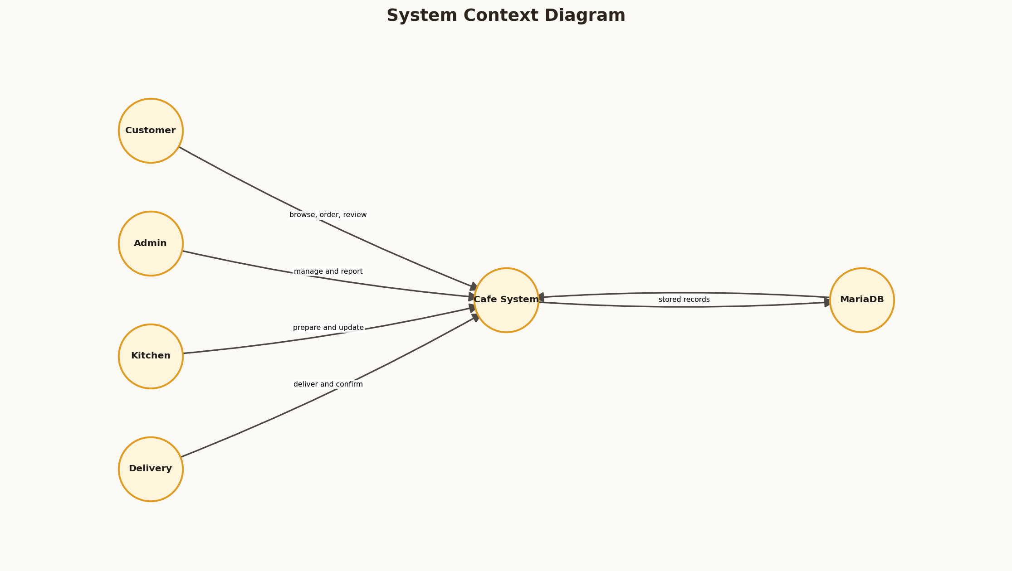
Figure 1: System Context Diagram
Arrow validation note: arrowheads point from the initiating or child component toward the receiving, referenced, or next-state component. Every endpoint was programmatically checked before the figure was embedded.

CHAPTER 4: SYSTEM ANALYSIS AND DESIGN

4.2 Layered Architecture
4.2 Layered Architecture is an important part of the Cafe platform because it connects visible user interaction with reliable server-side processing. The implementation was designed for a local XAMPP environment while retaining patterns that can be migrated to a hosted Apache and MariaDB deployment.
In practical operation, the architecture separates browser presentation, PHP rendering, action handling, helpers, PDO and storage. In this project, GET requests render pages while POST requests pass through action and security checks. Requests are checked at the server boundary, data is exchanged through prepared PDO statements, and the resulting state is rendered back into a responsive interface.
The resulting outcome is the source remains lightweight without losing logical separation. The design also provides traceability for testing because each interface action maps to a named action handler, one or more database operations, and an observable response.
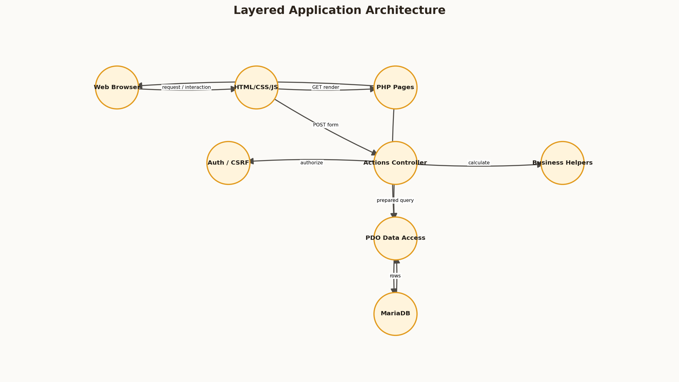
Figure 2: Layered Application Architecture
Arrow validation note: arrowheads point from the initiating or child component toward the receiving, referenced, or next-state component. Every endpoint was programmatically checked before the figure was embedded.

CHAPTER 4: SYSTEM ANALYSIS AND DESIGN

4.3 Customer Use Cases
4.3 Customer Use Cases is an important part of the Cafe platform because it connects visible user interaction with reliable server-side processing. The implementation was designed for a local XAMPP environment while retaining patterns that can be migrated to a hosted Apache and MariaDB deployment.
In practical operation, customer use cases begin with authentication and continue through menu, cart, checkout, tracking and review. In this project, directed relationships show the sequence of user intent. Requests are checked at the server boundary, data is exchanged through prepared PDO statements, and the resulting state is rendered back into a responsive interface.
The resulting outcome is functional coverage can be compared with implemented pages. The design also provides traceability for testing because each interface action maps to a named action handler, one or more database operations, and an observable response.
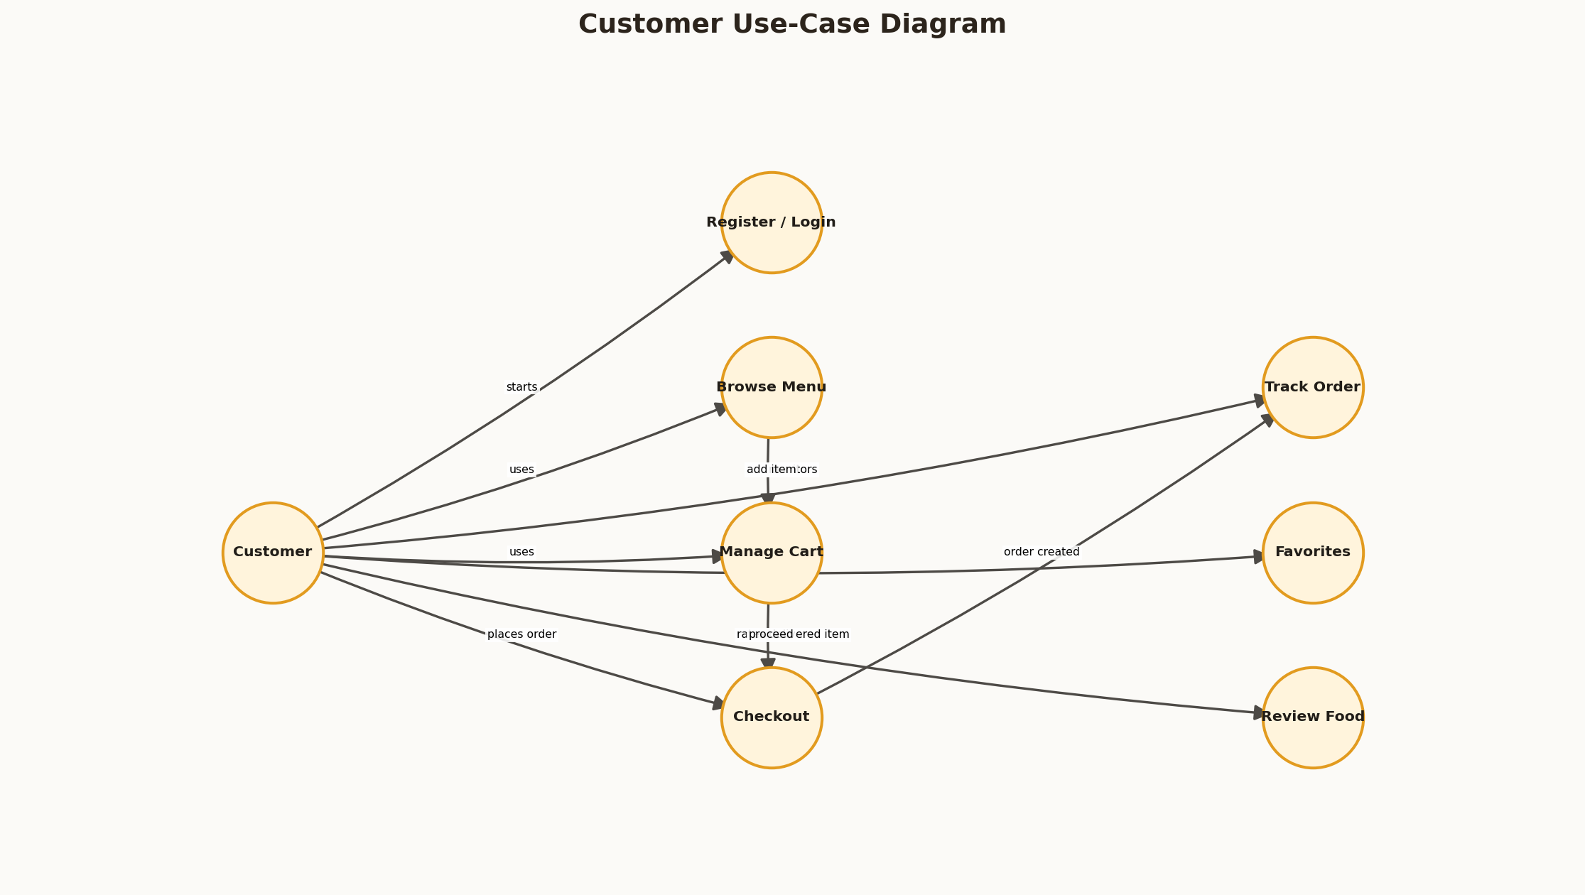
Figure 3: Customer Use-Case Diagram
Arrow validation note: arrowheads point from the initiating or child component toward the receiving, referenced, or next-state component. Every endpoint was programmatically checked before the figure was embedded.

CHAPTER 4: SYSTEM ANALYSIS AND DESIGN

4.4 Staff Use Cases
4.4 Staff Use Cases is an important part of the Cafe platform because it connects visible user interaction with reliable server-side processing. The implementation was designed for a local XAMPP environment while retaining patterns that can be migrated to a hosted Apache and MariaDB deployment.
In practical operation, staff use cases are partitioned by administrative, kitchen and delivery duties. In this project, role guards and state transitions prevent unrelated actions. Requests are checked at the server boundary, data is exchanged through prepared PDO statements, and the resulting state is rendered back into a responsive interface.
The resulting outcome is least-privilege operation is supported. The design also provides traceability for testing because each interface action maps to a named action handler, one or more database operations, and an observable response.
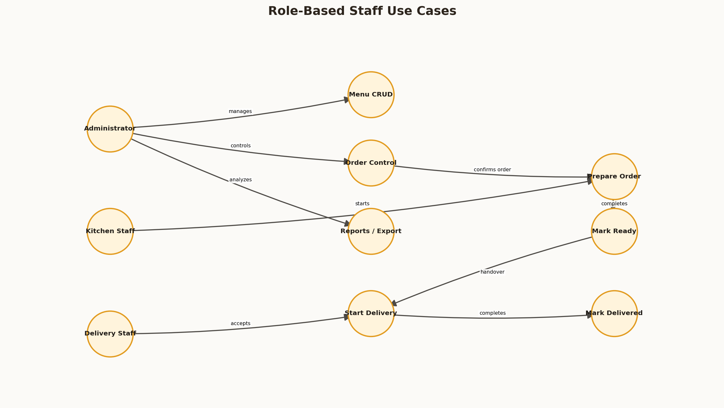
Figure 4: Role-Based Staff Use Cases
Arrow validation note: arrowheads point from the initiating or child component toward the receiving, referenced, or next-state component. Every endpoint was programmatically checked before the figure was embedded.

CHAPTER 4: SYSTEM ANALYSIS AND DESIGN

4.5 Context-Level Data Flow
4.5 Context-Level Data Flow is an important part of the Cafe platform because it connects visible user interaction with reliable server-side processing. The implementation was designed for a local XAMPP environment while retaining patterns that can be migrated to a hosted Apache and MariaDB deployment.
In practical operation, the level-zero DFD summarizes how credentials, menu data, order data and status information move. In this project, processes communicate with explicit stores rather than hidden state. Requests are checked at the server boundary, data is exchanged through prepared PDO statements, and the resulting state is rendered back into a responsive interface.
The resulting outcome is data responsibilities can be reviewed before database design. The design also provides traceability for testing because each interface action maps to a named action handler, one or more database operations, and an observable response.
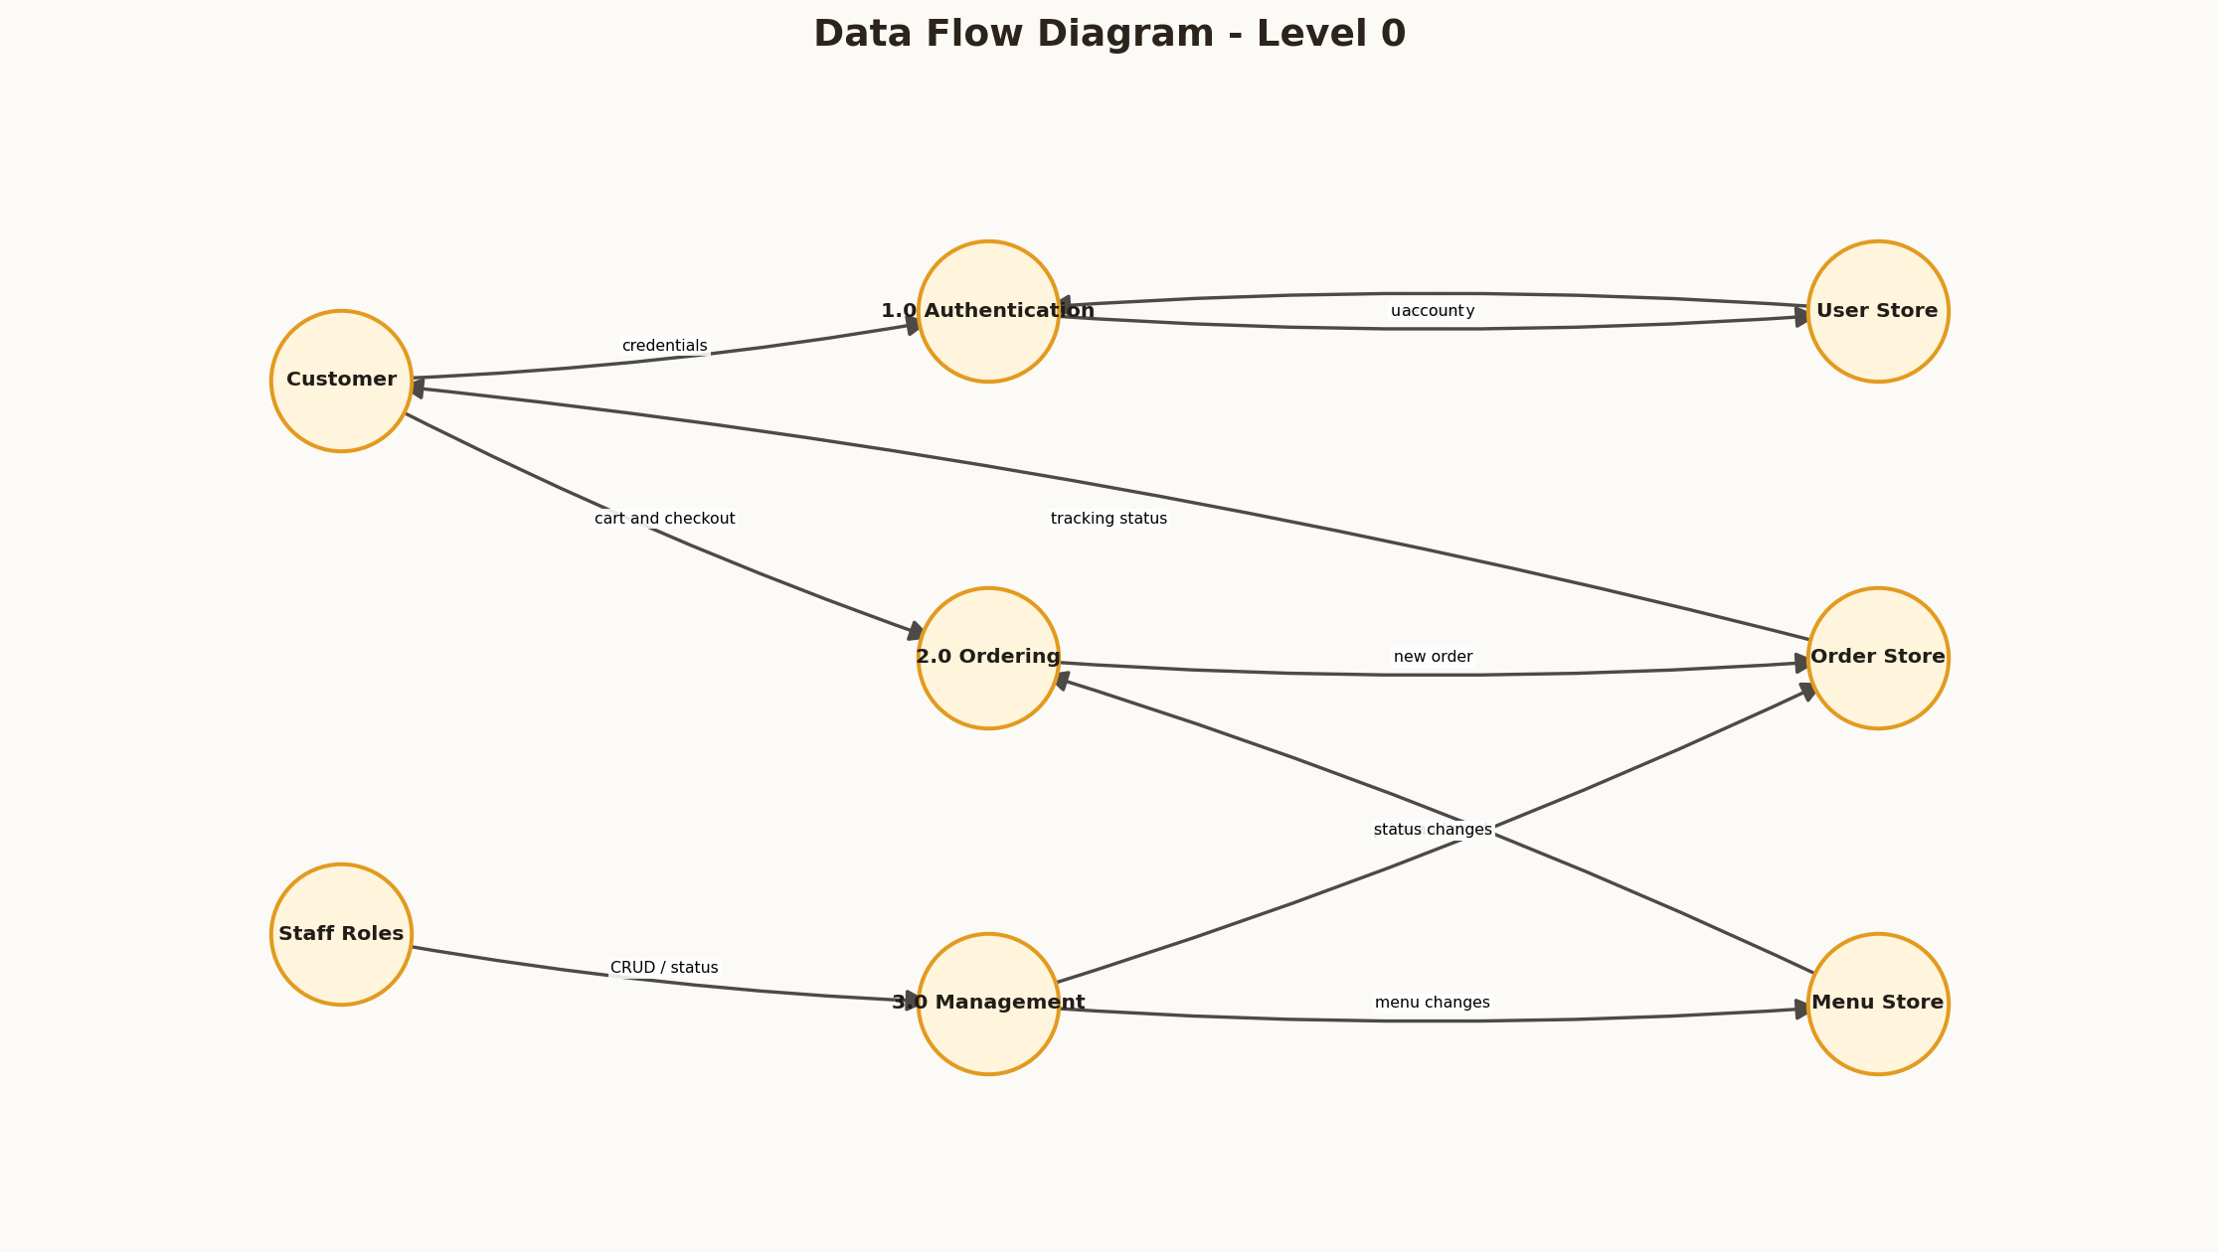
Figure 5: Data Flow Diagram - Level 0
Arrow validation note: arrowheads point from the initiating or child component toward the receiving, referenced, or next-state component. Every endpoint was programmatically checked before the figure was embedded.

CHAPTER 4: SYSTEM ANALYSIS AND DESIGN

4.6 Detailed Order Data Flow
4.6 Detailed Order Data Flow is an important part of the Cafe platform because it connects visible user interaction with reliable server-side processing. The implementation was designed for a local XAMPP environment while retaining patterns that can be migrated to a hosted Apache and MariaDB deployment.
In practical operation, the level-one order DFD expands validation, calculation, insertion, stock update, transaction and notification. In this project, every directed edge represents data or control passed to the next stage. Requests are checked at the server boundary, data is exchanged through prepared PDO statements, and the resulting state is rendered back into a responsive interface.
The resulting outcome is partial orders are avoided through transaction rollback. The design also provides traceability for testing because each interface action maps to a named action handler, one or more database operations, and an observable response.
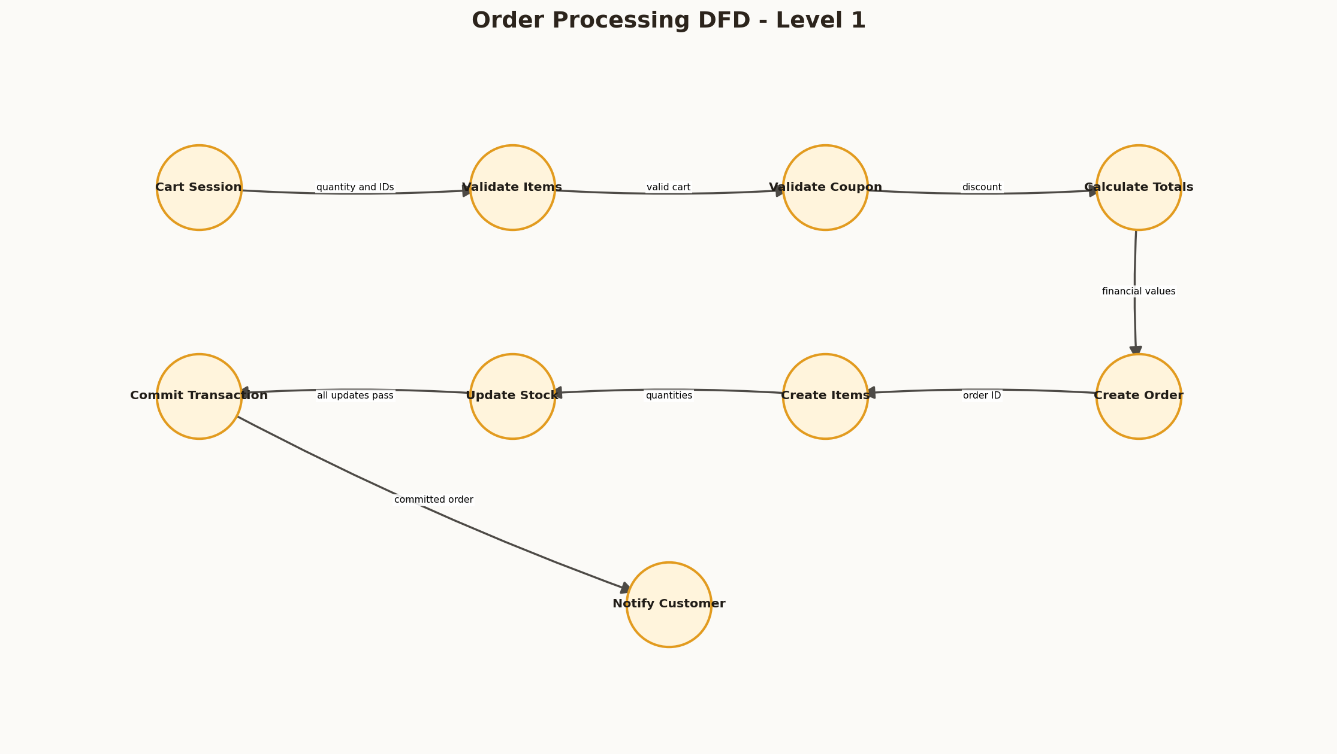
Figure 6: Order Processing DFD - Level 1
Arrow validation note: arrowheads point from the initiating or child component toward the receiving, referenced, or next-state component. Every endpoint was programmatically checked before the figure was embedded.

CHAPTER 4: SYSTEM ANALYSIS AND DESIGN

4.7 Navigation Design
4.7 Navigation Design is an important part of the Cafe platform because it connects visible user interaction with reliable server-side processing. The implementation was designed for a local XAMPP environment while retaining patterns that can be migrated to a hosted Apache and MariaDB deployment.
In practical operation, navigation connects public discovery to customer pages and separates staff destinations by role. In this project, active sidebar states and protected redirects preserve context. Requests are checked at the server boundary, data is exchanged through prepared PDO statements, and the resulting state is rendered back into a responsive interface.
The resulting outcome is users reach permitted functionality with fewer ambiguous controls. The design also provides traceability for testing because each interface action maps to a named action handler, one or more database operations, and an observable response.
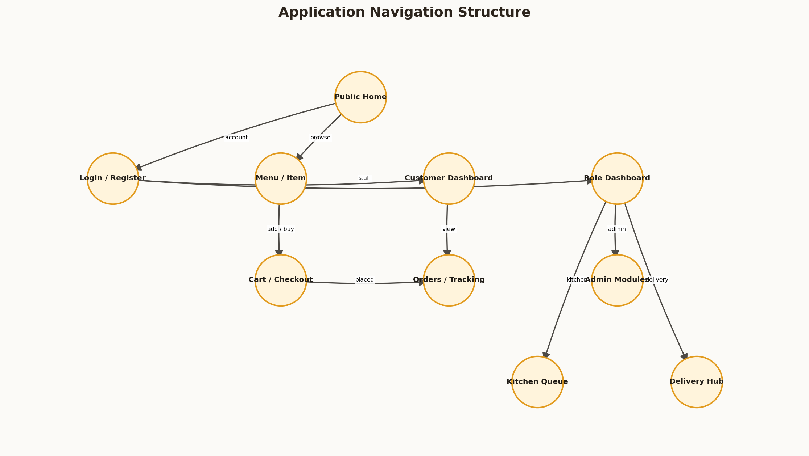
Figure 7: Application Navigation Structure
Arrow validation note: arrowheads point from the initiating or child component toward the receiving, referenced, or next-state component. Every endpoint was programmatically checked before the figure was embedded.

CHAPTER 4: SYSTEM ANALYSIS AND DESIGN

4.8 Order State Machine
4.8 Order State Machine is an important part of the Cafe platform because it connects visible user interaction with reliable server-side processing. The implementation was designed for a local XAMPP environment while retaining patterns that can be migrated to a hosted Apache and MariaDB deployment.
In practical operation, order status is modeled as a directional lifecycle rather than an arbitrary label. In this project, kitchen and delivery transitions have defined predecessors. Requests are checked at the server boundary, data is exchanged through prepared PDO statements, and the resulting state is rendered back into a responsive interface.
The resulting outcome is invalid jumps and cross-rider updates can be rejected. The design also provides traceability for testing because each interface action maps to a named action handler, one or more database operations, and an observable response.
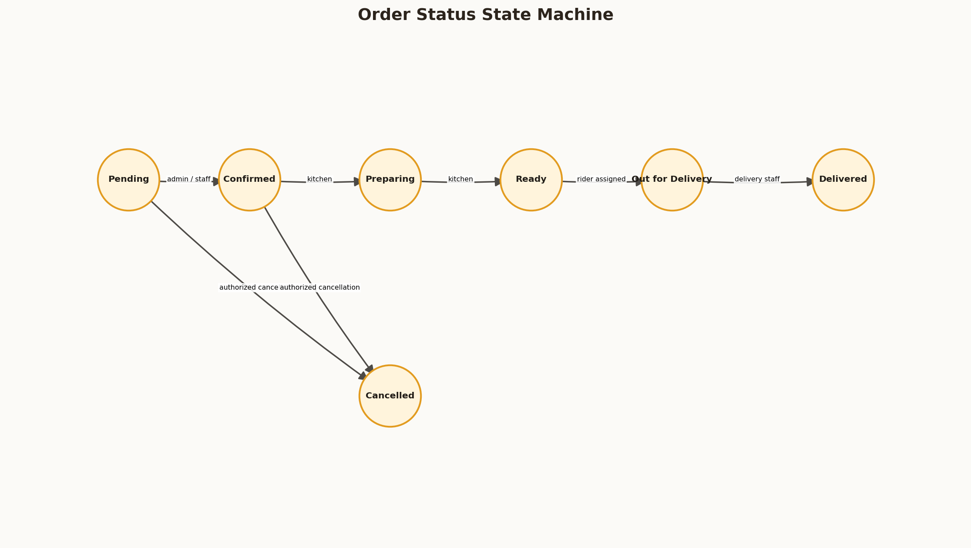
Figure 8: Order Status State Machine
Arrow validation note: arrowheads point from the initiating or child component toward the receiving, referenced, or next-state component. Every endpoint was programmatically checked before the figure was embedded.

CHAPTER 5: DATABASE DESIGN

5.1 Database Design Objectives
5.1 Database Design Objectives is an important part of the Cafe platform because it connects visible user interaction with reliable server-side processing. The implementation was designed for a local XAMPP environment while retaining patterns that can be migrated to a hosted Apache and MariaDB deployment.
In practical operation, the data model must retain identity, menu, financial, fulfillment and feedback records without unnecessary duplication. In this project, foreign keys link transactional rows and indexes support common status and category access. Requests are checked at the server boundary, data is exchanged through prepared PDO statements, and the resulting state is rendered back into a responsive interface.
The resulting outcome is records remain consistent and queryable. The design also provides traceability for testing because each interface action maps to a named action handler, one or more database operations, and an observable response.

CHAPTER 5: DATABASE DESIGN

5.2 Entity Relationship Model
5.2 Entity Relationship Model is an important part of the Cafe platform because it connects visible user interaction with reliable server-side processing. The implementation was designed for a local XAMPP environment while retaining patterns that can be migrated to a hosted Apache and MariaDB deployment.
In practical operation, the ER model represents primary entities and foreign-key direction from child record to referenced parent. In this project, orders own line items while users, menu items and categories remain reusable entities. Requests are checked at the server boundary, data is exchanged through prepared PDO statements, and the resulting state is rendered back into a responsive interface.
The resulting outcome is deletion policies preserve historical meaning where appropriate. The design also provides traceability for testing because each interface action maps to a named action handler, one or more database operations, and an observable response.
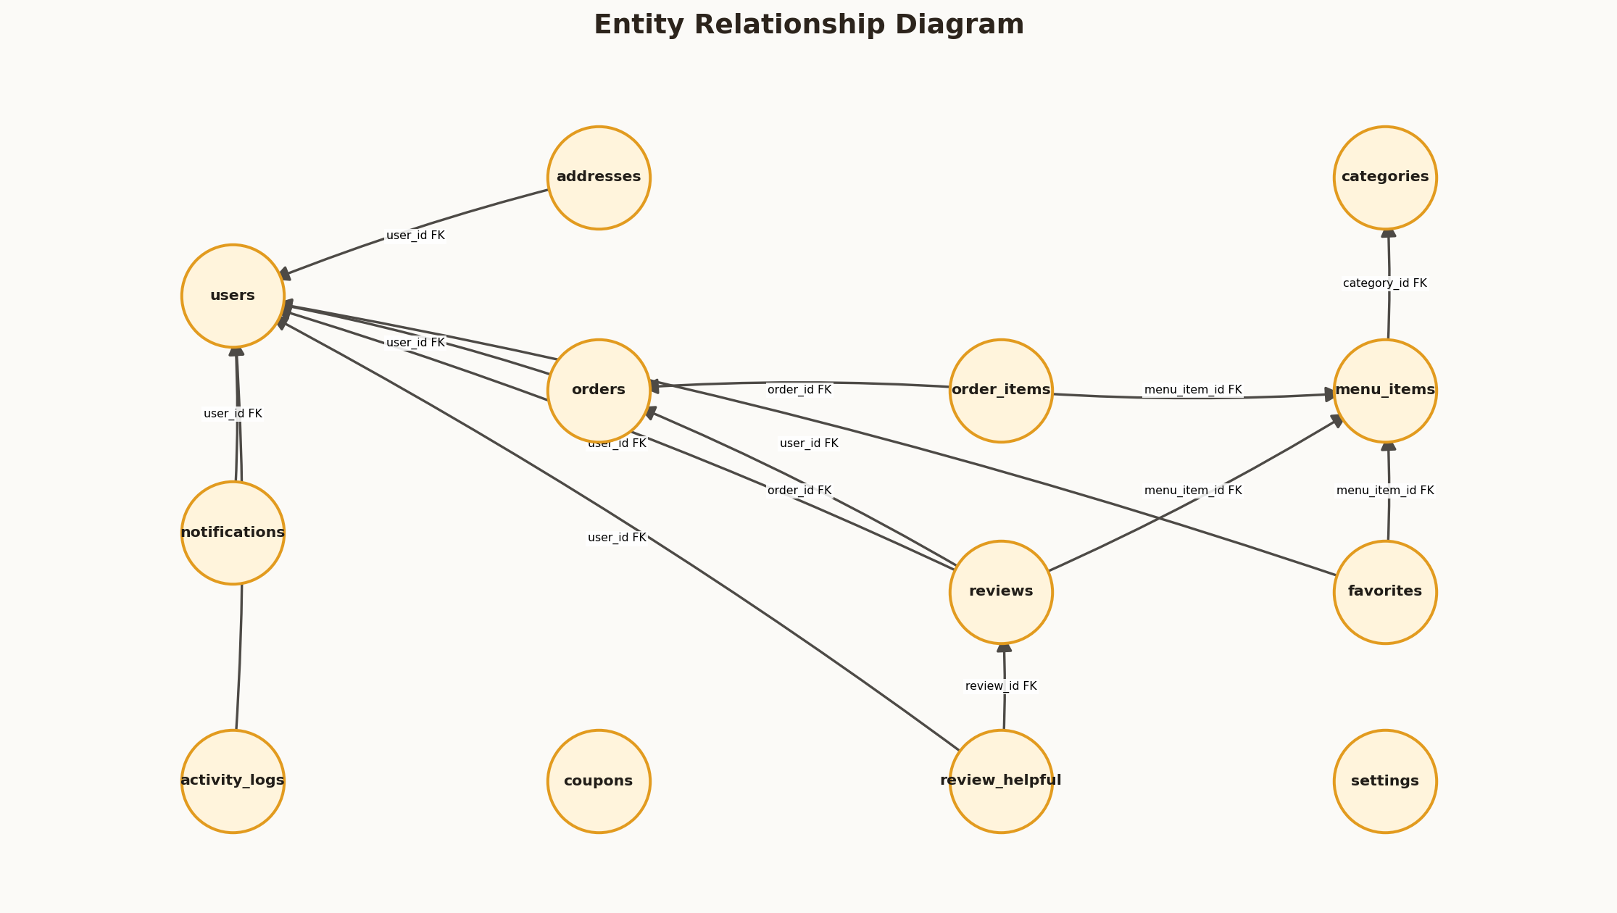
Figure 9: Entity Relationship Diagram
Arrow validation note: arrowheads point from the initiating or child component toward the receiving, referenced, or next-state component. Every endpoint was programmatically checked before the figure was embedded.

CHAPTER 5: DATABASE DESIGN

5.3 User and Address Tables
5.3 User and Address Tables is an important part of the Cafe platform because it connects visible user interaction with reliable server-side processing. The implementation was designed for a local XAMPP environment while retaining patterns that can be migrated to a hosted Apache and MariaDB deployment.
In practical operation, users store authentication identity, role, contact and account state while addresses store reusable delivery locations. In this project, password values contain hashes rather than plain text. Requests are checked at the server boundary, data is exchanged through prepared PDO statements, and the resulting state is rendered back into a responsive interface.
The resulting outcome is authentication and profile data remain centralized. The design also provides traceability for testing because each interface action maps to a named action handler, one or more database operations, and an observable response.

CHAPTER 5: DATABASE DESIGN

5.4 Menu and Category Tables
5.4 Menu and Category Tables is an important part of the Cafe platform because it connects visible user interaction with reliable server-side processing. The implementation was designed for a local XAMPP environment while retaining patterns that can be migrated to a hosted Apache and MariaDB deployment.
In practical operation, categories group dishes and menu items store price, image, dietary, rating, preparation and stock properties. In this project, availability flags support soft removal from the public menu. Requests are checked at the server boundary, data is exchanged through prepared PDO statements, and the resulting state is rendered back into a responsive interface.
The resulting outcome is historical order items remain readable after menu changes. The design also provides traceability for testing because each interface action maps to a named action handler, one or more database operations, and an observable response.

CHAPTER 5: DATABASE DESIGN

5.5 Order and Order-Item Tables
5.5 Order and Order-Item Tables is an important part of the Cafe platform because it connects visible user interaction with reliable server-side processing. The implementation was designed for a local XAMPP environment while retaining patterns that can be migrated to a hosted Apache and MariaDB deployment.
In practical operation, orders store customer snapshot, totals, payment, fulfillment and timestamps while order items preserve purchased name and price. In this project, transactional insertion and stock decrement occur together. Requests are checked at the server boundary, data is exchanged through prepared PDO statements, and the resulting state is rendered back into a responsive interface.
The resulting outcome is financial reconstruction and reporting are possible. The design also provides traceability for testing because each interface action maps to a named action handler, one or more database operations, and an observable response.

CHAPTER 5: DATABASE DESIGN

5.6 Supporting Tables
5.6 Supporting Tables is an important part of the Cafe platform because it connects visible user interaction with reliable server-side processing. The implementation was designed for a local XAMPP environment while retaining patterns that can be migrated to a hosted Apache and MariaDB deployment.
In practical operation, coupons, reviews, favorites, notifications, helpful votes, settings and activity logs extend the core model. In this project, each supporting table has a narrow responsibility. Requests are checked at the server boundary, data is exchanged through prepared PDO statements, and the resulting state is rendered back into a responsive interface.
The resulting outcome is features can evolve without overloading order records. The design also provides traceability for testing because each interface action maps to a named action handler, one or more database operations, and an observable response.
Table | Purpose | Important Fields
coupons | Discount rules | code, type, value, minimum_order, valid_until
reviews | Verified feedback | rating, comment, admin_reply, helpful_count
favorites | Saved dishes | user_id, menu_item_id
notifications | Customer updates | title, message, icon, is_read
settings | Restaurant configuration | setting_key, setting_value
activity_logs | Privileged audit support | user_id, action, ip_address

CHAPTER 6: IMPLEMENTATION

6.1 Project Structure
6.1 Project Structure is an important part of the Cafe platform because it connects visible user interaction with reliable server-side processing. The implementation was designed for a local XAMPP environment while retaining patterns that can be migrated to a hosted Apache and MariaDB deployment.
In practical operation, configuration, helpers, action handlers, customer pages, dashboards, assets, SQL, uploads and documentation are stored in recognizable locations. In this project, shared behavior is required from functions.php and configuration is centralized. Requests are checked at the server boundary, data is exchanged through prepared PDO statements, and the resulting state is rendered back into a responsive interface.
The resulting outcome is new contributors can locate responsibilities quickly. The design also provides traceability for testing because each interface action maps to a named action handler, one or more database operations, and an observable response.
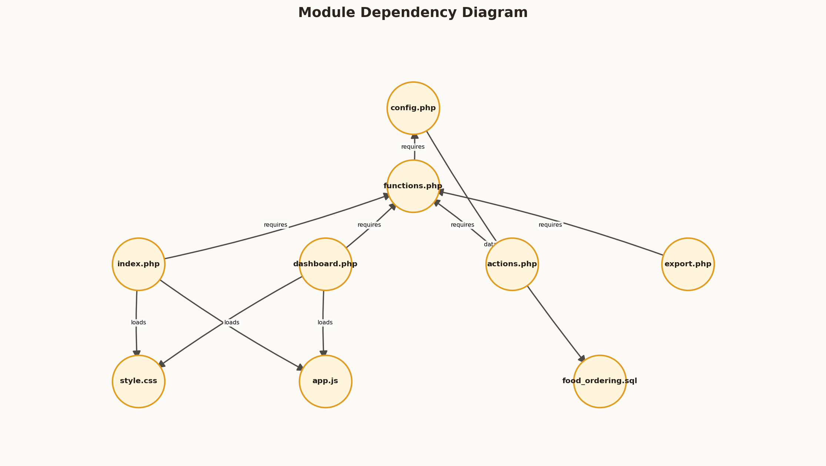
Figure 10: Module Dependency Diagram
Arrow validation note: arrowheads point from the initiating or child component toward the receiving, referenced, or next-state component. Every endpoint was programmatically checked before the figure was embedded.
Path | Responsibility
index.php | Public and customer routes
dashboard.php | Role-specific dashboards
actions.php | POST action controller
functions.php | Shared auth, CSRF, cart and query helpers
config.php | Session and PDO configuration
database/food_ordering.sql | Schema and demo data
assets/ | Styles, scripts and visual assets
uploads/menu/ | Validated menu uploads

CHAPTER 6: IMPLEMENTATION

6.2 Authentication Implementation
6.2 Authentication Implementation is an important part of the Cafe platform because it connects visible user interaction with reliable server-side processing. The implementation was designed for a local XAMPP environment while retaining patterns that can be migrated to a hosted Apache and MariaDB deployment.
In practical operation, login retrieves an active account by email and verifies a password hash before regenerating the session ID. In this project, the session stores role identity used by guards and navigation. Requests are checked at the server boundary, data is exchanged through prepared PDO statements, and the resulting state is rendered back into a responsive interface.
The resulting outcome is credentials are never compared as plain text. The design also provides traceability for testing because each interface action maps to a named action handler, one or more database operations, and an observable response.
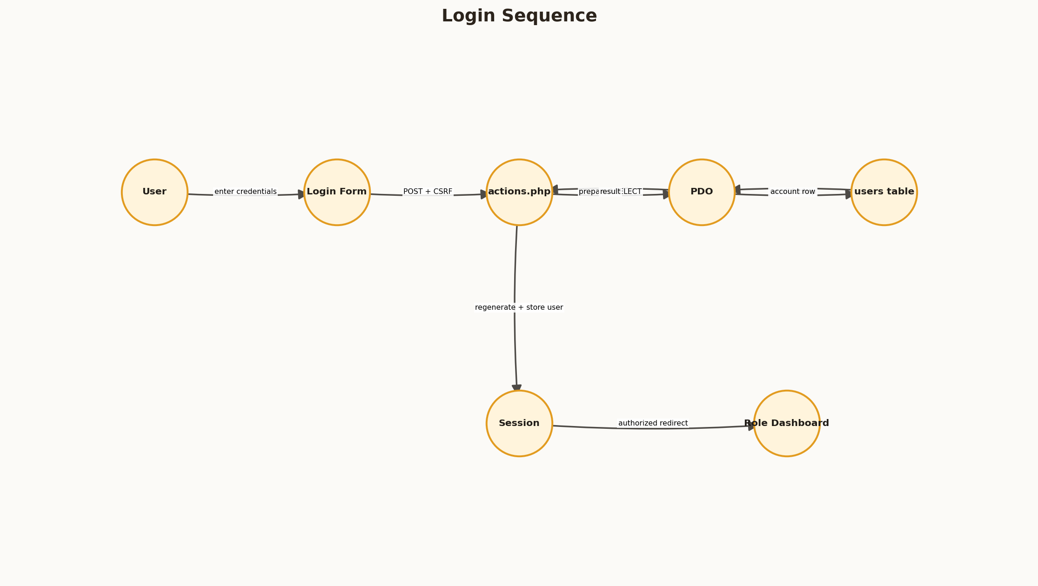
Figure 11: Login Sequence
Arrow validation note: arrowheads point from the initiating or child component toward the receiving, referenced, or next-state component. Every endpoint was programmatically checked before the figure was embedded.

CHAPTER 6: IMPLEMENTATION

6.3 Customer Interface Implementation
6.3 Customer Interface Implementation is an important part of the Cafe platform because it connects visible user interaction with reliable server-side processing. The implementation was designed for a local XAMPP environment while retaining patterns that can be migrated to a hosted Apache and MariaDB deployment.
In practical operation, the public landing page, menu, item details, cart, checkout, dashboard, favorites, orders and tracking pages are rendered from live data. In this project, forms map to named actions and visible totals are recalculated on both client and server. Requests are checked at the server boundary, data is exchanged through prepared PDO statements, and the resulting state is rendered back into a responsive interface.
The resulting outcome is customer actions remain functional as well as attractive. The design also provides traceability for testing because each interface action maps to a named action handler, one or more database operations, and an observable response.

CHAPTER 6: IMPLEMENTATION

6.4 Cart, Coupon and Checkout Logic
6.4 Cart, Coupon and Checkout Logic is an important part of the Cafe platform because it connects visible user interaction with reliable server-side processing. The implementation was designed for a local XAMPP environment while retaining patterns that can be migrated to a hosted Apache and MariaDB deployment.
In practical operation, cart state is held in the session while product prices, availability and stock are revalidated before order creation. In this project, coupon rules are recalculated against the current subtotal and checkout enforces minimum value. Requests are checked at the server boundary, data is exchanged through prepared PDO statements, and the resulting state is rendered back into a responsive interface.
The resulting outcome is tampered or stale cart information cannot silently create invalid orders. The design also provides traceability for testing because each interface action maps to a named action handler, one or more database operations, and an observable response.
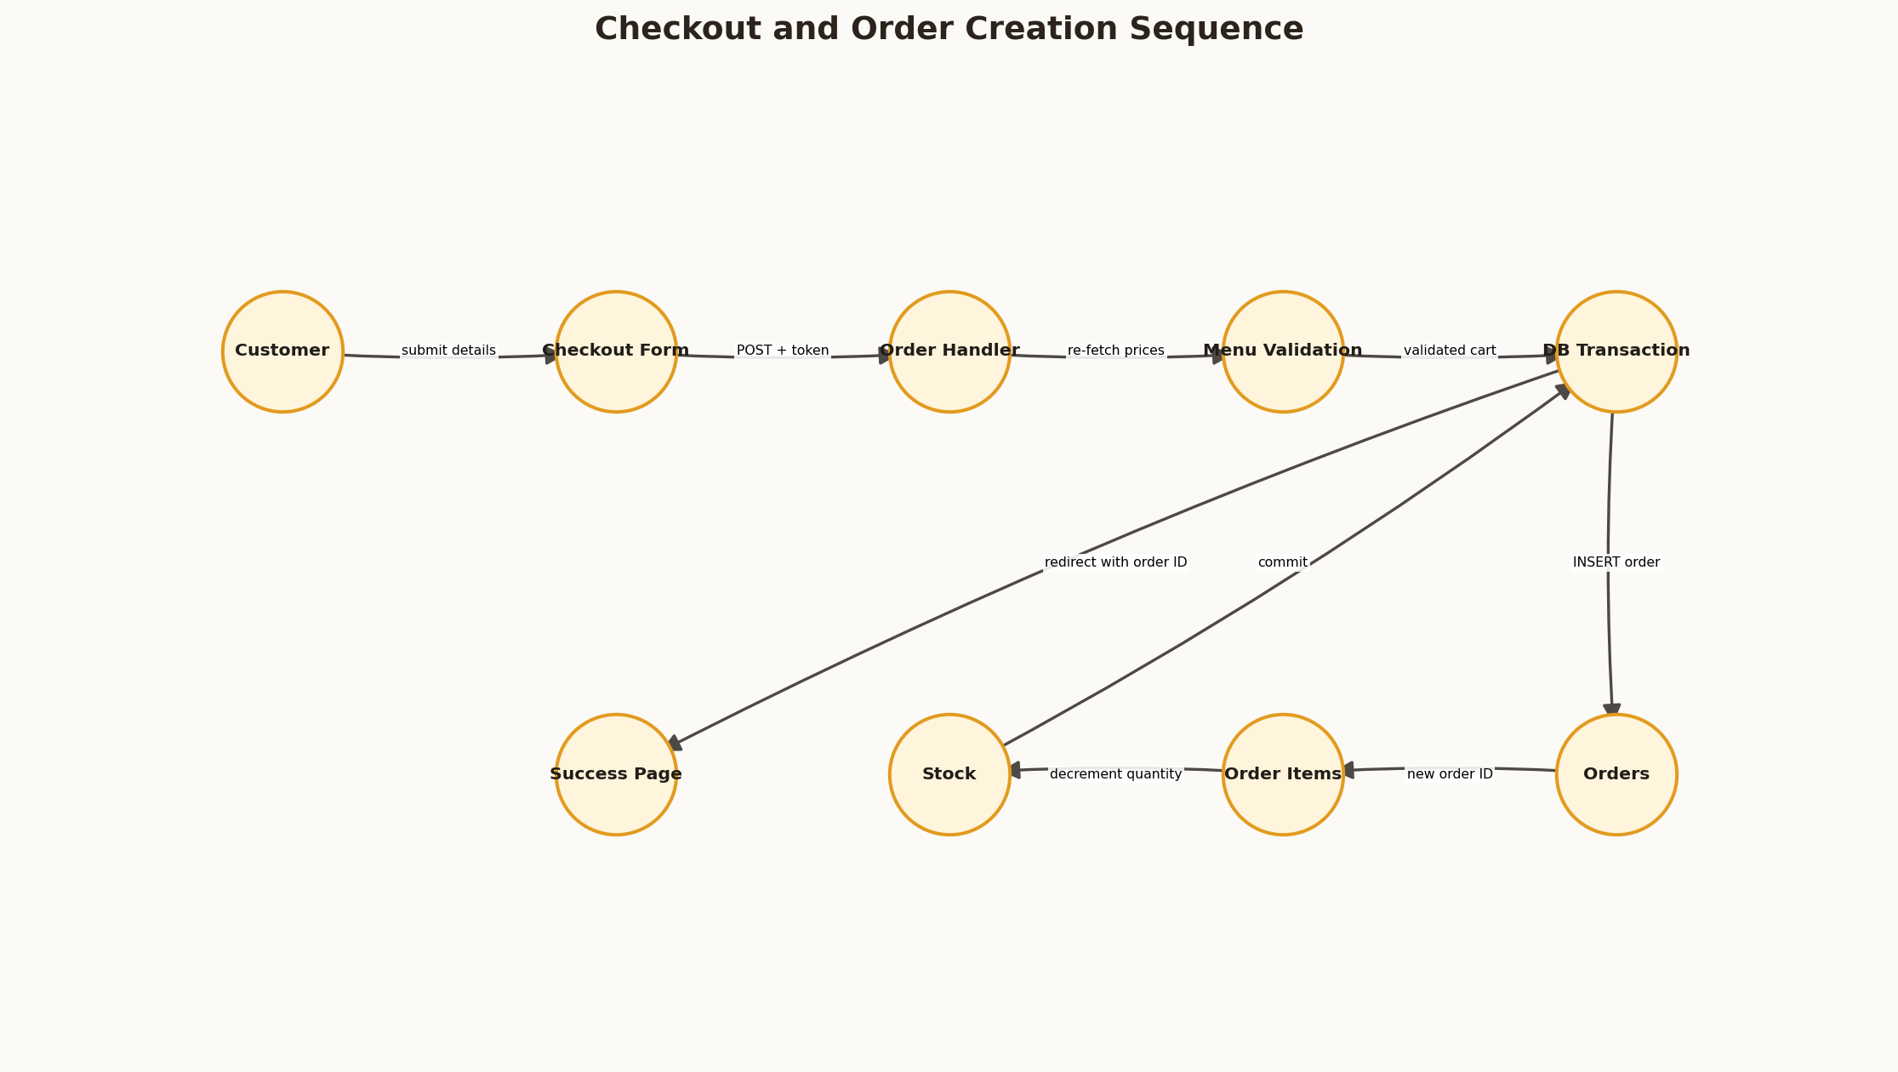
Figure 12: Checkout and Order Creation Sequence
Arrow validation note: arrowheads point from the initiating or child component toward the receiving, referenced, or next-state component. Every endpoint was programmatically checked before the figure was embedded.

CHAPTER 6: IMPLEMENTATION

6.5 Administrative Dashboard
6.5 Administrative Dashboard is an important part of the Cafe platform because it connects visible user interaction with reliable server-side processing. The implementation was designed for a local XAMPP environment while retaining patterns that can be migrated to a hosted Apache and MariaDB deployment.
In practical operation, administrators receive real totals, paginated menu records, CSV export and CRUD interfaces. In this project, image uploads use MIME checks, random filenames and size limits. Requests are checked at the server boundary, data is exchanged through prepared PDO statements, and the resulting state is rendered back into a responsive interface.
The resulting outcome is dashboard controls persist changes instead of acting as placeholders. The design also provides traceability for testing because each interface action maps to a named action handler, one or more database operations, and an observable response.

CHAPTER 6: IMPLEMENTATION

6.6 Kitchen Dashboard
6.6 Kitchen Dashboard is an important part of the Cafe platform because it connects visible user interaction with reliable server-side processing. The implementation was designed for a local XAMPP environment while retaining patterns that can be migrated to a hosted Apache and MariaDB deployment.
In practical operation, confirmed orders enter the kitchen queue where staff can begin preparation and mark completion. In this project, the interface displays item quantity, instructions and elapsed time. Requests are checked at the server boundary, data is exchanged through prepared PDO statements, and the resulting state is rendered back into a responsive interface.
The resulting outcome is the kitchen is isolated from unrelated administrative functions. The design also provides traceability for testing because each interface action maps to a named action handler, one or more database operations, and an observable response.

CHAPTER 6: IMPLEMENTATION

6.7 Delivery Dashboard
6.7 Delivery Dashboard is an important part of the Cafe platform because it connects visible user interaction with reliable server-side processing. The implementation was designed for a local XAMPP environment while retaining patterns that can be migrated to a hosted Apache and MariaDB deployment.
In practical operation, ready orders are offered to delivery staff and assignment occurs when delivery begins. In this project, another rider cannot update an already assigned delivery. Requests are checked at the server boundary, data is exchanged through prepared PDO statements, and the resulting state is rendered back into a responsive interface.
The resulting outcome is the final action records delivery and settles cash-on-delivery status. The design also provides traceability for testing because each interface action maps to a named action handler, one or more database operations, and an observable response.

CHAPTER 6: IMPLEMENTATION

6.8 Reporting and Settings
6.8 Reporting and Settings is an important part of the Cafe platform because it connects visible user interaction with reliable server-side processing. The implementation was designed for a local XAMPP environment while retaining patterns that can be migrated to a hosted Apache and MariaDB deployment.
In practical operation, reports aggregate revenue, order values and repeat activity while settings control contact, hours, fees, thresholds and tax. In this project, CSV export uses filtered order data and settings are upserted through a whitelist. Requests are checked at the server boundary, data is exchanged through prepared PDO statements, and the resulting state is rendered back into a responsive interface.
The resulting outcome is operational data can be reviewed and adjusted safely. The design also provides traceability for testing because each interface action maps to a named action handler, one or more database operations, and an observable response.

CHAPTER 7: SECURITY AND RELIABILITY

7.1 Authentication and Authorization
7.1 Authentication and Authorization is an important part of the Cafe platform because it connects visible user interaction with reliable server-side processing. The implementation was designed for a local XAMPP environment while retaining patterns that can be migrated to a hosted Apache and MariaDB deployment.
In practical operation, authentication establishes identity and authorization limits every privileged action by role. In this project, customer-only routes redirect staff to dashboards and inactive accounts cannot sign in. Requests are checked at the server boundary, data is exchanged through prepared PDO statements, and the resulting state is rendered back into a responsive interface.
The resulting outcome is data and functions are protected beyond visual menu hiding. The design also provides traceability for testing because each interface action maps to a named action handler, one or more database operations, and an observable response.

CHAPTER 7: SECURITY AND RELIABILITY

7.2 CSRF and Session Security
7.2 CSRF and Session Security is an important part of the Cafe platform because it connects visible user interaction with reliable server-side processing. The implementation was designed for a local XAMPP environment while retaining patterns that can be migrated to a hosted Apache and MariaDB deployment.
In practical operation, every state-changing form includes a session token checked before action dispatch. In this project, empty or mismatched tokens produce a 419 response and successful login regenerates the session identifier. Requests are checked at the server boundary, data is exchanged through prepared PDO statements, and the resulting state is rendered back into a responsive interface.
The resulting outcome is forged cross-site form submissions are rejected. The design also provides traceability for testing because each interface action maps to a named action handler, one or more database operations, and an observable response.
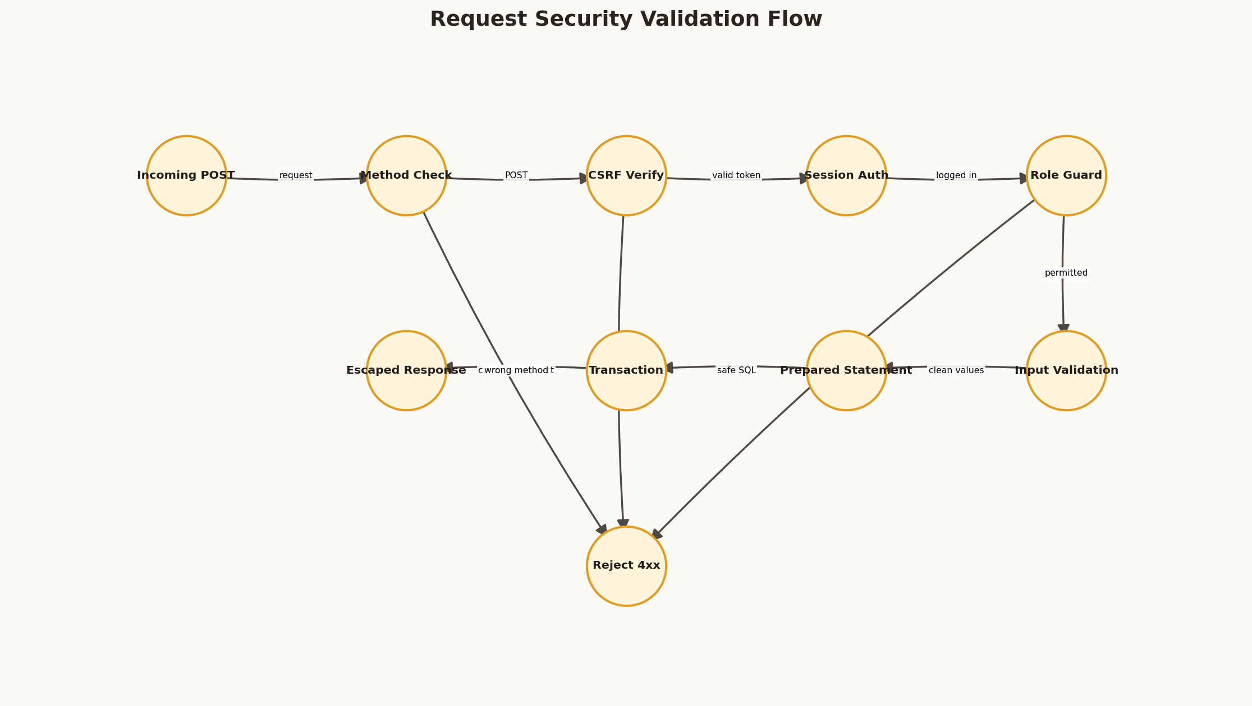
Figure 13: Request Security Validation Flow
Arrow validation note: arrowheads point from the initiating or child component toward the receiving, referenced, or next-state component. Every endpoint was programmatically checked before the figure was embedded.

CHAPTER 7: SECURITY AND RELIABILITY

7.3 SQL Injection and XSS Prevention
7.3 SQL Injection and XSS Prevention is an important part of the Cafe platform because it connects visible user interaction with reliable server-side processing. The implementation was designed for a local XAMPP environment while retaining patterns that can be migrated to a hosted Apache and MariaDB deployment.
In practical operation, PDO prepared statements separate SQL structure from values and output uses HTML escaping. In this project, dynamic redirects are restricted to recognized local prefixes. Requests are checked at the server boundary, data is exchanged through prepared PDO statements, and the resulting state is rendered back into a responsive interface.
The resulting outcome is common injection and stored markup risks are reduced. The design also provides traceability for testing because each interface action maps to a named action handler, one or more database operations, and an observable response.

CHAPTER 7: SECURITY AND RELIABILITY

7.4 Transaction and Stock Integrity
7.4 Transaction and Stock Integrity is an important part of the Cafe platform because it connects visible user interaction with reliable server-side processing. The implementation was designed for a local XAMPP environment while retaining patterns that can be migrated to a hosted Apache and MariaDB deployment.
In practical operation, order creation validates current menu values and updates order, line items, stock, coupon count and notification in one transaction. In this project, a failed stock update throws an exception and rolls back. Requests are checked at the server boundary, data is exchanged through prepared PDO statements, and the resulting state is rendered back into a responsive interface.
The resulting outcome is the database avoids partially completed orders. The design also provides traceability for testing because each interface action maps to a named action handler, one or more database operations, and an observable response.

CHAPTER 7: SECURITY AND RELIABILITY

7.5 Upload and Validation Controls
7.5 Upload and Validation Controls is an important part of the Cafe platform because it connects visible user interaction with reliable server-side processing. The implementation was designed for a local XAMPP environment while retaining patterns that can be migrated to a hosted Apache and MariaDB deployment.
In practical operation, uploaded images are restricted by MIME type, size and randomized server filename. In this project, numeric, date, email, role and text-length checks are applied before storage. Requests are checked at the server boundary, data is exchanged through prepared PDO statements, and the resulting state is rendered back into a responsive interface.
The resulting outcome is invalid content fails with an understandable response. The design also provides traceability for testing because each interface action maps to a named action handler, one or more database operations, and an observable response.
Control | Rule
Image MIME | JPEG, PNG, WebP or GIF
Maximum image size | 2 MB application limit
Filename | Random 24-character hexadecimal value
Coupon code | Uppercase letters, digits, underscore or hyphen
Staff role | Admin, kitchen, delivery or staff only
Review comment | 5 to 500 characters

CHAPTER 8: TESTING AND VALIDATION

8.1 Testing Strategy
8.1 Testing Strategy is an important part of the Cafe platform because it connects visible user interaction with reliable server-side processing. The implementation was designed for a local XAMPP environment while retaining patterns that can be migrated to a hosted Apache and MariaDB deployment.
In practical operation, testing combines PHP syntax checks, JavaScript parsing, HTTP flows, database queries, role sign-in tests and cleanup. In this project, each test follows the browser-to-handler-to-database-to-response story. Requests are checked at the server boundary, data is exchanged through prepared PDO statements, and the resulting state is rendered back into a responsive interface.
The resulting outcome is evidence covers more than page rendering. The design also provides traceability for testing because each interface action maps to a named action handler, one or more database operations, and an observable response.
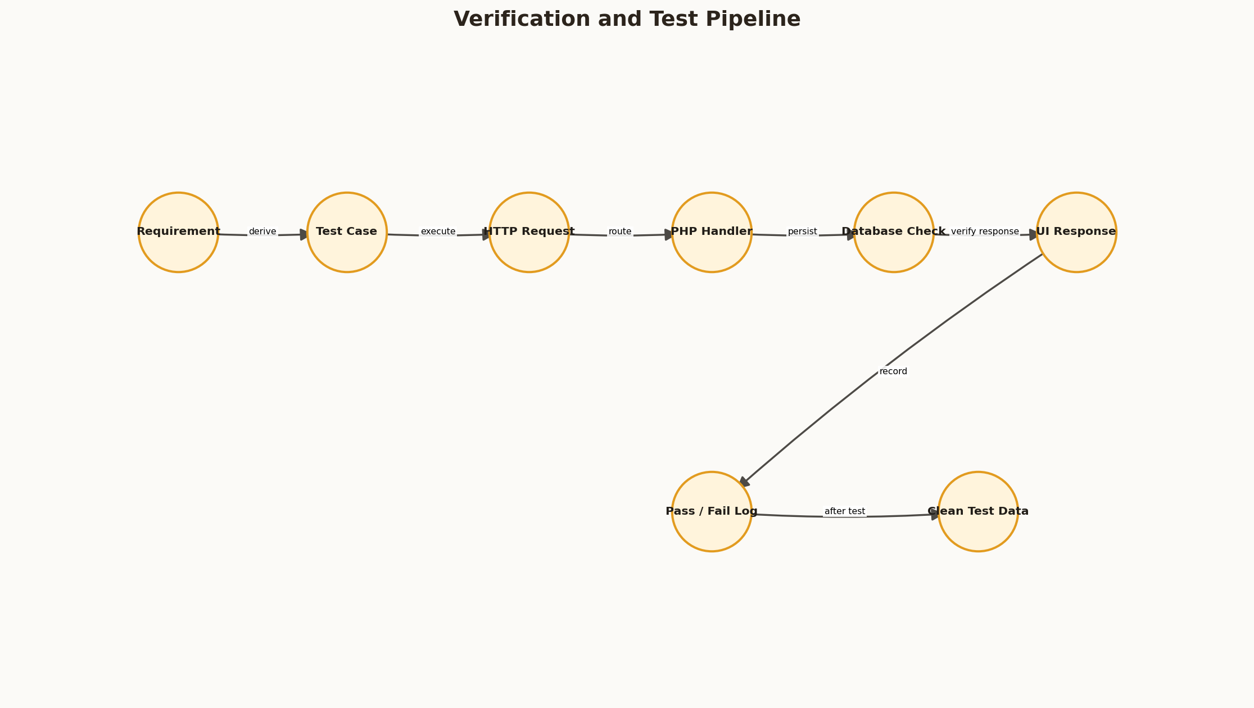
Figure 14: Verification and Test Pipeline
Arrow validation note: arrowheads point from the initiating or child component toward the receiving, referenced, or next-state component. Every endpoint was programmatically checked before the figure was embedded.

CHAPTER 8: TESTING AND VALIDATION

8.2 Authentication Tests
8.2 Authentication Tests is an important part of the Cafe platform because it connects visible user interaction with reliable server-side processing. The implementation was designed for a local XAMPP environment while retaining patterns that can be migrated to a hosted Apache and MariaDB deployment.
In practical operation, valid and invalid credentials, inactive users, customer redirects and staff dashboards are checked. In this project, CSRF omission and unauthorized export access are tested separately. Requests are checked at the server boundary, data is exchanged through prepared PDO statements, and the resulting state is rendered back into a responsive interface.
The resulting outcome is identity boundaries behave as expected. The design also provides traceability for testing because each interface action maps to a named action handler, one or more database operations, and an observable response.

CHAPTER 8: TESTING AND VALIDATION

8.3 Cart and Checkout Tests
8.3 Cart and Checkout Tests is an important part of the Cafe platform because it connects visible user interaction with reliable server-side processing. The implementation was designed for a local XAMPP environment while retaining patterns that can be migrated to a hosted Apache and MariaDB deployment.
In practical operation, tests add several items, change quantity, verify live markup, apply and remove coupons, reach checkout and place an order. In this project, database records and stock changes are inspected before temporary test data is removed. Requests are checked at the server boundary, data is exchanged through prepared PDO statements, and the resulting state is rendered back into a responsive interface.
The resulting outcome is calculation and persistence agree. The design also provides traceability for testing because each interface action maps to a named action handler, one or more database operations, and an observable response.

CHAPTER 8: TESTING AND VALIDATION

8.4 Multi-Role Lifecycle Test
8.4 Multi-Role Lifecycle Test is an important part of the Cafe platform because it connects visible user interaction with reliable server-side processing. The implementation was designed for a local XAMPP environment while retaining patterns that can be migrated to a hosted Apache and MariaDB deployment.
In practical operation, a test order is confirmed by an administrator, prepared by kitchen staff, accepted by a rider and completed. In this project, the final database record contains delivered status, assigned rider and paid COD state. Requests are checked at the server boundary, data is exchanged through prepared PDO statements, and the resulting state is rendered back into a responsive interface.
The resulting outcome is the principal business workflow is verified end to end. The design also provides traceability for testing because each interface action maps to a named action handler, one or more database operations, and an observable response.

CHAPTER 8: TESTING AND VALIDATION

8.5 CRUD and Upload Tests
8.5 CRUD and Upload Tests is an important part of the Cafe platform because it connects visible user interaction with reliable server-side processing. The implementation was designed for a local XAMPP environment while retaining patterns that can be migrated to a hosted Apache and MariaDB deployment.
In practical operation, temporary menu, staff and coupon records exercise create, update, status toggle and delete paths. In this project, a real PNG is submitted through multipart upload and served back through the web server. Requests are checked at the server boundary, data is exchanged through prepared PDO statements, and the resulting state is rendered back into a responsive interface.
The resulting outcome is management forms and storage behavior are confirmed. The design also provides traceability for testing because each interface action maps to a named action handler, one or more database operations, and an observable response.

CHAPTER 8: TESTING AND VALIDATION

8.6 Review, Settings and Export Tests
8.6 Review, Settings and Export Tests is an important part of the Cafe platform because it connects visible user interaction with reliable server-side processing. The implementation was designed for a local XAMPP environment while retaining patterns that can be migrated to a hosted Apache and MariaDB deployment.
In practical operation, customer review submission, admin reply, helpful vote, visibility moderation, settings persistence and CSV response are checked. In this project, content type and downloaded byte length provide export evidence. Requests are checked at the server boundary, data is exchanged through prepared PDO statements, and the resulting state is rendered back into a responsive interface.
The resulting outcome is secondary features are verified rather than assumed. The design also provides traceability for testing because each interface action maps to a named action handler, one or more database operations, and an observable response.

CHAPTER 8: TESTING AND VALIDATION

8.7 Responsive and Usability Review
8.7 Responsive and Usability Review is an important part of the Cafe platform because it connects visible user interaction with reliable server-side processing. The implementation was designed for a local XAMPP environment while retaining patterns that can be migrated to a hosted Apache and MariaDB deployment.
In practical operation, desktop and mobile breakpoints are reviewed for navigation, cards, forms, tables and persistent sidebars. In this project, cache-busting asset versions prevent stale CSS from hiding visual fixes. Requests are checked at the server boundary, data is exchanged through prepared PDO statements, and the resulting state is rendered back into a responsive interface.
The resulting outcome is the current interface remains usable across common viewport sizes. The design also provides traceability for testing because each interface action maps to a named action handler, one or more database operations, and an observable response.

CHAPTER 8: TESTING AND VALIDATION

8.8 Test Result Summary
8.8 Test Result Summary is an important part of the Cafe platform because it connects visible user interaction with reliable server-side processing. The implementation was designed for a local XAMPP environment while retaining patterns that can be migrated to a hosted Apache and MariaDB deployment.
In practical operation, all critical flows pass after fixes for headers, permissions, credential exposure, dropdown overlap and calculated totals. In this project, the database is restored to clean demo data after destructive tests. Requests are checked at the server boundary, data is exchanged through prepared PDO statements, and the resulting state is rendered back into a responsive interface.
The resulting outcome is the repository remains reproducible for viewers and examiners. The design also provides traceability for testing because each interface action maps to a named action handler, one or more database operations, and an observable response.

CHAPTER 9: DEPLOYMENT AND USER MANUAL

9.1 Deployment Architecture
9.1 Deployment Architecture is an important part of the Cafe platform because it connects visible user interaction with reliable server-side processing. The implementation was designed for a local XAMPP environment while retaining patterns that can be migrated to a hosted Apache and MariaDB deployment.
In practical operation, the local deployment uses a browser, Apache, PHP runtime, project folder and MariaDB service. In this project, phpMyAdmin imports the supplied schema and uploaded images are stored under the project. Requests are checked at the server boundary, data is exchanged through prepared PDO statements, and the resulting state is rendered back into a responsive interface.
The resulting outcome is the environment can be reproduced without a commercial service. The design also provides traceability for testing because each interface action maps to a named action handler, one or more database operations, and an observable response.
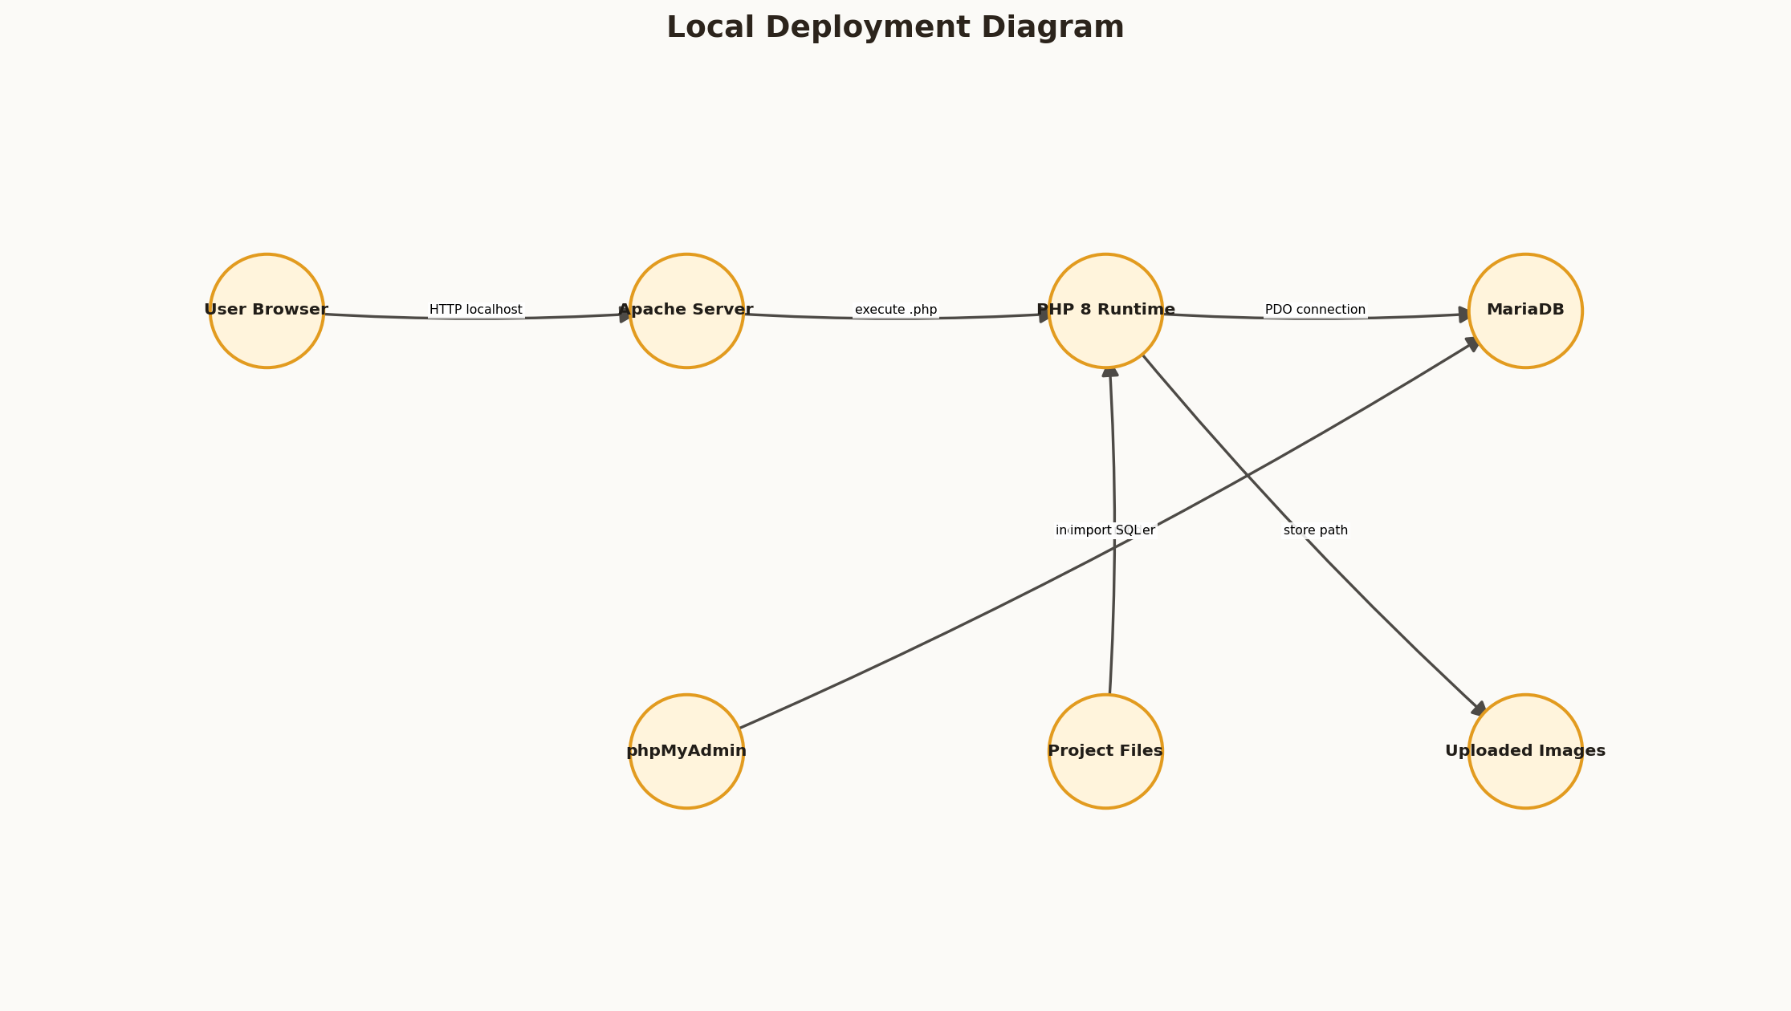
Figure 15: Local Deployment Diagram
Arrow validation note: arrowheads point from the initiating or child component toward the receiving, referenced, or next-state component. Every endpoint was programmatically checked before the figure was embedded.

CHAPTER 9: DEPLOYMENT AND USER MANUAL

9.2 Installation Procedure
9.2 Installation Procedure is an important part of the Cafe platform because it connects visible user interaction with reliable server-side processing. The implementation was designed for a local XAMPP environment while retaining patterns that can be migrated to a hosted Apache and MariaDB deployment.
In practical operation, installation requires XAMPP, copying the project to htdocs, starting Apache and MySQL, importing SQL and opening localhost. In this project, the README provides exact paths, URLs and troubleshooting advice. Requests are checked at the server boundary, data is exchanged through prepared PDO statements, and the resulting state is rendered back into a responsive interface.
The resulting outcome is non-technical users can follow a linear setup process. The design also provides traceability for testing because each interface action maps to a named action handler, one or more database operations, and an observable response.

CHAPTER 9: DEPLOYMENT AND USER MANUAL

9.3 Customer User Manual
9.3 Customer User Manual is an important part of the Cafe platform because it connects visible user interaction with reliable server-side processing. The implementation was designed for a local XAMPP environment while retaining patterns that can be migrated to a hosted Apache and MariaDB deployment.
In practical operation, customers register or sign in, browse categories, search, add items, modify quantities, apply coupons, checkout and track. In this project, delivered orders expose review forms and favorites remain available from the sidebar. Requests are checked at the server boundary, data is exchanged through prepared PDO statements, and the resulting state is rendered back into a responsive interface.
The resulting outcome is the user journey is consistent from desktop to mobile. The design also provides traceability for testing because each interface action maps to a named action handler, one or more database operations, and an observable response.

CHAPTER 9: DEPLOYMENT AND USER MANUAL

9.4 Administrator User Manual
9.4 Administrator User Manual is an important part of the Cafe platform because it connects visible user interaction with reliable server-side processing. The implementation was designed for a local XAMPP environment while retaining patterns that can be migrated to a hosted Apache and MariaDB deployment.
In practical operation, administrators sign in to a role dashboard and use menu, orders, customers, team, coupons, reviews, reports and settings pages. In this project, edit and archive actions use confirmation and all state-changing requests carry CSRF tokens. Requests are checked at the server boundary, data is exchanged through prepared PDO statements, and the resulting state is rendered back into a responsive interface.
The resulting outcome is operational tasks are grouped by navigation item. The design also provides traceability for testing because each interface action maps to a named action handler, one or more database operations, and an observable response.

CHAPTER 9: DEPLOYMENT AND USER MANUAL

9.5 Kitchen and Delivery Manuals
9.5 Kitchen and Delivery Manuals is an important part of the Cafe platform because it connects visible user interaction with reliable server-side processing. The implementation was designed for a local XAMPP environment while retaining patterns that can be migrated to a hosted Apache and MariaDB deployment.
In practical operation, kitchen users process confirmed tickets while delivery users work only with ready or assigned orders. In this project, buttons advance the allowed next state and customer notifications record updates. Requests are checked at the server boundary, data is exchanged through prepared PDO statements, and the resulting state is rendered back into a responsive interface.
The resulting outcome is specialized roles require minimal training. The design also provides traceability for testing because each interface action maps to a named action handler, one or more database operations, and an observable response.

CHAPTER 9: DEPLOYMENT AND USER MANUAL

9.6 Backup and Maintenance
9.6 Backup and Maintenance is an important part of the Cafe platform because it connects visible user interaction with reliable server-side processing. The implementation was designed for a local XAMPP environment while retaining patterns that can be migrated to a hosted Apache and MariaDB deployment.
In practical operation, database exports, upload backups, credential changes and periodic review of dependencies are recommended. In this project, production deployment must replace default root credentials and demo accounts. Requests are checked at the server boundary, data is exchanged through prepared PDO statements, and the resulting state is rendered back into a responsive interface.
The resulting outcome is operational continuity and privacy are improved. The design also provides traceability for testing because each interface action maps to a named action handler, one or more database operations, and an observable response.

CHAPTER 10: RESULTS, LIMITATIONS AND FUTURE WORK

10.1 Results and Achievements
10.1 Results and Achievements is an important part of the Cafe platform because it connects visible user interaction with reliable server-side processing. The implementation was designed for a local XAMPP environment while retaining patterns that can be migrated to a hosted Apache and MariaDB deployment.
In practical operation, the final system integrates attractive public, customer and staff experiences with functional server-side behavior. In this project, fifteen database tables and multiple roles support the full order lifecycle. Requests are checked at the server boundary, data is exchanged through prepared PDO statements, and the resulting state is rendered back into a responsive interface.
The resulting outcome is project objectives are substantially achieved. The design also provides traceability for testing because each interface action maps to a named action handler, one or more database operations, and an observable response.

CHAPTER 10: RESULTS, LIMITATIONS AND FUTURE WORK

10.2 Current Limitations
10.2 Current Limitations is an important part of the Cafe platform because it connects visible user interaction with reliable server-side processing. The implementation was designed for a local XAMPP environment while retaining patterns that can be migrated to a hosted Apache and MariaDB deployment.
In practical operation, online payment options are demonstrations, delivery location is not real-time GPS, and outbound email is not configured. In this project, the project targets one restaurant and local deployment. Requests are checked at the server boundary, data is exchanged through prepared PDO statements, and the resulting state is rendered back into a responsive interface.
The resulting outcome is limitations are explicit rather than disguised as completed integrations. The design also provides traceability for testing because each interface action maps to a named action handler, one or more database operations, and an observable response.

CHAPTER 10: RESULTS, LIMITATIONS AND FUTURE WORK

10.3 Future Enhancements
10.3 Future Enhancements is an important part of the Cafe platform because it connects visible user interaction with reliable server-side processing. The implementation was designed for a local XAMPP environment while retaining patterns that can be migrated to a hosted Apache and MariaDB deployment.
In practical operation, future work can add Razorpay or Stripe, maps, delivery OTP, email/SMS, WebSocket updates, multiple branches, taxes by jurisdiction and automated tests. In this project, the existing schema and role architecture provide extension points. Requests are checked at the server boundary, data is exchanged through prepared PDO statements, and the resulting state is rendered back into a responsive interface.
The resulting outcome is the academic prototype can evolve into a hosted service. The design also provides traceability for testing because each interface action maps to a named action handler, one or more database operations, and an observable response.

CHAPTER 10: RESULTS, LIMITATIONS AND FUTURE WORK

10.4 Conclusion
10.4 Conclusion is an important part of the Cafe platform because it connects visible user interaction with reliable server-side processing. The implementation was designed for a local XAMPP environment while retaining patterns that can be migrated to a hosted Apache and MariaDB deployment.
In practical operation, Cafe demonstrates the design, implementation and verification of a practical database-backed food ordering system. In this project, customer convenience is connected to controlled restaurant workflows and reporting. Requests are checked at the server boundary, data is exchanged through prepared PDO statements, and the resulting state is rendered back into a responsive interface.
The resulting outcome is the project provides a strong foundation for further full-stack study. The design also provides traceability for testing because each interface action maps to a named action handler, one or more database operations, and an observable response.

CHAPTER 8: TESTING AND VALIDATION

Detailed Functional Test Cases
ID | Scenario | Input | Expected Result | Status
TC-01 | Customer login | Valid seeded credentials | Customer home/dashboard | Pass
TC-02 | Invalid login | Wrong password | Error flash; no session | Pass
TC-03 | Add cart item | Available menu ID | Session quantity created | Pass
TC-04 | Update quantity | Quantity 3 | Line and grand totals update | Pass
TC-05 | Apply coupon | WELCOME100 over minimum | Discount applied | Pass
TC-06 | Remove coupon | Active coupon | Discount removed | Pass
TC-07 | Place order | Valid cart/address | Order and items committed | Pass
TC-08 | Kitchen transition | Confirmed order | Preparing then ready | Pass
TC-09 | Delivery transition | Ready order | Rider assigned and delivered | Pass
TC-10 | Menu image upload | Valid PNG under 2 MB | Random local image path | Pass
TC-11 | CSV export | Admin authenticated | CSV content-type and rows | Pass
TC-12 | Missing CSRF | POST without token | HTTP 419 | Pass
TC-13 | Staff edit | Existing kitchen user | Updated persistent profile | Pass
TC-14 | Review reply | Admin response | Reply visible to customer | Pass
TC-15 | Settings save | Valid fee/tax values | Upserted settings | Pass

CHAPTER 8: TESTING AND VALIDATION

Boundary and Negative Test Cases
ID | Boundary / Invalid Input | Expected Protection | Result
NT-01 | Empty CSRF token | Reject with 419 | Pass
NT-02 | Quantity above 10 | Clamp to 10 | Pass
NT-03 | Quantity exceeds stock | Reject checkout | Pass
NT-04 | Expired coupon | Reject or remove | Pass
NT-05 | Order below minimum | Reject order placement | Pass
NT-06 | Non-image upload | Reject MIME type | Pass
NT-07 | Image above size limit | Reject upload | Pass
NT-08 | Kitchen attempts delivered | Reject transition | Pass
NT-09 | Second rider updates assignment | Reject ownership | Pass
NT-10 | Duplicate review | Reject second submission | Pass
NT-11 | Unauthenticated export | Redirect to login | Pass
NT-12 | Unknown action | Safe error flash | Pass

PROJECT MANAGEMENT

Project Risk Register
Risk | Probability | Impact | Mitigation
Database service not running | Medium | High | Clear XAMPP checks and error page
Port 80 conflict | Medium | Medium | README port 8080 procedure
Stale browser assets | Medium | Low | filemtime cache versioning
Invalid uploads | Medium | High | MIME, size and randomized filename
Unauthorized status change | Low | High | Role and state-transition guards
Stock race during checkout | Low | High | Conditional update in transaction
Demo credentials used publicly | Medium | High | Change credentials before production
External image outage | Medium | Low | Local upload and placeholder support

REFERENCES

Bibliography
- PHP Documentation. PHP Manual: Sessions, password_hash, PDO and file uploads. https://www.php.net/docs.php
- MariaDB Documentation. SQL syntax, transactions, foreign keys and indexes. https://mariadb.com/kb/en/documentation/
- Apache Friends. XAMPP installation and local server environment. https://www.apachefriends.org/
- Bootstrap Documentation. Responsive grid, components and utilities. https://getbootstrap.com/docs/5.3/
- Bootstrap Icons. Open-source icon library. https://icons.getbootstrap.com/
- OWASP Foundation. Cross-Site Request Forgery Prevention Cheat Sheet.
- OWASP Foundation. SQL Injection Prevention Cheat Sheet.
- OWASP Foundation. Cross Site Scripting Prevention Cheat Sheet.
- Ian Sommerville. Software Engineering. Requirements, architecture and testing principles.
- Ramez Elmasri and Shamkant Navathe. Fundamentals of Database Systems.
- Roger S. Pressman. Software Engineering: A Practitioner's Approach.
- MDN Web Docs. HTML forms, responsive design and JavaScript APIs. https://developer.mozilla.org/

APPENDICES

Appendix A: Database Table Dictionary
Table | Primary Key | Main Relationships | Role
users | id | Parent of addresses, orders, reviews, favorites | Identity and RBAC
addresses | id | user_id -> users | Saved delivery location
categories | id | Parent of menu_items | Menu organization
menu_items | id | category_id -> categories | Dish catalogue and stock
coupons | id | Referenced by code snapshot | Discount rules
orders | id | user_id and delivery_user_id -> users | Order header
order_items | id | order_id -> orders; menu_item_id -> menu_items | Purchased lines
reviews | id | user, order and menu foreign keys | Verified feedback
favorites | Composite | user and menu foreign keys | Saved dishes
notifications | id | user_id -> users | Status updates
activity_logs | id | user_id -> users | Audit support
settings | setting_key | Independent | Restaurant configuration

APPENDICES

Appendix B: Representative Action Catalogue
Action | Authorized Role | Persistent Effect
login | Any active account | Session identity and activity log
register | Public | New customer user
add_cart / update_cart | Public session | Session cart
apply_coupon / remove_coupon | Public session | Session discount
place_order | Customer | Order, lines, stock, coupon count, notification
submit_review | Customer | Review and menu rating
order_status | Admin / staff roles | Status, rider and payment state
save_item | Admin | Menu insert/update and optional upload
save_staff / toggle_staff | Admin | Staff account state
save_coupon / toggle_coupon | Admin | Coupon rules
reply_review / toggle_review | Admin | Moderation state
save_settings | Admin | Whitelisted settings upsert

APPENDICES

Appendix C: Installation Checklist
- Install XAMPP in C:\xampp with Apache, PHP, MySQL/MariaDB and phpMyAdmin.
- Copy the project to C:\xampp\htdocs\food-ordering-website.
- Start Apache and MySQL from the XAMPP Control Panel.
- Open http://localhost/phpmyadmin and import database/food_ordering.sql.
- Open http://localhost/food-ordering-website/.
- Use README.md for demo accounts and troubleshooting.
- Change all credentials before any public deployment.
Installation acceptance criteria: the public home returns HTTP 200, the menu displays seeded items, customer and staff accounts authenticate, and the database contains all expected tables.

APPENDICES

Appendix D: Diagram Arrow Validation
Diagram | Nodes | Directed Arrows | Validation
System Context Diagram | 6 | 6 | PASS
Layered Application Architecture | 8 | 10 | PASS
Customer Use-Case Diagram | 8 | 10 | PASS
Role-Based Staff Use Cases | 10 | 9 | PASS
Data Flow Diagram - Level 0 | 8 | 10 | PASS
Order Processing DFD - Level 1 | 9 | 8 | PASS
Entity Relationship Diagram | 13 | 14 | PASS
Login Sequence | 7 | 8 | PASS
Checkout and Order Creation Sequence | 9 | 9 | PASS
Order Status State Machine | 7 | 7 | PASS
Local Deployment Diagram | 7 | 6 | PASS
Module Dependency Diagram | 9 | 10 | PASS
Request Security Validation Flow | 10 | 11 | PASS
Application Navigation Structure | 10 | 10 | PASS
Verification and Test Pipeline | 8 | 7 | PASS

Validation algorithm: each edge is stored as (source, target, label). Generation fails when the source or target is absent, when a self-loop is found, or when an edge label is empty. NetworkX draws an -|> arrowhead toward the target node. Therefore, the visible arrow direction matches the declared semantic direction.

APPENDICES

Appendix E: Submission Customization Checklist
- Replace institution, department, roll number and supervisor placeholders.
- Insert official college logo on the title page if required.
- Collect signatures on certificate and declaration pages.
- Update the Word table of contents and verify final pagination.
- Replace or add screenshots required by the department template.
- Review citation style against institutional guidelines.
- Export a final PDF and inspect every diagram at 100% zoom.
- Confirm repository and source-code links remain accessible.

End of Report
Cafe: Online Food Ordering and Restaurant Management System
This report was generated from the implemented Cafe project and includes programmatically validated directed diagrams. Institution-specific placeholders remain editable in Microsoft Word.

