CS 6384 Computer Vision
Assignment 2
Sumit Kumar
Dal833771

- Harris Corner Detector output:
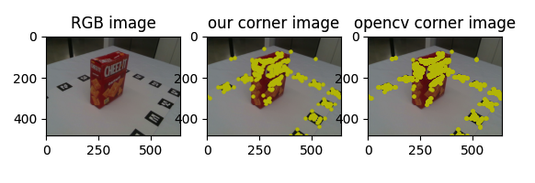
- SIFT Feature Matching output:
