**Experiment1.1**

**Student Name: Modassir Imran UID: 20BCS9727**

**Branch: CSE Section/Group: 606 /B**

**Semester: 6th Date of Performance: 08/02/2023**

**Subject Name: IOT Lab Subject Code: 20CST358**

1. **Aim:**Familiarisation with Arduino/Raspberry Pi hardware and perform necessary software installation.

**2. Objective:** 1. To study hardware and software related to IoT

2. To understand the function of Node MCU, Arduino Uno and Raspberry Pi.

**3. Script and Output:**

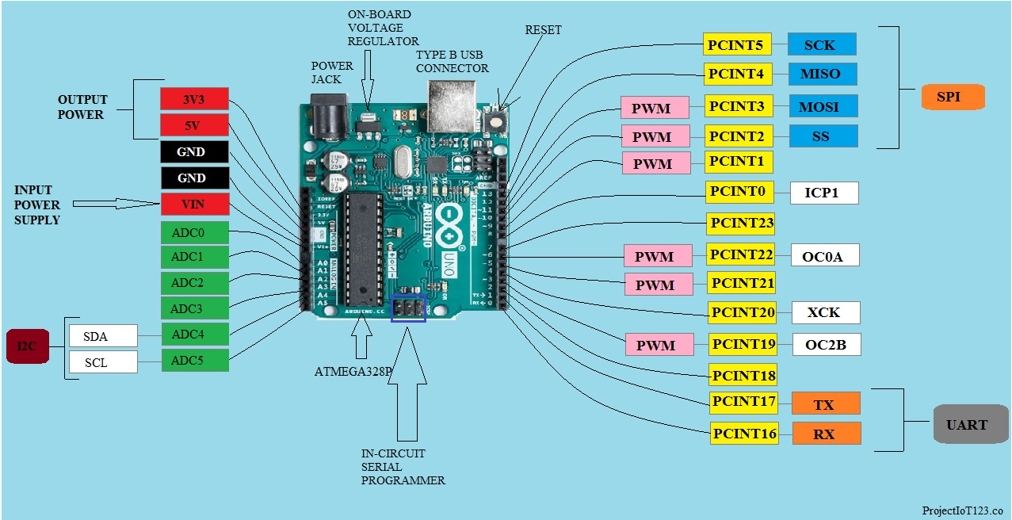

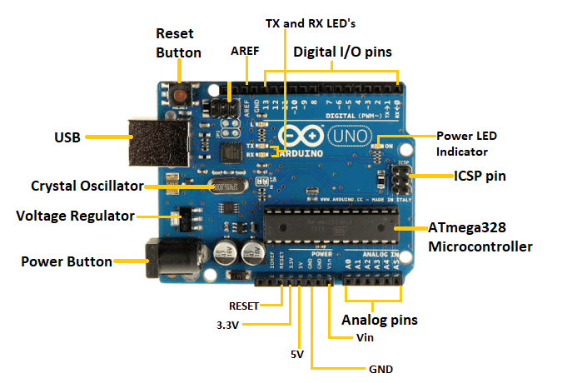

1. Power USB Arduino board can be powered by using the USB cable from your computer. All you need to do is connect the USB cable to the USB connection (1).

2. Power (Barrel Jack) Arduino boards can be powered directly from the AC mains power supply by connecting it to the Barrel Jack (2).

3. Voltage Regulator The function of the voltage regulator is to control the voltage given to the Arduino board and stabilize the DC voltages used by the processor and other elements.

• Most of the components used with Arduino board works fine with 3.3 volt and 5 volt.

• GND (8)(Ground) − There are several GND pins on the Arduino, any of which can be used to ground your circuit.

• Vin (9) − This pin also can be used to power the Arduino board from an external power source, like AC mains power supply.

#### Raspberry Pi Documentation - Raspberry Pi hardware

#### ****Raspberry PI Interfaces:****

It supports SPI, serial and I2C interfaces for data transfer.

Serial : Serial Interface on Raspberry has receive(Rx) and Transmit(Tx) pins for communication with serial peripherals.

SPI: Serial Peripheral Interface (SPI) is a synchronous serial data protocol used for communicating with one or more peripheral devices. In an SPI connection, there is one master device and one or more peripheral devices.

There are 5 pins Raspberry for SPI interface.

o MISO(Master In Slave Out): Master line for sending data to the peripherals.

o MOSI(Master Out Slave In): Slave Line for sending data to the master.

o SCK(Serial Clock): Clock generated by master to synchronize data transmission.

o CE0(Chip Enable 0): To enable or disable devices.

o CE1(Chip Enable 1): To enable or disable devices.

#### ****Applications****

1. Hobby projects.

2. Low cost PC/tablet/laptop

3. IoT applications

4. Media center

5. Robotics ⎫ Industrial/Home automation

#### ****INSTALLING THE ARDUINO IDE****

1. Visit <http://www.arduino.cc/en/main/software> to download the latest Arduino IDE version for your computer’s operating system. There are versions for Windows, Mac, and Linux systems. At the download page, click on the “Windows Installer” option for the easiest installation.

2. Save the .exe file to your hard drive.

3. Open the .exe file.

4. Click the button to agree to the licensing agreement:

[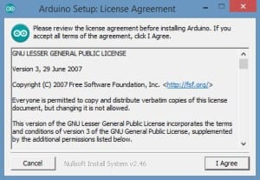](https://www.circuitbasics.com/wp-content/uploads/2014/12/Arduino-Setup-Lisence-Agreement.jpg)

5. Decide which components to install, then click “Next”:

[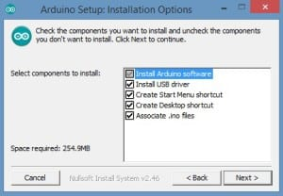](https://www.circuitbasics.com/wp-content/uploads/2014/12/Arduino-Setup-Installation-Options.jpg)

6. Select which folder to install the program to, then click “Install”:

[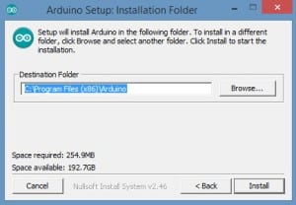](https://www.circuitbasics.com/wp-content/uploads/2014/12/Arduino-Setup-Installation-Folder.jpg)

7. Wait for the program to finish installing, then click “Close”:

[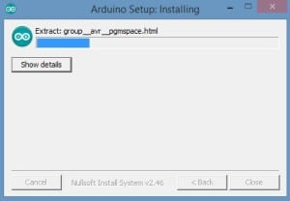](https://www.circuitbasics.com/wp-content/uploads/2014/12/Arduino-Setup-Installing.jpg)

8. Now find the Arduino shortcut on your Desktop and click on it. The IDE will open up and you’ll see the code editor:

[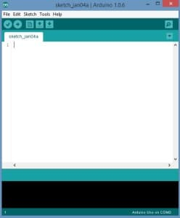](https://www.circuitbasics.com/wp-content/uploads/2014/12/Arduino-Software.jpg)

#### ****CONFIGURING THE ARDUINO IDE****

The next thing to do is to make sure the software is set up for your particular Arduino board. Go to the “Tools” drop-down menu, and find “Board”. Another menu will appear, where you can select from a list of Arduino models. I have the Arduino Uno R3, so I chose “Arduino Uno”.

[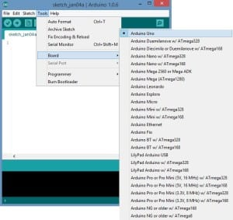](https://www.circuitbasics.com/wp-content/uploads/2014/12/Arduino-Tools.jpg)

#### ****EXPLORING THE ARDUINO IDE****

If you want, take a minute to browse through the different menus in the IDE. There is a good variety of example programs that come with the IDE in the “Examples” menu. These will help you get started with your Arduino right away without having to do lots of research:

[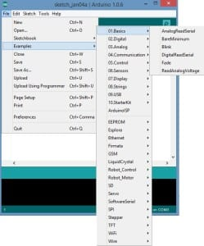](https://www.circuitbasics.com/wp-content/uploads/2014/12/Arduino-Example-Code.jpg)