**UNIVERSITY INSTITUTE OF ENGINEERING**

**Department of Computer Science & Engineering**

**Subject Name:** IOT Lab

**Subject Code:** 20CSP-358

**Submitted to: Submitted by:**

Er. Namrata **Name:** Pratik kumar Dey

**UID:** 21BCS8183

**Section:** 20BCS_DM-718

**Group:** B

**INDEX**

|  |  |  |  |  |  |  |
| --- | --- | --- | --- | --- | --- | --- |
| **Ex. No** | **List of Experiments** | **Conduct (MM: 12)** | **Viva**  **(MM: 10)** | **Record (MM: 8)** | **Total**  **(MM: 30)** | **Remarks/Signature** |
| 1.1 | Briefly describe Arduino and Raspberry Pi hardware along with their respective software installation. |  |  |  |  |  |
| 1.2 | Describe in detail about all sensors used in IoT applications. |  |  |  |  |  |
| 1.3 |  |  |  |  |  |  |
| 2.1 |  |  |  |  |  |  |
| 2.2 |  |  |  |  |  |  |
| 2.3 |  |  |  |  |  |  |
| 2.4 |  |  |  |  |  |  |
| 3.1 |  |  |  |  |  |  |
| 3.2 |  |  |  |  |  |  |
| 3.3 |  |  |  |  |  |  |

**Experiment-1.2**

**Student Name:** Pratik Kumar Dey **UID:** 21BCS8183

**Branch:** BE CSE (Lateral Entry) **Section/Group:** 718/B

**Semester:** 6th **Date of Performance:** 26/02/2023

**Subject Name:** IOT Lab **Subject Code:** 20CSP-358

1. **Aim/Overview of the practical:**

Describe in detail about all sensors used in IoT applications.

1. **Apparatus / Simulator Used:**

* Windows 7 or above
* Arduino IDE

1. **Objective:**

* To study hardware and software related to IOT.
* To understand and identify different sensors used in IOT

1. **Script and Output:**

***Sensors:***

The sensors are defined as a machine, module, or a device that detect changes in the environment. The sensors transfer those changes to the electronic devices in the form of a signal. A sensor and electronic devices always work together. The output signal is easily readable by humans. Nowadays, Sensors are used in daily lives. For example, controlling the brightness of the lamp by touching its base, etc. The use of sensors is expanding with new technologies.

The sensor is a device, which is made up of Single Crystal Silicon. It is considered as a widely used semiconductor material. It has superior mechanical stability, machinability, etc. It can also combine electronics and sensing elements on the same substrate. The sensors are used to measure the physical quantities, such as pressure, temperature, sound, humidity, and light, etc.

An example of sensors is Fire Alarm, a detector present on the fire alarm detects the smoke or heat. The signal generated from the detector is sent to the alarming system, which produces an

alert in the form of alarm. The types of detectors are smoke detectors, heat detectors, carbon monoxide detectors, multi-sensors detectors, etc.

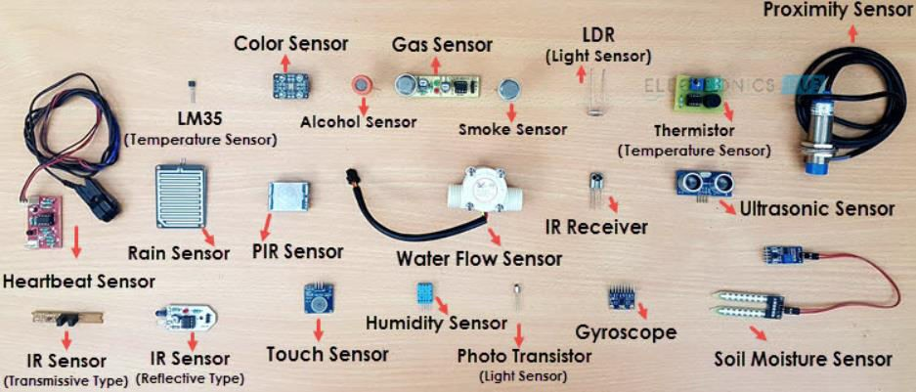

***Types of Sensors:***

1. ***Temperature Sensors:-*** A temperature sensor is a device used to measure temperature. This can be air temperature, liquid temperature or the temperature of solid matter. There are different types of temperature sensors available and they each use different technologies and principles to take the temperature measurement.

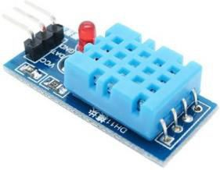

1. ***Proximity Sensor/IR Sensor:-*** A proximity sensoris a [sensor](https://en.wikipedia.org/wiki/Sensor) able to detect the presence of nearby objects without any physical contact. A proximity sensor often emits an [electromagnetic](https://en.wikipedia.org/wiki/Electromagnetic_field) field or a beam of [electromagnetic radiation](https://en.wikipedia.org/wiki/Electromagnetic_radiation) ([infrared](https://en.wikipedia.org/wiki/Infrared), for instance), and looks for changes in the [field](https://en.wikipedia.org/wiki/Electric_field) or return [signal.](https://en.wikipedia.org/wiki/Signal) The object being sensed is often referred to as the proximity sensor's target. Different proximity sensor targets demand different sensors.

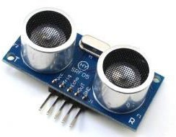.

1. 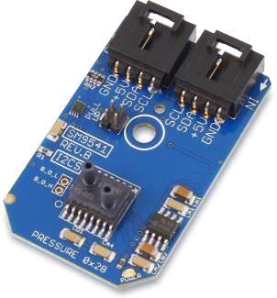***Pressure Sensor:-*** A pressure sensor is a device for [pressure measurement](https://en.wikipedia.org/wiki/Pressure_measurement) of [gases](https://en.wikipedia.org/wiki/Gas) or [liquids](https://en.wikipedia.org/wiki/Liquids). Pressure is an expression of the force required to stop a fluid from expanding, and is usually stated in terms of force per unit area. A pressure sensor usually acts as a [transducer](https://en.wikipedia.org/wiki/Transducer); it generates a signal as a [function](https://en.wikipedia.org/wiki/Function_(mathematics)) of the pressure imposed. For the purposes of this article, such a signal is electrical.
2. ***Gas Sensor:-*** A gas detector is a device that detects the presence of [gases](https://en.wikipedia.org/wiki/Gas) in an area, often as part of a safety system. A gas detector can sound an alarm to operators in the area where the leak is occurring, giving them the opportunity to leave. This type of device is important because there are many gases that can be harmful to organic life, such as humans or animals.

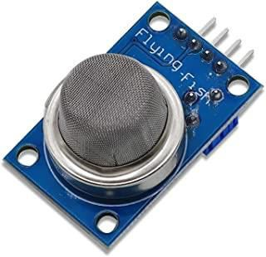

1. ***Smoke Sensor:-*** A smoke detector is a sensor that detects smoke as a primary indication of fire. It provides a signal to a fire alarm system in a large building, or produces an audible and visual signal locally in a room or a home. Smoke detectors are usually housed in a small, round shaped plastic case, and placed at the roof where there are risks of fire or fire hazards.

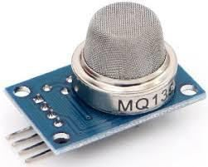

1. ***IR Sensor:-*** An infrared sensor (IR sensor) is a radiation-sensitive optoelectronic component with a spectral sensitivity in the infrared wavelength range 780 nm … 50 µm. IR sensors are now widely used in motion detectors, which are used in building services to switch on lamps or in alarm systems to detect unwelcome guests.

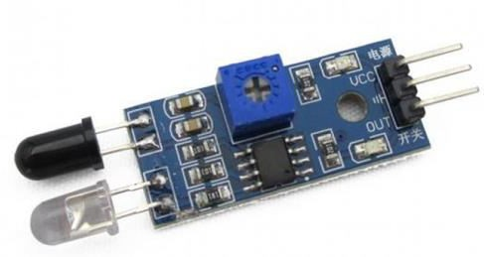

1. ***Motion Detection Sensor:-*** A motion sensor (or motion detector) is an electronic device that is designed to detect and measure movement. Motion sensors are used primarily in home and business security systems, but they can also be found in phones, paper towel dispensers, game consoles, and virtual reality systems. Unlike many other types of sensors (which can be handheld and isolated), motion sensors are typically embedded systems with three major components: a [sensor](https://www.fierceelectronics.com/sensors/what-a-sensor) unit, an [embedded computer,](https://www.fierceelectronics.com/embedded/what-embedded-computer) and hardware (or the mechanical component). These three parts vary in size and configuration, as motion sensors can be customized to perform highly specific functions. For example, motion sensors can be used to activate floodlights, trigger audible alarms, activate switches, and even alert the police.

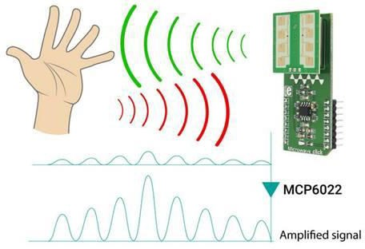

**Evaluation Grid (To be created as per the SOP and Assessment guidelines by the faculty):**

|  |  |  |  |
| --- | --- | --- | --- |
| Sr. No. | Parameters | Marks Obtained | Maximum Marks |
| 1. |  |  |  |
| 2. |  |  |  |
| 3. |  |  |  |

**Conclusion:-**

I have successfully completed this experiment.