Spark Catalyst Optimizer
The Catalyst Optimizer is Spark SQL's query optimization framework built on Scala's functional programming constructs (specifically, trees and rules). It transforms a user's query through multiple phases to produce the most efficient physical execution plan.

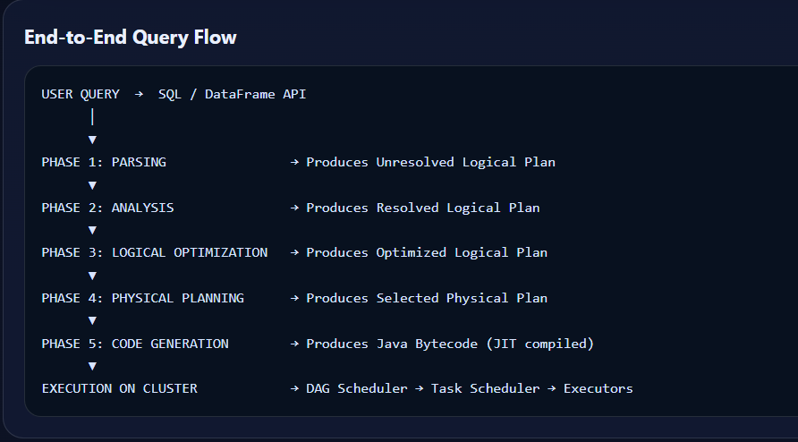

Phase 1: Parsing
The entry point of Catalyst. It takes either a SQL string or DataFrame/Dataset API calls and converts them into an Abstract Syntax Tree (AST), producing an Unresolved Logical Plan.

What happens:
- SQL text is parsed using an ANTLR4 grammar parser
- DataFrame operations are converted using TreeNode builders
- Produces an Unresolved Logical Plan where column names, table names, and data types are NOT yet validated
- At this stage, Spark only understands the structure of the query, not whether it is semantically correct

Output:
Unresolved Logical Plan (tree of unresolved attributes and relations)

Phase 2: Analysis (Catalog Lookup)
The Analyzer resolves references in the unresolved logical plan by consulting the Catalog (metadata store). It validates that tables, columns, functions, and types actually exist.

What happens:
- Resolves table names against the Catalog (Hive Metastore, Delta Lake catalog, etc.)
- Resolves column references to actual columns with data types
- Expands wildcard (*) selections into explicit column lists
- Resolves aliases and implicit type casts (e.g., INT compared to LONG)
- Resolves User-Defined Functions (UDFs)
- Uses fixed-point iteration: rules are applied repeatedly until no further changes occur

Key Rules Applied:
Rule | Description
ResolveRelations | Maps table name → schema definition
ResolveReferences | Maps column name → data type from schema
TypeCoercion | Adds implicit casts where types mismatch
ResolveFunctions | Validates and resolves built-in / UDF functions

Output:
Resolved Logical Plan (fully typed tree with validated references)

Phase 3: Logical Optimization
Applies rule-based transformations to the resolved logical plan to reduce data movement and computation. These optimizations are independent of physical execution details (cost, partitioning, cluster resources).

Key Optimizations:
Optimization | Description
Predicate Pushdown | Push WHERE filters as close to the data source as possible (e.g., into Parquet scan). Reduces the amount of data read.
Column Pruning | Drop unused columns early in the plan. Only columns referenced downstream are retained.
Constant Folding | Evaluate constant expressions at compile time (e.g., 1+1 becomes 2).
Boolean Simplification | Simplify redundant boolean logic (e.g., TRUE AND x becomes x).
Combine Filters | Merge adjacent Filter nodes into a single conjunctive filter.
Null Propagation | Short-circuit expressions that are guaranteed NULL.
Partition Pruning | Eliminate partitions that cannot contain matching data.
Push Down Limit | Push LIMIT operator closer to scan to reduce processed rows.

How It Works:
- Approximately 70+ rule batches are applied iteratively
- Each batch applies pattern-matching rules to transform subtrees of the plan
- Rules run until a fixed point is reached (no more transformations possible)
- Custom rules can be injected via SparkSessionExtensions

Output:
Optimized Logical Plan

Phase 4: Physical Planning
Converts the optimized logical plan into one or more candidate physical plans. Each physical plan maps logical operators to actual Spark execution operators. A cost model selects the best plan.

Decisions Made:
Decision Area | Options
Join Strategy | BroadcastHashJoin (small table broadcast), SortMergeJoin (large-large), ShuffleHashJoin
Aggregation Strategy | HashAggregate (fits in memory) vs SortAggregate (spill-safe)
Scan Method | Columnar batch reads (Parquet/ORC) vs row-based scan
Data Exchange | Shuffle partitioning strategy, repartition, coalesce decisions

Cost-Based Optimization (CBO):
- Enabled via spark.sql.cbo.enabled = true
- Uses table/column statistics: row count, distinct values, null count, min/max, histogram
- Statistics collected via ANALYZE TABLE ... COMPUTE STATISTICS
- Estimates cardinality at each node to choose optimal join order and strategy
- Without statistics, falls back to heuristic rules (e.g., broadcast if table < 10MB)

Output:
Selected Physical Plan (single best plan chosen by cost model)

Phase 5: Code Generation (Tungsten / Whole-Stage CodeGen)
The final phase generates optimized Java bytecode from the selected physical plan. This is part of Project Tungsten, which focuses on low-level CPU and memory efficiency.

What happens:
- Multiple operators are fused into a single Java function (Whole-Stage CodeGen)
- Eliminates virtual function call overhead between operators
- Uses off-heap memory management (UnsafeRow) for CPU cache-friendly data layout
- The Janino library compiles generated Java source into bytecode at runtime
- Avoids unnecessary object creation and garbage collection pressure
- Produces tight inner loops that process columnar batches efficiently

Benefits:
- Up to 10x performance improvement over the Volcano iterator model
- Reduced GC pressure from fewer object allocations
- Better CPU utilization through cache-friendly memory access patterns
- SIMD-compatible processing for vectorized operations

Output:
RDD of InternalRow — ready for execution on the cluster

Example Walkthrough
Query:
SELECT name, age FROM people WHERE age > 25 AND city = 'NYC'

Phase | What Happens
Parse | Filter(age>25 AND city='NYC') → Project(name, age) → UnresolvedRelation(people)
Analyze | Resolves "people" → schema {name:STRING, age:INT, city:STRING, ...}, validates all columns exist
Logical Opt | Column Pruning: only reads name, age, city. Predicate Pushdown: pushes filter to scan level.
Physical Plan | FileScan parquet [name,age,city] PushedFilters:[age>25, city='NYC'] — avoids reading other columns
CodeGen | Single tight loop: read columnar batch → apply filter → emit (name, age) tuples — no iterator overhead

Phase Summary Table
Phase | Input | Output | Mechanism
Parsing | SQL string / DF ops | Unresolved Logical Plan | ANTLR parser (SQL) or TreeNode builder (DF)
Analysis | Unresolved Plan + Catalog | Resolved Logical Plan | Rule-based, fixed-point iteration
Logical Optimization | Resolved Plan | Optimized Logical Plan | ~70+ rule batches applied iteratively
Physical Planning | Optimized Logical Plan | Selected Physical Plan | Generate candidates → cost model → pick cheapest
Code Generation | Physical Plan | Java bytecode (JIT) | Janino compiler, whole-stage codegen pipelines

Key Design Principles
Tree Transformation: Everything is a tree of nodes; optimizations are pattern-matching rules that transform subtrees
Rule Batches: Rules are grouped and applied repeatedly until a fixed point (no more changes)
Extensibility: Custom optimization rules can be injected via SparkSessionExtensions
Cost Model (CBO): When statistics are available (spark.sql.cbo.enabled=true), physical planning uses cardinality estimates to choose join strategies

