Linux Operating System.

1 Which account is created on Linux installation?
- With the installation of Linux, a super user account is created called as ‘root’.

2 You wish to print a file ‘draft’ with 60 lines to a page. What command would you use?
- The command that I would use is: pr -l60
- The default page length when using pr is 66 lines.
- The -l option specifies a different length.
3 To find any file in given location?
- The command is : find filename*
* any file start “filename” will be displayed.
- The command is : find *fn*
*fn* all find in which “fn” appear in its name will be displayed.
4 To give permission to any file ?
- for ls -l is used to check permission allowed in any file.
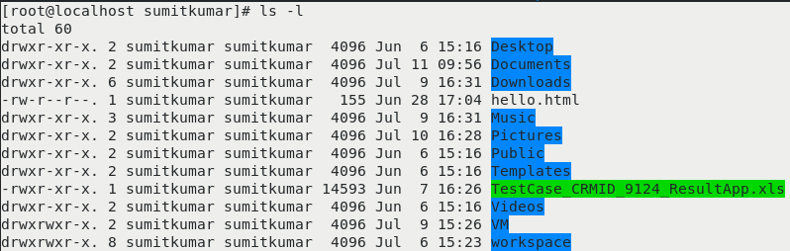
- for above output ‘-’ means there is a file.
rwx
Owner of the file and he has
Read write and execute
permission
- for above output ‘d’ means directory.
After that there is drwxr-xr-x
directory
r-x
User has read and
Execute permission
r-x
User has read and
Execute permission

- Permission to read, r, is given the numeric value of 4
- Permission to write, w, is given the value 2
- Permission to execute, x, is given the value 1
so in above case permission is give by rwx : 4+2+1 =7
r-x : 2+1 =3
r-x : 2+1 =3
permission given to this is 733 so use below command to give full permission
so to give permission for all command : chmod 777 Desktop
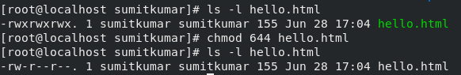
5 To give permission to any user ?
- To give permission to any user CHOWN command is used.
Ex chown sumitkumar filename

6 How do you create a new user account?
- To add new user account useradd command is used.
Ex : useradd Test;
and for password passwd username I.e, passed Test (Enter then cmd ask for password).
7 How to find a word in file ?
- To find a word in a file then grep command is used
ex grep “hello” filename
8 How to check for CPU information ?
- To check for CPU information cat command is used with /proc/cpuinfo.
Command : cat /proc/cpuinfo .

9 How to check for process information ?
- To check for process information
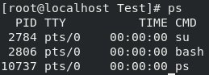
Command : ps is used.

Command : ps -aux
Command : ps -aux | grep terminal
Command : kill processid
Command : top command for all running process
9 How to get information about each command by using command ?
- TO know about all about each command use “MAN” command
Ex : man ps
another way Ex : ps –help
10 How to open any file in gedit or leafpad ?
- To open any file in gedit or leafpad
command : leafpad filename
gedit filename

