SQL

Query 1: Select * from SUMIT_crmtestregis limit 10;
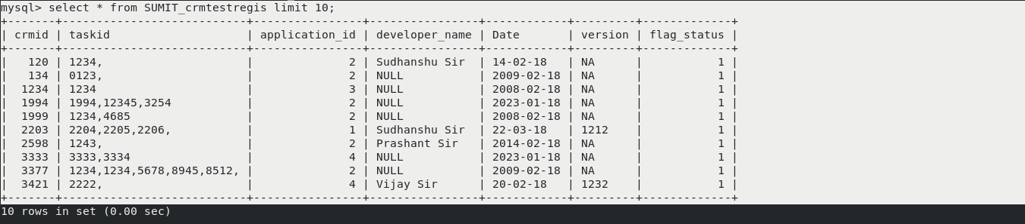

Repeated row according to any ID with count of each row or duplicate values .
Having :
group by:

Query 2: select crmid,count(crmid) from SUMIT_Testcases group by crmid having count(crmid) > 1 ;
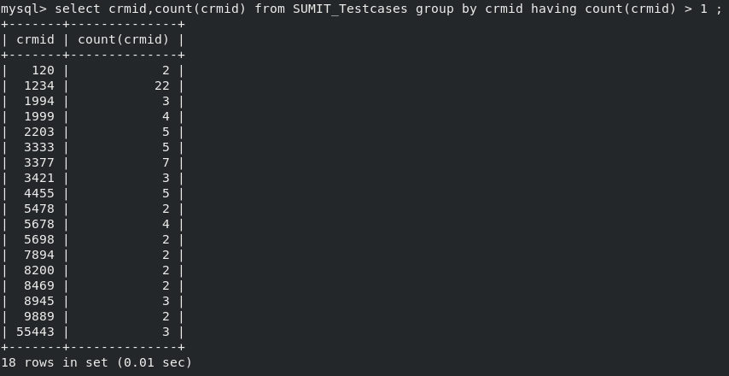
If we want complete data means repeated row with complete data.
Query 3: select * from SUMIT_Testcases group by crmid having count(crmid) > 1 ;
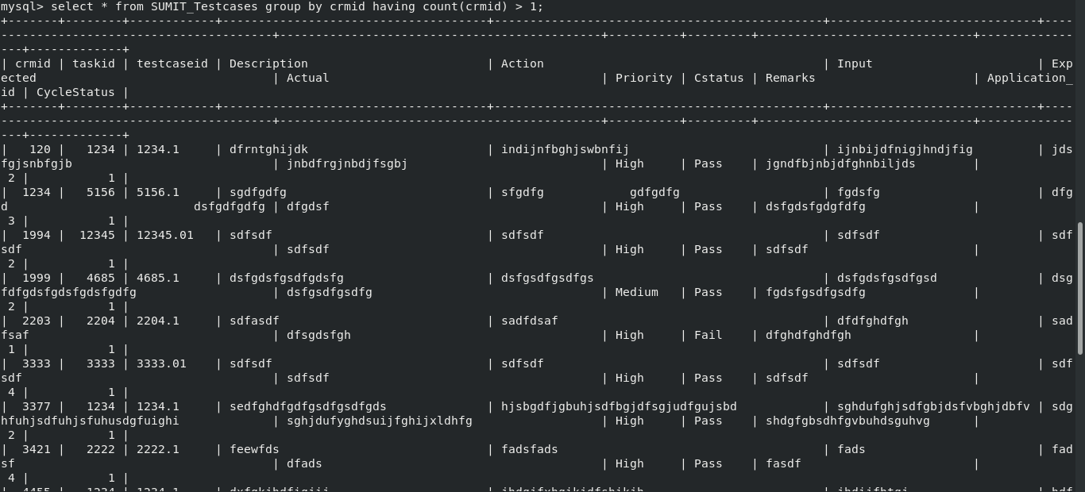

If we want unique row from the given table;

Query 4: select DISTINCT crmid from SUMIT_Testcases ;
OR
select crmid from SUMIT_Testcases group by crmid;
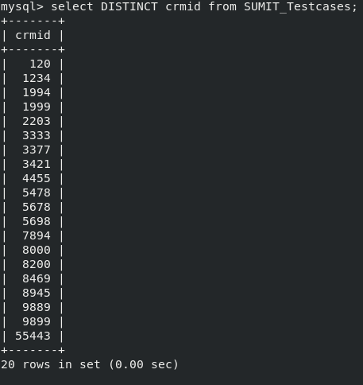

If we want unique row with all data from the given table ;
Query 5: select * from SUMIT_Testcases group by crmid ;

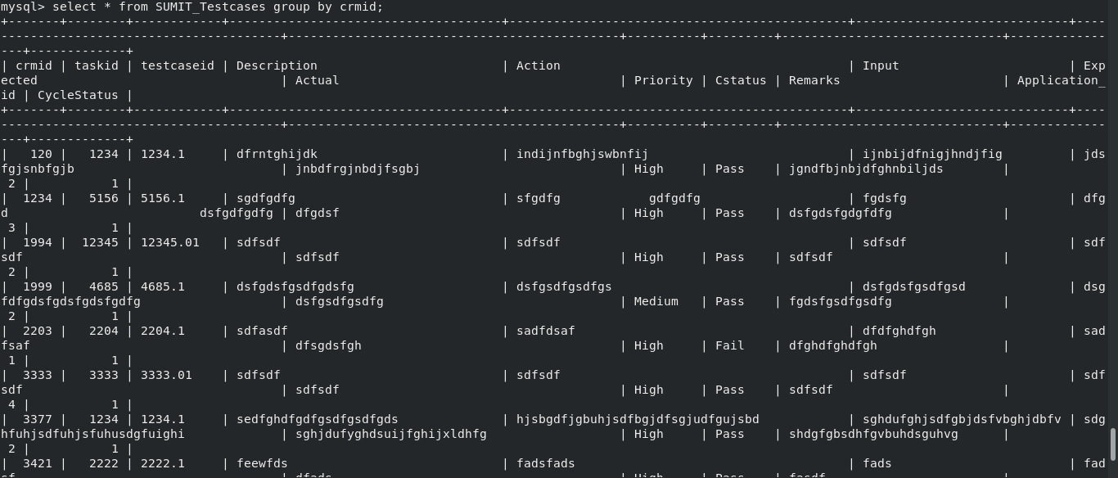

If we want non repeated row means count =1

Query 6: select * from SUMIT_Testcases group by crmid having count(crmid) =1;

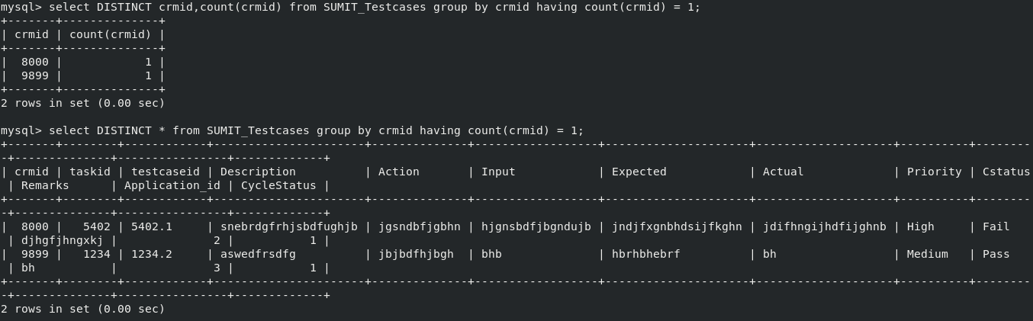

If we want all name started with any character then

Query 7: select * from SUMIT_Testcases having crmid like ‘9%’;

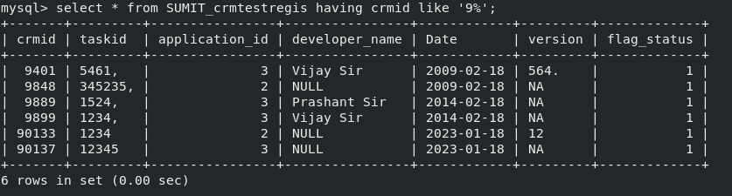

If we want all name ending with any character then

Query 8: select * from SUMIT_Testcases having crmid like ‘%1’;

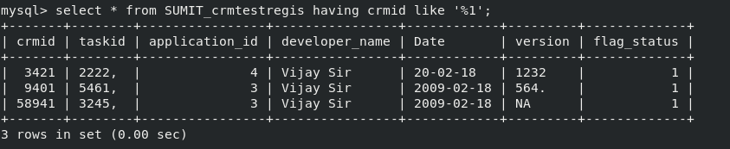

If we want all name through out the table with any character then

Query 9: select * from SUMIT_Testcases having crmid like ‘%1%’;

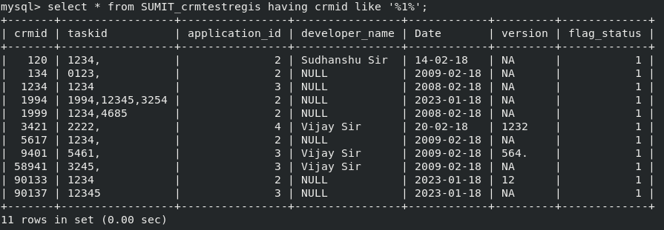

If we want to find the max salary from the given tables;

Query 10: Select max(crmid) from SUMIT_crmtestregis;

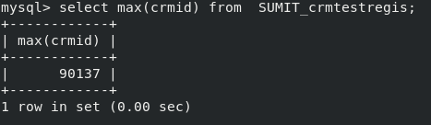
If we want to find the 2nd max salary from the given tables;

Query 11: select max(crmid) from SUMIT_crmtestregis where crmid < (Select max(crmid) from SUMIT_crmtestregis);
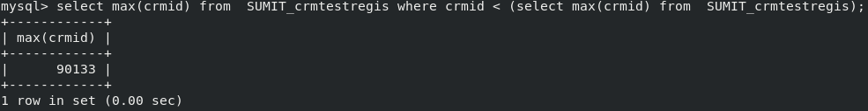

If we want to find the 3r or nth max salary from the given tables;

Query 12: select max(crmid) from SUMIT_crmtestregis where crmid < (select max(crmid) from SUMIT_crmtestregis where crmid < (select max(crmid) from SUMIT_crmtestregis));
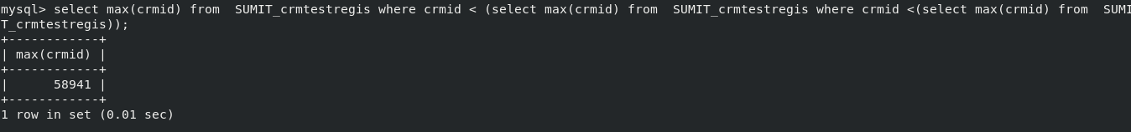

Another way using distinct

Query 13: select DISTINCT crmid from SUMIT_Testcases order by crmid desc limit 2,1;
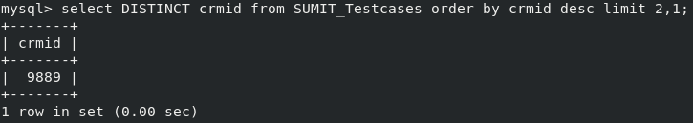

Join : used to join two tables;
1) Inner Join

Query 11: select * from SUMIT_Testcases having crmid like ‘%1%’;

