**IIT MANDI CS-207 APPLIED DATABASE PRACTICUM SPRING 2021**

ASSIGNMENT 3: Understanding Mysql and PHP

(In groups of 4-5 students containing B. Tech. 2nd years)

**Dr. Varun Dutt Due: Before 1:00 PM on March 11th , 2021**

**Readings:**

* Class notes and slides from week 3
* Activity 3 on Moodle

**Objectives:**

* Understand how Mysql works
* Manipulating Mysql through PHP

**Submission:**

Each group will make one single submission.

Please submit as a zipped file containing the following documents:

* + HTML file and CSS stylesheet with proper filenames
  + A PHP file with the code
  + Also give the mysql dump

**Assignment:**

Q1. 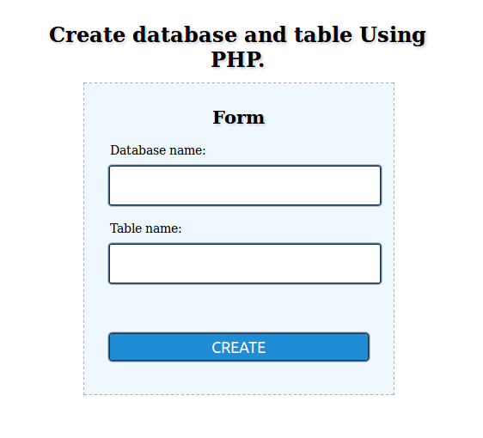i) Connect to Mysql using PHP using MySQLi

1. Create a webpage similar to the one attached below using HTML, CSS and PHP.

When the user enters the database name and table name into the text boxes and clicks on the “**CREATE**” button, a database and table should be created in Mysql. You will only enter the table name in the form while the schema (table design) needs to be hard-coded in the PHP file.

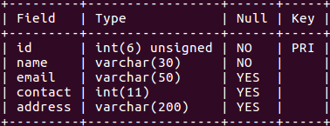The Table should have the following Schema. Also the ID field value should be the **PRIMARY KEY** and should automatically increment with each insertion and **should not be entered manually**.

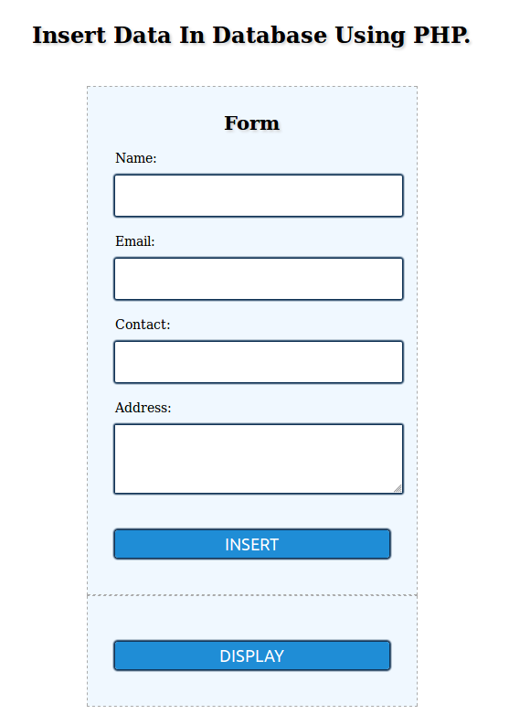Q2. Create a webpage similar to the one attached below using HTML, CSS and PHP.

1. The webpage created in the previous question should redirect to this page after creation of the table and database in Mysql. (Hint: use Header in the PHP file).
2. On clicking **INSERT**, the values of **NAME, EMAIL, CONTACT** and **ADDRESS** should be inserted in the Mysql table created in the previous question. Also the page should redirect to the same page so that more record can be entered.
3. Insert a minimum of 5 records into the Mysql table.

Q3. After the records have been inserted, when the user clicks on the “**DISPLAY**” button the contents of the Mysql table should be displayed in an HTML page in tabular form.

BONUS: This question should only be attempted after all the previous questions have been completed

1. Connect to Mysql using PDO (PHP Data Objects). Only connect to Mysql (Hint: https://www.w3schools.com/php/php_mysql_connect.asp)