**Collection Framework**

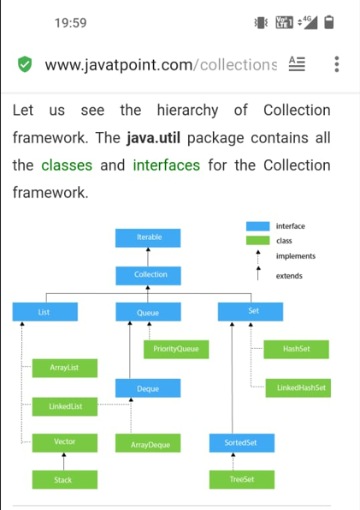

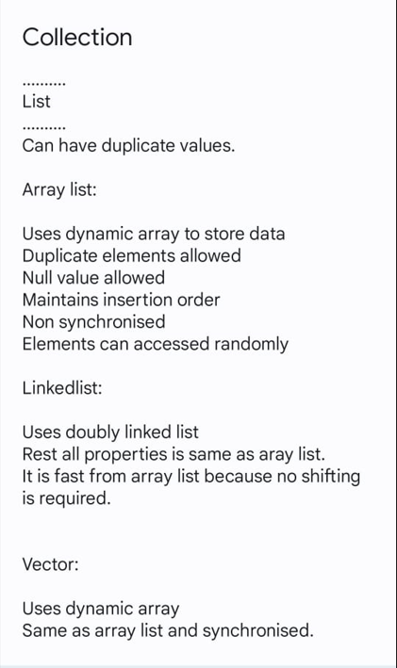

**Note: List allows null value and duplicate elements and maintains insertion order.**

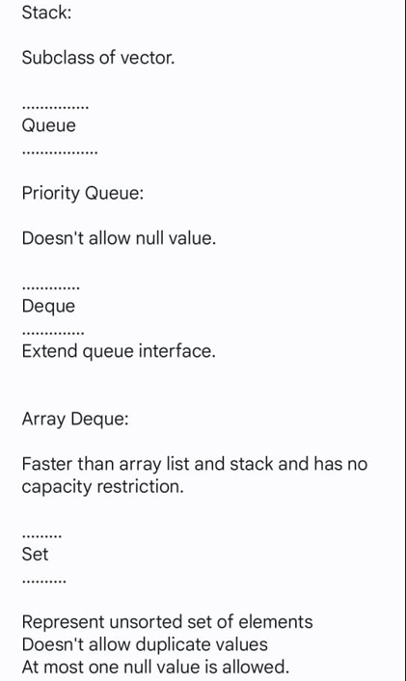

**Note: Queue allows duplicate data values but not null vales and not synchronized. Insertion order is not maintained.**

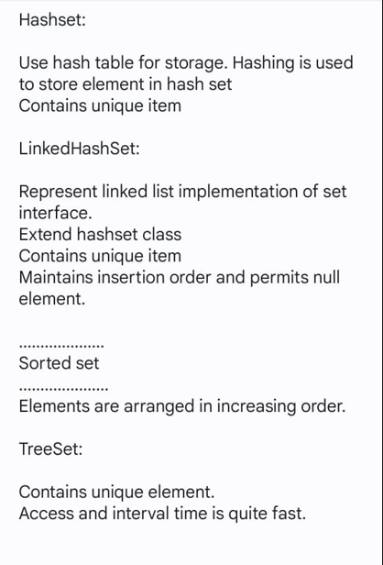

**Note: Set does not allow duplicate items. HashSet and LinkedHashSet allow one null value. Tree Set does not allow null values if you try to add runtime exception generated maintains ascending order.**

**Not synchronized.**

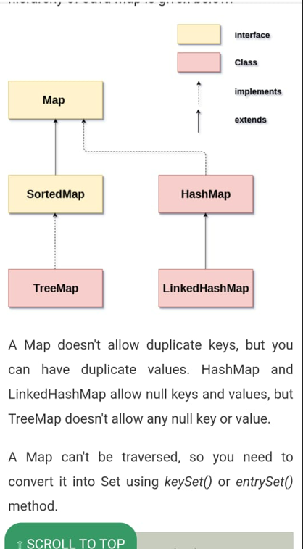

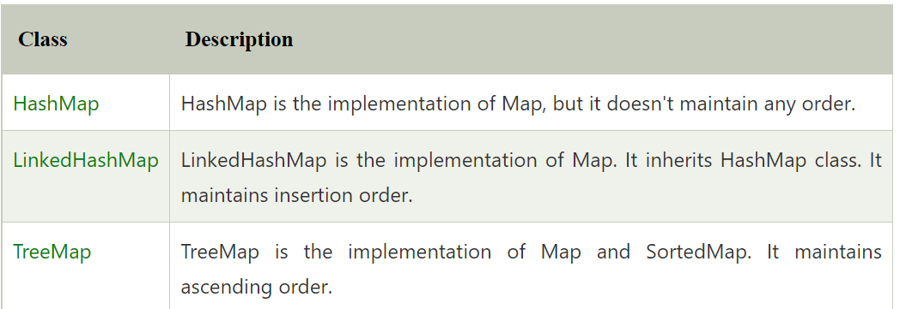

**Note: HashMap and LinkedHashMap allow one null key and multiple null values. Not synchronized.**

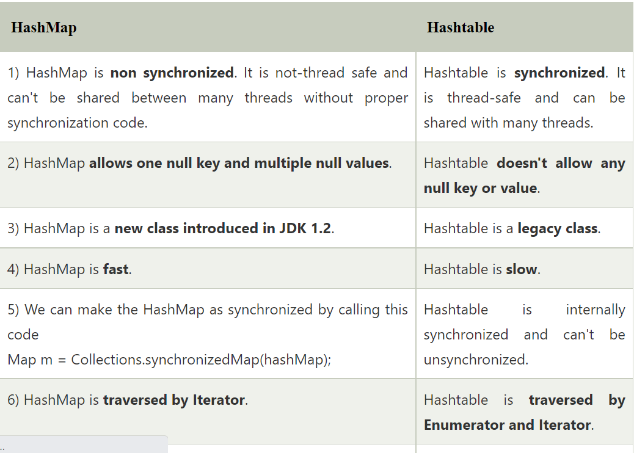

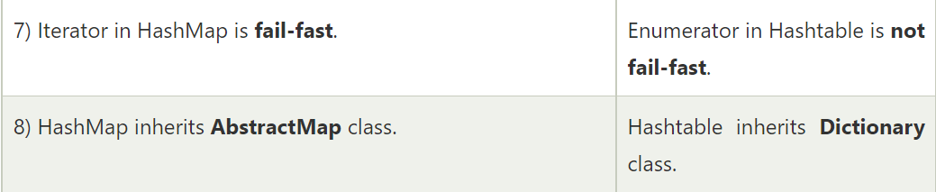

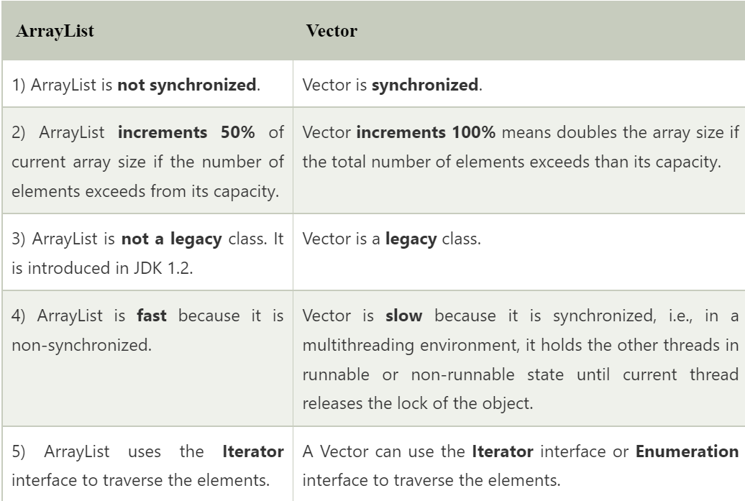

Whenever an instance of ArrayList in Java is created then by default the capacity of Arraylist is **10.**

The default value of a vector is 0.