**Microservice**

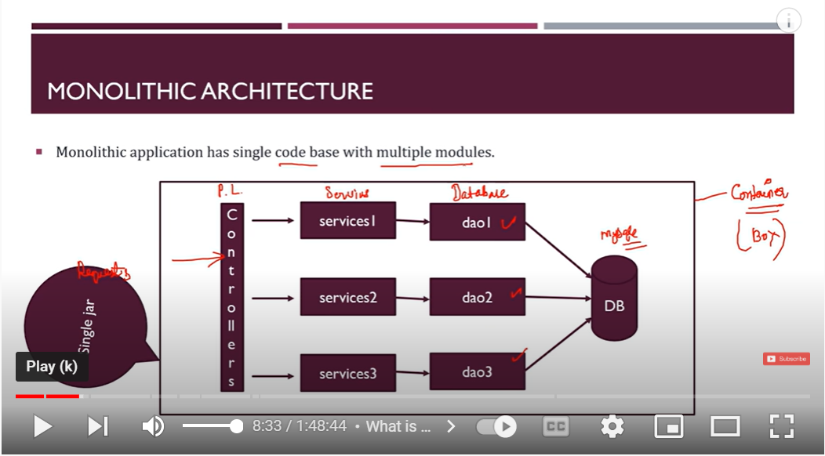

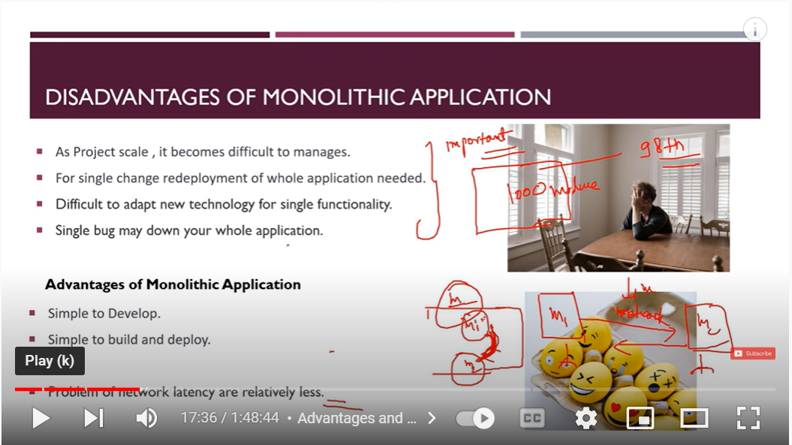

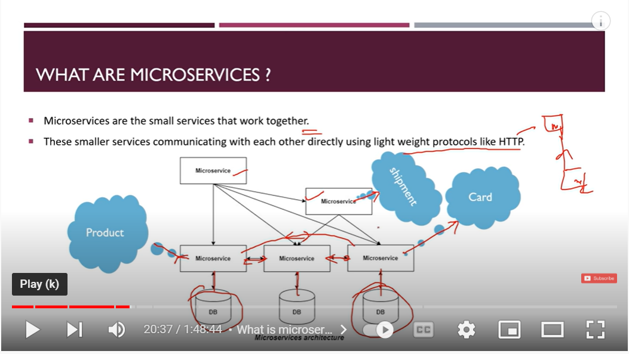

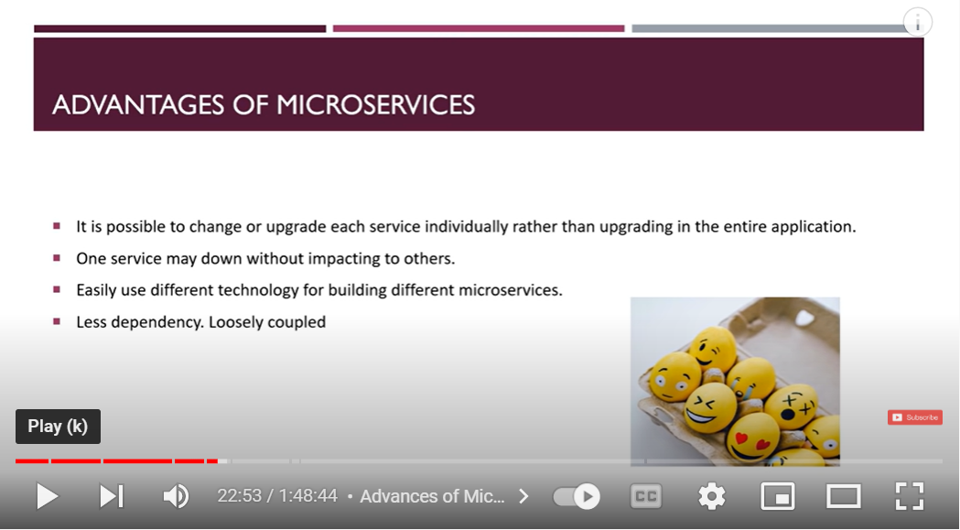

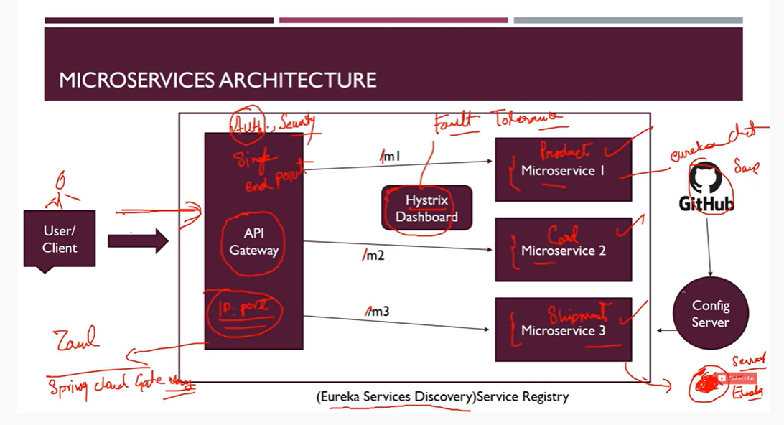

API Gateway acts as single endpoint of microservices. Eureka server where we register our micorservices.

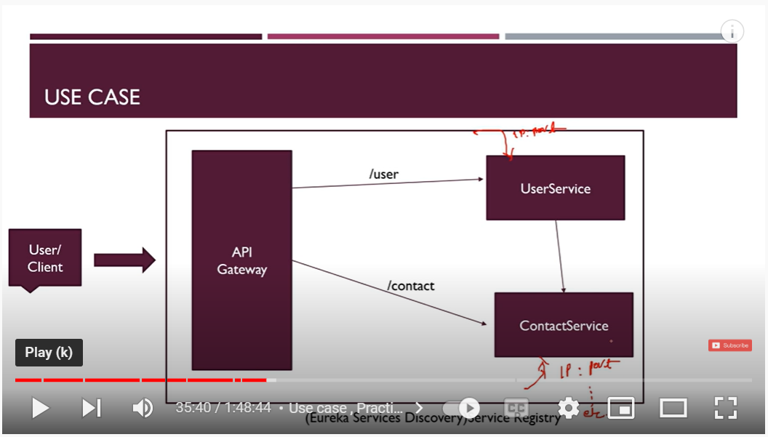

Purpose of Eureka Server and Client is service discovery means information of all microservice is placed at one place.

**Eureka Server Configuration**

We create Eureka server by adding following dependencies in below screenshot:

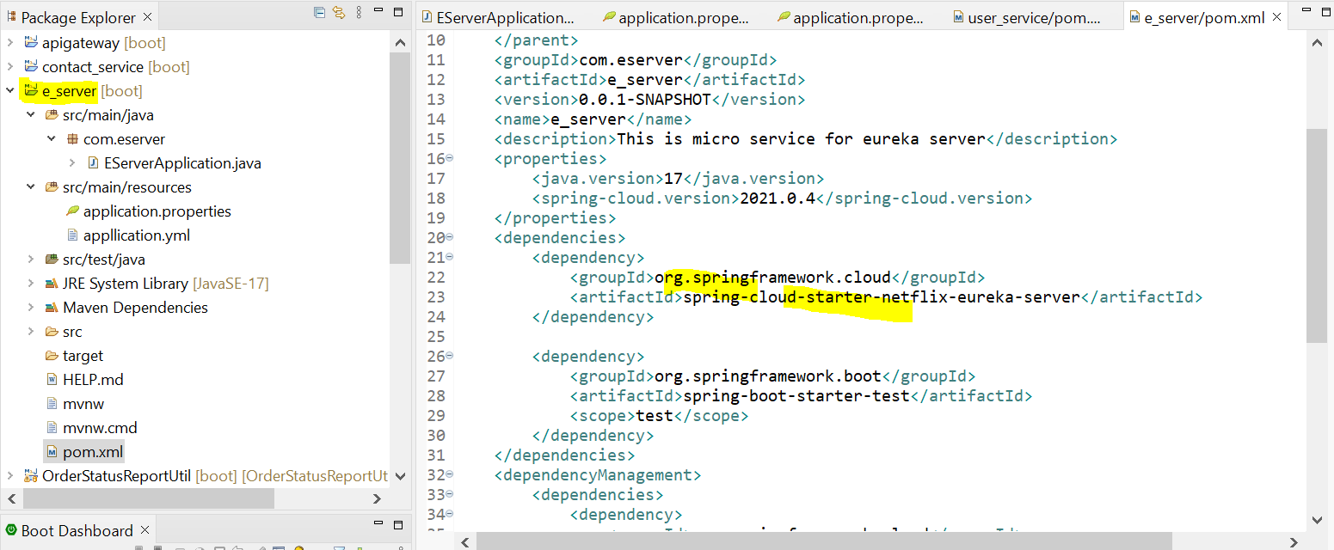

Also, in main we must enable Eureka Server using below annotation:

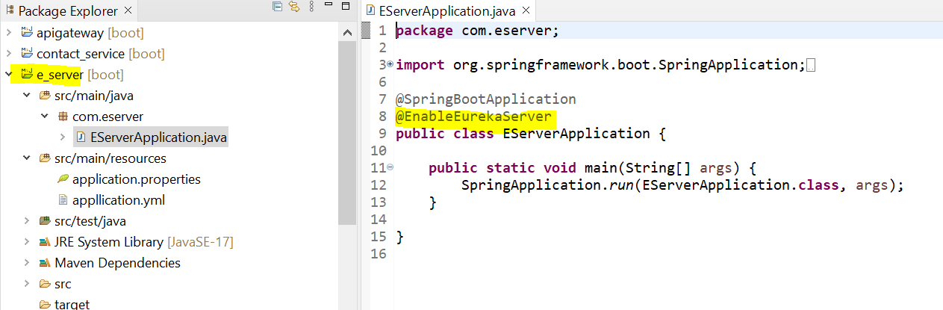

We must specify below properties in Eureka server to not get register himself as Eureka client:

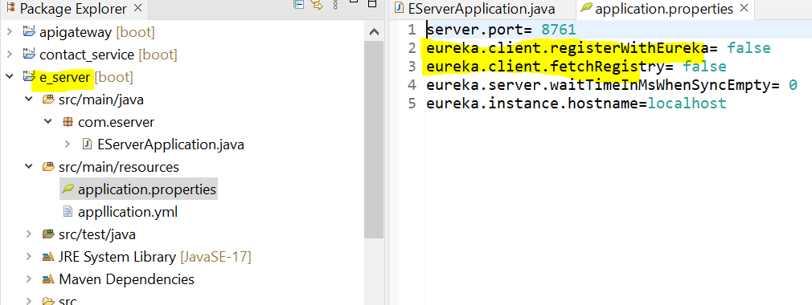

8761 is default port of Eureka Server.

**Eureka Client Configuration**

To make our microservice as Eureka client we must add dependency of Eureka client in pom.xml specified below in screenshot:

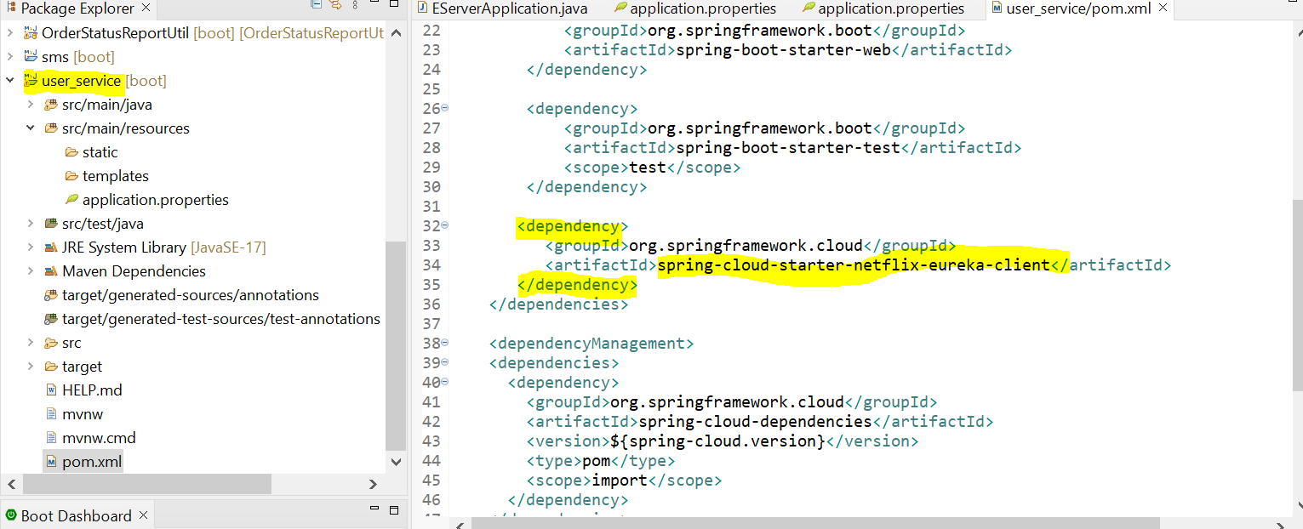

When we specify Eureka client dependency then spring boot automatically check for the default port (8761) of Eureka server if it is running or not and if running then register this client to default port of Eureka server. **In future if you are changing the default port of Eureka server then we have to specify the same in Eureka client application.properties where in Eureka server is running.**

**Specify application and Eureka instance host name**

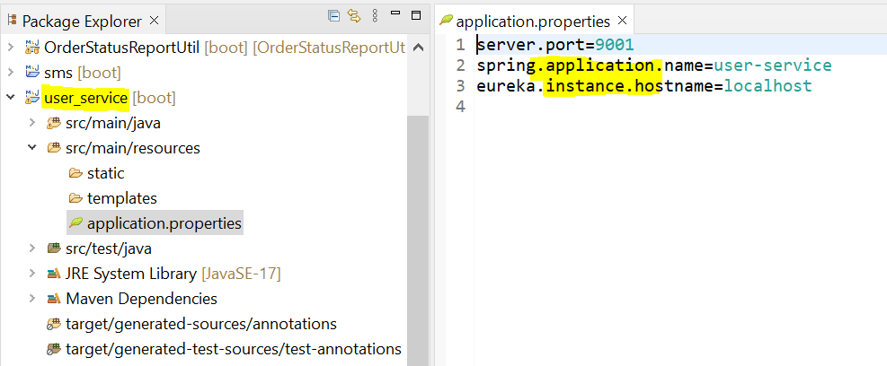

**API Gateway**

API Gateway is also a kind of Eureka Client. Following dependency must added in pom:

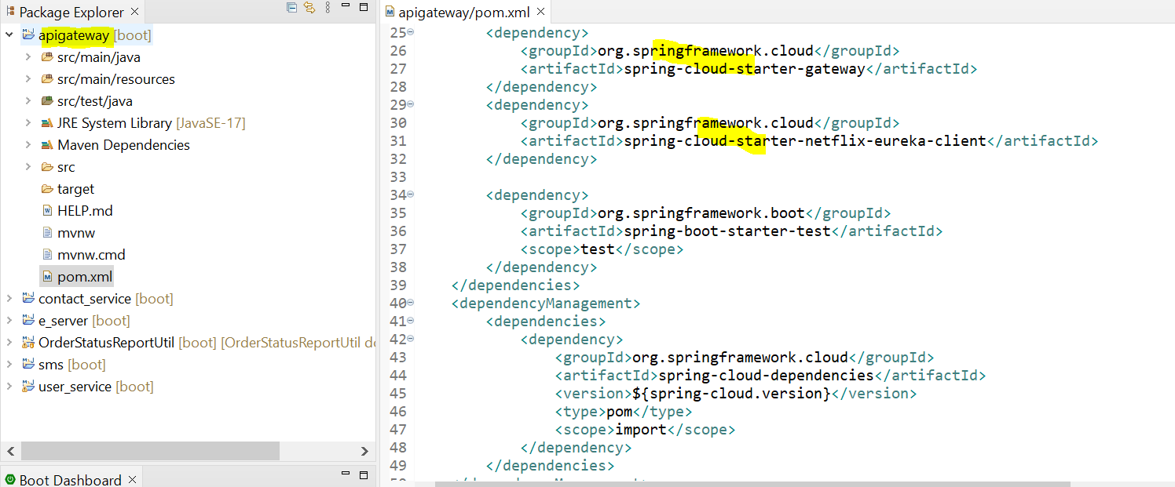

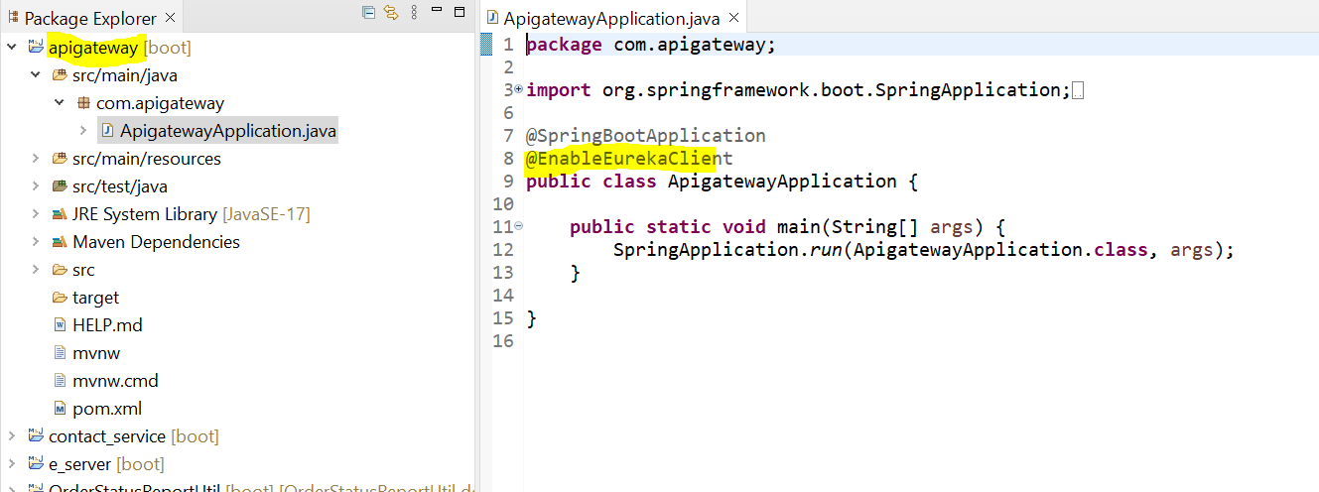

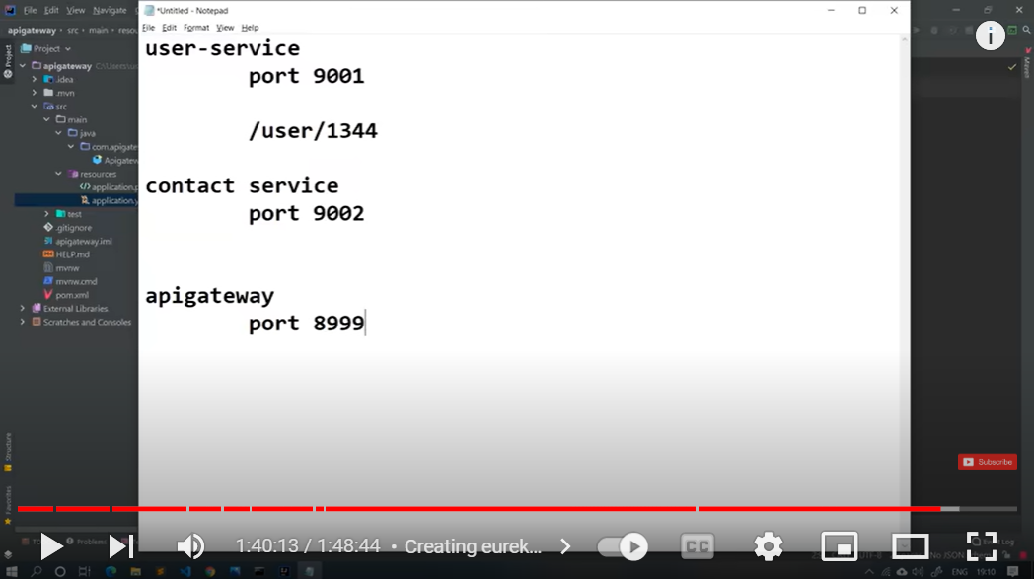

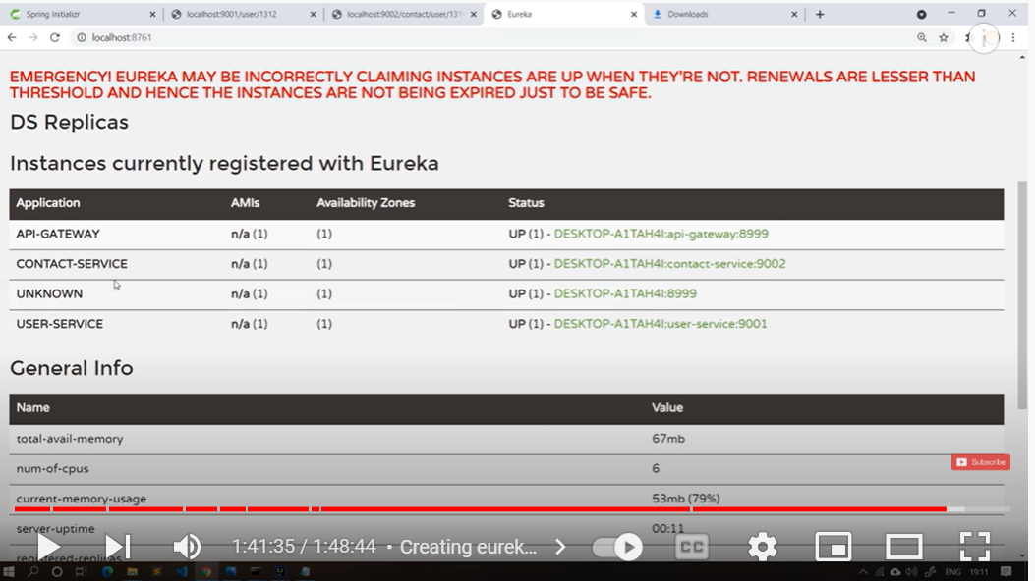

**Configuring route in API Gateway**

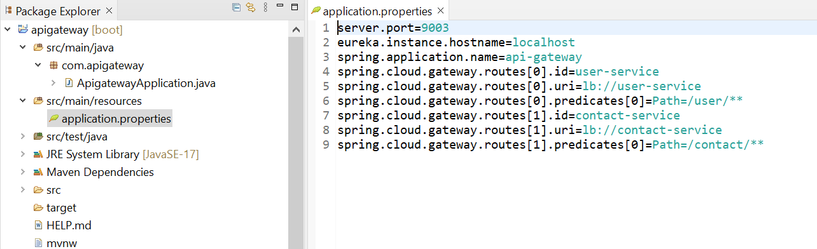

Here we have specified the routes. If any request will come like /user/** then it will route it to user-service. Similarly for contact.