1. In the below elements which of them are values or an expression? eg:- values can be integer or string and expressions will be mathematical operators.

\* 🡺 expression

'hello' 🡺 Value

-87.8 🡺 Value

- 🡺 Expression

/ 🡺 Expression

* 🡺 Expression

6 🡺 Value

2. What is the difference between string and variable?

A String that is comprises of single, double, or triple quotes. The characters of string can be call with the help of index no. from Left to Right and from Right to Left. It can have multiple line by using ‘\n’ i.e., used for next line.

A variable also called as identifier where values are stored or hold for temporary purpose. In python we can reassign the variables

3. Describe three different data types.

As we know data type determines which type of data that is and what we can do with that data.

There are many types of data types: - Strings, integers, Floats, Boolean, Lists, Tuples, Dictionaries.

Lists 🡪 It’s collection of ordered data. It can be appended and popped out as per requirement. It allows duplicate elements

Tuples 🡪 It’s collection of ordered data. It is immutable that means it cannot be changed. It also allows duplicate elements

Dictionaries 🡪🡪 It’s collection of un-ordered data. It is mutable and can be changed. All the keys are unique.

4. What is an expression made up of? What do all expressions do?

It’s combination of multiple operands, variables.

There are different types of expressions as mentioned below: -

1. Integral 🡪 which give result in integer
2. Constant 🡪 it consists only constant values. That cannot be changed.
3. Floating 🡪 which give result in floating
4. Relational 🡪 It basically compare the arithmetic expression and they give o/p as True or False.
5. Logical 🡪 There can be multiple relational expression that can produce Boolean results.

5. This assignment statements, like spam = 10. What is the difference between an expression and a statement?

An Expression is made up of values, containers, and mathematical operators.

A Statement is just like a command that a python interpreter executes like print

6. After running the following code, what does the variable bacon contain?

bacon = 22

bacon + 1

It gives 23 as the o/p as we are adding 1 to the store value of bacon

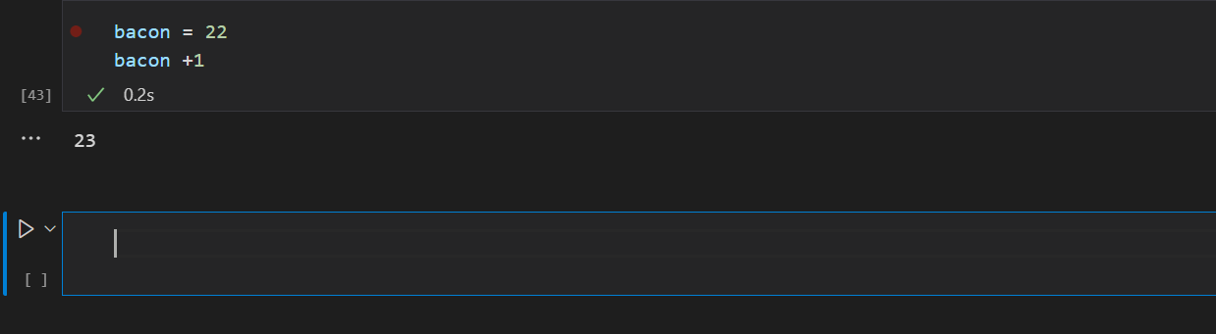

7. What should the values of the following two terms be?

'spam' + 'spamspam'

'spam' \* 3

Both will give the same result

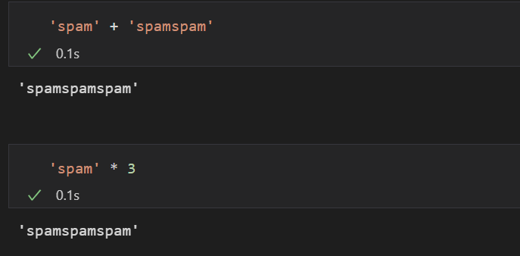

8. Why is eggs a valid variable name while 100 is invalid?

Because we can’t give an integer name as a variable name.

9. What three functions can be used to get the integer, floating-point number, or string version of a value?

Int(), float(), str()

10. Why does this expression cause an error? How can you fix it?

'I have eaten ' + 99 + ' burritos.'

We can use double quotes to concatenate both the results

