1.What are the two values of the Boolean data type? How do you write them?

Ans) True and False

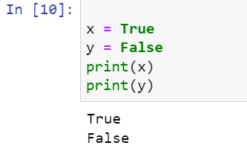

2. What are the three different types of Boolean operators?

Ans) And, OR, Not

3. Make a list of each Boolean operator's truth tables (i.e. every possible combination of Boolean values for the operator and what it evaluate ).

Ans) True and True is True.

True and False is False.

False and True is False.

False and False is False.

True or True is True.

True or False is True.

False or True is True.

False or False is False.

not True is False.

not False is True.

4. What are the values of the following expressions?

(5 > 4) and (3 == 5) 🡺 False

not (5 > 4) 🡺 False

(5 > 4) or (3 == 5) 🡺 True

not ((5 > 4) or (3 == 5)) 🡺 False

(True and True) and (True == False) 🡺 False

(not False) or (not True) 🡺 True

5. What are the six comparison operators?

Ans) = =, !=, >, <, >=, <=

6. How do you tell the difference between the equal to and assignment operators?Describe a condition and when you would use one.

Ans) In assignment operator we use only one equal sign but while in comparison we use two equal signs

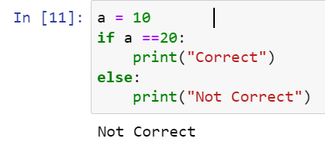

7. Identify the three blocks in this code:

spam = 0

if spam == 10:

print('eggs')

if spam > 5:

print('bacon')

else:

print('ham')

print('spam')

print('spam')

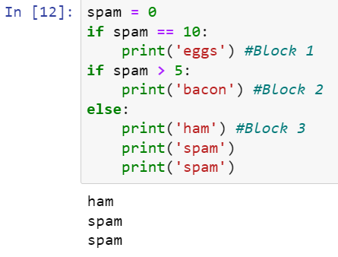

8. Write code that prints Hello if 1 is stored in spam, prints Howdy if 2 is stored in spam, and prints Greetings! if anything else is stored in spam.

Ans 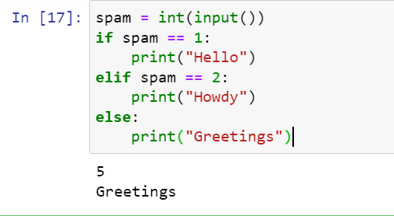

9.If your programme is stuck in an endless loop, what keys you’ll press?

Ans) Cntl + C 🡺 It will terminate the session

10. How can you tell the difference between break and continue?

Ans) In break 🡪 When we apply break in the code it will not allow to compile the rest code

Continue 🡪 this is usually used when there is some error in a long complex code and stillwe want to execute the code

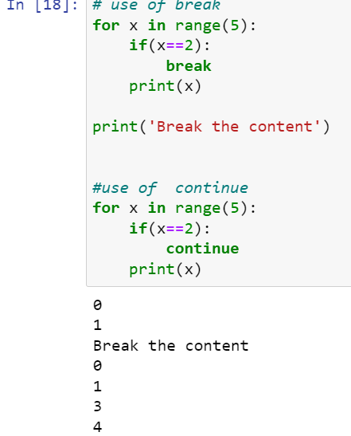

11. In a for loop, what is the difference between range(10), range(0, 10), and range(0, 10, 1)?

Ans) range(10) 🡪 It will give o/p from 0 till 9

Range(0,10) 🡪 It will give o/p from 0 till 10 because we have mentioned start as 0 and stop as 10

Range(0,10,1) 🡪 Similar to above with now taking steps as 1

12. Write a short program that prints the numbers 1 to 10 using a for loop. Then write an equivalent program that prints the numbers 1 to 10 using a while loop.

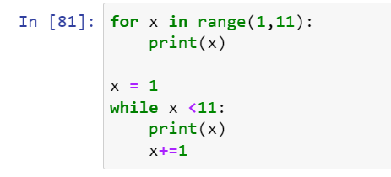

13. If you had a function named bacon() inside a module named spam, how would you call it after importing spam?

The function can be call by spam.bacon()