1. What exactly is []?

Ans) This is the empty list

1. In a list of values stored in a variable called spam, how would you assign the value 'hello' as the third value? (Assume [2, 4, 6, 8, 10] are in spam.)

Ans) 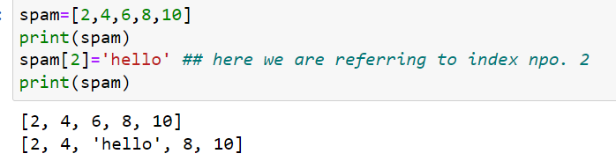

Let's pretend the spam includes the list ['a', 'b', 'c', 'd'] for the next three queries.

1. What is the value of spam[int(int('3' * 2) / 11)]?

Ans) 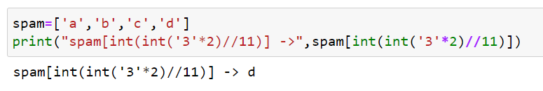

1. What is the value of spam[-1]?

Ans) ‘d’

1. What is the value of spam[:2]?

Ans)’ a’ ,’b’, ’c’

Let's pretend bacon has the list [3.14, 'cat,' 11, 'cat,' True] for the next three questions.

1. What is the value of bacon.index('cat')?

Ans) 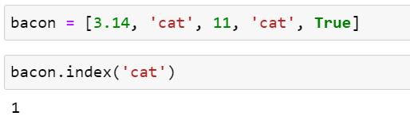

1. How does bacon.append(99) change the look of the list value in bacon?

Ans) 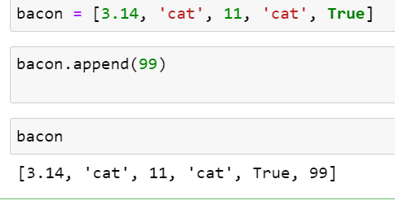

1. How does bacon.remove('cat') change the look of the list in bacon?

Ans) 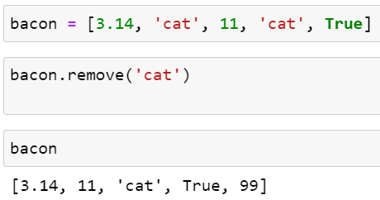

1. What are the list concatenation and list replication operators?

Ans) 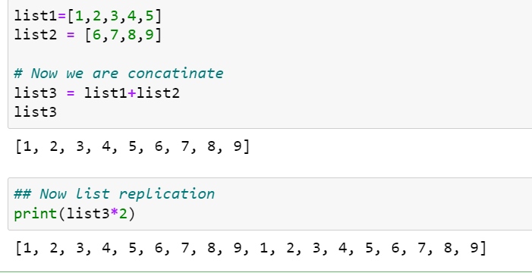

1. What is difference between the list methods append() and insert()?

Ans) 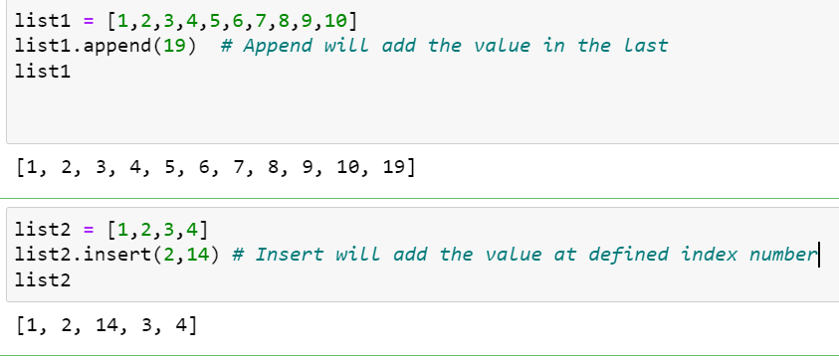

1. What are the two methods for removing items from a list?

Ans) 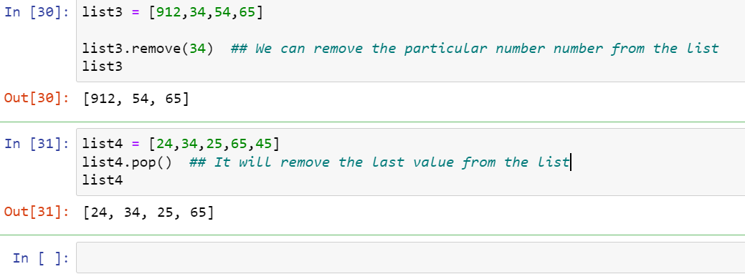

1. Describe how list values and string values are identical.

Ans) Both lists and strings can be passed to len() function, have indexes and slices and can concatenated or replicated.

1. What's the difference between tuples and lists?

Ans) Main diff is lists are mutable and can be modified depending upon the usage. Tuples are immutable means we cannot change the values from the tuples

1. How do you type a tuple value that only contains the integer 42?

Ans) (42,) The **trailing comma** is mandatory otherwise python will consider it as a integer

1. How do you get a list value's tuple form? How do you get a tuple value's list form?

Ans) We can convert list to tuple and vice-versa

1. Variables that "contain" list values are not necessarily lists themselves. Instead, what do they contain?

Ans) They contain reference to list variables

1. How do you distinguish between copy.copy() and copy.deepcopy()?

Ans) The copy.copy() function will do a shallow copy of a list, while the copy.deepcopy() function will do a deep copy of a list. That is, only copy.deepcopy() will duplicate any lists inside the list