DATA SCIENCE WITH PYTHON | ANALYST INTERNSHIP
Data Cleaning and Preprocessing Pipeline
for Beauty & Wellness Analytics
Week 3 Task Report - Pipeline design, Python implementation, validation and reproducibility
Prepared by | Sumit Kumar Sharma
Internship | Data Science with Python Analyst Internship, Coimbatore
Task | Week 3 - Data Cleaning and Preprocessing Pipeline Development
Domain | Beauty & Wellness (skincare, haircare, makeup, fragrance, bath & body, supplements)
Technology | Python 3, pandas, NumPy, scikit-learn, matplotlib
Deliverables | This report (DOCX) + runnable Python project with 19 tests
Report date | October 2026

Result at a glance: 5,250 raw rows -> 4,644 clean rows | data quality 92.8% -> 99.8% | 22/22 checks passed

Table of Contents
1. Executive Summary 3
2. Introduction and Objectives 4
3. Data Quality Issues in Beauty & Wellness Data 5
4. Raw Data Profile and Baseline 6
5. Pipeline Architecture 8
6. Cleaning Methodology 10
7. Python Tools and Why They Are Suitable 15
8. Pseudo-code and Implementation Highlights 16
9. Results and Validation 19
10. How Cleaned Data Improves Analysis and Modelling 23
11. Documentation and Reproducibility 25
12. Innovative Solutions to Common Data Quality Problems 27
13. Limitations and Future Work 28
14. Conclusion 29
Appendix A - Project Structure 30
Appendix B - Data Dictionary (Cleaned Dataset) 31
Appendix C - Submission Description 33
References 34
List of figures: Fig. 1 label variants (s.4) | Fig. 2 pipeline flowchart (s.5) | Fig. 3 missing values (s.6) | Fig. 4 price outliers (s.6) | Fig. 5 ratings (s.6) | Fig. 6 row attrition (s.9) | Fig. 7 quality scorecard (s.9)

1. Executive Summary
Beauty and wellness analytics depends on data that is collected by many hands: customers type their own ratings and reviews, brands publish catalogue data in their own formats, and marketplaces merge everything into one export. The result is data that is rich in insight but full of defects. This report documents a complete, reproducible data cleaning and preprocessing pipeline built in Python for a review-level beauty and wellness dataset (product catalogue + customer profile + review attributes) conceptualised in the earlier weeks of this internship.
The pipeline reads a deliberately messy raw extract, repairs or isolates every defect it finds, engineers analysis-ready features, scales and encodes the data for modelling, and proves the outcome with automated validation. Every decision is configurable, logged and tested, so the same raw file always produces the same clean file.
Headline results
Raw input: 5,250 rows x 23 columns -> Clean analysis table: 4,644 rows x 57 columns -> ML-ready matrix: 4,644 rows x 74 features (3,715 train / 929 test). Overall data-quality score rose from 92.8% to 99.8%; all 22 of 22 validation checks and 19 of 19 unit tests pass.
Dimension | Before | After | How it was measured
Completeness | 96.5% | 99.2% | Share of key-field cells that are observed; after cleaning, 'Unknown' labels and imputed values are counted as NOT complete (strict)
Uniqueness | 95.2% | 100.0% | Rows that are not exact or near duplicates (customer + product + date)
Validity | 96.0% | 100.0% | Rows free of impossible values before; share of validation checks passed after
Consistency | 83.4% | 100.0% | Categorical values already identical to the canonical label (6 label fields)
Overall | 92.8% | 99.8% | Mean of the four dimensions

What was fixed (selected): 70 spellings of 6 categories were consolidated; prices written in rupees, dollars and euros were unified to INR; 1,426 pack sizes in fl oz, oz, litres and kilograms were converted to ml/g; 778 ratings written as '4 stars', '8/10', 'four' or '55' were repaired; 251 exact and near duplicates were removed; 355 unusable rows were quarantined with a documented reason instead of being silently deleted; and personal e-mail addresses and phone numbers were replaced by salted SHA-256 pseudonyms.
What is original in this work: product and customer master reconciliation (using other rows of the same entity to repair a value), a price-versus-product-median rule that catches x10 and x0.1 typing errors, repeated-digit typo repair for ratings, an INCI-style ingredient synonym normaliser, SPF recovery from product names, Indian season features, missing-not-at-random indicator flags, and a rating-versus-review-text mismatch detector for suspicious reviews.

2. Introduction and Objectives

2.1 Background
The beauty and wellness industry is increasingly data driven: brands track which formulations earn high ratings in humid versus dry cities, and marketplaces recommend products by skin type. Public sources of such data (marketplace reviews, brand catalogues, survey exports) share a weakness: nobody validated them, so using them directly produces misleading averages and biased models. A disciplined pipeline turns one-off manual fixes into a reusable asset.

2.2 The dataset concept
The dataset carried forward from earlier weeks is a review-level table: each row is one customer review of one product, enriched with product catalogue attributes and customer profile attributes. The raw export has 23 text columns, grouped as follows.
Group | Columns | Intended type | Typical raw example
Identifiers | Review ID, Customer ID, Product ID | string key | R100310, C20518, P1043
Customer profile | Age, Gender, City, Skin Type, Skin Concern | int / category | '33', 'F', 'CBE', 'oily skin', 'N/A'
Contact (PII) | Customer Email, Customer Phone | string | 'USER20518@GMAIL.COM', '+91 98765-43210'
Product catalogue | Product Name, Brand, Category, Price, Size, Launch Date, SPF, Ingredients | string / float / date | 'Rs. 2660', '17.6 oz', 'Aqua; Vit C | Glycerine'
Review | Review Date, Rating, Review Text, Would Recommend, Purchase Channel | date / float / text / bool | '05.03.2025', '8/10', '<p>LOVE it!!!</p>', 'TRUE'

2.3 Objectives
- Identify the data-quality problems typical of publicly available beauty and wellness data and quantify them on the raw extract.
- Design a step-by-step cleaning method for missing values, outliers, duplicates, inconsistent formats and invalid values.
- Implement the method in Python (pandas, NumPy, scikit-learn) as a modular, tested and logged pipeline.
- Demonstrate, with before/after evidence, how the cleaned data improves analysis and modelling.
- Document the process so that anyone can reproduce the result exactly.

2.4 Scope and honest assumptions
- Synthetic raw data. To demonstrate the pipeline on a fully known truth, the project includes a generator that builds a clean ground truth and then injects realistic defects (about 20 defect types). The numbers in this report therefore describe this synthetic extract; they illustrate the method, not the real market. The pipeline accepts any CSV with the same columns (python main.py --input file.csv).
- Fixed assumptions. Ambiguous dates such as 05/03/2025 are read day-first (Indian convention). USD and EUR are converted at fixed demonstration rates (83 and 90 INR) that are stored in config.py.
- Scope. The report covers cleaning, preprocessing and validation. Predictive modelling is outside this week's scope; the output is prepared so that modelling can begin immediately.

3. Data Quality Issues in Beauty & Wellness Data
Table 1 catalogues the issues that are typical of public beauty and wellness data. Several are general (duplicates, missing values) but many are specific to the domain: ingredient naming (INCI), sun-protection claims, pack sizes in mixed volume and mass units, multi-currency prices on cross-border marketplaces, seasonality, and personal data in customer profiles.
# | Issue | Typical example | Impact if ignored | Detection / treatment
1 | Placeholder 'missing' tokens | 'N/A', '?', '-', 'null', 'not available' in age or skin type | Counted as real categories; hides true missingness | Token set -> NaN; count logged
2 | Non-random missingness | App users hide age; supplement buyers skip skin type | Biased imputation and segments | Missingness by group; indicator flags
3 | Exact and near duplicates | Scraper re-pull; double-click submit with new review ID | Inflated sample size, over-weighted opinions | Row dedupe + (customer, product, date) key
4 | Inconsistent labels | 'skin care', 'SKINCARE', 'Skincre'; 'CBE', 'Kovai' | Same group split into many | Canonical lists: exact -> synonym -> fuzzy
5 | Mixed currency/format prices | '₹1,299', 'Rs. 999', '$12.99', '499 /-' | Wrong price statistics | Regex parse + FX to INR
6 | Mixed pack-size units | '50 ml', '1.7 fl oz', '0.1 L', '100gm', '3.5 oz' | Price-per-100 ml meaningless | Unit table -> ml / g
7 | Rating scale chaos | '4/5', '8/10', 'four', '4 stars', '55', '0', '-1' | Biased average rating | Parse, rescale, repair typo, else quarantine
8 | Impossible values | Age 999 or -5; lipstick Rs. 99,999; size 0 ml | Distorted means, broken scaling | Domain rules -> NaN, then reconcile
9 | Date ambiguity and logic errors | '05/03/2025'; review in the future; review before launch | Wrong seasonality and product-age | Multi-format parser; rule checks; quarantine
10 | Dirty review text | HTML tags, URLs, emoji, 'AMAZING!!!!!', double spaces | Noisy NLP features | Text normaliser
11 | Ingredient naming variants | 'Aqua' = 'Water (Aqua)'; 'Vit C' = 'Ascorbic acid' | Ingredient-effect analysis fails | INCI synonym map, de-dup, claim flags
12 | Conflicting product attributes | Same product with different size or launch date across rows | Unstable product features | Master reconciliation by most frequent value
13 | SPF claim inconsistencies | 'SPF 30', '50+', 'PA++++', blank | Sun-care segment mis-identified | Parse; recover from product name; else 0
14 | Personal data exposure | E-mail, phone numbers in review exports | Privacy and legal risk | Validate, then salted SHA-256 pseudonyms
15 | Suspicious / fake reviews | 5 stars with 'terrible rash, waste of money' | Misleading satisfaction metrics | Rating-sentiment mismatch flag
16 | Seasonal / regional effects | Monsoon vs winter product demand; city spellings | Missed drivers of ratings | Season and city features
17 | Skewed targets | Ratings cluster at 4 and 5 stars | Naive models predict the majority | Documented; binary target + stratified split
Table 1: Catalogue of data-quality issues in public beauty & wellness data

4. Raw Data Profile and Baseline
The raw extract contains 5,250 rows and 23 columns, all read as text on purpose (reading every field as a string prevents pandas from guessing types and silently coercing '55' or 'four'). Profiling the raw file before touching it produced the following baseline.

4.1 Label inconsistency
Field | Distinct raw values | Valid canonical values | Reduction
category | 70 | 6 | 91%
brand | 128 | 14 | 89%
skin type | 35 | 5 | 86%
gender | 17 | 3 | 82%
city | 74 | 10 | 86%
purchase channel | 16 | 3 | 81%
Table 2: Label variants found in the raw data vs the canonical vocabulary

4.2 Missingness
After converting placeholder tokens such as 'N/A' and '?' to true missing values, the raw missing rates for the main analysis fields were:
Field | Missing % | Field | Missing %
customer_age | 9.6% | launch_date | 3%
gender | 2.9% | spf | 1.8%
city | 2.7% | ingredients | 3.4%
skin_type | 9.6% | rating | 1.6%
skin_concern | 3.9% | review_text | 4.7%
price | 3.3% | would_recommend | 3.9%
size | 2.5% | purchase_channel | 1.9%
brand | 1.3% | review_date | 0.9%
Table 3: Raw missing-value rates after token normalisation
The missingness is not purely random. Age is missing for 28% of App purchases versus 4.7% online and 5.9% in store, and skin type is missing for 32.9% of Wellness Supplement reviews versus roughly 5% for other categories. This is a classic missing at random (MAR) pattern: missingness depends on an observed variable. Simple global-mean imputation would therefore bias the app and supplement segments, which motivates the group-aware strategy of Section 6.

4.3 Impossible values and format chaos
A naive analysis of the raw file gives plainly wrong answers: ages range from -5 to 999; the mean rating is 4.91 (because '8/10' and '55' are read as 8 and 55); and the mean price of a Skincare product appears as Rs. 9,051 when the true figure is about Rs. 1,531. The size column mixes millilitres, fluid ounces, litres, grams, ounces and kilograms, and review dates appear in six visible formats.
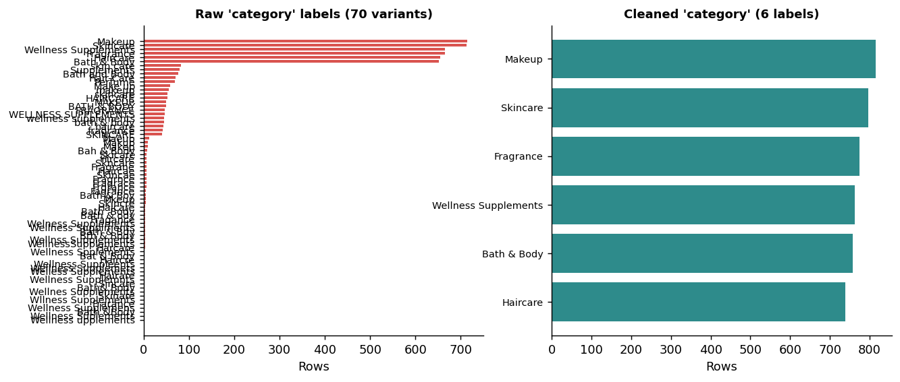
Figure 1: Raw 'category' labels (70 variants) vs the cleaned 6 categories

5. Pipeline Architecture
The pipeline is a sequence of 15 small steps. Each step takes a DataFrame and a shared context object, returns a DataFrame, and records what it changed in an issue register. A runner executes the steps in order and logs rows in/out, missing cells and run time per step.
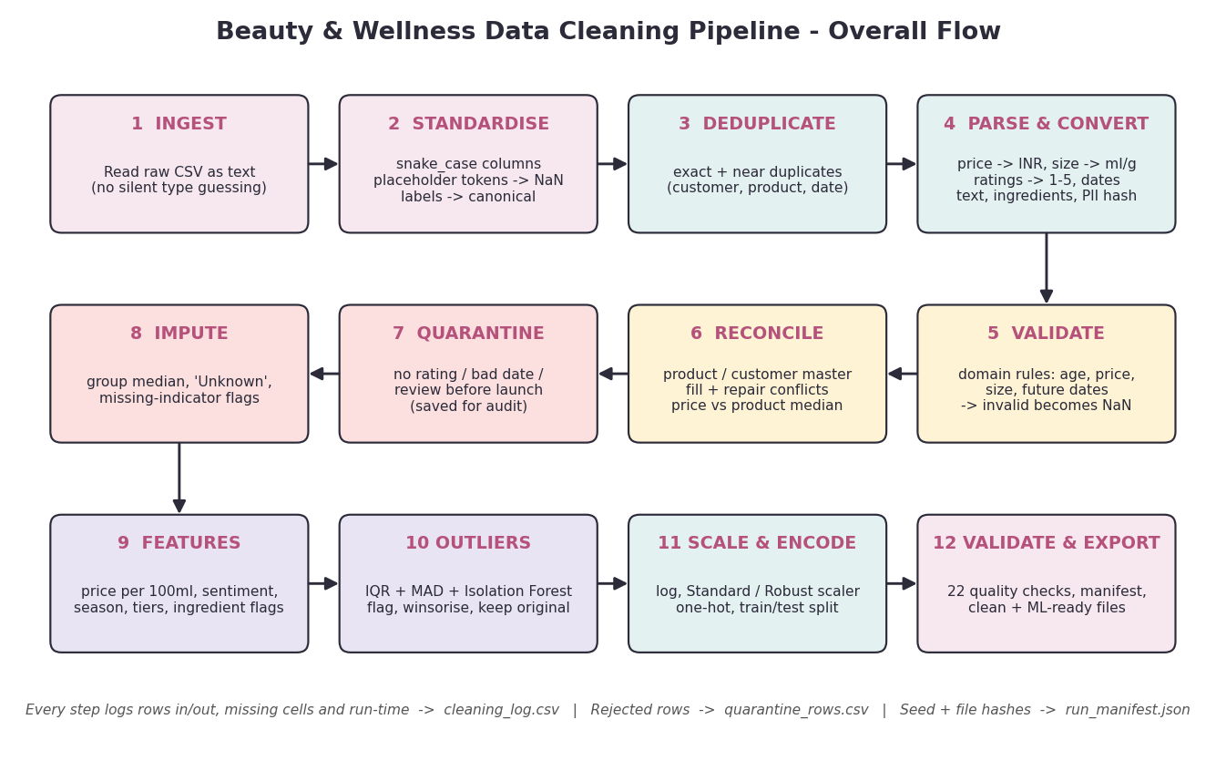
Figure 2: Overall data preprocessing flow (12 stages, 15 coded steps)

5.1 Step order and rationale
The order matters. Cheap, safe, information-preserving operations come first; operations that depend on trustworthy values come later; irreversible decisions (quarantine, imputation, scaling) come last.
Step | What it does | Why here
01-02 Standardise | snake_case column names; placeholder tokens -> NaN | Every later step can rely on real NaN values
03 Exact duplicates | Drop fully identical rows | Cheap, safe and shrinks the data early
04 Categoricals | Map labels to canonical lists (exact, synonym, fuzzy) | Product and customer grouping in step 11 needs clean keys
05-06 Parse | Price -> INR, size -> ml/g, rating -> 1-5, SPF, age, dates | Typed values are needed for every rule and statistic
07 Text | Clean review text; normalise ingredient lists | Independent of numeric logic; prepares NLP and flags
08 PII | Validate then hash e-mail and phone; drop raw columns | Privacy by design: sensitive data never reaches saved files
09 Near duplicates | Same customer+product+date, keep most complete | Needs parsed dates; must precede statistics
10 Domain rules | Impossible values -> NaN (age, price, size, future date) | Turns errors into 'missing' so they can be repaired
11 Reconcile | Fill/repair from product and customer masters; price vs product median | Best source of truth: other rows of the same entity
12 Quarantine | Remove rows with no valid rating/date or review before launch | Only after repair attempts have failed
13 Impute | Group median / 'Unknown' + indicator flags | Last resort for what remains
14 Features | Price per 100 ml, sentiment, season, tiers, ingredient flags | Needs complete, valid inputs
15 Outliers | IQR, MAD, Isolation Forest; winsorised copy | Statistical outliers only make sense on repaired data
Export | Log, scale/encode on train split, validate, manifest | Scalers must be fitted on the training split only
Table 4: Pipeline steps and the reasoning behind their order

5.2 Design principles
- Never destroy information silently. Invalid values become NaN (and are logged); unusable rows go to a quarantine file with a reason.
- Preserve the original next to the treated value. For example price_inr is kept beside price_inr_winsor, and outliers are flagged rather than deleted.
- Prefer evidence over assumptions. Other rows of the same product or customer are better evidence than a global median.
- Everything configurable in one place. Vocabularies, thresholds, FX rates and formats live in config.py; its SHA-256 hash is stored in the run manifest.
- No data leakage. Scalers are fitted on the training split only.
- Testable units. Each parser is a pure function with unit tests.

6. Cleaning Methodology
This section explains how each class of defect is handled, including the reasoning and the results measured on the raw extract.

6.1 Ingestion and missing-value tokens
The file is read with pd.read_csv(path, dtype=str, keep_default_na=False). Reading as text guarantees that nothing is parsed incorrectly before our own rules run. A configurable token set (empty string, N/A, NA, null, none, -, ?, unknown, not available, etc.) is then converted to true missing values after trimming whitespace and ignoring case. This single step converted 2,665 placeholder cells.

6.2 Duplicates
Duplicates are handled at two levels because the real-world causes differ.
- Exact duplicates (150 rows): identical in every column - typically a repeated export. drop_duplicates() keeps the first.
- Near duplicates (101 rows): the same customer reviewed the same product on the same day but the row has a new review ID and slightly different text (double submission). After parsing, rows are keyed on (customer_id, product_id, review_date) and the most complete row is kept. Running this after parsing matters: '05/03/2025' and '2025-03-05' are only recognised as equal once both are dates.

6.3 Standardising categorical labels
Categorical fields (category, brand, skin type, gender, city, channel, skin concern) use a three-tier matcher implemented with the standard-library difflib:
- Exact match after normalisation (lower-case, '&' to 'and', punctuation removed, spaces collapsed). 'SKINCARE ' and 'Skincare' both become skincare.
- Synonym lookup from a curated dictionary (for example 'skin care' -> Skincare, 'CBE' / 'Kovai' -> Coimbatore, 'Bangalore' -> Bengaluru, 'F' -> Female, 'offline' -> Store).
- Fuzzy match with difflib.get_close_matches at a cut-off of 0.78 for typos such as 'Skincre' or 'Lumiere Botanicz'. Values below the cut-off are set to missing rather than guessed.
Unmatched values are not forced into a class; they become missing and are given a second chance in the entity reconciliation step. The match result is cached per distinct value so the fuzzy matcher runs once per distinct raw value, not once per row. The result: category 70 -> 6 labels, brand 128 -> 14, skin type 35 -> 5, gender 17 -> 3, city 74 -> 10 and channel 16 -> 3.

6.4 Parsing numeric fields

Price
A regular expression extracts the first number after removing thousands separators; currency symbols or codes ($, USD, €, EUR, otherwise INR) select the conversion rate. Formats such as '₹1,299', 'Rs. 999', 'INR 1,299.00', '499 /-' and '$12.99' all become floats in INR. 524 prices were converted from USD/EUR.

Pack size
A single regex captures the number and unit; a lookup table converts to a base unit: ml for volume (ml, L, fl oz) and g for mass (g, gm, kg, oz). 1.7 fl oz becomes 50.3 ml; 0.1 kg becomes 100 g. A unit field records whether the product is measured by volume or mass, which is essential for a correct price-per-100 ml feature. Rounding in the source (1.7 fl oz is a rounded 50 ml) is later neutralised by the product-master step.

Rating
Ratings are parsed with the following rules, in order: (1) words 'one'..'five' become digits; (2) fractions such as '4/5' or '8/10' are rescaled to a 5-point scale; (3) otherwise the first number is taken ('4 stars' -> 4); (4) repeated-digit values 11, 22, 33, 44, 55 are treated as double-key typos and repaired to the single digit; (5) anything outside 1-5 becomes missing; (6) values are snapped to the nearest 0.5. This rescued 778 ratings and rejected 141 impossible ones (for example 0, 6 and -1).

Age and SPF
Age is extracted as a number and then validated against 13-90 (the domain rule). SPF is parsed from strings such as 'SPF 30', '50+' or '50 PA++++' and validated to 0-100; when the SPF field is missing, the product name is searched for 'SPF nn' and otherwise 0 is assumed (no SPF claim).

6.5 Dates
Dates arrive in eight possible formats (ISO, dd/mm/yyyy, dd-mm-yyyy, dd Mon yyyy, Mon dd, yyyy, dd.mm.yyyy and others). pd.to_datetime is called once per explicit format with errors='coerce', and each pass only parses the values the previous passes failed on. Explicit formats are deliberately preferred to format='mixed' because they make the day-first assumption visible and testable. Two logic rules follow: a review date later than the reference date is invalid, and a review dated before the product's launch is a contradiction.

6.6 Review text and ingredients
Review text. The cleaner unescapes HTML entities, strips tags and URLs, removes emoji (Unicode ranges), collapses runs of repeated punctuation ('!!!!!' -> '!') and repeated characters ('soooo' -> 'soo'), normalises whitespace and converts text written entirely in capitals to sentence case. Empty results become missing.
Ingredients. Lists are split on commas, semicolons, pipes and new lines; each item is lower-cased and stripped; synonyms follow INCI-style conventions ('Aqua', 'Water (Aqua)', 'Purified water' -> water; 'Vit C', 'Vitamin C' -> ascorbic acid; 'Nicotinamide', 'Vitamin B3' -> niacinamide; 'Parfum' -> fragrance); duplicates are removed while preserving order. From the normalised list the pipeline derives the ingredient count and claim/safety flags such as has_fragrance, has_alcohol, has_paraben, has_sulfate, has_retinol, has_niacinamide, has_hyaluronic_acid and has_vitamin_c.

6.7 Privacy: e-mail and phone
E-mail addresses are lower-cased and validated against a regular expression; phone numbers keep the last 10 digits and must match the Indian mobile pattern [6-9] followed by nine digits. 215 e-mails and 157 phone numbers were invalid and became missing. The raw values are then replaced by a salted SHA-256 pseudonym (first 16 hex characters). The same person still maps to the same token (so duplicate detection and joins work) but the original identifier is unrecoverable from the exported file. The salt is read from the environment variable BW_PII_SALT in production. The e-mail domain (gmail, yahoo, ...) is kept as a harmless feature.

6.8 Domain validation rules
Field | Rule (from config.py) | Records failing | Action
Age | 13 <= age <= 90 | 54 | Set to missing; recover from customer's other reviews
Pack size | 1 <= size <= 2,000 ml/g | 48 | Set to missing; recover from product master
Price | Rs. 20 <= price <= Rs. 100,000 | 61 | Set to missing; product median fills
Price vs product | 0.1 <= price / product median <= 10 | 33 | Set to missing; product median fills
Review date | <= reference date (2026-10-20) | 48 | Set to NaT; quarantined if unrecoverable
Review date vs launch | review_date >= launch_date | 43 | Quarantine (contradiction)
Rating | 1 <= rating <= 5 | 141 | Set to missing; quarantine (target variable)
Table 5: Domain rules applied and their counts on the raw extract

6.9 Entity reconciliation (product and customer masters)
The same product appears in many reviews, and the same customer reviews several products. Product attributes (brand, category, size, unit, launch date, SPF, ingredients, name) should be identical on every row; customer attributes (age, gender, city, skin type) should also be stable. The pipeline computes the most frequent non-null value for each entity and uses it to (a) fill gaps and (b) repair conflicts.
Attribute | Gaps filled from other rows | Source of truth
Customer age | 496 | Same customer's other reviews
Customer skin type | 458 | Same customer's other reviews
Pack size | 175 (plus 711 conflicts repaired) | Product master (mode)
Launch date | 154 | Product master
Ingredients | 173 | Product master
SPF | 84 | Product master
Brand | 67 | Product master
Price (after x10 / x0.1 check) | 257 | Product median price
Table 6: Values recovered by reconciliation instead of statistical imputation
This is more accurate than any global statistic because it uses information that actually belongs to that product or person. The 711 'size conflicts' are mostly rounding differences introduced by unit conversion (1.7 fl oz vs 50 ml), which the product mode neutralises.

6.10 Quarantine
Some rows cannot be repaired: no valid rating (the target variable), no valid review date, or a review that predates the product's launch. Instead of deleting them, the pipeline moves them to quarantine_rows.csv with a quarantine_reason, so that reviewers can audit decisions or recover rows if the rules change.
Quarantine reason | Rows
missing or invalid rating (target variable) | 221
missing or invalid review_date | 91
review_date before product launch_date | 43
Total | 355
Table 7: Rows moved to quarantine (7.1% of the de-duplicated data)

6.11 Handling the remaining missing values
Reconciliation resolves most gaps. What is left is handled with an explicit decision table that depends on the missingness mechanism and the role of the variable.
Field | Mechanism | Strategy | Records
Age | MAR (App users) | Median age of the gender group; flag age_imputed | 35
Gender, city, skin type | MCAR / MNAR | Category 'Unknown' (keeps the signal that data was withheld) | 9 / 8 / 19
Skin concern, channel, would_recommend | MCAR | Category 'Unknown'; not derived from rating to avoid leakage | 186 / 83 / 179
Price, size | MCAR | Product value, then category median | 0 remaining
Review text | Optional field | Empty string + has_review_text = 0 flag | 219
Rating, review date | Target / key | Not imputed - quarantined | 355 rows
Launch date | MCAR | Left as NaT; product-age feature uses the median | residual
Table 8: Missing-value strategy by field
Why not just use the mean?
A global mean would push the 28% of App users with a hidden age towards the overall average and understate variation. Using the customer's own other reviews first, then a group median, keeps segment differences intact, and the indicator flag lets a model learn whether 'missing' itself carries meaning (for example, privacy-conscious customers).
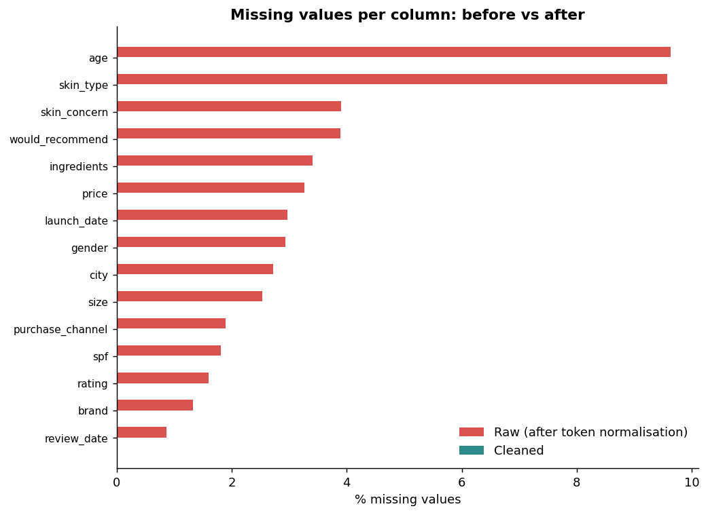
Figure 3: Missing values per column, raw vs cleaned

6.12 Outlier detection and treatment
Outliers are not all errors. A Rs. 6,000 perfume is normal; a Rs. 6,000 body wash is suspicious. The pipeline therefore separates errors (impossible values, removed by domain rules and the price-versus-product-median test) from statistical extremes (legitimate but unusual, flagged and capped for modelling).
Method | Where applied | Principle | Flagged | Treatment
Domain rules | Age, price, size, date | Impossible regardless of distribution | 211 values | -> NaN, then repaired
Price / product median | Price | A product's own price is the best reference | 33 | -> NaN, then product median
IQR (1.5 x) on log price | Price within each category | Robust fences; log handles skew | 76 | Flag + winsorised copy
Modified z-score (MAD) | Price per 100 ml within category | Median and MAD ignore the outliers themselves | 0 | Flag (none exceeded 3.5)
Isolation Forest (1%) | Log price, price/100, age, rating, text length, SPF | Multivariate: unusual combinations | 46 | Flag for review
Rating-text mismatch | Rating vs review sentiment | 5 stars with a negative review is suspicious | 35 | Flag
Table 9: Outlier methods, what they flagged on this run, and treatment
Winsorising (capping at the fences) is applied to a copy of the price (price_inr_winsor) so analysts can choose between the original and the capped value. Different methods catch different things, which is why they are combined: IQR flags 76 unusually priced items within categories, the MAD rule is deliberately conservative (nothing exceeded 3.5 on this data), and Isolation Forest highlights 46 unusual multivariate combinations that no single-column rule would notice.
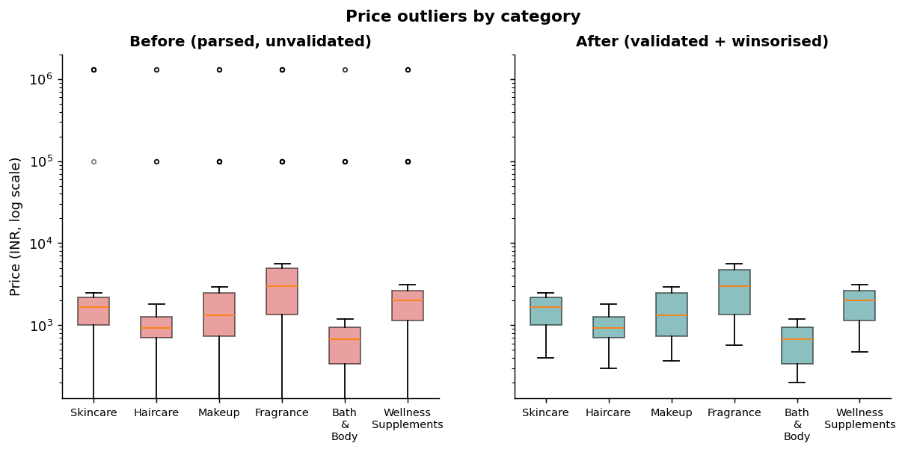
Figure 4: Price distribution by category, before and after treatment (log scale)
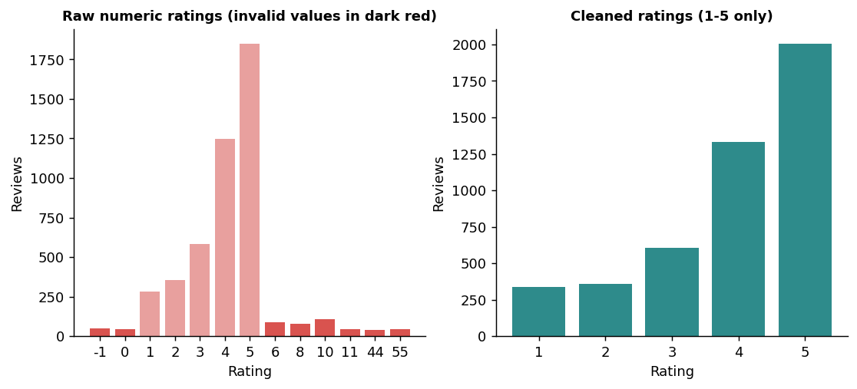
Figure 5: Ratings before (including impossible values) and after cleaning

7. Python Tools and Why They Are Suitable
The stack is intentionally small and standard so that it installs anywhere (four third-party packages) and every reviewer can read it. Library versions used for this run are recorded in the run manifest: Python 3.12.3, pandas 3.0.2, NumPy 2.4.4, scikit-learn 1.8.0.
Library | Used for | Why it is suitable
pandas | Reading CSV as text, .str string methods, to_datetime, groupby().transform(), duplicated, qcut, get_dummies | Vectorised, expressive table operations; groupby-transform lets a group statistic (median, mode) be broadcast back to every row without loops
NumPy | log1p, clip, where, NaN/inf handling, random generator for synthetic data | Fast array maths; default_rng(seed) gives reproducible random data
scikit-learn | IsolationForest, StandardScaler, RobustScaler, train_test_split | Industry-standard, tested implementations; fit on train and transform on all prevents leakage; stratified splitting keeps class balance
re / html | Price, size, rating, date and text patterns; HTML unescape | Precise control over messy human-written formats without extra dependencies
difflib | Fuzzy label matching ('Skincre' -> Skincare) | Part of the standard library; adequate for a few hundred distinct labels. For millions of labels rapidfuzz is the faster drop-in replacement
hashlib | Salted SHA-256 pseudonymisation of e-mail and phone | Standard, audited cryptographic hash
matplotlib | Flowchart and before/after charts | Full control and a deterministic image output suitable for a Word report
logging, json, argparse, pathlib | Audit log, run manifest, CLI, portable paths | Production-style traceability with zero extra packages
unittest | 19 automated tests | Ships with Python, so tests run anywhere with python -m unittest
Table 10: Libraries used and the reasoning behind each choice

7.1 Alternatives considered
Need | Option used here | Alternative for larger scale or stricter governance
Large data | pandas (5k-5M rows) | Polars or Dask for out-of-core / parallel processing
Fuzzy matching | difflib | rapidfuzz, or a reference-data service
Declarative validation | Custom rule checks (22) | pandera or Great Expectations with data docs
Missing-value visualisation | Bar chart of % missing | missingno matrix / heat-map
Sentiment | Transparent lexicon | VADER, TextBlob or a transformer model; multilingual / Hinglish models for real data
Units and currency | Lookup table, fixed FX | pint for units; dated FX table from a central bank API
Data versioning | SHA-256 manifest + Git | DVC or lakeFS
Table 11: Scaling-up and governance alternatives

8. Pseudo-code and Implementation Highlights

8.1 End-to-end pseudo-code
Pseudo-code 1: overall pipeline
FUNCTION clean_pipeline(raw_csv):
df <- read_csv(raw_csv, dtype = text) # never let pandas guess
df <- snake_case(columns); replace placeholder tokens by NaN
df <- drop exact duplicates
FOR field IN [brand, category, skin_type, gender, city, channel]:
df[field] <- map exact -> synonym -> fuzzy to canonical list
df.price <- parse currency, convert to INR
df.size <- parse number + unit, convert to ml or g
df.rating <- parse words / fractions / typos, keep 1..5 else NaN
df.dates <- try each known format in turn (day-first)
df.text, df.ingredients <- normalise; hash e-mail and phone
df <- keep most complete row per (customer, product, date)
FOR rule IN domain_rules: set violating values to NaN
FOR entity IN [product, customer]:
fill NaN and repair conflicts with the entity's most frequent value
price <- NaN where price / product_median outside [0.1, 10]; fill with product median
quarantine rows with no rating, no date or review before launch
impute leftovers: group median (numeric), 'Unknown' (categorical) + flags
add features: price per 100 ml, sentiment, season, age group, ingredient flags
flag outliers (IQR, MAD, Isolation Forest); winsorise a copy of price
split train/test (stratified); fit scalers on TRAIN; transform all; one-hot encode
validate (22 checks); write outputs, logs and run manifest

8.2 Selected implementation excerpts
Excerpt 1: categorical standardisation
# cleaning.py - three-tier label standardisation
def standardize_labels(series, canonical, synonyms=None, cutoff=0.78):
lookup = {_key(c): c for c in canonical} # exact
syn = {_key(k): v for k, v in (synonyms or {}).items()} # synonym
def resolve(val):
k = _key(val)
if k in lookup: return lookup[k]
if k in syn: return syn[k]
close = difflib.get_close_matches(k, list(lookup) + list(syn), n=1, cutoff=cutoff)
return lookup.get(close[0], syn.get(close[0])) if close else pd.NA # fuzzy
return series.map(resolve).astype("string")

Excerpt 2: rating parser
# cleaning.py - rating parser (words, fractions, typos, range check)
def parse_rating(series):
t = series.astype("string").str.lower().str.strip()
for word, val in WORD_NUMBERS.items():
t = t.str.replace(rf"\b{word}\b", str(val), regex=True)
frac = t.str.extract(r"(-?\d+(?:\.\d+)?)\s*/\s*(\d+(?:\.\d+)?)")
num, den = pd.to_numeric(frac[0]), pd.to_numeric(frac[1])
val = pd.to_numeric(t.str.extract(r"(-?\d+(?:\.\d+)?)")[0])
val = val.where(~(num.notna() & (den > 0)), num / den * 5) # 8/10 -> 4.0
val = val.where(~val.isin([11, 22, 33, 44, 55]), val % 10) # double-key typo
val = val.where(val.between(1, 5)) # else missing
return (val * 2).round() / 2

Excerpt 3: entity reconciliation
# imputation.py - repair values from the entity's own other rows
def reconcile_by_entity(df, entity_col, cols):
for col in cols:
mode = df.groupby(entity_col)[col].agg(most_frequent_non_null)
target = df[entity_col].map(mode)
missing = df[col].isna() & target.notna()
conflict = df[col].notna() & target.notna() & (df[col] != target)
df[col] = df[col].where(~missing, target).where(~conflict, target)
return df

Excerpt 4: outlier detection
# outliers.py - within-group IQR on log scale, plus winsorising
def grouped_iqr_flags(df, value_col, group_col, k=1.5):
logv = np.log1p(df[value_col]); flags = pd.Series(False, index=df.index)
for _, idx in df.groupby(group_col).groups.items():
q1, q3 = logv[idx].quantile([.25, .75]); iqr = q3 - q1
flags[idx] = (logv[idx] < q1 - k*iqr) | (logv[idx] > q3 + k*iqr)
return flags

Excerpt 5: train-only scaler fitting
# pipeline.py - scaling without leakage
train_idx, test_idx = train_test_split(df.index, test_size=0.2, stratify=df["high_rating"], random_state=42)
std = StandardScaler().fit(df.loc[train_idx, STD_COLS]) # fit on TRAIN only
ml[STD_COLS] = std.transform(df[STD_COLS]) # apply to train + test

8.3 Feature engineering
Feature | Definition | Analytical purpose
price_per_100 | winsorised price / size x 100 | Fair price comparison across pack sizes
price_tier | Budget / Mid / Premium by terciles within category | Segmenting by value position
season | Winter (Dec-Feb), Summer (Mar-May), Monsoon (Jun-Sep), Post-Monsoon (Oct-Nov) | Seasonal demand and ratings (humidity, sun)
product_age_days | review date - launch date | Newness / maturity effect
sentiment_score / label | (positive - negative cue words) / total cue words | Text signal for rating models
rating_sentiment_mismatch | rating >= 4 with negative text, or <= 2 with positive text | Suspicious or mis-keyed reviews
has_fragrance, has_paraben, has_sulfate, has_retinol, ... | Membership of normalised ingredient list | Ingredient-level effects on skin-type satisfaction
is_sunscreen | spf > 0 | Sun-care segment
age_group, high_rating, has_review_text | Age bands; rating >= 4; text present | Segmentation and classification target
age_imputed, size_value_imputed | Indicator flags | Lets models see where values are estimated
Table 12: Engineered features

8.4 Scaling and encoding
- Log transform (log1p) of price and price-per-100 to remove right skew.
- StandardScaler (mean 0, SD 1) for approximately symmetric variables: age, log price, size, product age, ingredient count, word count.
- RobustScaler (median and IQR) for variables that keep heavy tails: log price per 100 ml and review length.
- Min-max scaling of SPF to 0-1 using the training maximum.
- One-hot encoding (get_dummies) of category, skin type, gender, channel, season, age group, price tier, skin concern and city.
- Stratified 80/20 split on the high_rating target (3,715 train / 929 test rows); scaler parameters come from the training rows only.

9. Results and Validation

9.1 Step-by-step execution log
Table 13 is produced automatically by the pipeline (reports/cleaning_log.csv). The whole run, including synthetic data creation, takes only a few seconds on a laptop; the 15 cleaning steps themselves take under two seconds.
Step | Rows in | Rows out | Removed | Missing cells out | Seconds
01 standardise column names | 5,250 | 5,250 | 0 | 0 | 0.00
02 normalise missing tokens | 5,250 | 5,250 | 0 | 3,272 | 0.07
03 remove exact duplicates | 5,250 | 5,100 | 150 | 3,187 | 0.01
04 standardise categoricals | 5,100 | 5,100 | 0 | 3,187 | 0.15
05 parse numeric fields | 5,100 | 5,100 | 0 | 3,458 | 0.05
06 parse dates | 5,100 | 5,100 | 0 | 3,458 | 0.04
07 clean text & ingredients | 5,100 | 5,100 | 0 | 3,458 | 0.04
08 protect PII | 5,100 | 5,100 | 0 | 4,160 | 0.02
09 remove near-duplicates | 5,100 | 4,999 | 101 | 4,083 | 0.02
10 apply domain rules | 4,999 | 4,999 | 0 | 4,294 | 0.00
11 reconcile product/customer master | 4,999 | 4,999 | 0 | 2,072 | 0.97
12 quarantine unusable rows | 4,999 | 4,644 | 355 | 1,621 | 0.02
13 impute residual gaps | 4,644 | 4,644 | 0 | 883 | 0.02
14 engineer features | 4,644 | 4,644 | 0 | 1,062 | 0.07
15 detect & treat outliers | 4,644 | 4,644 | 0 | 1,062 | 0.35
Table 13: Per-step audit log (rows, missing cells and run time)
The missing-cell count rises at steps 05 and 08 because parsing converts unreadable values (for example an unparseable price or an invalid e-mail) into explicit missing values, and falls sharply at step 11 when reconciliation recovers values from other rows. It falls again at step 13 after imputation.
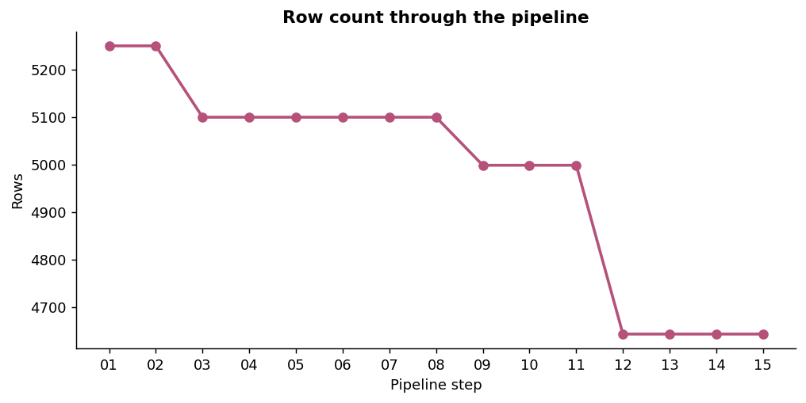
Figure 6: Row count through the pipeline (5,250 -> 4,644)
Row accounting: 5,250 raw rows - 150 exact duplicates - 101 near duplicates - 355 quarantined = 4,644 clean rows. The unit tests assert that raw rows always equal clean + quarantined + duplicates, so no row can disappear unrecorded.

9.2 Issue register
Every defect found is registered with its count and the action taken (reports/issue_register.csv, 53 entries on this run). The most significant are shown below.
Step | Issue | Records | Action
missing | placeholder tokens ('N/A', '?', '-', ...) | 2,665 | converted to true missing values
duplicates | exact duplicate rows | 150 | dropped (kept first)
categoricals | inconsistent labels in 'brand' | 832 | mapped to canonical label (exact/synonym/fuzzy)
categoricals | inconsistent labels in 'category' | 1,156 | mapped to canonical label (exact/synonym/fuzzy)
categoricals | inconsistent labels in 'skin_type' | 749 | mapped to canonical label (exact/synonym/fuzzy)
categoricals | inconsistent labels in 'gender' | 1,158 | mapped to canonical label (exact/synonym/fuzzy)
categoricals | inconsistent labels in 'city' | 1,016 | mapped to canonical label (exact/synonym/fuzzy)
categoricals | inconsistent labels in 'purchase_channel' | 821 | mapped to canonical label (exact/synonym/fuzzy)
categoricals | would_recommend written as Y/1/TRUE/... | 3,896 | mapped to Yes/No
numeric | prices in USD/EUR | 524 | converted to INR at fixed rates {'INR': 1.0, 'USD': 83.0, 'EUR': 90.0}
numeric | sizes in mixed units (fl oz, oz, L, kg) | 1,426 | converted to ml / g
numeric | ratings on other scales / words / typos | 778 | rescaled to 1-5 or typo corrected
numeric | ratings outside 1-5 | 141 | set to missing (row quarantined later)
dates | date strings in 8 possible formats in 'review_date' | 5,056 | parsed to datetime64 (day-first when ambiguous)
dates | date strings in 8 possible formats in 'launch_date' | 4,945 | parsed to datetime64 (day-first when ambiguous)
text | review texts with HTML/URLs/emoji/shouting/whitespace | 1,318 | normalised
text | ingredient lists with mixed separators/synonyms/duplicates | 4,924 | split, lower-cased, INCI-synonym mapped, de-duplicated
pii | invalid e-mail addresses | 215 | set to missing
pii | invalid phone numbers | 157 | set to missing
duplicates | near-duplicates (same customer+product+date, different review_id) | 101 | kept the most complete record
entity-master | product attribute 'size_value' missing | 175 | filled from other reviews of the same product
entity-master | product attribute 'size_value' conflicting | 711 | replaced by most frequent value
entity-master | product attribute 'size_unit' missing | 127 | filled from other reviews of the same product
entity-master | product attribute 'launch_date' missing | 154 | filled from other reviews of the same product
entity-master | product attribute 'ingredients_clean' missing | 173 | filled from other reviews of the same product
entity-master | customer attribute 'age' missing | 496 | filled from the same customer's other reviews
Table 14: Issue register (entries with at least 100 affected records)

9.3 Before and after
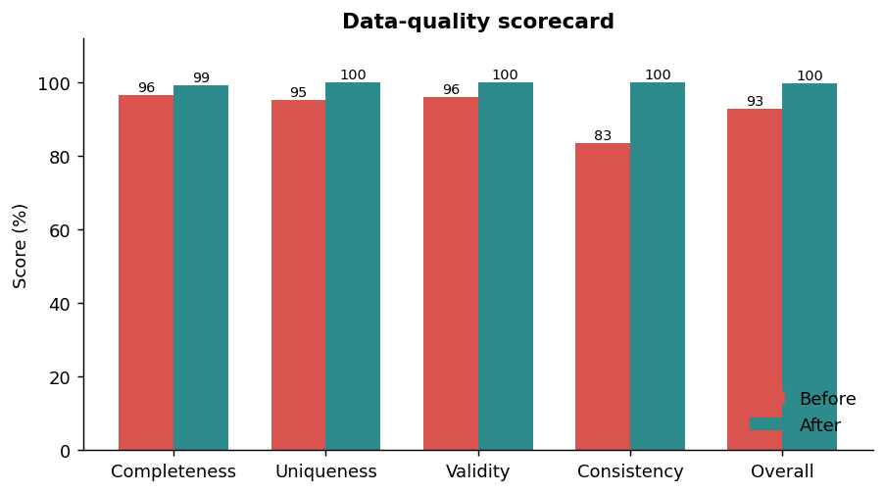
Figure 7: Data-quality scorecard
The scorecard shows the largest gain in consistency (83.4% -> 100%) because label variants were the most widespread defect, followed by uniqueness and validity. Completeness improves only from 96.5% to 99.2% because the after-measure is deliberately strict: an 'Unknown' label or an imputed age is not counted as complete. The report therefore does not overstate what imputation achieves.
Residual 'Unknown' share after cleaning | %
gender | 0.2%
city | 0.2%
skin type | 0.4%
skin concern | 4%
purchase channel | 1.8%
would recommend | 3.9%
age (median-imputed, flag age_imputed) | 0.8%
Table 15: Share of values that are still unknown or estimated

9.4 Automated validation
After the pipeline finishes, 22 rule-based checks run on the clean table and on the model matrix (the same idea as Great Expectations or pandera). With --strict, the program returns a non-zero exit status if any check fails, so it can gate a scheduled job or a CI pipeline.
Check | Result
required columns present | PASS
no nulls in required columns | PASS
review_id unique | PASS
no duplicate (customer, product, date) | PASS
rating within 1-5 | PASS
age within 13-90 | PASS
price positive and below hard cap | PASS
price within category ceiling (winsorised) | PASS
size within plausible range | PASS
spf within 0-100 | PASS
category canonical | PASS
brand canonical or Unknown | PASS
skin_type canonical or Unknown | PASS
city canonical or Unknown | PASS
review_date not in the future | PASS
review_date on/after launch_date | PASS
no raw PII columns | PASS
no infinite values | PASS
no NaN in model matrix | PASS
no inf in model matrix | PASS
train/test split present | PASS
standard-scaled train means ~0 | PASS
Table 16: Validation checks (all passed)
Beyond data validation, 19 unit and integration tests cover the parsers (price, size, rating, date, SPF), label standardisation, text/PII cleaning, outlier detectors, entity reconciliation, determinism (two runs give identical frames), row accounting and the ML matrix.

10. How Cleaned Data Improves Analysis and Modelling

10.1 Naive versus cleaned results
The clearest evidence of value is to ask the same simple question of the raw and the cleaned data.
Question | Naive answer on raw data | Answer after cleaning
Mean price - Skincare | Rs. 9,051 | Rs. 1,531
Mean price - Fragrance | Rs. 11,758 | Rs. 3,065
Mean price - Bath & Body | Rs. 4,497 | Rs. 660
Mean rating | 4.91 out of 5 | 3.93 out of 5
Customer age (min to max) | -5 to 999 | 18 to 62
Number of product categories | 70 | 6
Number of cities | 74 | 10
Table 17: The same question answered on raw and cleaned data
A mean rating of 4.91 would suggest near-perfect satisfaction; the true value is 3.93. A Skincare price of Rs. 9,051 would mislead pricing strategy by a factor of almost six. These are exactly the errors that an unprepared dataset passes silently into dashboards and models.

10.2 What the cleaned data enables
Analysis / model | How cleaning helps
Rating prediction (classification of high vs low rating) | Valid 1-5 target, no impossible predictors, stratified split, leakage-free scaling, indicator flags for imputed values
Customer segmentation (clustering) | Standardised age, skin type, city and channel; scaled numeric features so distance-based algorithms are not dominated by price or age
Price positioning and pricing analytics | INR-normalised price, price per 100 ml/g, within-category tiers, outlier-resistant winsorised copy
Ingredient-effect studies | Normalised INCI-style names and flags (e.g. fragrance, sulfate, retinol) make 'Aqua' and 'Water' the same ingredient
Sentiment and review mining | Clean text, sentiment label and rating-text mismatch flag to filter suspicious reviews
Seasonality and regional analysis | Reliable review dates, Indian seasons, canonical cities (Coimbatore, Chennai, Bengaluru, ...)
Recommender systems | De-duplicated (customer, product) interactions; stable product master; consistent skin-type vocabulary
Compliance and trust | No raw e-mail or phone numbers in analysis files; every exclusion is auditable via quarantine
Table 18: Downstream uses of the cleaned dataset

10.3 Illustrative segment view
Because the data are synthetic, the following figures only illustrate the kind of view that clean data supports; they are not market findings.
Category | Reviews | Mean rating | Mean price (Rs.) | Median price per 100 ml/g (Rs.) | Would recommend
Bath & Body | 758 | 3.97 | 660 | 315 | 76.8%
Fragrance | 774 | 3.94 | 3,065 | 5,270 | 75.7%
Haircare | 738 | 3.95 | 982 | 490 | 76.0%
Makeup | 815 | 3.93 | 1,527 | 8,300 | 76.6%
Skincare | 796 | 3.88 | 1,531 | 2,240 | 73.6%
Wellness Supplements | 763 | 3.89 | 1,853 | 532 | 75.5%
Table 19: Category summary computed from the cleaned file (synthetic data)

10.4 Model readiness
- The ML-ready file has 74 numeric features, no NaN and no infinite values (validated), a split column and two targets (rating, high_rating).
- Scalers are fitted on 3,715 training rows only, so test performance will not be inflated by leakage.
- Indicator flags and ingredient flags let tree-based models and regularised linear models exploit missingness and formulation information.
- Caution on leakage: the review sentiment score is derived from text that was written together with the rating. It is valid for explanatory work but should be excluded when predicting a rating from information available before a review is written.

11. Documentation and Reproducibility
A cleaning process is only trustworthy if another person can rerun it and obtain identical results, and if every change to the data can be explained. The project implements reproducibility at six levels.
Level | Mechanism | Artefact
1. Code | Modular package, one function per concern, docstrings, Git-friendly layout | src/bw_pipeline/*.py
2. Configuration | All rules, vocabularies and thresholds in one file; its SHA-256 recorded | config.py, run_manifest.json
3. Randomness | Fixed seed (42) for data generation, Isolation Forest and the train/test split | RANDOM_SEED
4. Environment | Library versions captured automatically; requirements.txt provided | run_manifest.json
5. Lineage and audit | Per-step log, issue register, quarantine file, data dictionary, SHA-256 of input and every output | cleaning_log.csv, issue_register.csv, quarantine_rows.csv, data_dictionary.csv
6. Verification | 22 data-validation checks and 19 tests; --strict exit code; determinism test | validation_checks.csv, tests/
Table 20: Reproducibility mechanisms

11.1 Run manifest
Excerpt of reports/run_manifest.json
{
"python": "3.12.3",
"pandas": "3.0.2",
"numpy": "2.4.4",
"scikit_learn": "1.8.0",
"random_seed": 42,
"reference_date": "2026-10-20",
"config_sha256": "6d4c64456f1f393f...",
"raw_file_sha256": "a48c9250082f9682...",
"raw_rows": 5250,
"clean_rows": 4644
}

Anyone who reruns python main.py should obtain output files with identical SHA-256 hashes when the same library versions are used. The determinism unit test compares two independent runs frame-for-frame.

11.2 Good documentation practice adopted
- Data dictionary (data_dictionary.csv, Appendix B) describing each of the 57 cleaned columns.
- Decision log in code: every rule has a name, a count and an action in the issue register, so 'why was this value changed?' can always be answered.
- Raw data is immutable. The raw file is never edited; every correction is a coded transformation.
- Quarantine, not deletion, with a reason column for audit and later recovery.
- README with installation, usage, outputs, layout and limitations; MIT licence.
- Version control recommended workflow: one commit per rule change, with the issue-register diff in the commit message; tag releases when config.py changes.
- Scheduling: the CLI returns exit code 1 under --strict when validation fails, so it can run in cron, GitHub Actions or Airflow.

11.3 How to run
Commands
python -m venv .venv && source .venv/bin/activate
pip install -r requirements.txt
python main.py --strict # generate, clean, validate, export, plot
python -m unittest discover -s tests -v # run 19 tests
python main.py --input my_raw.csv --seed 7

12. Innovative Solutions to Common Data Quality Problems
Problem | Common approach | Approach used here and why it is better
Missing age / skin type / size | Fill with global mean or mode | Entity master reconciliation: use the same customer's or product's other rows first, then group median, then 'Unknown' + flag. Preserves segment differences.
Price typos (x10, x0.1) | Global z-score or IQR | Price vs product-median ratio catches errors that look normal in the global distribution (a Rs. 12,990 lipstick may be inside the category range but is 10x its own product price).
Rating typos '55', '44' | Drop or cap at 5 | Repeated-digit repair recovers the intended value and logs the correction.
Many spellings of labels | Hard-coded replacements | Exact -> synonym -> fuzzy matcher with cut-off; unmatched values are refused rather than guessed.
Ingredient naming | Ignore or manual list | INCI-style synonym map + de-duplication + claim flags, enabling ingredient-level analysis.
Mixed units | Keep as text | Unit conversion to ml/g and a volume/mass flag, so price per 100 ml is comparable.
SPF missing | Treat as missing | Recover from product name; otherwise treat as 'no SPF claim' (0).
Outliers in skewed prices | Delete the rows | Within-category IQR on log scale, winsorised copy, original kept; IQR + MAD + Isolation Forest comparison.
Suspicious reviews | Not addressed | Rating-sentiment mismatch flag (5 stars + negative text).
Missing not at random | Impute silently | Indicator flags and 'Unknown' categories keep the information that data was withheld.
Privacy | Drop columns late | Salted SHA-256 pseudonyms at step 8, before anything is written.
Seasonality | Calendar month only | Indian seasons (Winter, Summer, Monsoon, Post-Monsoon) as a domain feature.
Row deletion | Silent removal | Quarantine file with reasons and row-accounting test.
Table 21: Domain-aware solutions to common data-quality problems

13. Limitations and Future Work
- Synthetic evidence. The demonstration data are generated; real public data will contain additional defects (multilingual and Hinglish reviews, scraped HTML fragments, review bursts). The pipeline's modular design makes adding such steps straightforward.
- Fixed exchange rates and day-first dates are assumptions; a production system should use dated FX rates and a per-source date-format registry.
- Lexicon sentiment is simple and English-only. Replace with VADER or a multilingual transformer for real reviews.
- Fuzzy matching with difflib suits hundreds of labels; for larger vocabularies use rapidfuzz or entity-resolution libraries.
- Imputation uses medians and entity modes; model-based methods (KNNImputer, IterativeImputer / MICE) could be compared through a masked-value experiment.
- Future work: drift monitoring across weekly extracts, pandera schemas, data versioning with DVC, a Streamlit dashboard of the quality scorecard, and a first predictive model (high-rating classifier) using the ML-ready file.

14. Conclusion
The Week 3 task asked for a robust cleaning and preprocessing pipeline for beauty and wellness data. This project delivers a complete, working implementation: a 15-step, configuration-driven pipeline that repaired or quarantined every defect it was designed to find, raised overall data quality from 92.8% to 99.8%, produced an analysis-ready table and a leakage-free ML matrix, and proved the result with 22 data checks and 19 unit tests.
Beyond the mechanics, the work shows an approach: treat dirty data as evidence to be explained rather than noise to be deleted; use the most reliable information available (other rows of the same product or customer) before statistics; keep the original beside every treated value; flag instead of removing when in doubt; protect personal data from the first step; and log everything so the process can be audited and repeated. These principles transfer directly to the next stages of the internship: exploratory analysis, feature selection and predictive modelling.

Appendix A - Project Structure
Folder layout
beauty_wellness_cleaning/
|-- main.py CLI entry point
|-- requirements.txt README.md LICENSE .gitignore
|-- src/bw_pipeline/
| |-- config.py rules, vocabularies, thresholds
| |-- data_generator.py synthetic raw data with ~20 injected defect types
| |-- cleaning.py parsers, label standardiser, text and PII helpers
| |-- imputation.py entity reconciliation, group median, constants
| |-- outliers.py IQR, MAD, grouped winsorising, Isolation Forest
| |-- features.py price/100, sentiment, seasons, ingredient flags
| |-- validation.py 22 checks + quality scorecard
| |-- pipeline.py 15 steps, runner, ML export, manifest
| |-- visualization.py flowchart and charts
| `-- context.py issue register, quarantine, snapshots
|-- tests/test_pipeline.py 19 tests
|-- data/raw | interim | processed
|-- reports/ (logs, registers, scorecard, manifest, figures/)
`-- logs/pipeline.log

Output file | Content
data/processed/beauty_wellness_clean.csv | 4,644 rows x 57 columns, cleaned and feature-rich
data/processed/beauty_wellness_ml_ready.csv | 4,644 rows x 78 columns: ids, targets, split and 74 features
data/processed/quarantine_rows.csv | 355 rejected rows with reasons
reports/cleaning_log.csv, issue_register.csv | Per-step and per-issue audit trail
reports/quality_scorecard.csv, quality_report.json, validation_checks.csv | Quality evidence
reports/run_manifest.json, data_dictionary.csv | Reproducibility and documentation
reports/figures/*.png | Flowchart and before/after charts
Table A1: Files produced by one run

Appendix B - Data Dictionary (Cleaned Dataset)
Column | Type | Description
review_id | text | Unique review identifier
customer_id | text | Pseudonymous customer key
age | int64 | Customer age in years (13-90), imputed where unavailable (see age_imputed)
gender | text | Female / Male / Other / Unknown
city | text | Standardised Indian city
skin_type | text | Oily / Dry / Combination / Normal / Sensitive / Unknown
skin_concern | text | Primary concern the product addresses
review_date | datetime | Review date (datetime)
product_id | text | Product key
product_name | text | Marketing name
brand | text | Canonical brand
category | text | Canonical product category
launch_date | datetime | Product launch date
spf | float64 | Sun protection factor claim (0 = none)
rating | float64 | Customer rating 1-5
would_recommend | text | Yes / No / Unknown
purchase_channel | text | Online / Store / App / Unknown
price_inr | float64 | Price in INR (currency-converted, validated)
size_value | float64 | Pack size in ml or g
size_unit | text | ml (volume) or g (mass)
review_text_clean | text | Cleaned review text
ingredients_clean | text | Pipe-separated normalised ingredient list
email_domain | text | E-mail provider domain
email_hash | text | Salted SHA-256 pseudonym of e-mail
phone_hash | text | Salted SHA-256 pseudonym of phone
age_imputed | int64 | 1 if age was estimated
size_value_imputed | int64 | 1 if size was estimated
price_per_100 | float64 | INR per 100 ml/g (winsorised price)
has_review_text | int64 | Derived / flag column
review_length | Int64 | Derived / flag column
review_word_count | int64 | Derived / flag column
sentiment_score | float64 | Lexicon sentiment -1..1
sentiment_label | text | negative / neutral / positive
rating_sentiment_mismatch | int64 | 1 if rating and text sentiment disagree
review_year | int32 | Derived / flag column
review_month | int32 | Derived / flag column
review_quarter | int32 | Derived / flag column
season | str | Indian season of the review month
product_age_days | int64 | Days between launch and review
age_group | text | Age band
is_sunscreen | int64 | Derived / flag column
price_tier | text | Budget / Mid / Premium within category
high_rating | int64 | 1 if rating >= 4 (classification target)
has_fragrance | int64 | Derived / flag column
has_alcohol | int64 | Derived / flag column
has_paraben | int64 | Derived / flag column
has_sulfate | int64 | Derived / flag column
has_retinol | int64 | Derived / flag column
has_niacinamide | int64 | Derived / flag column
has_hyaluronic_acid | int64 | Derived / flag column
has_vitamin_c | int64 | Derived / flag column
n_ingredients | int64 | Count of distinct ingredients
price_outlier_iqr | int64 | 1 = IQR outlier within category
price_outlier_mad | int64 | 1 = modified z-score outlier on price per 100
price_inr_winsor | float64 | Price capped at within-category IQR fences
multivariate_outlier | int64 | 1 = Isolation Forest anomaly
anomaly_score | float64 | Isolation Forest decision score (lower = more anomalous)
Table B1: Columns of beauty_wellness_clean.csv (from reports/data_dictionary.csv)

Appendix C - Submission Description
The following text can be pasted into the "Write description for the report" field of the submission form (about 260 words).
Report description
This report documents a complete data cleaning and preprocessing pipeline for beauty and wellness data, built in Python as the Week 3 task of my Data Science with Python Analyst Internship. It first catalogues seventeen data-quality problems typical of public beauty and wellness sources, such as placeholder missing values, duplicate reviews, inconsistent category and city labels, prices in different currencies, pack sizes in ml, fl oz and grams, chaotic rating scales, impossible ages, ambiguous dates, dirty review text, inconsistent ingredient names and exposed personal data. A 15-step, configuration-driven pipeline then fixes each problem using pandas, NumPy and scikit-learn. Highlights include a three-tier label matcher (exact, synonym, fuzzy), product and customer master reconciliation to recover missing values from other rows, a price-versus-product-median rule that catches typing errors, IQR, modified z-score and Isolation Forest outlier detection, privacy-preserving SHA-256 pseudonyms for e-mail and phone, and feature engineering such as price per 100 ml, sentiment, Indian seasons and ingredient flags. Data are scaled and encoded with train-only fitting to avoid leakage. On a 5,250-row messy extract the pipeline produced 4,644 clean rows, quarantined 355 unusable rows with documented reasons, and raised overall data quality from 92.8 percent to 99.8 percent. All 22 validation checks and 19 unit tests pass. The report includes the flowchart, pseudo-code, library justification, before and after charts, and a reproducibility section covering configuration hashing, fixed seeds, audit logs and a run manifest. The accompanying GitHub project contains the full runnable code.

References
- McKinney, W. (2022). Python for Data Analysis, 3rd ed. O'Reilly Media.
- pandas development team. pandas documentation. https://pandas.pydata.org/docs/
- Pedregosa, F. et al. (2011). Scikit-learn: Machine Learning in Python. Journal of Machine Learning Research, 12, 2825-2830.
- Liu, F. T., Ting, K. M. and Zhou, Z.-H. (2008). Isolation Forest. IEEE International Conference on Data Mining.
- Iglewicz, B. and Hoaglin, D. (1993). How to Detect and Handle Outliers. ASQC Quality Press (modified z-score).
- Little, R. J. A. and Rubin, D. B. (2019). Statistical Analysis with Missing Data, 3rd ed. Wiley.
- Wickham, H. (2014). Tidy Data. Journal of Statistical Software, 59(10).
- Personal Care Products Council. International Nomenclature of Cosmetic Ingredients (INCI) conventions.

