## Angles

#### Angles

The amount of turn between two straight lines that have a common endpoint that is a vertex.

**Different Pairs of angles**

1. **Adjacent Angles**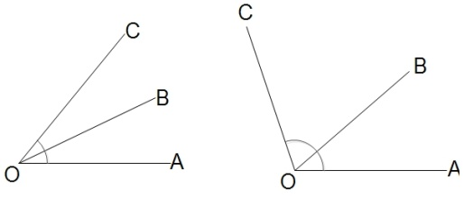  
   ∠

AOB and∠BOC have common vertex O and a common arm OB. They are called adjacent angles.

• **Linear Pair**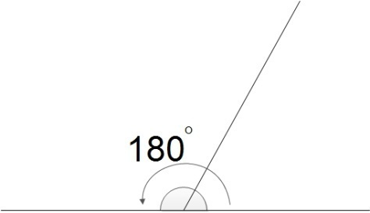  
∠AOB and∠BOC are a pair of adjacent angles. Their sum is a straight angle (180°).  
i.e∠AOB +∠BOC = 180°  
∠AOB and∠BOC are called a linear pair.

• **Vertically Opposite Angles**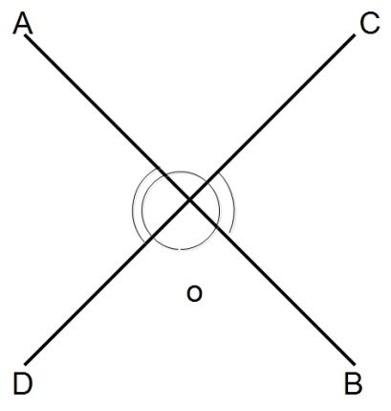  
∠AOC and ∠BOD are formed by the intersected line segments and they lie to the opposite side of the common vertex. They are called vertically opposite angles.∠AOD and∠BOC are another pairs of vertically opposite angles. Vertically opposite angles are always equal.  
∴∠AOC =∠BOD and ∠AOD =∠BOC.

• **Complementary Angles**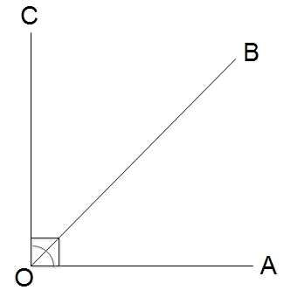  
The sum of∠AOB and∠BOC is a right angle (90°). i.e∠AOB +∠BOC = 90°  
∠AOB and∠BOC are called complementary angles.  
Here, complement of∠AOB = 90° -∠BOC  
Complement of∠

• BOC = 90° - AOB

• **Supplementary Angles**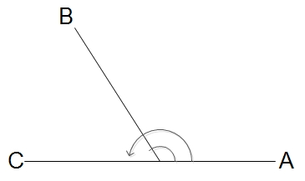  
The sum of ∠AOB and∠BOC is two right angles (180°).  
i.e∠AOB +∠BOC = 180°  
∠AOB and∠BOC are called supplementary angles.  
Here, supplement of∠AOB = 180° -∠BOC  
Supplement of∠BOC = 180° -∠

1. AOB

**Pairs of angles made by a transversal with lines**

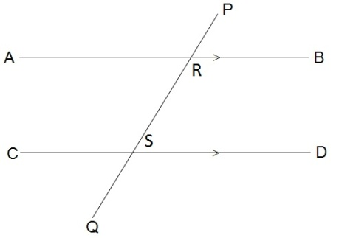

In the given figure, AB and CD and two parallel lines (AB//CD). PQ is the transversal that intersects AB at R and CD at S.

* + 1. **Exterior and alternate exterior angles**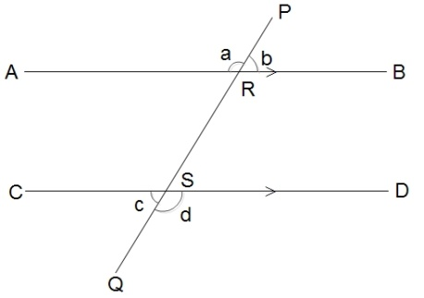  
       ∠

a,∠b,∠c and∠d are lying outside the parallel lines. They are called exterior angles.∠a and∠d are lying to the opposite side of the transversal. They are called alternate exterior angles.  
The alternate exterior angles made by a transversal with parallel lines are always equal.  
∴∠a =∠d and∠b =∠

• c

• **Interior and Co-interior angles**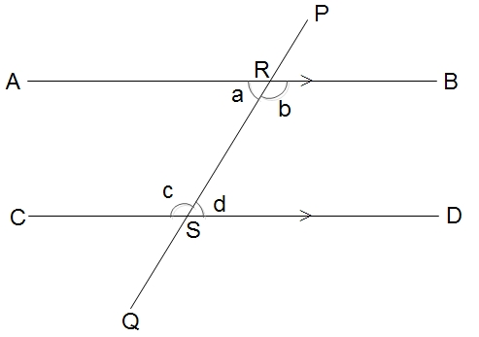  
∠a,∠b,∠c and∠d are lying inside the parallel lines. They are called interior angles. ∠a and∠c are the pair of interior angles lying to the same side of the transversal. They are called Co-interior angles. The sum of a pair of co-interior angles made by a transversal with parallel lines is always 180°.  
∴∠a + ∠c = 180° and∠b +∠d = 180°

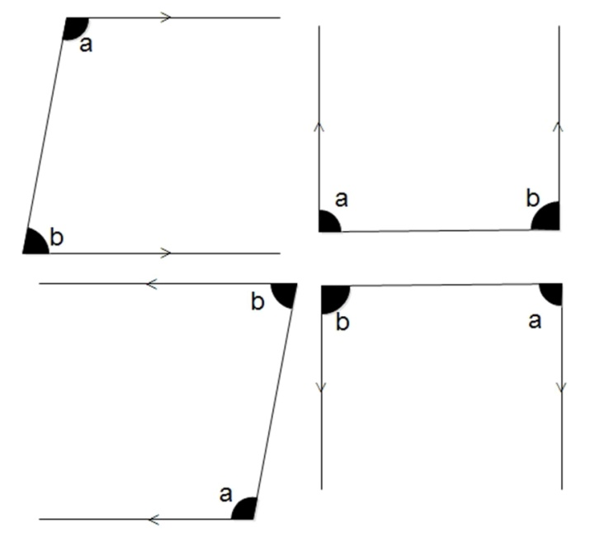

• **Alternate angles**  
∠a and∠d are a pair of interior angles lying to the opposite side of a transversal and they are not adjacent to each other. They are called alternate angles.∠b and∠c are another pairs of alternate angles.  
A pair of alternate angles made by a transversal with parallel lines is always equal.  
∴∠a =∠d and∠b =∠c  
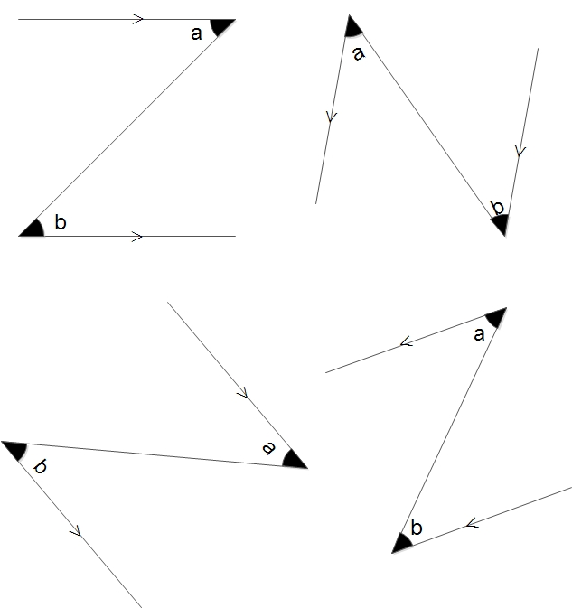

• **Corresponding angles**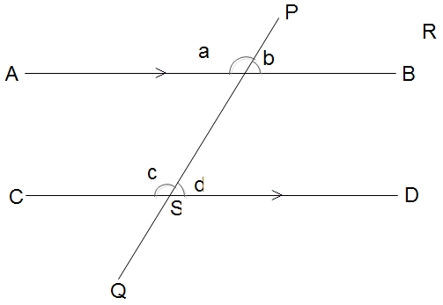  
∠a is an exterior and∠d is an interior angle lying to the same side of the transversal and they are not adjacent to each other.; They are called corresponding angles. b and d are another pairs of corresponding angles.  
A pair of corresponding angles made by a transversal with parallel lines is always equal.

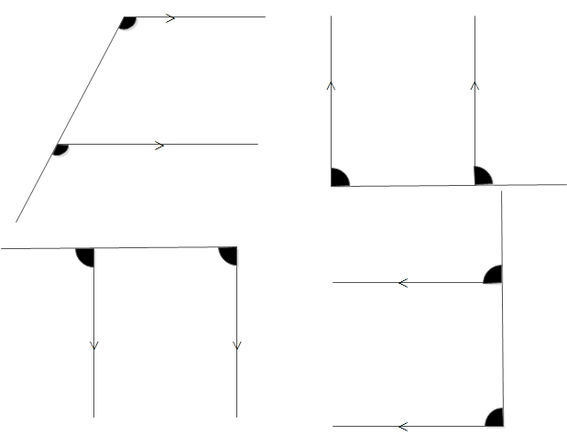

Q A

### Very Short Questions

#### [1. Mention the different pairs of angles.](https://www.kullabs.com/classes/subjects/units/lessons/exercises/3396#31918)

The different pairs of angles are:

1. Adjacent angles
2. Linear Pair
3. Vertically opposite angles
4. Complementary angles
5. Supplementary angles

### Short Questions

#### [1. If x° and (x+10)° are a pair of complementary angles, find them.](https://www.kullabs.com/classes/subjects/units/lessons/exercises/3396#31910)

Solution:

Here, x° + (x+10)° = 90° [The sum of a pair of complementary angles]

or, 2x° = 90° - 10°

or, x° = 80°2

= 40°

∴

x° = 40° and (x+10)° = 40° + 10° = 50°

#### [2. A pair of supplementary angles are in the ratio 3:2, find them.](https://www.kullabs.com/classes/subjects/units/lessons/exercises/3396#31911)

Solution:

Let the required supplementary angles be 3x° and 2x°.

∴

3x° + 2x° = 180° [The sum of a pair of supplementary angles]

or, 5x° = 180°

x° = 180°5

= 36°

∴

3x° = 3 × 36° = 108°

2x° = 2 × 36° = 72°

**A pair of supplementary angles are in the ratio 3:2, find them.**

Solution:

Let the required supplementary angles be 3x° and 2x°.

∴

3x° + 2x° = 180° [The sum of a pair of supplementary angles]

or, 5x° = 180°

x° = 180°5

= 36°

∴

3x° = 3 × 36° = 108°

2x° = 2 × 36° = 72°

**In the adjoining figure, find the sizes of unknown angles.**

#### [s](file:///D:\Project%20materail\angles.html%23collapse31913)

Solution:

Here, x° + 2x° + 3x° = 180° [Being the sum a straight angle]

or, 6x° = 180°

or, x° = 180°6

= 30°

∴

x° = 30°, 2x° = 2×30° = 60° and 3x° = 3×30° = 90°

Again, a° = x° = 30°, b = 2x° = 60° and c° = 3x° = 90° [Each pair is vertically opposite angles]

**Find the sizes of unknown angles of the following figure:**

**a)**

#### [s](file:///D:\Project%20materail\angles.html%23collapse31917)

Solution:

w = 110° [Being vertically opposite angles]

x = w = 110° [Being alternate angles]

y = x = 110° [Being vertically opposite angles]

y + z = 180° [Being the sum of a pair of co-interior angles]

or, 110 + z = 180°

or, z = 180° - 110° = 70°

So, w = x= y = 110° and z = 70°

***~~Arjun Shrestha~~***

**If x° and 112 are adjacent angles in linear pair, what is the value of x° ?**

67°  
69°  
66°  
68°

**If 2a° and 3a° formed a linear pair, what will be the value of them?**

75° and 106°  
73° and 107°  
72° and 108°  
74° and 109°

**Find the size of an angle which is four times its complement.**

80° and 100° this one  
70° and 80°  
70° and 90°  
80° and 90°

**Find the size of an angle which is five times its supplement.**

30° and 150°  
30° and 180°  
20° and 120°  
20° and 100°

**The amount of turn between two straight lines that have a common endpoint that is a ______ .**

vertex  
angles  
base  
edges

**The sum of two angles in supplementary angles are ______ .**

240°  
90°  
360°  
180°

**If the one angle of supplementary angle is 85°, then what will be other angles?**

100°  
90°  
95°  
105°

**The sum of angles in complementary angles are ______ .**

180°  
240°  
360°  
90°

**If the one angle of a complementary angle is 68°, then what will be other angle?**

24°  
28°  
26°  
22°

**The sum of straight line is _______ .**

90°  
180°  
240°  
360°