Circles

**Circle and its different parts**

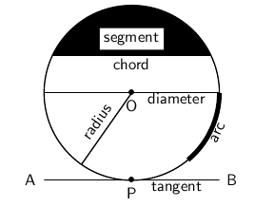source :cnx.org  
Fig :circle

A circle is a plane figure bounded by a curved line and every point of the line is equidistance from a fixed point called the centre of the circle.

1. **Circumference of circle**  
   The curved boundary line of a circle sis called its circumstance. The length of the circumference represents the perimeter of the circle.
2. **Radius of a circle**  
   The straight line is drawn from the centre of a circle to a point on its circumference is called the radius of the circle.  
   In the given figure, OA is the radius.
3. **Chord of a circle**  
   The straight line segment that joins any two points on the circumference of a circle is called the chords of a circle.  
   In the given figure, AB is the chord of the circle.
4. **Diameter of a circle**  
   The chord that passes through the centre of a circle is called the diameter of the circle. Diameter is also called the largest chord of any circle. In the given figure, CD is the diameter of a circle. The length of the diameter of a circle is two times its radius.  
   ∴
5. Diameter = 2 × radius
6. **Sector of a circle**  
   The region inside a circle bounded by its two radii (plural of radius is radii) is called sector.  
   In the figure, the shaded region AOB is the sector.
7. **Arc of a circle**  
   The part of a curve between two given points on the curve of a circle is called an arc.  
   In the figure, AB is the arc.
8. **Segment of a circle**  
   The region bounded by an arc and its corresponding chord is called the segment of a circle.  
   In the given figure, the shaded region represents a segment.
9. **Semi-circle**  
   Half part of a circle is called a semi-circle. A diameter divides a circle into two halves and each half is the semi-circle.  
   In the given figure, ABC is a semi-circle.

Things to remember

* The length of the circumference represents the perimeter of the circle.
* The length of the diameter of a circle is two times its radius.
* Half part of a circle is called a semi-circle.

### Questions and Answers

#### Click on the questions below to reveal the answers

**Find the radii, chords, diameters, sectors, arcs, segments and semi-circles from following figures:**

**Figure (a)**

#### [s](file:///D:\Project%20materail\test.html%23collapse31984)

**Figure (b)**

#### [s](file:///D:\Project%20materail\test.html)

**Figure (c)**

#### [s](file:///D:\Project%20materail\test.html)

Solution:

Figure a) = radii OA and OB, sector OAXB and arc AXB

Figure b) = segment CDY and Chord CD

Figure c) = semi-circle MYN and MXN, diameter MN

**Copy the figures and find the opposite arc of each angle:**

**Figure (a)**

**[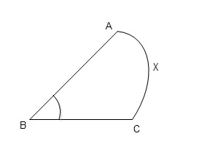](file:///D:\Project%20materail\test.html%23collapse31992)**

**Figure (b)**

**[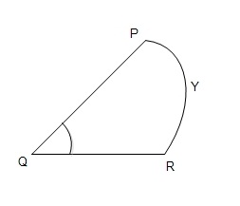](file:///D:\Project%20materail\test.html)**

**Figure (c)**

**[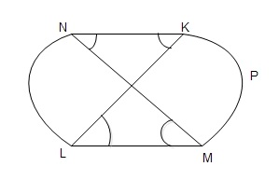](file:///D:\Project%20materail\test.html)**

**Figure (d)**

**[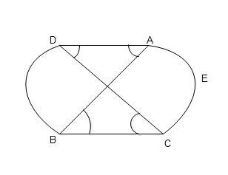](file:///D:\Project%20materail\test.html)**

Solution:

|  |  |  |
| --- | --- | --- |
| Angle | Opposite Arc | |
| ∠ |  | |
| ABC | | AXC |
| ∠ | |  |

|  |  |
| --- | --- |
| PQR | PYR |
| ∠ |  |

KLM, ∠KNM, ∠LKN, ∠

|  |  |
| --- | --- |
| LMN | KPM, LN |
| ∠ |  |

ABC, ∠ADC, ∠BAD, ∠

|  |  |
| --- | --- |
| BCD | AEC, BD |

**Copy the figures and find the centre and radii. Also find the arc opposite to each angle.**

**Figure (a)**

**[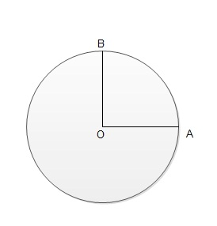](file:///D:\Project%20materail\test.html%23collapse32000)**

**Figure (b)**

**[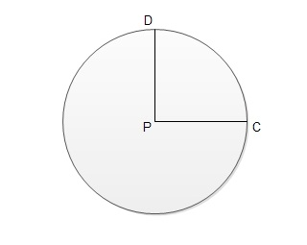](file:///D:\Project%20materail\test.html)**

**Figure (c)**

**[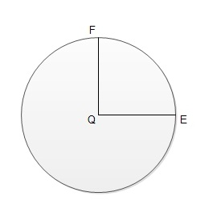](file:///D:\Project%20materail\test.html)**

**Figure (d)**

**[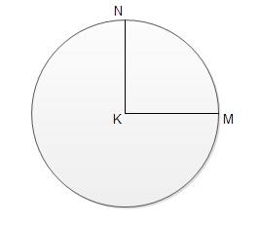](file:///D:\Project%20materail\test.html)**

**Figure (e)**

**[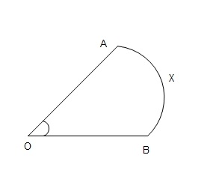](file:///D:\Project%20materail\test.html)**

**Figure (f)**

**[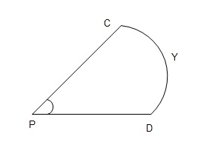](file:///D:\Project%20materail\test.html)**

**Figure (g)**

**[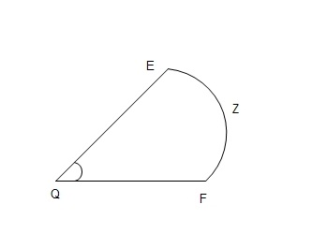](file:///D:\Project%20materail\test.html)**

**Figure (h)**

**[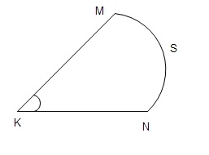](file:///D:\Project%20materail\test.html)**

Solution:

Centre and Radii of figure a) = OA and OB

Centre and Radii of figure  b) = CP and DP

Centre and Radii of figure c) = EQ and FQ

Centre and Radii of figure d) = KM and KN

|  |  |  |
| --- | --- | --- |
| Angle | Opposite Arc | |
| ∠ |  | |
| AOB | | AXB |
| ∠ | |  |

|  |  |
| --- | --- |
| CPD | CYD |
| ∠ |  |

|  |  |
| --- | --- |
| EQF | EZF |
| ∠ |  |

|  |  |
| --- | --- |
| MKN | MSN |

**The straight line is drawn from the centre of a circle to a point on its circumference is called ______ .**

the radius of the circle  
the diameter of a square  
the diameter of a circle  
the radius of a square

**The curved boundary line of a circle is called its ______ .**

radius  
center  
circle  
circumstance

**Half part of a circle is called a ________ .**

semi-circle  
radius   
diameter  
circumstance

**The part of a curve between two given points on the curve of a circle is called ______ .**

an arc   
the side  
the edge  
a radius

**The region bounded by an arc and its corresponding chord is called ______ .**

the sector  
the radius of a circle  
the segment of a circle  
the perimeter of the circle