**Co-ordinates**

#### Co-ordinates

The ordered pair of the number which is used to indicate the position of a point on a grid is known as the coordinates of a point.For example,

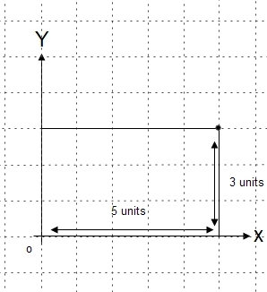

The position of the point P on the grid is 5 units along 3 units up is written as (5,3).

**Co-ordinates axes and quadrants**

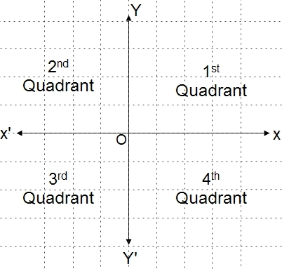

Co-ordinates axes are the horizontal and vertical number lines which intersect each other perpendicularly at the point O.

Here, XOX' is called x-axis or abscissa

YOY' is called the y-axis or ordinate.

The point O is called the origin.

Similarly, the interested x-axis and y-axis divide the co-ordinate plane into 4 regions which are known as quadrants.

XOY is called 1st quadrant.

X'OYis called 2nd quadrant

X'OY' is called 3rd quadrant

XOY' is called 4th quadrant

**Finding points in all four quadrants**

The following are the points which are used to find the points in all four quadrants,

1. In the first quadrant, the co-ordinates of a point are (x,y).
2. In the second quadrant, the co-ordinates of a point are (-x,y)
3. In the third quadrant, the co-ordinates of point are (-x,-y).
4. In the fourth quadrant, the co-ordinates of point (x,-y).
5. The co-ordinates of the origin are (0,0).
6. The co-ordinates of any point on the x-axis are (x,0) or (-x,0).
7. The co-ordinates of any point on the y-axis are (0,y) or (0,-y).

**Plotting points in all four quadrants**

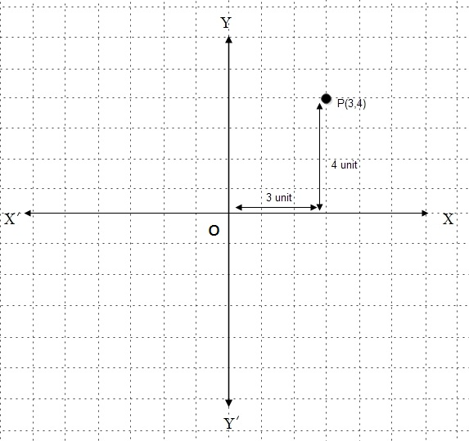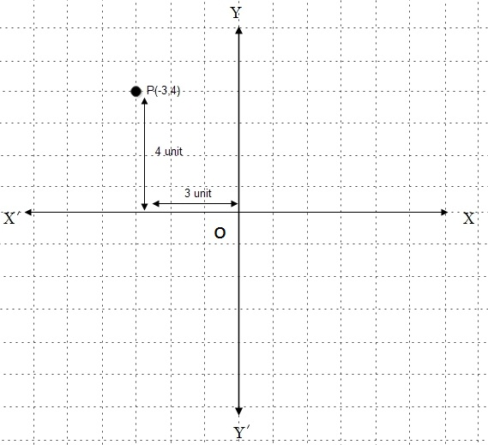

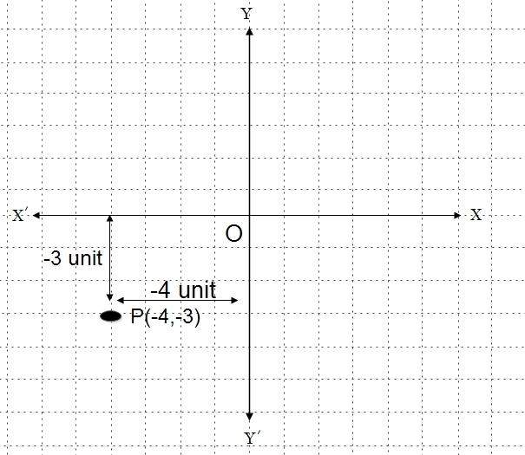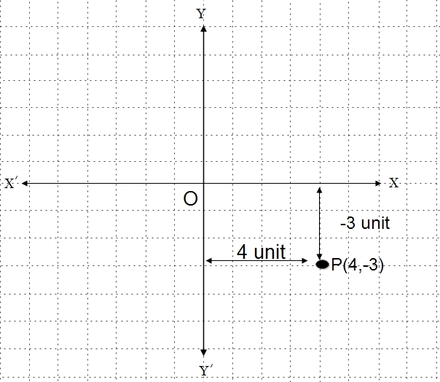

For plotting the points we use graph paper to plot the given points in different quadrants. On the graph paper, we should first draw the co-ordinate axes XOX' and YOY'.

Thiings to remember

* The following are the points which are used to find the points in all four quadrants,
  1. In the first quadrant, the co-ordinates of a point are (x,y).
  2. In the second quadrant, the co-ordinates of a point are (-x,y)
  3. In the third quadrant, the co-ordinates of point are (-x,-y).
  4. In the fourth quadrant, the co-ordinates of point (x,-y).
  5. The co-ordinates of the origin are (0,0).
  6. The co-ordinates of any point on the x-axis are (x,0) or (-x,0).
  7. The co-ordinates of any point on the y-axis are (0,y) or (0,-y).

### Questions and Answers

#### Click on the questions below to reveal the answers

**What are the coordinate axes and quadrants? Mention.**

The coordinate axes are mentioned below:

* XOX' is called the x-axis or abscissa.
* YOY' is called the y-axis or ordinate.
* The point O is called the origin.

Similarly, The quadrants of coordinate are mentioned below:

* The region XOY is called the first quadrant.
* The region X'OY is called the second quadrant.
* The region X'OY' is called the third quadrant.
* The region XOY' is called the fourth quadrant.

**State the quadrant where each of the following points lies:**

**A(2,3) , B(-3,2), C(-2,-3) and D(3,-2)**

Solution:

Given point, A(2,3)  
Since both x and y coordinates are positive, so it lies in the first quadrant.

Also, Given points, B(-3,2)}  
Since x-coordinate is negative and y-coordinate is positive, so it lies in the second quadrant.

Similarly, Given points, C(-2,-3)  
Since both x and y coordinates are negative, so it lies in the third quadrant.

And, Given points, D(3,-2)  
Since x-coordinate is positive and y-coordinate is negative, so it lies in the fourth quadrant.

Quiz

**A point is 5 units right from the origin along x-axis and 3 units up along y-axis, then its coordinates are ______.**

(5, 3)  
(-5, -3)  
(5, -3)  
(3, 5)

**A point is 2 units left from the origin along x-axis and 7 units down along y-axis, then its coordinates are ______.**

(7, -2)  
(-2, -7)  
(2, 7)  
(-2, -7)

**The coordinates of the origin are ______.**

(0, 1)  
(0, 0)  
(1, 1)  
(1, 0)

**If the abscissa of a point -6 and its ordinate is 4, then its coordinates are _______.**

(-6, -4)  
(-6, 4)  
(4, -6)  
(6, -4)

**If the coordinates of a point are (5, -3), it lies in ______ quadrant.**

third  
one  
second   
fourth

**If the coordinates of a point are (-4, -8), it lies in ______ quadrant.**

fourth  
first  
second  
third

**If the coordinates a point are (3, 0), it is lies on ______ axis.**

y-axis  
- abscissa  
x-axis  
- ordinate

**If the coordinates of a point are (0, -6), it lies on _______ axis.**

- abscissa  
- ordinate  
y-axis  
x-axis

* **You scored /12**

•   
[Take test again](https://www.kullabs.com/classes/subjects/units/lessons/notes/note-detail/6071)

• **A point is 5 units right from the origin along x-axis and 3 units up along y-axis, then its coordinates are ______.**

(5, 3)  
(-5, -3)  
(5, -3)  
(3, 5)

• **A point is 2 units left from the origin along x-axis and 7 units down along y-axis, then its coordinates are ______.**

(7, -2)  
(-2, -7)  
(2, 7)  
(-2, -7)

• **The coordinates of the origin are ______.**

(0, 1)  
(0, 0)  
(1, 1)  
(1, 0)

• **If the abscissa of a point -6 and its ordinate is 4, then its coordinates are _______.**

(-6, -4)  
(-6, 4)  
(4, -6)  
(6, -4)

• **If the coordinates of a point are (5, -3), it lies in ______ quadrant.**

third  
one  
second   
fourth

• **If the coordinates of a point are (-4, -8), it lies in ______ quadrant.**

fourth  
first  
second  
third

• **If the coordinates a point are (3, 0), it is lies on ______ axis.**

y-axis  
- abscissa  
x-axis  
- ordinate

• **If the coordinates of a point are (0, -6), it lies on _______ axis.**

- abscissa  
- ordinate  
y-axis  
x-axis

• **In which quadrants do the (-2, 5) point lie?**

second   
first  
third  
fourth

**n which quadrants do the (3, 6) point lie?**

first   
fourth  
second  
third

**In which quadrants do the (4, -3) point lie?**

fourth  
second  
third  
first

**In which quadrants do the (-7 -9) point lie?**

first  
second  
fourth   
third

## Reflection of Geometrical Figures

#### Reflection in Geometrical Figures

The reflection of a geometrical figure means the formation of the image of the figure after reflecting the figure about the line of reflection.

**Properties of Reflection**

1. There should be equal distance between the geometrical figure and its image from the line of reflection.
2. The areas of the geometrical figure and its image are equal.
3. The appearance of the image of a figure is opposite to figure.

**Reflection of geometrical figures using coordinates**

Here, we can find the co-ordinates of the images of geometrical figures formed due to the reflection by x-axis and y-axis separately. In this case, x-axis and y-axis are called the axis of reflection.

1. **X-axis as the axis of reflection**  
   When a geometrical figure is reflected about x-axis as the axis of reflection, the x-coordinate of the image remains the same and the sign of y-coordinate of the image as changed.  
     
   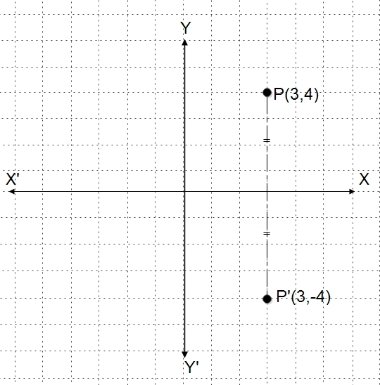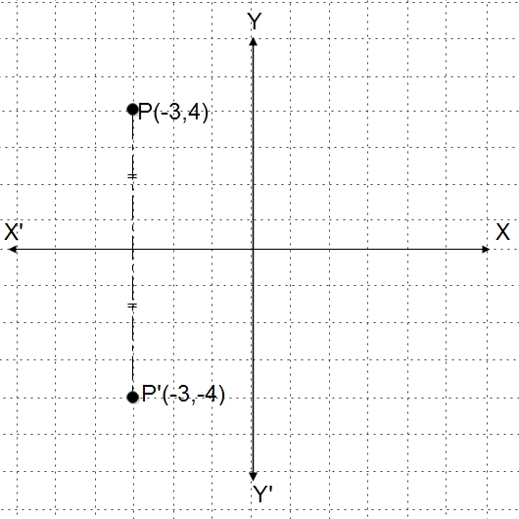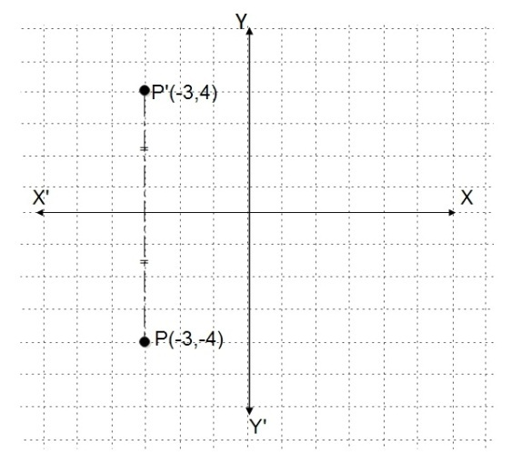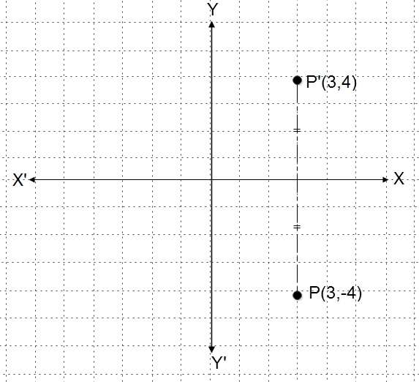
2. **Y-axis as the axis of reflection**  
   When a geometrical figure is reflected about y-axis as the axis of reflection, the sign of x-coordinate of the image is changed but the y-coordinate of the image remains the same.

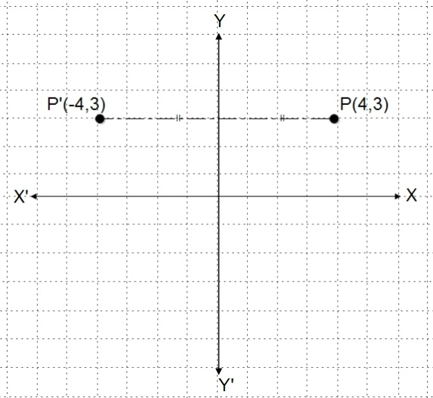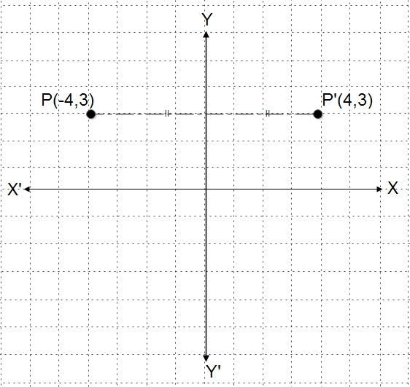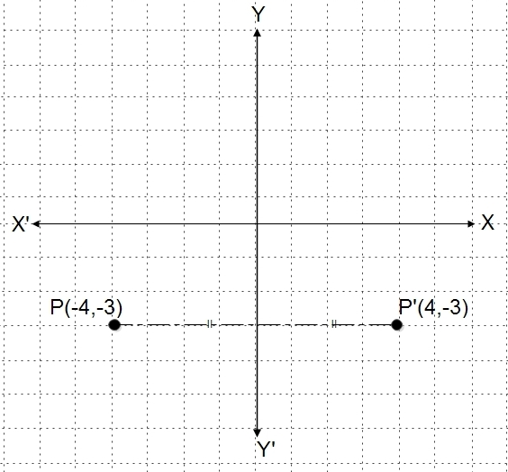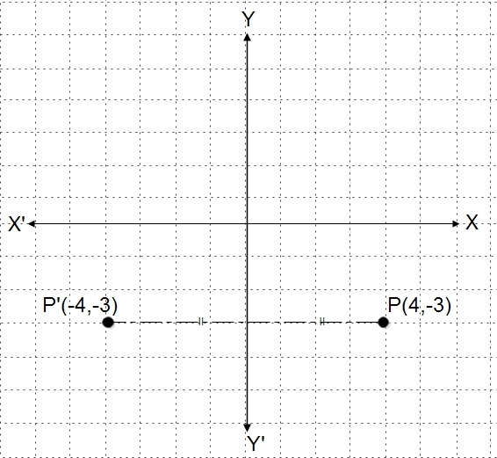

Things to remember

* Properties of Reflection
  1. There should be equal distance between the geometrical figure and its image from the line of reflection.
  2. The areas of the geometrical figure and its image are equal.
  3. The appearance of the image of a figure is opposite to figure.

.

### Questions and Answers

#### Click on the questions below to reveal the answers

**Draw a graph when A(2,-2), B(5,3) and C(1,4) are the vertices of △**

#### ABC. When △

**ABC is reflected about y-axis.**

Solution:

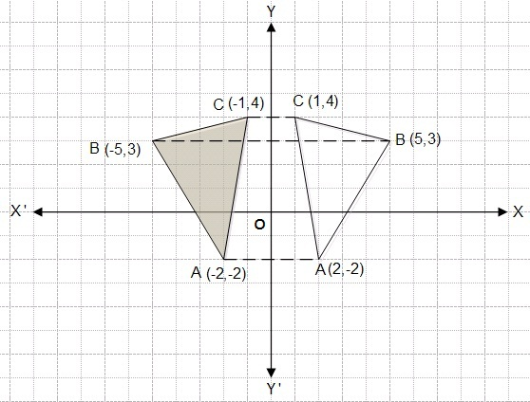

A(2,-2)→

A’(-2,-2)

B(5,3)→

B’(-5,3)

C(1,4)→

C’(-1,4)

So, the coordinates of the vertices of image △

A’B’C’ are A(-2,-2), B(-5,3) and C(-1,4).

#### Draw a graph when A(-2,3), B(2,1) and C(4,4) are the vertices of △

#### ABC. When △

**ABC is reflected about x-axis.**

Solution:

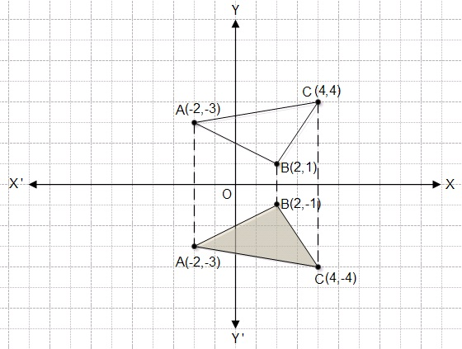

A(-2,3)→

A’(-2,-2)

B(2,1)→

B’(2,-1)

C(4,4)→

C’(4,-4)

So, the coordinates of the vertices of image △

A’B’C’ are A(-2,-3), B(2,-1) and C(4,-4).

Quiz

**What coordinates of image do we get from the points (2, 6) under the reflection about the x-axis?**

(-2, 6)   
(-6, 2)  
(-2, -6)   
(2, -6)

**What coordinates of image do we get from the points (-3, 8) under the reflection about the x-axis?**

(-3, -8)  
(-8, 3)  
(-8, -3)  
(-3, 8)

**What coordinates of image do we get from the points (7, -4) under the reflection about the x-axis?**

(4, 7)  
(-4, 7)  
(7, 4)  
(-4, -7)

**What coordinates of image do we get from the points (-5, -9) under the reflection about the x-axis?**

(5, 9)  
(-9, 5)  
(-9, -5)  
(-5, 9)

**What coordinates of image do we get from the points (0, -6) under the reflection about the x-axis?**

(0, 6)  
(-0, 6)  
(-6, 0)  
(6, 0)

**What coordinates of image do we get from the points (5, 3) under the reflection about the y-axis?**

(-3, -5)  
(-3, 5)  
(5, 3)  
(-5, 3)

**What coordinates of image do we get from the points (4, -7) under the reflection about the y-axis?**

(-4, 7)  
(-4, -7)  
(7, -4)  
(-7, -4)

**What coordinates of image do we get from the points (-9, 6) under the reflection about the y-axis?**

(6, -9)  
(-6, 9)   
(-9, -6)  
(9, 6)

**What coordinates of image do we get from the points (-2, -5) under the reflection about the y-axis?**

(-5, -2)  
(2, -5)  
(5, 2)  
(-2, -5)

**What coordinates of image do we get from the points (-3, 0) under the reflection about the y-axis?**

(3, -0)  
(0, 3)  
(-0, -3)  
(3, 0)

## Rotation of Geometrical Figures

#### Rotation of geometrical figures

When each vertex of a geometrical figure is rotated through a certain angle in a certain direction about a given centre of rotation the figure is said to be rotated through the same centre of rotation.

To rotate a geometrical figure, following three conditions are required

1. Centre of Rotation
2. Angle of Rotation
3. Direction of Rotation

A figure can be rotated in two directions

1. Anti-clockwise direction
2. Clockwise direction

**Rotation through 90° in anticlockwise direction**

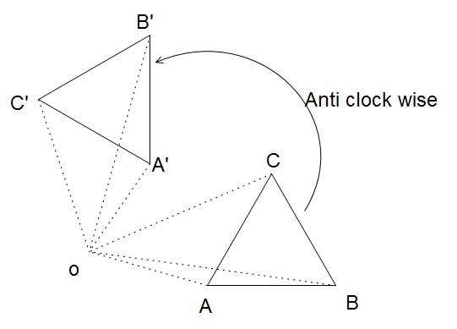

1. Join each vertex of the figure to the centre of rotation with dotted lines.
2. On each dotted lines draw 90° at O with the help of a protractor in an anticlockwise direction.
3. With the help of compass, cut off OA' = OA, OB' = OB and OC' = OC.
4. Join A', C', and C'.

Therefore, △

A'B'C' is the image of △

ABC formed due to the rotation through 90° in the anticlockwise direction about 0.

**Rotation through 90° in clockwise direction**

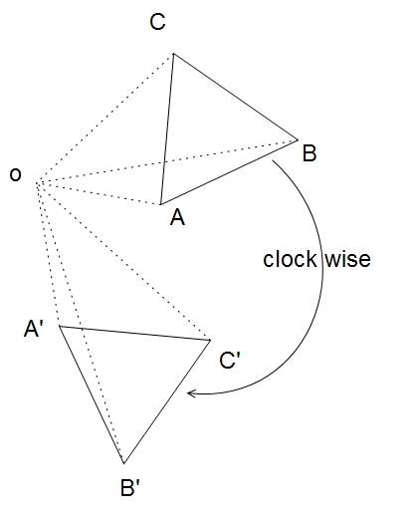

Those similar steps are followed which are mentioned above. While making the angle of 90° you should draw it in the clockwise direction. In the diagram, △

A'B'C' is the image of △

ABC formed due to the rotation through 90° in a clockwise direction about O. In a similar way, we can rotate geometrical figure through 180° in an anti-clockwise or clockwise direction about the given centre of rotation.

**Rotation of Geometrical figures using coordinates**

When the coordinates of the image of a point are rotated through 90° and 180° in anticlockwise and clockwise directions about the centre of rotation at an origin.

**Rotation through 90° in clockwise about origin**

When a point is rotated through 90° in an anti-clockwise direction about the origin as the centre of rotation, the x and y coordinates are exchanged by making the sign of y coordinates just opposite.

i.e P(x,y)→P'(-y,x)

**Rotation through 90° in clockwise about origin**

When a point is rotated through 90° in the clockwise direction about the origin as the centre of rotation, the x and y coordinates are exchanged by making the sign of x coordinates just opposite.

i.e P(x,y)→P'(y,-x)

**Rotation through 180° in anticlockwise and clockwise about origin**

When a point is rotated through 180° about origin the coordinates of the image are the same in both directions.When a point is rotated through 180° in anticlockwise or in a clockwise direction about the origin as the centre of rotation the x and y coordinates of the image remain same just by changing their signs.

i.e P(x,y)→P'(-x,-y)

**Function machine and relation between the variables x and y**

Observe the diagram of a function machine. When different numbers are inserted into the machine, it does the certain process to bring out results under the certainly given rule. Here, the inserted numbers are called inputs and the result coming out from the machine are called outputs.

Things to remember

* Rotation through 90 in anticlockwise direction
  1. Join each vertex of the figure to the centre of rotation with dotted lines.
  2. On each dotted lines draw 90 at O with the help of a protractor in an anticlockwise direction.
  3. With the help of compass, cut off OA' = OA, OB' = OB and OC' = OC.
  4. Join A', C', and C'.

### Questions and Answers

#### Click on the questions below to reveal the answers

**Draw a graph when A(2,1), B(4,3) and C(1,4) are the vertices of △**

#### ABC. When △

**ABC is rotated through 90 in an anti-clockwise direction about the origin.**

Solution:

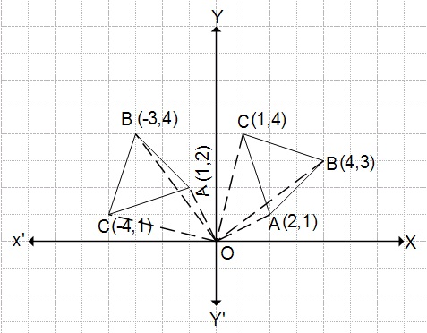

A(2,1)→

A’(-1,2)

B(4,3)→

B’(-3,4)

C(1,4)→

C’(-4,1)

So, the coordinates of the vertices of image △

A’B’C’ are A(-1,2), B(-3,4) and C(-4,1).

**Discover the rotation between input (x) and output (y) from the given table. Then, find the missing numbers.**

**numbers.**

|  |  |  |  |  |  |  |  |
| --- | --- | --- | --- | --- | --- | --- | --- |
| Input(x) | 1 | 2 | 3 | 4 | 5 | 6 | 7 |
| Output(y) | 4 | 5 | 6 | … | … | … | … |

Solution:

Here, when input is 1, output = 4→

1 + 3 →

input + 3

When input is 2, output = 5→

2 + 3 →

input +3

When input is 3, output = 6→

3 + 3→

input+3

Similarly, when input is x, output = x+3

∴

The required relation is y = x + 3.

Now, when x = 4, y = 4+3 = 7

When x= 5, y = 5+3 = 8

When x = 6, y = 6+3 = 9

When x = 7, y = 7+3 = 10.

**The relation between input (x) and (y) is given by y = 2x – 1. Input the numbers from 1 to 4 in the relation and show the output in the table.**

Solution:

Here, the relation is y = 2x – 1

When x = 1, y = 2×1-1 =`1; when x = 2, y = 2×2-1 = 3

When x = 3, y = 2×3-1 = 5; when x = 4, y = 2×4-1 = 7

|  |  |  |  |  |
| --- | --- | --- | --- | --- |
| Input (x) | 1 | 2 | 3 | 4 |
| Output (y) | 1 | 3 | 5 | 7 |

Quiz

**What will be the image of a point (3, 7) when related through 90° in an anti-clockwise direction about the origin.**

(-3, -7)  
(-7, 3)  
(3, 7)  
(-7, -3)

**What will be the image of a point (0, -3) when related through 90° in an anti-clockwise direction about the origin.**

(-0, -3)   
(3, 0)  
(0, 3)  
(-0, 3)

**What will be the image of a point (-1, -7) when they are rotated through 90° in a clockwise direction about the origin.**

(7, 1)  
(-7, 1)  
(7, -1)  
(1, 7)

**What will be the image of a point (4, 2) when they are rotated through 90° in a clockwise direction about the origin.**

(4, -2)  
(2, -4)   
(-4, -2)  
(2, 4)

**What will be the image of a point (-2, 5) when rotated through 180° in an anti-clockwise direction about the origin.**

(2, -5)   
(-2, 5)  
(2, 5)  
(-5, 2)

**What will be the image of a point (4, -7)) when rotated through 180° in an anti-clockwise direction about the origin.**

(-7, 4)  
(7, 4)  
(7, -4)  
(-4, 7)

**What will be the image of a point (0, 2) when rotated through 180° in an anti-clockwise direction about the origin.**

(0, 2)   
(2, -0)  
(0, -2)  
(-0, 2)

**What will be the image of a point (9, -8) when rotated through 90° in an anti-clockwise direction about the origin.**

(-8, 9)  
(9, 8)  
(8, 9)  
(-9, -8)

**What will be the image of a point (-4, 0) when rotated through 90° in a clockwise direction about the origin.**

(-4, -0)  
(-0, 4)  
(0, 4)  
(4, 0)

**What will be the image of a point (1, 6) when rotated through 180° in an anti-clockwise direction about the origin.**

(6, 1)  
(-1, 6)  
(-6, -1)  
(-1, -6)